Do Alternate Wetting and Drying Irrigation Technology and Nitrogen Rates Affect Rice Sheath Blight?

Water and nitrogen management play vital roles in rice production. However, the mismanagement of these two management practices may trigger sheath blight of rice, caused by *Rhizoctonia solani*, which is favored by wet conditions, high relative humidity, and high nitrogen fertilizer levels. To understand how different combinations of water and nitrogen management affect sheath blight epidemics, we conducted two separate split-plot experiments with a water saving (alternate wetting and drying) regime and traditional flood irrigation regime combined with differing nitrogen treatments in the dry seasons of 2015 and 2016. Disease was scored in the same way in both experiments using a sheath blight assessment scale for field evaluation developed at the International Rice Research Institute to assess the severity on infected sheaths and leaves while sheath blight incidence on tillers were counted per hill. We were unable to detect any difference in the incidence of tiller sheath blight due to irrigation, tiller and leaf sheath blight did differ significantly by irrigation treament but leaf sheath blight severity did not. Our findings suggests that farmers can adopt water saving technologies without risking increased sheath blight incidence. We suggest that further cross-cutting research in this area is warranted.

# Introduction

Alternate wetting and drying (AWD) is an irrigation technique for irrigated rice (*Oryza sativa* L.) developed by the International Rice Research Institute (IRRI) and its partners that saves about 15-40% of irrigation water (B. Bouman and Tuong 2001; L. Feng et al. 2007). In AWD rice, fields are exposed to several dry phases during the growth period without exposing the plants to water stress. In order to avoid yield decline under AWD “safe” thresholds have been developed. Under safe AWD irrigation water is applied when the field water level reaches 15cm below the soil surface (Richards and Sander 2014). Fields are furthermore kept flooded during the flowering period. As an added benefit to saving water, AWD also reduces greenhouse gas (GHG) emissions of rice fields, which are a substantial factor in the GHG budget of rice producing countries, by around 50% (Sander et al. 2016; Yan et al. 2005).

The AWD technology has been identified as promising climate smart practice for different rice growing regions that can stabilize rice production in water scarce areas as well as help reduce the carbon footprint of rice production. Various countries, *e.g.*, Bangladesh, Vietnam, Thailand and the Philip pines, plan to widely apply AWD to local rice production (Ministry of Environment and Forests (MOEF) Government of the People’s Republic of Bangladesh 2015). However, a change in water regime in rice fields on large scale might encompass different other effects, for example related to plant health.

Nitrogen is known to affect sheath blight (Castilla et al. 1996)…

We therefore established field experiments in order to determine what effects AWD could have on sheath blight disease (*Rhizoctonia solani* Kühn), anastamosis group 1 [(teleomorph: *Thanatephorus cucumeris* (A.B. Frank) Donk.] of rice.

Sheath blight is economically important worldwide and it is difficult to find resistance to the disease (Srinivasachary et al. 2011). Therefore management is usually a combination of cultural practices, which include nitrogen and water management. High nitrogen levels

# Materials and Methods

## Crop establishment

Two experiments were conducted at the International Rice Research Institute’s (IRRI) Ziegler Experiment Station in Los Baños, Calabarzon, Philippines (latitude 14° 11’ N, , longitude 121° 15’ E) in the 2015 and 2016 dry seasons. For the 2016 season changes were made to optimize the experiment based on findings from the 2015 season.

Nurseries of NSIC Rc222, a short-season in-bred irrigated lowland rice variety with 114 day maturity when transplanted were established on 27 December 2014 and 7 January 2015 for the 2015 and 2016 experiments, respectively. Seedlings were transplanted on 9 January 2015 and 20 to 22 January 2016 in hills with six to eight seedlings per hill with a distance of 20 cm within and between rows.

## Inoculum

An isolate of *Rhizoctonia solani* AG1-1a from infected rice was maintained on potato dextrose agar (PDA) medium in tubes. The isolate was transferred to 90mm Petri dishes containing PDA and incubated a room temperature (20 to 27°C). Glass bottles of autoclaved rice grain and hull substrate were prepared and plugs of the culture were transferred from Petri dishes to the autoclaved substrate and incubated at room temperature for two weeks.

## Experimental Design

Both experiments consisted of split-plot design with four replicates where irrigation was the main plot and nitrogen (N) rate was the split plot treatment. The main plot treatments were alternate wetting and drying (AWD) and continuously flooded (CF) or farmers’ practice, the control treatment. The changes between seasons and experiments are detailed following.

### 2015 Dry Season Experiment

The main plot size was 12m x 12m (144 sq m), with a sub-plot size of 5m x 5m (25 sq m). Replication size was 12m x 24m (288 sq m) with a buffer of 1m per sub-plot for a whole experiment size of 1,152 sq m.

Irrigation in AWD plots was determined by the water level in plots, *i.e.*, when the water level reached 15cm below the soil surface irrigation water was applied to a level of 5cm. In CF plots a standing water layer of 3-5cm was maintained throughout the growing season.

The sub-plot treatments were different rates of nitrogen, N0 (no nitrogen supply), N100 (100 kg per ha applied as urea in three splits at final harrowing, active tillering and panicle initiation) and N120 (120 kg per ha applied as urea in three splits at final harrowing, active tillering and panicle initiation).

The plots were inoculated 20 days after transplanting using 151g of inoculum per plot (4m x 11m).

### 2016 Dry Season Experiment

In 2016 dry season the plot size was increased and due to these changes, the replicate sizes are are not equal as necessitated by the use of a larger area for the experiment. The main plot sizes were: Block 1 (B1) 21m x 20.5m (412.5 sq m) and Block 2 (B2) 20.25m x 21.6m (437.4 sq m). The sub-plot sizes were B1 21m x 10.25m (215.25 sq m), B2 20.25m x 10.8m (218.7 sq m). The replication sizes were B1 - 42m x 20.5m (861 sq m) and B2 - 40.5m x 21.6m (874.8 sq m). A buffer 0.5m per sub-plot was used and the overall experiment size was 3471.6 sq m.

Sub-plot N rates differed from the 2015 rates with only two nitrogen treatments, N60 (60 kg per ha as urea split into two applications) and N180 (180 kg per ha in three splits) was applied.

Based on the 2015 results, the inoculation methods were modified in 2016 to increase the amount of inoculum applied to a smaller area. Plots were inoculated 41 days after transplanting using ten bottles per one sampling area (1m x 1m) per plot, where one bottle contained 151g inoculum. A total amount of 1,510g of inoculum was applied to a 1m x 1m area.

## Data Collection and Analysis

Disease scoring was the same in both experiments using the same sheath blight disease assessment scale for field evaluation developed at IRRI where 0 - no disease; 1 - trace to 1% severity; 2 - 1 to 5%; 3 - 5 to 15%; 4 - 15 to 50%; 5 - 50 to 100%. Where severity was considered to be the amount of leaf or sheath tissue covered by sheath blight lesions. Two sample areas per plot (1m x 1m) were assessed. For nine hills per sample, the number of tillers per hill and number of tillers with sheath blight (incidence) were measured. Tiller sheath blight severity was measured for four tillers per hill and six leaves tiller using the rating scale. Five disease assessments were made in the 2015 experiment and four disease assessments were made in the 2016 experiment, respectively.

Disease severity values were converted to the midpoint percentage value of the disease assessment scale. Area under the disease progress stairs (AUDPS) (Simko and Piepho 2012) was calculated for both disease incidence and severity. As most of the data’s residuals did not meet assumptions for normality, the analysis was carried out using multivariate generalised linear mixed models implemented in the MCMCglmm package (Hadfield 2010) in the R programming environment (R Core Team 2018).

# Results

## Tiller Sheath Blight Incidence

In 2015 the incidence of tiller sheath blight remained low throughout the growing season only reaching 15% in 2015 in the N120/flooded treatment (Figure 1). The nitrogen treatments, N100 and N120, were both significantly different when compared with the control N0 treatment. However, water management was not significantly different.

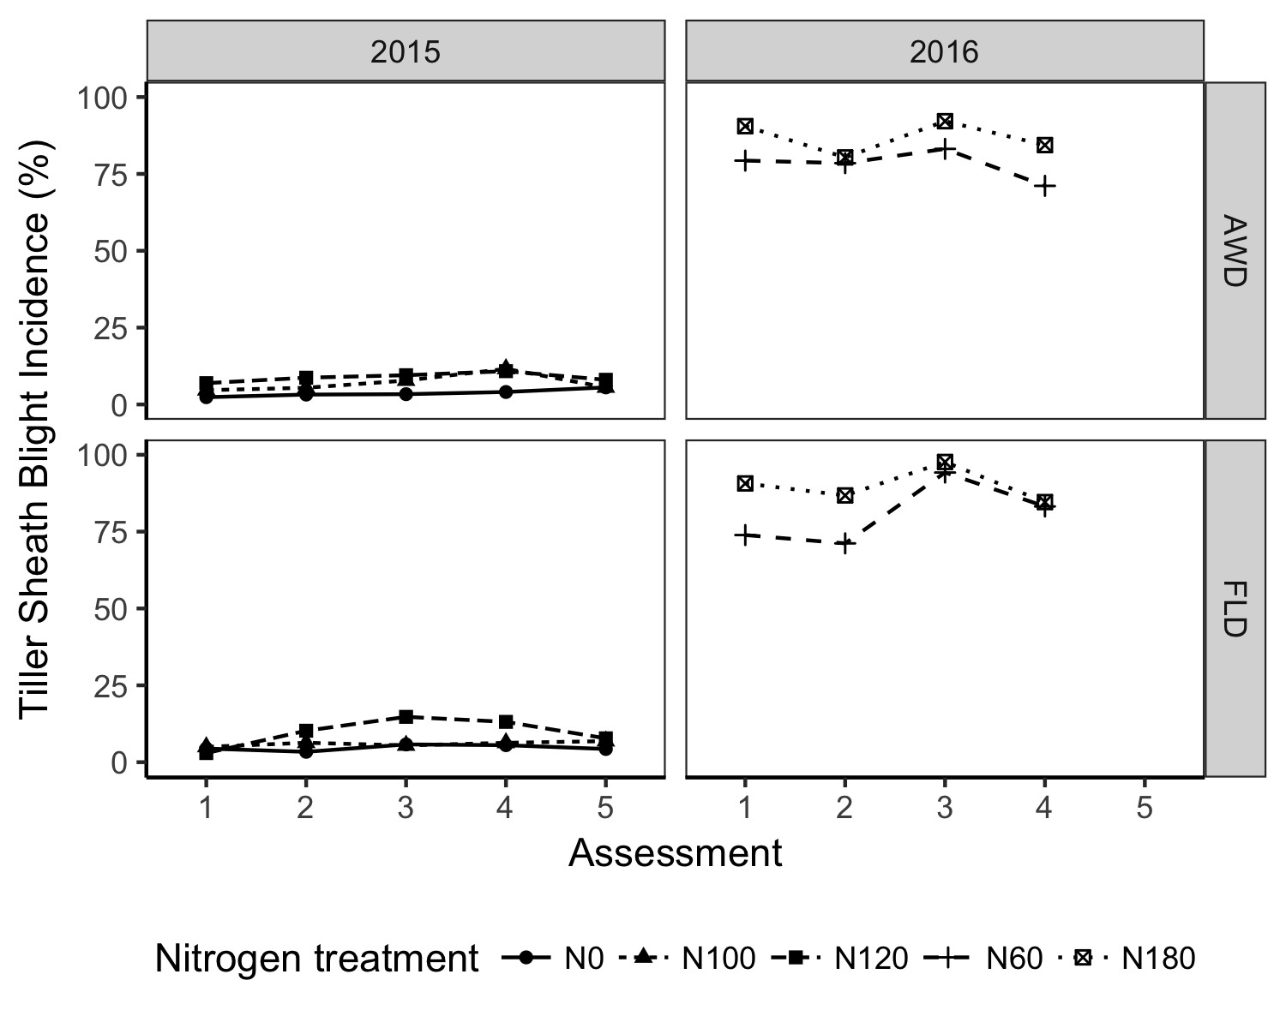

Figure 1 Tiller sheath blight incidence progress was measured in the 2015 experiment at five assessment points and 2016 experiment at four assessment points during the dry season both years. Main plot irrigation treaments were permanently flooded (FLD) and alternate wetting and drying (AWD). Five different nitrogen treatments were applied depending on the experiment. In the 2015 experiment three nitrogen rate treatements were applied: no N (N0), 100 units of N (N100) and 180 units of N (N180). In the 2016 experiment, two nitrogen rate treatments were applied: 60 units of N (N60) and 180 units of N (N180).

The changes to the inoculation methodology resulted in a much higher rate of infection in 2016, with the N180/flooded treatment reaching a maximum value of 98% incidence at the third observation (Figure 1). The nitrogen treatment N180, was significantly different than the control N60 treatment. As in the 2015 study, water management did not significantly differ.

## Tiller Sheath Blight Severity

In 2015 both the N100 and N120 treatments were significantly different than the control N0 treatment. The AWD water management was also significantly different from the control flooding treatment.

In 2016 the N180 treatment was significantly different from the N60 treatment. The AWD water management was also significantly different from the control flooding treatment.

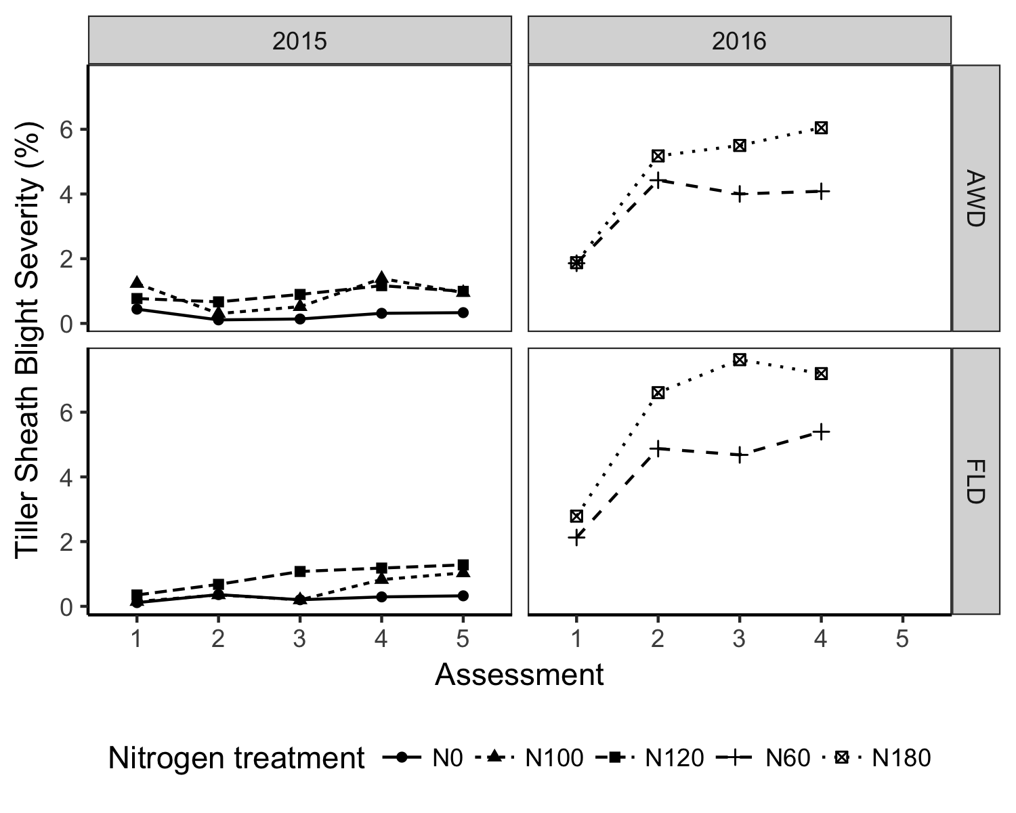

Figure 2 Tiller sheath blight severity progress was measured in the 2015 experiment at five assessment points and 2016 experiment at four assessment points during the dry season both years. Main plot irrigation treaments were permanently flooded (FLD) and alternate wetting and drying (AWD). Five different nitrogen treatments were applied depending on the experiment. In the 2015 experiment three nitrogen rate treatements were applied: no N (N0), 100 units of N (N100) and 180 units of N (N180). In the 2016 experiment, two nitrogen rate treatments were applied: 60 units of N (N60) and 180 units of N (N180).

## Leaf Sheath Blight Severity

In 2015 both the N100 and N120 treatments were significantly different than the N0 treatment. The AWD water management was also significantly different from the control flooding treatment.

In 2016 the none of the treatments, nitrogen rate or water management, were significantly different from the control treatment for leaf sheath blight severity.

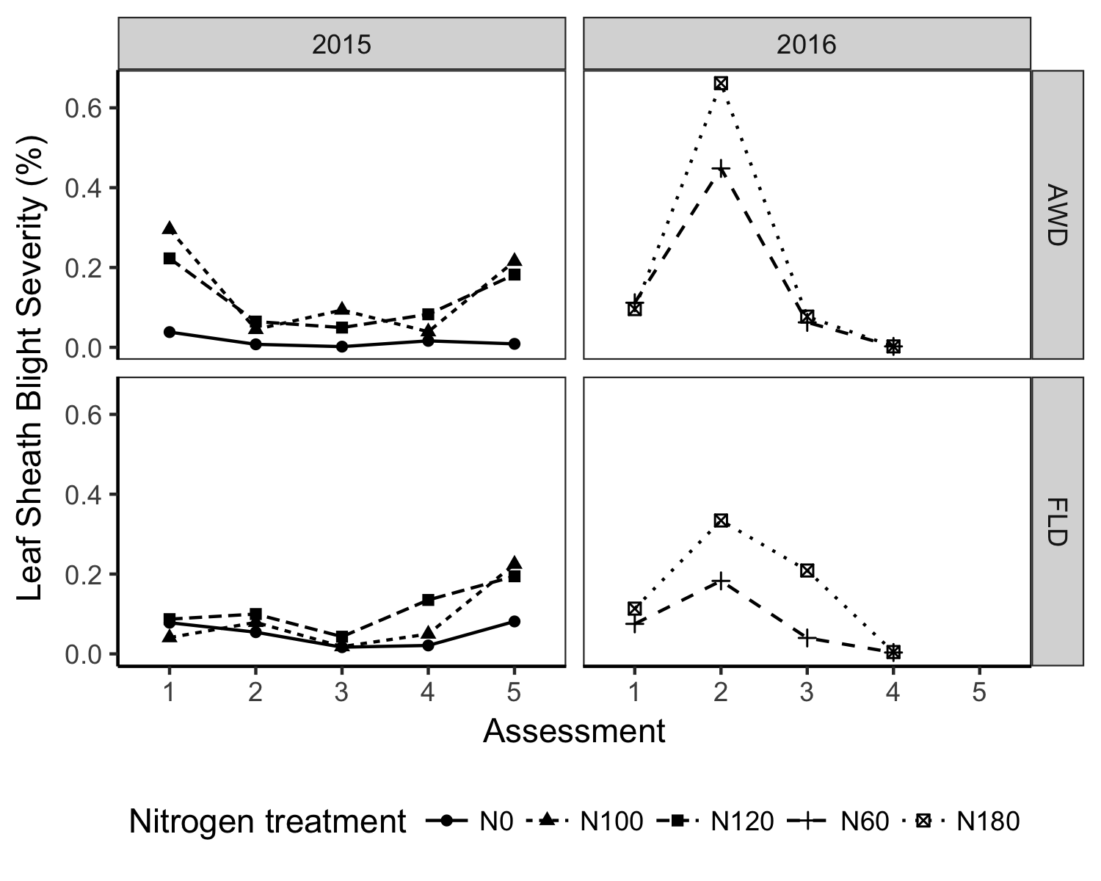

Figure 3 Leaf sheath blight severity progress was measured in the 2015 experiment at five assessment points and 2016 experiment at four assessment points during the dry season in both years. Main plot irrigation treaments were permanently flooded (FLD) and alternate wetting and drying (AWD). Five different nitrogen treatments were applied depending on the experiment. In the 2015 experiment three nitrogen rate treatements were applied: no N (N0), 100 units of N (N100) and 180 units of N (N180). In the 2016 experiment, two nitrogen rate treatments were applied: 60 units of N (N60) and 180 units of N (N180).

# Discussion

# Notes

## Acknowledgments

The authors wish to thank Rachel King University of Southern Queensland Statistical Consulting Unit for her insightful comments on the analysis of this paper, Dale Amozola for technical support in the field. Lastly, Michael Noel, who helped design and manage the first year of the project but passed away in 2015.

##### pagebreak

# References

Bouman, B., & Tuong, T. (2001). Field water management to save water and increase its productivity in irrigated lowland rice. *Agricultural Water Management*, *49*(1), 11–30. doi:[10.1016/S0378-3774(00)00128-1](https://doi.org/10.1016/S0378-3774(00)00128-1)

Castilla, N., Leano, R., Elazhour, F., Teng, P., & Savary, S. (1996). Effects of plant contact, inoculation pattern, leaf wetness regime, and nitrogen supply on inoculum efficiency in rice sheath blight. *Journal of Phytopathology*, *144*(4), 187–192.

Feng, L., Bouman, B., Tuong, T., Cabangon, R., Li, Y., Lu, G., & Feng, Y. (2007). Exploring options to grow rice using less water in northern china using a modelling approach: I. field experiments and model evaluation. *Agricultural Water Management*, *88*(1 - 3), 1–13. doi:[10.1016/j.agwat.2006.10.006](https://doi.org/10.1016/j.agwat.2006.10.006)

Hadfield, J. D. (2010). MCMC methods for multi-response generalized linear mixed models: The MCMCglmm R package. *Journal of Statistical Software*, *33*(2), 1–22. <http://www.jstatsoft.org/v33/i02/>

Ministry of Environment and Forests (MOEF) Government of the People’s Republic of Bangladesh. (2015). Intended nationally determined contributions (indc). <http://www4.unfccc.int/ndcregistry/PublishedDocuments/Bangladesh%20First/INDC_2015_of_Bangladesh.pdf>

R Core Team. (2018). *R: A language and environment for statistical computing*. Vienna, Austria: R Foundation for Statistical Computing. <https://www.R-project.org/>

Richards, M., & Sander, B. O. (2014). *Alternate wetting and drying in irrigated rice* (CSA Practice Brief). Copenhagen, Denmark: CGIAR Research Program on Climate Change, Agriculture; Food Security (CCAFS).

Sander, B. O., Wassmann, R., & Siopongco, J. D. L. C. (2016). Mitigating greenhouse gas emissions from rice production through water-saving techniques: Potential, adoption and empirical evidence. In C. T. Hoanh, R. Johnston, & V. Smakhtin (Eds.), (p. 193). Centre for Agriculture; Biosciences International.

Simko, I., & Piepho, H.-P. (2012). The area under the disease progress stairs: Calculation, advantage, and application. *Phytopathology*, *102*(4), 381–389.

Srinivasachary, Willocquet, L., & Savary, S. (2011). Resistance to rice sheath blight (rhizoctonia solani kühn) [(teleomorph: Thanatephorus cucumeris (a.B. frank) donk.] disease: Current status and perspectives. *Euphytica*, *178*(1), 1–22. doi:[10.1007/s10681-010-0296-7](https://doi.org/10.1007/s10681-010-0296-7)

Yan, X., Yagi, K., Akiyama, H., & Akimoto, H. (2005). Statistical analysis of the major variables controlling methane emission from rice fields. *Global Change Biology*, *11*(7), 1131–1141. doi:[10.1111/j.1365-2486.2005.00976.x](https://doi.org/10.1111/j.1365-2486.2005.00976.x)

##### pagebreak

### Colophon

This report was generated on 2018-04-14 16:23:26 using the following computational environment and dependencies:

## setting value   
## version R version 3.4.4 (2018-03-15)  
## system x86_64, darwin17.4.0   
## ui unknown   
## language (EN)   
## collate en_AU.UTF-8   
## tz Australia/Brisbane   
## date 2018-04-14   
##   
## package * version date source   
## assertthat 0.2.0 2017-04-11 CRAN (R 3.4.2)   
## backports 1.1.2 2017-12-13 cran (@1.1.2)   
## base * 3.4.4 2018-03-15 local   
## bindr 0.1.1 2018-03-13 CRAN (R 3.4.4)   
## bindrcpp 0.2.2 2018-03-29 cran (@0.2.2)   
## bookdown * 0.7 2018-02-18 CRAN (R 3.4.4)   
## colorspace 1.3-2 2016-12-14 CRAN (R 3.4.2)   
## compiler 3.4.4 2018-03-15 local   
## datasets * 3.4.4 2018-03-15 local   
## devtools 1.13.5 2018-02-18 CRAN (R 3.4.4)   
## digest 0.6.15 2018-01-28 cran (@0.6.15)   
## dplyr 0.7.4 2017-09-28 CRAN (R 3.4.4)   
## evaluate 0.10.1 2017-06-24 cran (@0.10.1)   
## ggplot2 * 2.2.1.9000 2018-04-07 Github (hadley/ggplot2@3c9c504)  
## ggpubr * 0.1.6 2017-11-14 CRAN (R 3.4.4)   
## glue 1.2.0 2017-10-29 cran (@1.2.0)   
## graphics * 3.4.4 2018-03-15 local   
## grDevices * 3.4.4 2018-03-15 local   
## grid 3.4.4 2018-03-15 local   
## gtable 0.2.0 2016-02-26 CRAN (R 3.4.2)   
## highr 0.6 2016-05-09 cran (@0.6)   
## hms 0.4.2 2018-03-10 CRAN (R 3.4.4)   
## htmltools 0.3.6 2017-04-28 cran (@0.3.6)   
## httr 1.3.1 2017-08-20 CRAN (R 3.4.2)   
## kableExtra * 0.8.0 2018-04-05 cran (@0.8.0)   
## knitr * 1.20 2018-02-20 CRAN (R 3.4.4)   
## labeling 0.3 2014-08-23 CRAN (R 3.4.2)   
## lazyeval 0.2.1 2017-10-29 cran (@0.2.1)   
## magrittr * 1.5 2014-11-22 CRAN (R 3.4.2)   
## memoise 1.1.0 2017-04-21 CRAN (R 3.4.2)   
## methods * 3.4.4 2018-03-15 local   
## munsell 0.4.3 2016-02-13 CRAN (R 3.4.2)   
## pillar 1.2.1 2018-02-27 CRAN (R 3.4.4)   
## pkgconfig 2.0.1 2017-03-21 CRAN (R 3.4.2)   
## plyr 1.8.4 2016-06-08 CRAN (R 3.4.2)   
## R6 2.2.2 2017-06-17 CRAN (R 3.4.2)   
## Rcpp 0.12.16 2018-03-13 CRAN (R 3.4.4)   
## readr 1.1.1 2017-05-16 CRAN (R 3.4.2)   
## reshape2 1.4.3 2017-12-11 cran (@1.4.3)   
## rice.awd.pests * 0.0.0.9000 2018-04-12 local   
## rlang 0.2.0.9001 2018-04-12 Github (r-lib/rlang@82b2727)   
## rmarkdown 1.9 2018-03-01 CRAN (R 3.4.4)   
## rprojroot 1.3-2 2018-01-03 cran (@1.3-2)   
## rstudioapi 0.7 2017-09-07 CRAN (R 3.4.2)   
## rvest 0.3.2 2016-06-17 CRAN (R 3.4.2)   
## scales 0.5.0.9000 2018-01-15 Github (hadley/scales@d767915)   
## stats * 3.4.4 2018-03-15 local   
## stringi 1.1.7 2018-03-12 CRAN (R 3.4.4)   
## stringr 1.3.0 2018-02-19 CRAN (R 3.4.4)   
## tibble 1.4.2 2018-01-22 cran (@1.4.2)   
## tools 3.4.4 2018-03-15 local   
## utils * 3.4.4 2018-03-15 local   
## viridisLite 0.3.0 2018-02-01 cran (@0.3.0)   
## withr 2.1.2 2018-03-15 Github (r-lib/withr@79d7b0d)   
## xfun 0.1 2018-01-22 cran (@0.1)   
## xml2 1.2.0 2018-01-24 cran (@1.2.0)   
## yaml 2.1.18 2018-03-08 CRAN (R 3.4.4)

The current Git commit details are:

## Local: master /Users/adamsparks/Development/rice_awd_pests/  
## Remote: master @ origin (https://github.com/openplantpathology/rice_awd_pests.git)  
## Head: [06a8ce3] 2018-04-14: add ggpubr to "suggests"