Function Point Calculation

Here is 2 types of function types

1. Transaction functional type
   * External Input I/P (EI)
   * External Output O/P (EO)
   * External Inquiry (EQ)
2. Data functional type
   * Internal logical file (ILF)
   * External Interface file (EIF)

**FP = Count_Total * (0.65+0.01*(Σ(Fi))**

**Value adjust meant Factors illustrates**

* 0 - No Influences or No Important
* 1 – Incidental OR simple
* 2 - Moderate
* 3 - Average
* 4 - Significant
* 5 - Essential

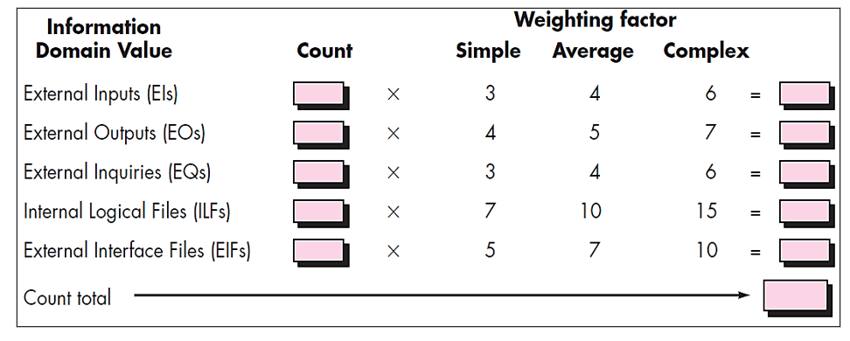

# Exercise 1(A):

A system has 10 external inputs, 20 external outputs, 25 different external queries, manages 4 internal logical files, and interfaces with 4 different legacy systems. All of these data are of average complexity, and the overall system is relatively simple. Compute FP for the system.

## Solution:

Unadjusted Function Points (UFP):

|  |  |  |  |
| --- | --- | --- | --- |
| **Component** | **Count** | **Complexity** | **FP Contribution** |
| External Inputs (EI) | 10 | Average (3) | 10 x 3 = 30 |
| External Outputs (EO) | 20 | Average (4) | 20 x 4 = 80 |
| External Queries (EQ) | 25 | Average (3) | 25 x 3 = 75 |
| Internal Logical Files (ILF) | 4 | Average (7) | 4 x 7 = 28 |
| External Interface Files (EIF) | 4 | Average (5) | 4 x 5 = 20 |

**Total UFP = 233**

Since the system is relatively simple, we'll use the default Value Adjustment Factor (VAF) of 1.0:

**FP = UFP x VAF = 233 x 1.0 = 233**

# Exercise 2(A):

Compute function point value for a project with the following domain characteristics:

• Number of user inputs: 5  
• Number of user outputs: 5  
• Number of user enquiries: 6  
• Number of files: 5  
• Number of external interfaces: 5  
Assume that all the complexity adjustment values are simple. Where Σ (Fi) = 25

## Solution:

Unadjusted Function Points (UFP):

|  |  |  |  |
| --- | --- | --- | --- |
| **Component** | **Count** | **Complexity** | **FP Contribution** |
| User Inputs (EI) | 5 | Simple (3) | 5 x 3 = 15 |
| User Outputs (EO) | 5 | Simple (4) | 5 x 4 = 20 |
| User Enquiries (EQ) | 6 | Simple (3) | 6 x 3 = 18 |
| Internal Logical Files (ILF) | 5 | Simple (7) | 5 x 7 = 35 |
| External Interface Files (EIF) | 5 | Simple (5) | 5 x 5 = 25 |

**Total UFP = 113**

With Σ (Fi) = 25, we can calculate the Value Adjustment Factor (VAF) and FP as follows:

VAF = 0.65 + 0.01 x Σ(Fi)  
VAF = 0.65 + 0.01 x 25 = 0.65 + 0.25 = 0.90

**FP = UFP x VAF = 113 x 0.90 = 101.7 ≈ 102**

# Exercise 3(A):

Given the following values, compute function point when all complexity adjustment factor (CAF) and weighting factors are average:

• User Input = 50  
• User Output = 40  
• User Inquiries = 35  
• User Files = 6  
• External Interface = 4

## Solution:

Unadjusted Function Points (UFP):

|  |  |  |  |
| --- | --- | --- | --- |
| **Component** | **Count** | **Complexity** | **FP Contribution** |
| User Inputs (EI) | 50 | Average (4) | 50 x 4 = 200 |
| User Outputs (EO) | 40 | Average (5) | 40 x 5 = 200 |
| User Enquiries (EQ) | 35 | Average (4) | 35 x 4 = 140 |
| Internal Logical Files (ILF) | 6 | Average (7) | 6 x 7 = 42 |
| External Interface Files (EIF) | 4 | Average (5) | 4 x 5 = 20 |

**Total UFP = 602**

Since all complexity adjustment factors (CAF) are average, Σ(Fi) = 35:  
VAF = 0.65 + 0.01 x Σ(Fi)  
VAF = 0.65 + 0.01 x 35 = 0.65 + 0.35 = 1.00

**FP = UFP x VAF = 602 x 1.00 = 602**

# Exercise 4(B):

Compute the function point for the following data:

• Number of user inputs = 24  
• Number of user outputs = 46  
• Number of inquiries = 8  
• Number of files = 4  
• Number of external interfaces = 2  
• All complexity adjustment factors (CAF) are significant and weighting factors are average.

## Solution:

Unadjusted Function Points (UFP):

|  |  |  |  |
| --- | --- | --- | --- |
| **Component** | **Count** | **Complexity** | **FP Contribution** |
| User Inputs (EI) | 24 | Average (4) | 24 x 4 = 96 |
| User Outputs (EO) | 46 | Average (5) | 46 x 5 = 230 |
| User Enquiries (EQ) | 8 | Average (4) | 8 x 4 = 32 |
| Internal Logical Files (ILF) | 4 | Average (7) | 4 x 7 = 28 |
| External Interface Files (EIF) | 2 | Average (5) | 2 x 5 = 10 |

**Total UFP = 396**

With significant CAF, Σ(Fi) = 70:  
VAF = 0.65 + 0.01 x Σ(Fi)  
VAF = 0.65 + 0.01 x 70 = 0.65 + 0.70 = 1.35

**FP = UFP x VAF = 396 x 1.35 = 534.6 ≈ 535**

# Exercise 5(C):

Calculate the function point for a software application with multiple Processing Factors 5, 1, 0, 4, 3, 5, 4, 3, 4, 5, 2, 3, 4, 2 by using the following given data:

• The number of EI (Average): 22 Low = Simple  
• The number of EO (Low): 45 Medium = Average  
• The number of EI (High): 6 High = Complex  
• The number of ILF (Average): 5  
• The number of ELF (Low): 2

## Solution:

Unadjusted Function Points (UFP):

|  |  |  |  |
| --- | --- | --- | --- |
| **Component** | **Count** | **Complexity** | **FP Contribution** |
| External Inputs (EI) | 22 | Average (3) | 22 x 3 = 66 |
| External Outputs (EO) | 45 | Low (4) | 45 x 4 = 180 |
| External Inputs (EI) | 6 | High (6) | 6 x 6 = 36 |
| Internal Logical Files (ILF) | 5 | Average (7) | 5 x 7 = 35 |
| External Interface Files (EIF) | 2 | Low (5) | 2 x 5 = 10 |

**Total UFP = 327**

With the given processing factors, Σ(Fi) = 46:  
VAF = 0.65 + 0.01 x Σ(Fi)  
VAF = 0.65 + 0.01 x 46 = 0.65 + 0.46 = 1.11

**FP = UFP x VAF = 327 x 1.11 = 363.97 ≈ 364**