

Darshan University

A Project Report on

**“Diary Management System”**

Under the subject

**Software Engineering (2101CS503)**

B. Tech, Semester – 5

Computer Science & Engineering Department

|  |  |
| --- | --- |
| Submitted By | |
| Student Name: Kuldeep Sonara | Enrollment No.: 21010101185 |
| Academic Year  (2023-2024) | |
| Internal Guide  Prof. Devangi Kotak  Darshan University | Dean-DIET  Dr. Gopi Sanghani  Darshan University |

|  |  |
| --- | --- |
|  | **Computer Science & Engineering Department**  **Darshan University** |

**DECLARATION**

We hereby declare that the SRS, submitted along with the **Software Engineering** **(2101CS503)** for entitled **“Dairy Management System”** submitted in partial fulfilment for the Semester-5 of **Bachelor Technology (B. Tech)** in **Computer Science and Engineering (CSE)** Departmentto Darshan University, Rajkot, is a record of the work carried out at **Darshan University, Rajkot** under the supervision of **Devangi Kotak** and that no part of any of report has been directly copied from any students’ reports, without providing due reference.

(Kuldeep Sonara)

Student’s Signature

Date: __________

|  |  |
| --- | --- |
|  | **Computer Science & Engineering Department**  **Darshan University** |

**CERTIFICATE**

This is to certify that the SRS on **“Dairy Management System” has** been satisfactorily prepared by **Kuldeep Sonara** (**21010101185**) under my guidance in the fulfillment of the course **Software Engineering (2101CS503)** work during the academic year 2023-2024.

|  |  |  |
| --- | --- | --- |
| Internal Guide  Prof. Devangi Kotak  Darshan University |  | Dean-DIET  Dr. Gopi Sanghani  Darshan University |

**Acknowledgement**

I wish to express my sincere gratitude to my project guide Prof.Devangi Kotak and all the faculty members for helping me through my project by giving me the necessary suggestions and advices along with their valuable co- ordination in completing this work.

I also thank my parents, friends and all the members of the family for their precious support and encouragement which they had provided in completion of my work. In addition to that, I would also like to mention the Darshan University personals who gave me the permission to use and experience the valuable resources required for the project from the University premises.

Thus, in conclusion to the above said, I once again thank the faculties and members of **Darshan University** for their valuable support in completion of the project.

Thanking You

**Kuldeep Sonara**

**ABSTRACT**

The Dairy Management System is customized Solution designed to streamline and digitize the daily operations of dairy products suppliers. By replacing traditional manual processes with digital framework , this system to enhance efficiency and reduce humans efforts. Key Features include user login for secure access, one-click Product search, and admin login for system monitoring, customer can view their order, request new order, and Raise query or issues. The admin can generate various reports for analysis. This system revolutionizes dairy supply management, improving inventory control, order tracking, and customer satisfaction.

Its implementation transforms manual processes into a seamless digital experience, optimizing dairy product supply chains

**Table of Contents**

List of Figures I

List of Tables II

1 Introduction 1

1.1 Product perspective 1

1.2 Product features 1

1.2.1 There are three different users who will be user this product : 1

1.2.2 The features that are required for amine are: 1

1.2.3 The features that are required for a seller’s : 1

1.2.4 The features that are required for a customer’s: 1

1.3 Functional Requirement 1

1.3.1 Company 1

1.3.2 Seller’s 2

1.3.3 Customer: 2

1.3.4 Usability: 2

1.3.5 Security: 2

1.3.6 Accurate: 2

2 Design and Implementation Constraints 3

2.1 Use case diagram 3

2.2 Activity diagram and Swimlane diagram 4

2.3 Sequence diagram 6

2.4 State diagram 7

2.5 Class diagram 8

2.6 Data flow diagram 9

2.6.1 Context diagram (level-0) 9

2.6.2 DFD Level-1 9

2.6.3 DFD Level-2 10

3 External interface requirement (Screens) 11

3.1 Screen-1: Registration Form 11

3.2 Screen-2: Login Form 12

3.3 Screen-3: Add borrower book 13

4 Database design 14

5 Stories and Scenario 2

5.1 Story-1: Book a Sloat 2

Scenarios 2

5.2 Story-2:billing 3

5.2.1 Scenario 3

5.3 Story-3 :Login as user 3

5.3.1 Scenario 3 4

5.4 Story-4 :sloat booking 4

5.5 Story-5 : users Dashborde 4

5.6 Story-6: product page load 5

5.7 Story-7: Add membership 5

5.8 Story-8: add new payment method 5

5.9 Story-9: order history 5

5.10 Story-10: payment timings 5

6 Test cases 7

7 References 14

# List of Figures

Figure 2.1‑1 Use case diagram for Diary management system 3

Figure 2.2‑1 Activity diagram for bulling 4

Figure 2.2‑2 Swimlane diagram for supplies 5

Figure 2.3‑1 Sequence diagram for ordering 6

Figure 2.4‑1 State diagram of ordering possessing 7

Figure 2.4‑2 State diagram for Librarian 7

Figure 2.5‑1 Class diagram for Diary management system 8

Figure 2.6‑1 Context diagram for Diary management system 9

Figure 2.6‑2 DFD level-1 for Diary management system 9

Figure 2.6‑3 DFD level-2 for order for memberships 10

Figure 3.1‑1 Screen-1: dashboard 11

Figure 3.2‑1 Screen-2: Login Form 12

Figure 3.3‑1 Screen-3: order detail’s pages 13

# List of Tables

Table 3.1‑1 Screen element of Registration form 11

Table 3.2‑1 Screen element of product page 12

Table 3.3‑1 Screen element of Add borrower book 13

Table 4.1 : Address 15

Table 4.2 User’s 15

Table 4.3 order’s 15

Table 4.4 : drivers 17

Table 4.5 payment 17

Table 4.6 Admin 17

Table 4.7 Supplier 17

# Introduction

## Product perspective

This project basically updating a manually processes of dairy products Supplying system in to full digital internet-based application so that users can track own account and track monthly dairy products and monthly expenses on it an d etc.. This version is controlled all dairy products quality and give satisfaction to customers.

## Product features

### There are three different users who will be user this product :

* Company of suppliers have a admin login.
* Seller’s who produce a product and Supplies or sell to company.
* Customers who order a product to company.

### The features that are required for amine are:

* Control a Supplies of productas.
* Monitoring of sell and buy of product’s.
* Monitoring of quality of products.
* Mine access of Customer and Producers Accounts.
* Full software’s Control for customization and listing a product’s.
* Add new products and delete also. And cerate catalogs of products.

### The features that are required for a seller’s :

* Manag a sell and monitoring quantity.
* Dailey payment on sells products.
* Time alerts for collection of milk and other products.
* Account managing and creating.

### The features that are required for a customer’s:

* Order taking.
* Monthly plan for milk and others, order for batter productivity.
* Account managing and creating.

## Functional Requirement

### Company

* **Add products :** new product listing must in database.
* **Update products :** any change in product detail, they must be update in database.
* **Delete products :** wrong or old product remove in system.
* **Producer management :** To manage thy password and Id and username. And system track and record thy producers.
* **Bar-code :** Add bar-code airy unique products to identify and they bar-code to identify seller and they location.
* **Quality Check:** applying quality Check for every region Milk.
* **Taking:** Track milk trunks form producers to mine facility. And after that track they delivery to customers.
* **Support:** add support Section to producers and Customers and workers also.
* **Payments:** payment management for producer and collect from customer’s.
* **Salary magnet:** System can management form salary’s to employees and worker’s.

### Seller’s

* **Account :** Mange they own account.
* **Time Saddling:** time alerts for collect of milk.
* **Sell’s and payment:** manage they sells and payments of sells daily. And they detail must be add into databases.
* **Support:** connect to company and solve a they problems.

### Customer:

* **Orders :** new order must be add in database.
* **Taking:** user track they products.
* **Payment:** Track thy payment and Alert for monthly payment or daily payment.
* **Support:** add support system to solve they problem to company.
* **Search:** user can search products and catalogues
* **Account Management:** user can change any detail they can be update in databases and create a new account.

### Usability:

* This UI is simple an essay to understand they fetcher’s and no need to any special training. Supporting different language.

### Security:

* Add layers of security for users info and other information.

### Accurate:

* The orders stored and shows system immediate.

# Design and Implementation Constraints

## Use case diagram

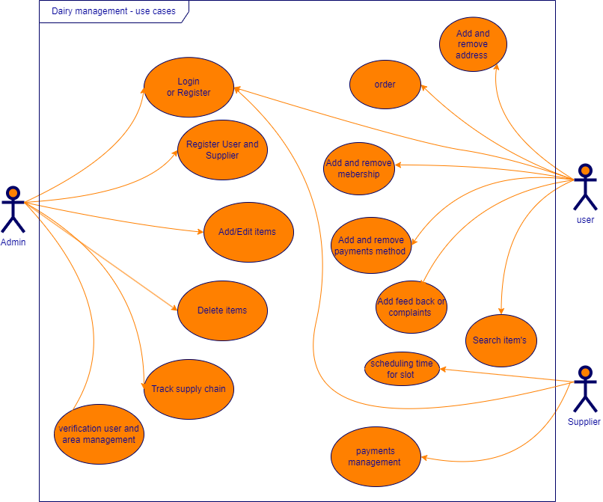

Figure ‑ Use case diagram for Diary management system

## Activity diagram and Swimlane diagram

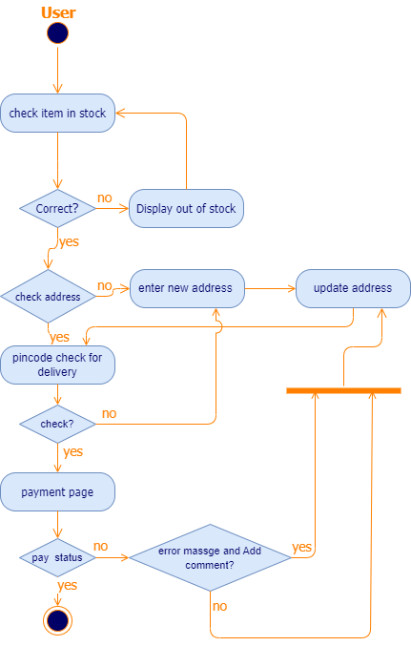

Figure ‑ Activity diagram for bulling

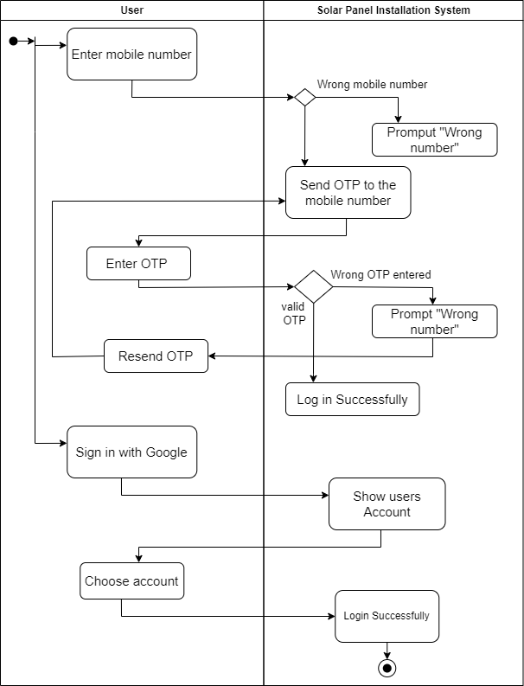

Figure ‑ Swimlane diagram for supplies

## Sequence diagram

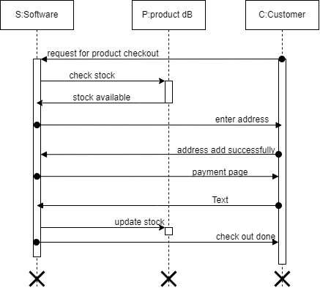

Figure ‑ Sequence diagram for ordering

## State diagram

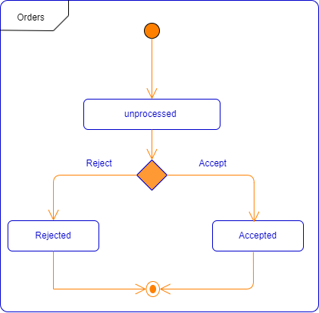

Figure ‑ State diagram of ordering possessing

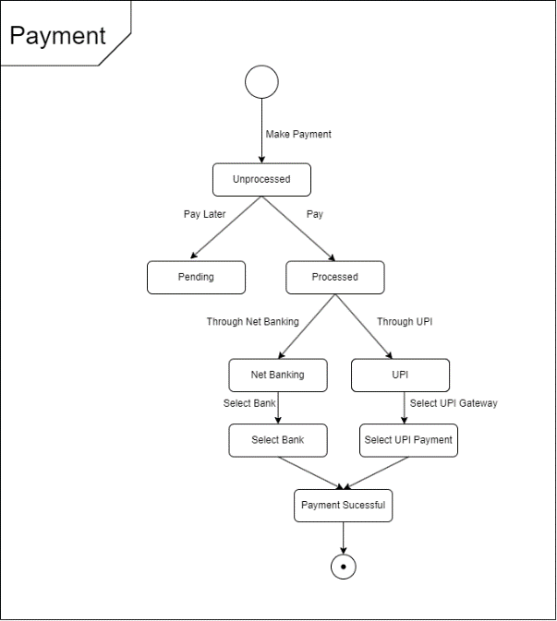

Figure ‑ State diagram for Diary Management System

## Class diagram

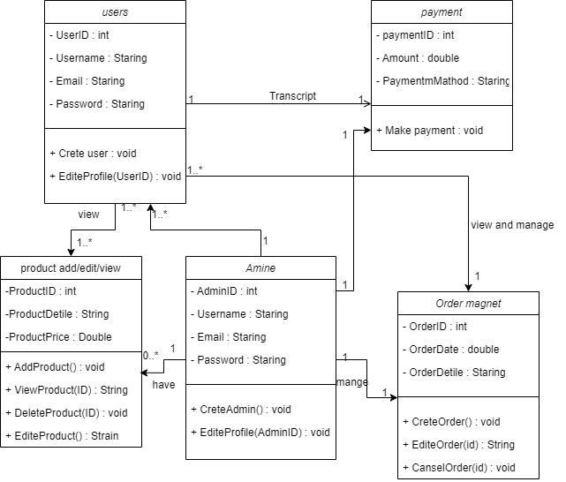

Figure ‑ Class diagram for Diary management system

## Data flow diagram

### Context diagram (level-0)

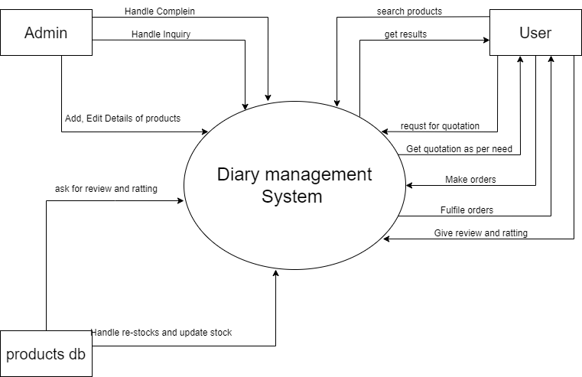

Figure ‑ Context diagram for Diary management system

### DFD Level-1

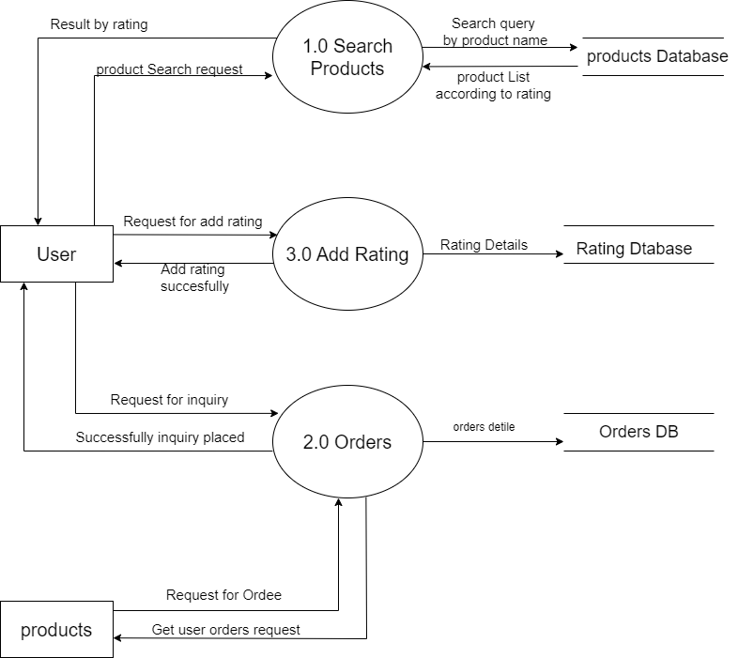

Figure ‑ DFD level-1 for Diary management system

### DFD Level-2

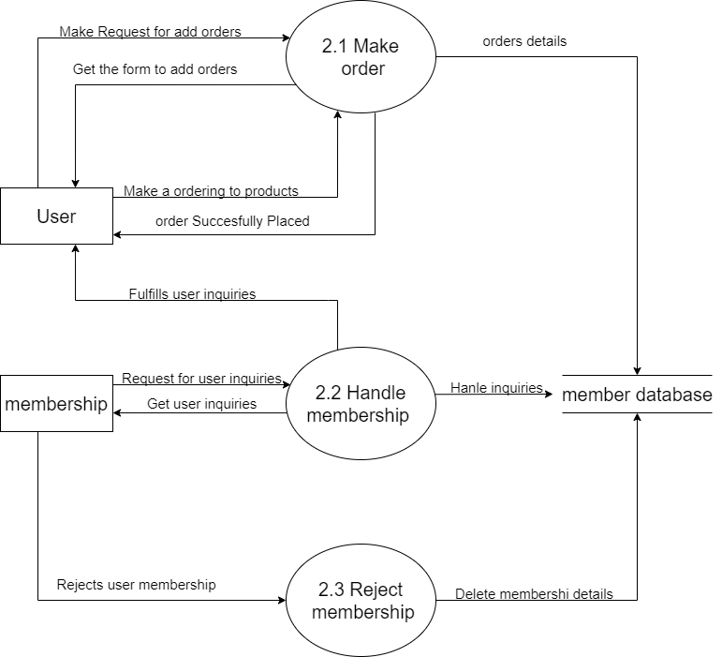

Figure ‑ DFD level-2 for order for memberships

# External interface requirement (Screens)

## Screen-1: place Order

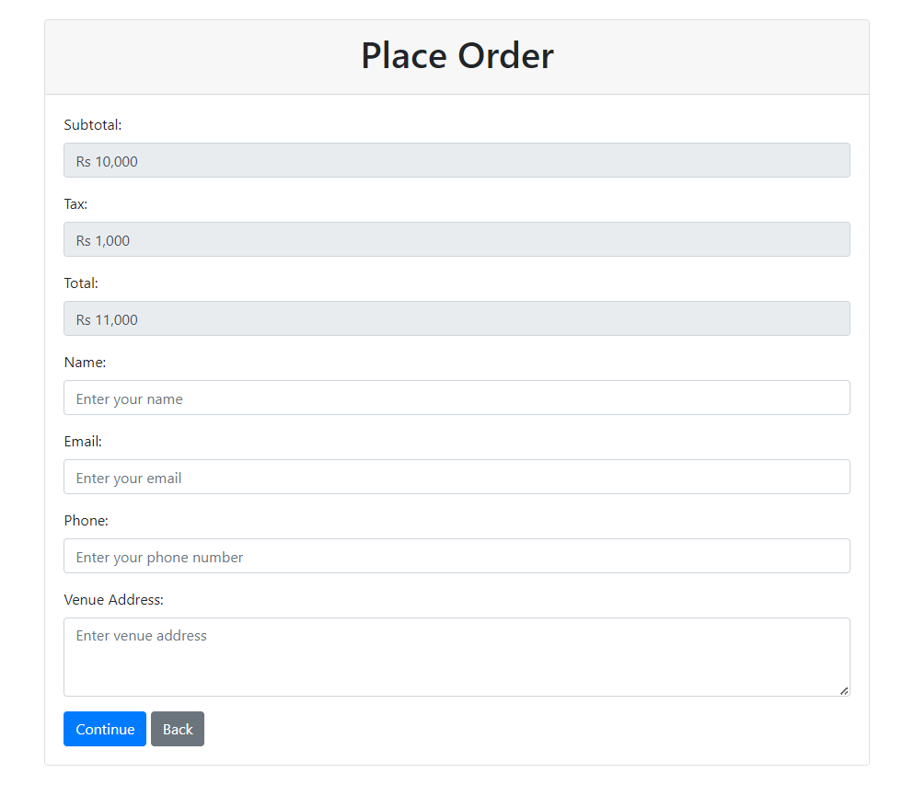

Figure ‑ Screen-1: place Order

**Purpose:** This form to help please a user to please orders.

Table ‑ Screen element of place Order

|  |  |  |  |  |  |
| --- | --- | --- | --- | --- | --- |
| Sr. | Screen Element | Input Type | O/M | 1/N | Description |
| 1 | Subtotal | text | M | 1 | Display amount to order without tex. |
| 2 | Tax | text | M | 1 | Display Tax on order. |
| 3 | Total | Text | M | 1 | Display total amount with tax. |
| 4 | Name | Text input | M | 1 | Enter your name to billing. |
| 5 | Email | Text Input | o | 1 | Enter your Email. |
| 6 | Phone | Text input | M | 1 | Enter your mobile number. |
| 7 | Add address | Text inpurt | M | 1 | Add address to delivery. |
| 8 | Continue | Button | M | 1 | Navigate to appropriate link’s. |
| 9 | Back | Button | M | 1 | Navigate to proves page. |

## Screen-2: Product List

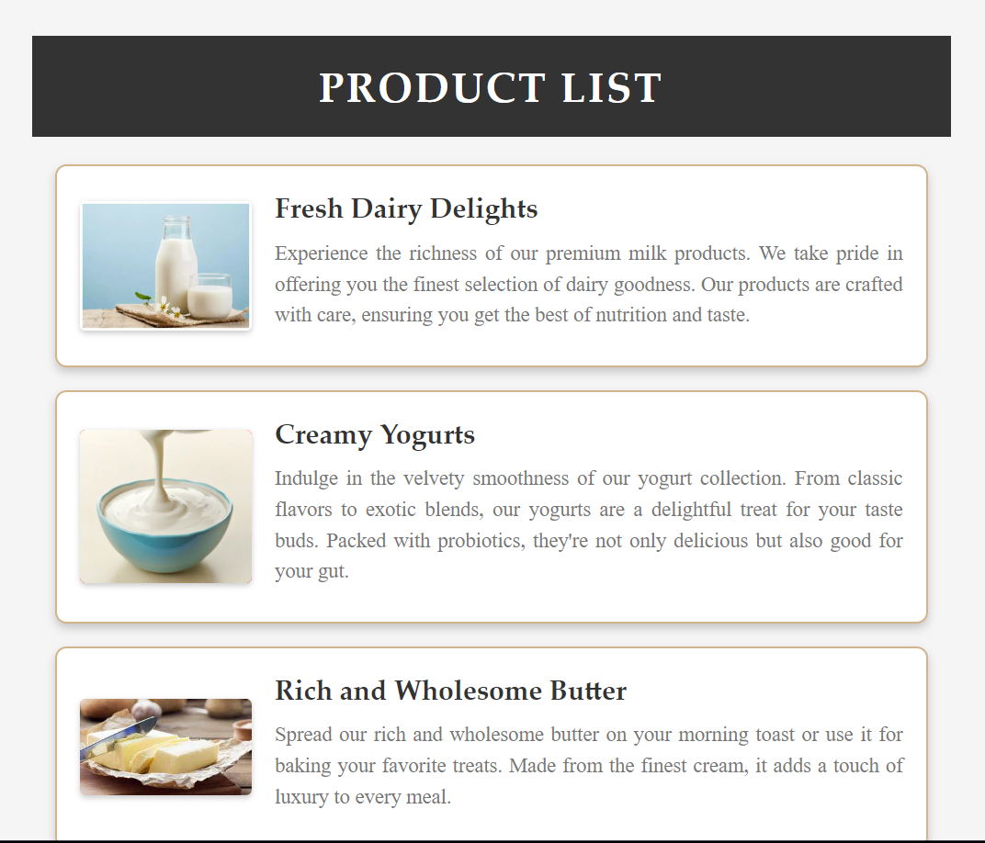

Figure ‑ Screen-2: product list

**Purpose:** This page help to find products from product list

Table ‑ Screen element of product list

|  |  |  |  |  |  |
| --- | --- | --- | --- | --- | --- |
| Sr. | Screen Element | Input Type | O/M | 1/N | Description |
| 1 | Product image | Image | M | 1 | Product image. |
| 2 | Product name | Text | M | 1 | Product name. |
| 3 | Product explanation | Text | M | 1 | Product explanation. |
| 4 | Links on card | Text | M | 1 | Product link on card click. |

## Screen-3: Add Product

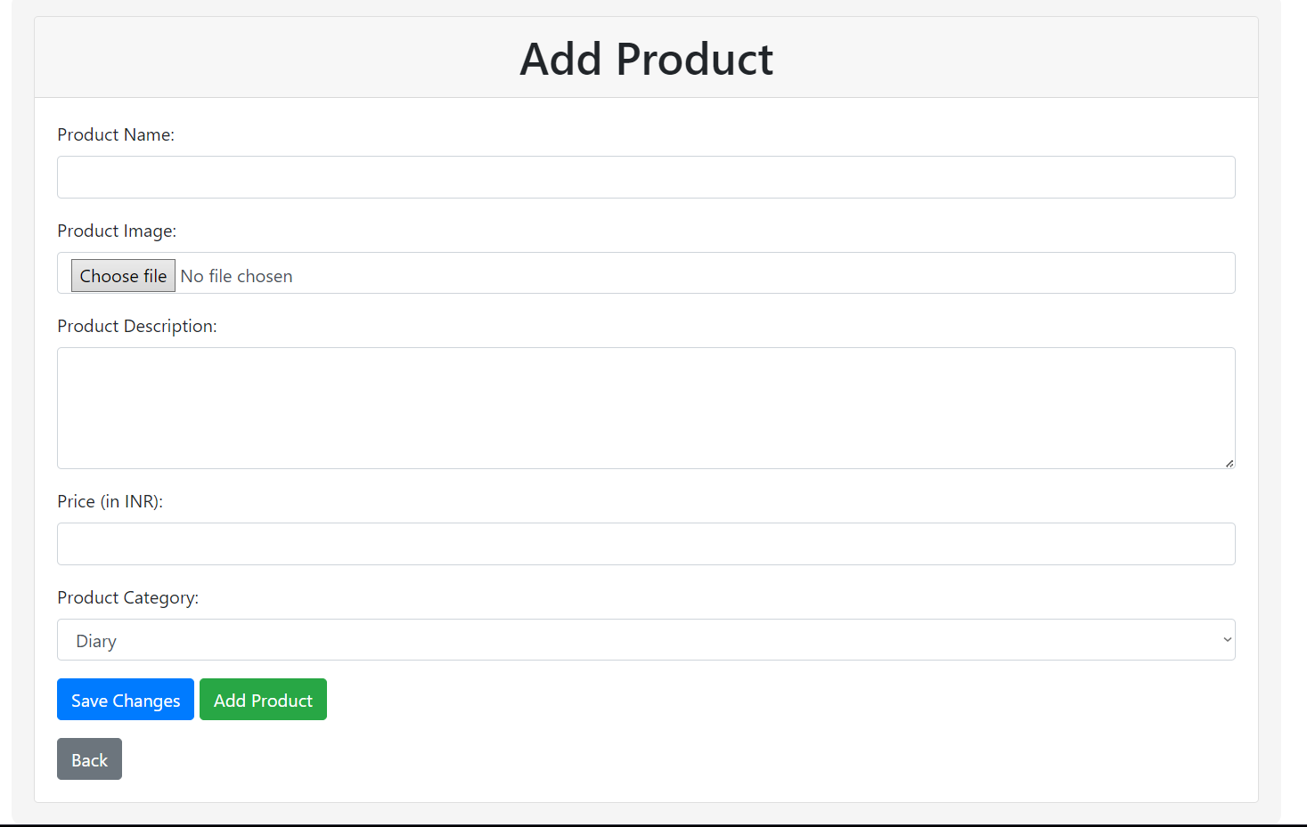

Figure ‑ Screen-3: Add product pages

**Purpose:** This module will allow the system administrator to add, edit, update or delete borrowers of product. The admin can add borrower information and manage it.

Table ‑ Screen element of Add product pages

|  |  |  |  |  |  |
| --- | --- | --- | --- | --- | --- |
| Sr. | Screen Element | Input Type | O/M | 1/N | Description |
| 1 | Product name | Text input | M | 1 | Enter a name of product. |
| 2 | Product image | Upload button | M | 1 | upload a image of product. |
| 3 | Product description | Text Area | M | 1 | Entera description of product. |
| 4 | Price(in INR) | Text input | M | 1 | Enter your Price of product. |
| 5 | Product category | Dropdown | o | 1 | Select product category. |
| 6 | Save charges | Button | M | 1 | Save charge in selcteted product not in new product. |
| 7 | Add product | Button | M | 1 | Navigate to final check screens. |
| 8 | Back | Button | M | 1 | Navigate to proves page. |

# Database design

List of Tables for diary management system :

* Address
* User
* Orders
* Drivers
* Payment
* Admin
* Suppliers

Table 4.1 : Adderss

|  |  |  |  |  |
| --- | --- | --- | --- | --- |
| **Field Name** | **Datatype** | **Null** | **Constraint** | **Description** |
| AddressID | int | Not Null | Primary Key | Auto Increment |
| userID | Varchar(50) | Allow Null | Foreign key | Reference of user table |
| SupplierID | Varchar(100) | Allow Null | Foreign key | Reference of Supplier table |
| State | Varchar(155) | Not Null | - | - |
| City | Varchar(155) | Not Null | - | - |
| Street/Area | Varchar(255) | Not Null | - | - |
| Houses No./Mine rode | Varchar(255) | Not Null | - | - |
| pincode | Varchar(100) | Not Null | - | - |

Table 4.2 : User

|  |  |  |  |  |
| --- | --- | --- | --- | --- |
| **Field Name** | **Datatype** | **Null** | **Constraint** | **Description** |
| USerID | int | Not Null | Primary Key | Auto Increment |
| AddressID | int | Not Null | Foreign Key | Reference of Address table |
| Name | Varchar(255) | Not Null | - | - |
| emile | Varchar(50) | Not Null | - | - |
| Password | Varchar(100) | allow Null | - | - |
| PhoneNo. | Varchar(12) | Not null | - | - |
| Admin ID | int | Allow null | Foreign key | Reference of Admin table |

Table 4.3: Orders

|  |  |  |  |  |
| --- | --- | --- | --- | --- |
| **Field Name** | **Datatype** | **Null** | **Constraint** | **Description** |
| OrderID | int | Not Null | Primary Key | Auto Increment |
| Userid | int | Not Null | Foreign key | Reference of user table |
| Order date | Datetime | Not Null | - | - |
| Driver id | int | Allow Null | - | - |
| Delivery Status | Varchar(10) | Not Null | - | - |

Table 4.4: drivers

|  |  |  |  |  |
| --- | --- | --- | --- | --- |
| **Field Name** | **Datatype** | **Null** | **Constraint** | **Description** |
| DriverID | int | Not Null | Primary Key | Auto Increment |
| AdminID | int | Not Null | Foreign Key | Reference of Admin table |
| AddersID | int | Not Null | Foreign Key | Reference of Address table |
| Name | Varchar(100) | Not Null | - | - |
| Emile | Varchar(100) | Allow Null | - | - |
| phoneNo | Varchar(100) | Not Null | - | - |

Table 4.5 : Payment

|  |  |  |  |  |
| --- | --- | --- | --- | --- |
| **Field Name** | **Datatype** | **Null** | **Constraint** | **Description** |
| PaymentID | Varchar(10) | Not Null | Primary Key | Auto Increment |
| OrderID | Varchar(10) | Not Null | Foreign Key | Reference of Booking Table |
| Amount | Float(10,2) | Not Null | - | - |
| PaymentType | Varchar(20) | Not Null | - | - |
| PaymentMathod | Varchar(100) | Allow Null | - | - |
| PaymentDate | Date | Not Null | - | - |
| Status | Varchar(10) | Not Null | - | - |

Table 4.6 : Admin

|  |  |  |  |  |
| --- | --- | --- | --- | --- |
| **Field Name** | **Datatype** | **Null** | **Constraint** | **Description** |
| AdminID | int | Not Null | Primary Key | Auto Increment |
| adminName | Varchar(100) | Not Null | - | - |
| EmileId | Varchar(100) | Not Null | - | - |
| phoneno | Varchar(12) | Not Null | - | - |

Table 4.7 : Supplier

|  |  |  |  |  |
| --- | --- | --- | --- | --- |
| **Field Name** | **Datatype** | **Null** | **Constraint** | **Description** |
| SupplierID | int | Not Null | Primary Key | Auto Increment |
| AdderssID | int | Not Null | Foreign key | Reference of Address table |
| name | Varchar(100) | Not Null | - | - |
| Admi id | int | Allow Null | Foreign key | Reference of Address table |
| phoneNo | Varchar(12) | Not Null | - | - |
| Emile | Varchar(50) | Not Null | - |  |

# Stories and Scenario

## Story-1: Book a Sloat

|  |  |  |
| --- | --- | --- |
| *Story # S1* | : | As a User,  I want to order a item’s  So that a secure items for a me . |
| Priority | **:** | High |
| Estimate | **:** | XL |
| Reason | **:** | Delvlopmet of ordering page is some complex but this priority is vary high |

## Scenarios

|  |  |  |
| --- | --- | --- |
| *Scenario# S1.1* | : | User can order a items base on this order details and delivery details like address and contact number and get a delivery time of the day. |
| Prerequisite | **:** | Webpage of ordering should be launched properly |
| Acceptance Criteria | **:** | **Given:** Users to the ordering page.  **When:** user correct the amount and delivery’s address and contact details to get a delivery time of the day  **Then** user will be navigated to the payment screen  Display price of product.  Display price of tax.  Display total prices.  Display delivery price.  Display other chargers. |

|  |  |  |
| --- | --- | --- |
| *Scenario# S1.2* | : | User can order a items base on this order details and delivery details like address and contact number and get a delivery time of the day. |
| Prerequisite | **:** | Webpage of ordering should be launched properly |
| Acceptance Criteria | **:** | **Given:** Users to the ordering page.  **When:**   * user select a **future** date and time to deliver items.   **Then**   * display a new date or time * display massage to updates |

|  |  |  |
| --- | --- | --- |
| *Scenario# S1.3* | : | User can order a items base on this order details and delivery details like address and contact number and get a delivery time of the day. |
| Prerequisite | **:** | Webpage of ordering should be launched properly |
| Acceptance Criteria | **:** | **Given:** Users to the ordering page.  **When**: User Click “payment” button.  **Then** :  Shoew massge of enter a address.  Select a payment methods. |

## Story-2:billing

|  |  |  |
| --- | --- | --- |
| *Story # S2* | : | As a User,  I want to Generate a invoice in app  So that bill get immediately. |
| Priority | **:** | Medium |
| Estimate | **:** | M |
| Reason | **:** | Invoice generation to get invoice using digital signature of owner |

### Scenario

|  |  |  |
| --- | --- | --- |
| *Scenario# S2.1* | : | User can get invoice using in software invoice generate fetcher’s. |
| Prerequisite | **:** | Webpage of invoice download lode properly |
| Acceptance Criteria | **:** | **Given:** Users to the invoice download page .  **When:** user click on navigate to invoice  **Then** user will see the invoice  And with there download butten,  With there digital signature |

|  |  |  |
| --- | --- | --- |
| *Scenario# S2.2* | : | User can get invoice using in software invoice generate fetcher’s. |
| Prerequisite | **:** | Webpage of invoice download lode properly |
| Acceptance Criteria | **:** | **Given:** Users to the invoice download page .  **When:** user can regenerate a invoice  **Then** user can regenerate a invoice  Whene error with previous invoices,  And show error masshe or successful message. |

|  |  |  |
| --- | --- | --- |
| *Scenario# S2.3* | : | User can get invoice using in software invoice generate fetcher’s. |
| Prerequisite | **:** | Webpage of invoice download lode properly |
| Acceptance Criteria | **:** | **Given:** Users to the invoice download page .  **When:** user can click on download button.  **Then** user can dowenlode pdf file of there invoice.  . |

## Story-3 :Login as user

|  |  |  |
| --- | --- | --- |
| *Story # S3* | : | As a user,  I want login,  So that I see my dashboard. |
| Priority | **:** | Low |
| Estimate | **:** | S |
| Reason | **:** | A login screen has option with user login . |

### Scenario 3

|  |  |  |
| --- | --- | --- |
| *Scenario# S3.1* | : | User can login using there user id and password. |
| Prerequisite | **:** | Webpage of login screen lodes properly. |
| Acceptance Criteria | **:** | **Given:** User can login to there dashboard  **When:** user can login using there user id and passwords.  **Then** user can login using there using id and passwords  Display user id ,  Display password, |

|  |  |  |
| --- | --- | --- |
| *Scenario# S3.2* | : | User can login using there user id and password. |
| Prerequisite | **:** | Webpage of login screen lodes properly. |
| Acceptance Criteria | **:** | **Given:** User can login to there dashboard  **When:** user can not registered first display error message  **Then** user can not registered first  Display error message first to register,  Navigate to registration diplay |

|  |  |  |
| --- | --- | --- |
| *Scenario# S3.3* | : | User can login using there user id and password. |
| Prerequisite | **:** | Webpage of login screen lodes properly. |
| Acceptance Criteria | **:** | **Given:** User can login to there dashboard  **When:** user can not fill not data properly  **Then** display error message if user id not filled  Display error message if password is not filed  Display error massage if form is empty. |

## Story-4 :sloat booking

|  |  |  |
| --- | --- | --- |
| *Story # S4* | : | As a Supplier,  I want Sloat booking,  So that I need reservation to seal my items. |
| Priority | **:** | **Medium** |
| Estimate | **:** | L |
| Reason | **:** | Development of Sloat booking page to book a Slat of sale there item’s. |

## Story-5 : users Dashborde

|  |  |  |
| --- | --- | --- |
| *Story # S5* | : | As a user,  I want see my dashboard,  So that I see my detail and handled data. |
| Priority | **:** | **Medium** |
| Estimate | **:** | L |
| Reason | **:** | Development of users dashboards to manage a data |

## Story-6: product page load

|  |  |  |
| --- | --- | --- |
| *Story # S6* | : | As a user,  I want see the product page detail,  So that I finding the mor about the detail. |
| Priority | **:** | **Medium** |
| Estimate | **:** | XL |
| Reason | **:** | Development of page Load to complex because they contains photos, price, reviews, and reflective products. |

## Story-7: Add membership

|  |  |  |
| --- | --- | --- |
| *Story # S7* | : | As a user,  I want add new membership,  So that I finding new membership plans and get the pricing. |
| Priority | **:** | **Low** |
| Estimate | **:** | S |
| Reason | **:** | Development of add new membershipto conations a pricing values payments listed |

## Story-8: add new payment method

|  |  |  |
| --- | --- | --- |
| *Story # S8* | : | As a user,  I want add new payment methods,  So that I finding new payments method. |
| Priority | **:** | **Low** |
| Estimate | **:** | L |
| Reason | **:** | Development of add new Payments method to save data to order much faster. |

## Story-9: order history

|  |  |  |
| --- | --- | --- |
| *Story # S9* | : | As a user,  I want see my order history,  So that I need to find orders history to fond older order. |
| Priority | **:** | **Low** |
| Estimate | **:** | L |
| Reason | **:** | Development of order history page. |

## Story-10: payment timings

|  |  |  |
| --- | --- | --- |
| *Story # S10* | : | As a supplier,  I want see my payment timings,  So that I need to find my payment. |
| Priority | **:** | **High** |
| Estimate | **:** | XL |
| Reason | **:** | Development of payments they see payments are get or not or which time are I get payment. |

# Test cases

|  |  |  |  |
| --- | --- | --- | --- |
| Project Name: | Dairy management system | Test Designed by: | Kuldeep Sonara |
| Module Name: | **Order** | **Test Designed date:** | 27-08-2023 |
| Release Version: | **1.0** | **Test Executed by:** | **Kuldeep Sonara** |
| Test Case ID | **TC_001** | **Test Execution date:** | 27-08-2023 |

|  |  |
| --- | --- |
| **Test Case Title** | Placing order successfully with vaild details |
| **Test Type** | Functional |
| **Test Priority** | High |
| **Pre-condition** | Web application should be accessible |

|  |  |  |  |  |
| --- | --- | --- | --- | --- |
| Pre-condition: Web application should be accessible | | | | |
| Test Case ID | **Test Title** | **Test Type** | **Description** | **Test Case ID** |
| TC_001 | Placing Order Successfully with valid details. | Functional | Order is successfully placed. | TC_001 |
| TC_002 | Failing to place order due to invalid details | Functional | Error message displayed. | TC_002 |
| TC_003 | Verify Order page elements | GUI | verify that all elements are availabe on order page. | TC_003 |

|  |  |
| --- | --- |
| **Test Case Title** | Login to web application with invalid credential |
| **Test Type** | Functional |
| **Test Priority** | Medium |
| **Pre-condition** | Web application should be accessible |

|  |  |  |  |  |  |  |  |
| --- | --- | --- | --- | --- | --- | --- | --- |
| **Test Step** | **Test Case Description** | **Expected Result** | **Actual Result** | **Coumnets** | **Status** | **Data** | **buge ID** |
| 1 | Access Web application URL | Access Order Page | The order page is displayed successfully. |  | Pass | <https://accounts.google.com/ServiceOrder> |  |
| 2 | Verify Total Amount field | Correct total amount should be fetched from the database and total amount amount field should not be editable | Correct total Amount is fetched and displayed in the total amount field. |  | Pass | Total Amount: 50000 |  |
| 3 | Enter name in name field | Name field should be editable and should accept name in name field | Address field input is accepted |  | pass | Name: Kuldeep sonara |  |
| 4 | Enter Mobile number in Mobile Number field | Mobile number field should be editable and should accept mobile number in mobile number field and the maximum length of mobile number should be of 10 digit | Mobile number field input accepted with the length of 10 digit |  | Pass | Mobile NO.:7861874394 |  |
| 5 | Enter Email Address in Email address field | Email address field should be editable and should accept valid email address in email address field | Valid Email address in email address field is accepted. |  | pass | Email:kuldeepsonara6@gmail.com |  |
| 6 | Enter venue address in venue address field | Venue address field should be editable and should accept the venue details | Address field input is accepted |  | Pass | Venue Address:Swati park |  |
| 7 | Enter Date of event in Date of event field | Date of Event field should be editable and should accept mobile number in mobile number field | Date of event field input accepted . |  | Pass | Date:27/8/2023 |  |
| 8 | Click on continue button | User should navigate to payment page | User is navigated to payment page |  | Pass |  |  |
| 9 | Click on back button | User should navigate to theme detail page | User is navigated to theme detail page. |  | Pass |  |  |

|  |  |
| --- | --- |
| **Test Case Title** | Failing to plase order due to Invalid data |
| **Test Type** | Functional |
| **Test Priority** | Medium |
| **Pre-condition** | Web application should be accessible |

|  |  |  |  |  |  |  |  |
| --- | --- | --- | --- | --- | --- | --- | --- |
| **Test Step** | **Test Case Description** | **Expected Result** | **Actual Result** | **Status** | **Comment** | **Data** | **Bug ID** |
| 1 | Verify that User is not able to place order if total amount value is not fetched or incorrect value is fetched from the database. | Should be display an error message Something went wrong while fetching the information. | Display an error of amount value is not fetched or incorrect value is fetched. | Pass |  |  |  |
| 2 | Verify that User is not able to navigate to payment page if User has leaved a name field blanked. | Set required field validation for name field | Performs a validation function | Pass |  |  |  |
| 3 | Verify that User is not able to navigate to payment page if User has leaved a mobile number field blanked or if mobile number length is not of 10 digit. | Set required field and maximum length validation for mobile number field. | Performs a validation function | Pass |  |  |  |
| 4 | Verify that User is not able to navigate to payment page if User has leaved a email address field blanked or if email address is not in valid format. | Set required field and email format validation for email address field. | Performs a validation function. | Pass |  |  |  |
| 5 | Verify that User is not able to navigate to payment page if User has leaved a venue address field blanked. | Set required field validation for venue address field. | Performs a validation function. | Pass |  |  |  |
| 6 | Verify that User is not able to navigate to payment page if User has leaved a Date field blanked. | Set required field validation for date field | Performs a validation function | Pass |  |  |  |

|  |  |
| --- | --- |
| **Test Case Title** | Verify order page elements |
| **Test Type** | GUI |
| **Test Priority** | Medium |
| **Pre-condition** | Web application should be accessible |

|  |  |  |  |  |  |  |  |
| --- | --- | --- | --- | --- | --- | --- | --- |
| **Test Step** | **Test Case Description** | **Expected Result** | **Actual Result** | **Status** | **Comment** | **Data** | **Bug ID** |
| 1 | Launch application with the given url | The site launched properly | Site launched successfully | Pass |  |  |  |
| 2 | Verify that the add order screen contains elements such as Total Amount, Name, Contact Number, Email Address,Venue Details,Event Date,Payment Page link and Theme detail page link. | All listed control displayed properly on the page | Add theme detail page loaded successfully | Pass |  |  |  |
| 3 | Verify that cursor is focused on “Name” text box on the page load | Cursor is focused in Name textbox | Cursor focus in Name textbox | Pass |  |  |  |
| 4 | Verify that tab functionality is working properly or not | When tab pressed cursor move in next control | Cursor moving in next control | Pass |  |  |  |
| 5 | Verify that all the fields such as Total Amount, Name, Contact Number, Email Address,Venue Details,Event Date has a valid placeholder | All text fields have proper placeholder | All text fields have proper placeholder | Pass |  |  |  |
| 6 | Verify that the labels float upward when the text field is in focus or filled (In case of floating label) | When field is focused or filled, label display on top of the filled | When field is focus or filled, label display on top of the filled | Pass | step required when fields with floating label |  |  |
| 7 | verify that Payment link page link working properly | when click on Continue button load Payment page. | Theme list page working | Pass |  |  |  |
| 8 | verift that Theme Detail page working properly | when click on back button load theme detail page | Theme detail page link working | Pass |  |  |  |

# References

• http://www.w3schools.com/html/html_intro.asp

• https://www.w3schools.com/php/default.asp

• <https://www.javatpoint.com/um>

• https://chat.chatgptdemo.net/

• https://www.scribd.com/document/440401779/Online-Doctor-Appointment-SRS-pdf

• https://staff.emu.edu.tr/alexanderchefranov/Documents/CMPE412/SRS.pdf