- Descriptive Statistics
- Mean:- Average of All Number
Example:- 10,20,30
10+20+30/3=20

Use:- KPI USE
Limitation:- Outlier less accuracy that.

- Median:-- Middle value of data

Steps:- ODD numbers count that (Divide two parts the middle)
EVEN numbers count that Middle two numbers get Average that AVG answer

Example:- 10,2,34,56,33,55,23
= 56 (ODD COUNTS)

10,20,30,40,50,60,70,90
40+50/2=45 (EVEN COUNTS)
Use:- Skewed Data Analysis

- Mode:- Most Frequent value in data
Example:- 2,3,3,4,5,6,4,4,4,4,6,6
= 4(Most Frequent Number)

Use:- Categorical Data

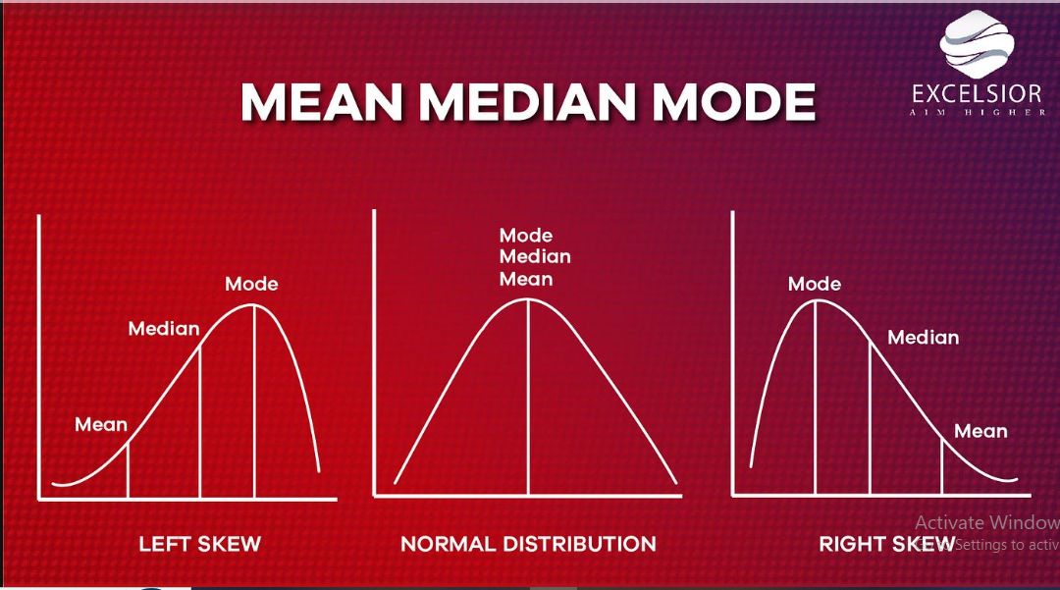

- Masure Of Dispersion
- Variance:- Measure Spread around the Mean(Values mean पासून किती पसरल्या आहेत ते मोजतं)
Distance from meansqureaverage

Types:- population variance (σ²)
Sample variance (s²)

- Standard Deviation: Variance Squared Root(Average पासून साधारण किती दूर values जातात)
USE:- Model Stablity,performance stability

Types:- Population SD
Sample SD

- Probablity:- Measure the likehood the Event

Example:- Coin toss- head(1/2)2—total outcomes(heads,tails)

Use:- Risk Analysis,predictions,

Statistics:- what happened
Analytics:- What may happens

Examples:- process that gives outcomes(coin toss)
Dice roll {1,2,3,4,5,6}

Types:-

- Classic Probablity:-Equal chance
Ex:- Cards,dice
Use:- therotical modeling

- Empirical Probablity:- Past Data
Ex:- 100 days rain 40 day= 0.4
Use:- wether Forescasting,demand prediction

- Subjective Probablity:- Experience
Ex:- Stock price
Use:- Risk assumption

Conditional Probablity:- एक घटना घडली असेल तर दुसरीची शक्यता

P(A∣B)=P(B)P(A∩B)​

Ex:- Use click add that purchace chances

Events:-

- Independent Event:- Not affected to each other
Ex:- Coin Toss
Use:- A/B Testing

- Dependant Event:- One affected to other
Ex:- Cards replacement
Use:- Sampling

Bayes Theoram: New data coming that probability are updated
P(A∣B)=P(B)P(B∣A)⋅P(A)​

Use:- Spam detection,Medical Diagonsis

Random Variable:-
- Discrete:- Countable numbers
Ex:- Purchaces

- Continous:- Not Countable
Ex:-salary,height

- Corealation and Covariance

- Covariance:- Shows the how move together
दोन variables एकत्र कसे बदलतात ते सांगते (direction)

SIGNS:-
- + Covariance → दोन्ही वाढतात / घटतात (same direction)
- − Covariance → एक वाढला तर दुसरा घटतो (opposite)
- 0 → linear relation नाही

Example:- Study of hours & Marks

- Covariance:- That measure the Strength + Direction of realationship
दोन variables मधील relation किती strong आहे ते सांगते.

Range –
1 ≤ r ≤ + 1 –
- +1 → perfect positive
- −1 → perfect negative
- 0 → no linear relation

Use Cases:-
- Feature Selection
- Buisness Analytics
- Finance

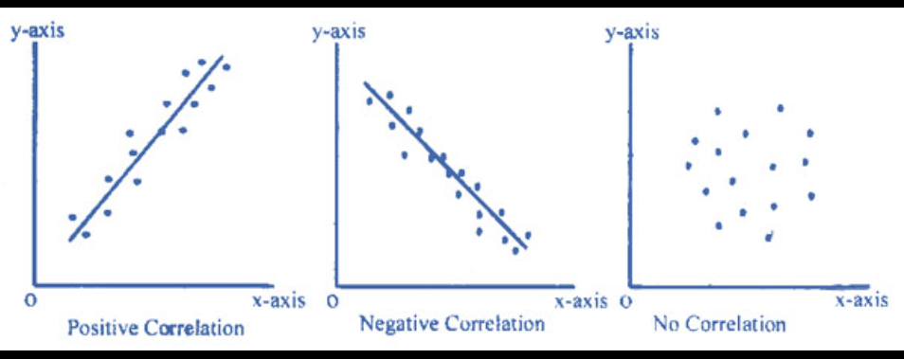

- Hypothesis Testing & P-value

A statistical model that decide whethet the a claim about a population is supported by the data(डेटावरून decision घेण्याची scientific पद्धत. आपण data वापरून claim बरोबर आहे की नाही ते तपासतो.)

1️⃣ Null Hypothesis (H₀) Marathi: “काही फरक नाही / effect नाही”
Default assumption – no change/effect.

2️⃣ Alternative Hypothesis (H₁ / Hₐ) Marathi: “फरक आहे / effect आहे”
What we want to prove.

- A/B Testing Fundamental
A/B Testing comapares two version which is perform the bette on the data

Use:-
- Guess नको, data-based decision हवा
- Conversion वाढवायला
- Risk कमी करायला
- 👉 Analytics + Business decision core

Example:-
Situation: Website वर Buy Now button
Version A: Blue button
Version B: Green button
👉 Users randomly divide
👉 ज्या button वर जास्त purchase → Winner
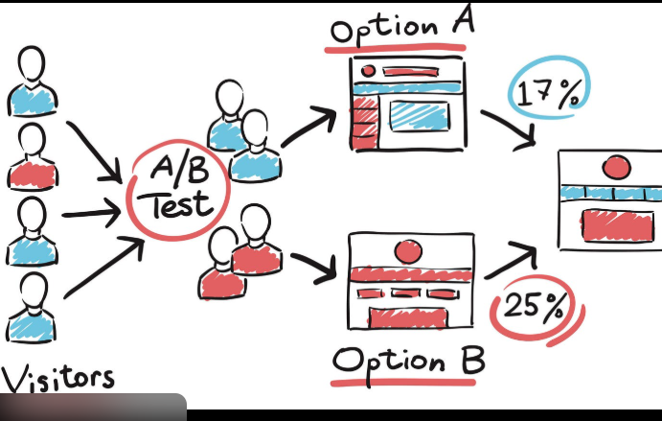

A/B Testing = Compare → Measure → Test → Decide

