INSURANCE FRAUD DETECTION USING MACHINE LEARNING

A SYNOPSIS OF UNIVERSITY PROJECT

Submitted by

Mr. Syed Atif - 20171CSE0702
Mr. Syed Shoaib - 20171CSE0709
Mr. Tejas Bhatnagar – 20171CSE0721
Mr. Thanuj Kumar S – 20171CSE0726
Mr. Utsav Deep – 20171CSE0734

Under the guidance of
Prof. T. Ramesh - Asst Prof CSE

in partial fulfillment for the award of the degree of
BACHELOR OF TECHNOLOGY

IN

COMPUTER SCIENCE AND ENGINEERING

AT


Department of Computer Science and Engineering
School of Engineering
PRESIDENCY UNIVERSITY
BANGALORE

Title of the Project: Insurance Fraud Detection using Machine Learning

Abstract:
Fraud is one of the largest and most well-known problems that insurers face. Fraudulent claims can be highly expensive for each insurer. Therefore, it is important to know which claims are correct and which are not. So that the companies can save money and people doing these frauds can be punished accordingly. Different types of insurance are prone to different crimes, however, in most cases, it manifests deliberate damage to the insured item or the purpose to obtain goods without paying. Detecting insurance fraud can be difficult since not every claim can be investigated thoroughly.

Rationale:

Insurance fraud has been around since the beginning of insurance organizations. These are varied and complex crimes that often go unnoticed and cost the insurance industry billions a year. It is not doable for insurance companies to check all claims personally since this will cost simply too much time and money. Only in the U.S., the loss on fraudulent insurance claims last year reached $34 billion.

Ideally, an insurance agent would have the capacity to investigate each case and conclude whether it is genuine or not. However, this process is not only time consuming, but costly. Sourcing and funding the skilled labor required to review each of the thousands of claims that are filed a day is simply unfeasible.

Objectives:

To build a classification methodology to determine whether a customer is placing a fraudulent insurance claim.
Requirements: Valid Data Set, Required Python Libraries

Planning of work:
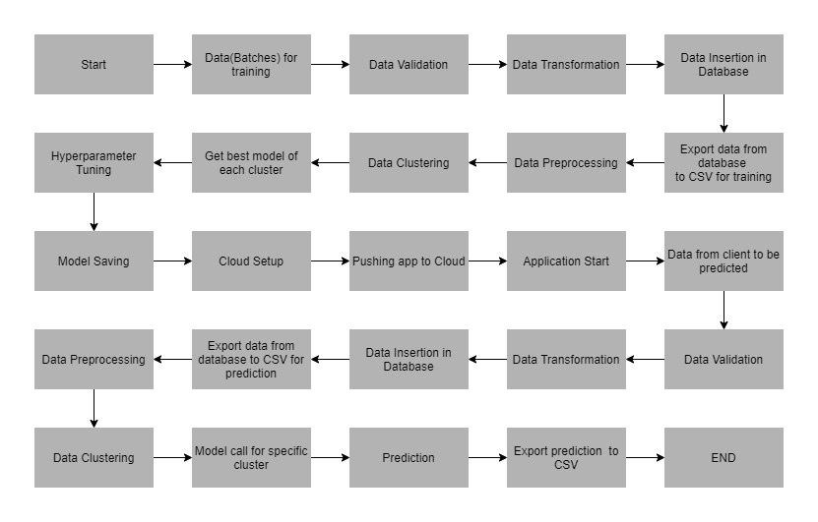

Expected outcomes:

Based on the data set being used, this model will be able to detect the instances where a person is trying falsely claim insurance. We will be deploying the model to a cloud platform.

References:

- E. Belhadji, G. Dionne and F. Tarkhani, A Model for the Detection of Insurance Fraud Geneva Papers on Risk and Insurance Theory, vol. 25, pp. 517-538, may 2012. [Link]

- K. J. Crocker and S. Tennyson, "Insurance Fraud and Optimal Claims Settlement Strategies: An Empirical Investigation of Liability Insurance Settlements", The Journal of Law and Economics, vol. 45, no. 2, april 2010. [Link]

- Kajia Muller, The Identification of Insurance Fraud-an Empirical Analysis Working papers on Risk Management and Insurance, no. 137, June 2013. [Link]

Date of Submission: 22-02-2021

Signature(s) of Student(s) Name and Signature of Guide

1.

2.

3.

4.

5.

Contact Details of the Students:

Roll No | Name | E-Mail ID | Contact Number
20171CSE0709 | Syed Shoaib | 201710100881@presidencyuniversity.in | 8951791714
20171CSE0702 | Syed Atif | 201710100874@presidencyuniversity.in | 9880194742
20171CSE0721 | Tejas Bhatnagar | 201710100893@presidencyuniversity.in | 9738898069
20171CSE0726 | Thanuj Kumar S | 201710100898@presidencyuniversity.in | 8147120321
20171CSE0734 | Utsav Deep | 201710100906@presidencyuniversity.in | 8867834645

