LESSON 1: Git
What is git?
Git is a free, open-source distributed version control system designed to track changes in source code and files over time. It allows multiple developers to work on the same project simultaneously without overwriting each other's work. Created by Linus Torvalds in 2005 for Linux kernel development, Git has become the global standard for modern software engineering.
Essential Git Commands
To use Git via the command line, developers rely on a few foundational commands:
- git init
- git status
- git add <file>
- git commit -m "message"
- git push
- git pull

- Git init
What is Git init?
git init is the command used to create a new, empty Git repository or reinitialize an existing one. Running this command transforms your current directory into a Git repository, allowing you to start tracking changes, managing code versions, and creating development branches.
How to use Git init?
To use git init, open teminal, cd (your project folder name), and run the command git init
Example:
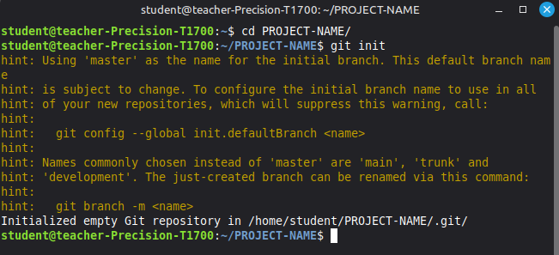

2. Git add
What is git status?
git status command displays the current state of your Git working directory and staging area. It serves as an informative snapshot that tells you which branch you are working on, which files have changed, and whether those changes are ready to be saved.
How to use git status?
- Open terminal
- Use command “cd (your project name)”
- Use command git status
Example:
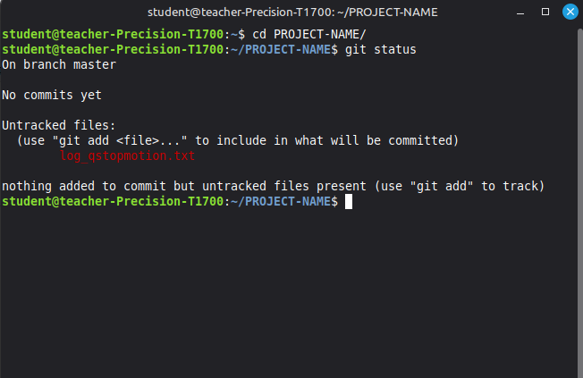

3. git add
What is git add?
git add command moves changes from your local working directory to the Git staging area (also called the "index"), preparing them to be included in your next commit.
How to use git add?
- Open terminal
- Use command “cd (your project name)”
- Use command “git status” to see your file that you need to add
- Use command “git add (file name)”
- Use git status again and you will see you file turn green
Example:
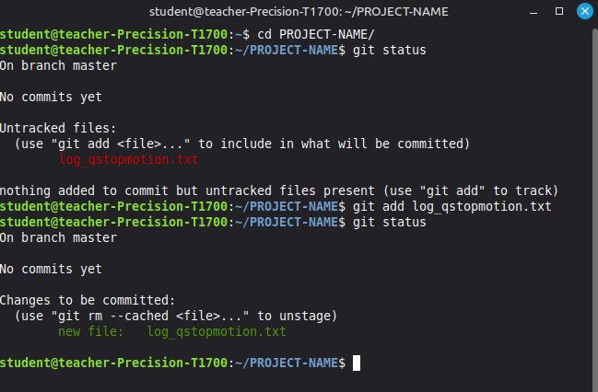

4. git commit –m “message”

