|  |  |
| --- | --- |
| Gerb-BMSTU_01 | **Министерство науки и высшего образования Российской Федерации**  **Федеральное государственное бюджетное образовательное учреждение**  **высшего образования**  **«Московский государственный технический университет**  **имени Н.Э. Баумана**  **(национальный исследовательский университет)»**  **(МГТУ им. Н.Э. Баумана)** |

ФАКУЛЬТЕТ «Информатика и системы управления»\_\_\_\_\_\_\_\_\_\_\_\_\_\_\_\_\_\_\_\_\_\_\_

КАФЕДРА «Программное обеспечение ЭВМ и информационные технологии»\_

**Лабораторная работа 2-я по Unix**

|  |  |
| --- | --- |
| **Тема: «Процессы. Системные вызовы fork() и exec()»**  **Студент** Куликов Д. А.  **Группа** ИУ7-52Б  **Оценка (баллы) \_\_\_\_\_\_\_\_\_\_\_\_\_\_\_**  **Преподаватель** Рязанова Н. Ю. |  |

Москва.

2020 г.

**Задание 1.**

#include <stdio.h>

#include <stdlib.h>

#include <unistd.h>

int main()

{

int child1 = fork();

if (child1 == -1)

{

perror("Can't fork");

exit(1);

}

else if (child1 == 0)

{

printf("Child: pid=%d, pidid=%d, groupid=%d\n", getpid(), getppid(), getpgrp());

sleep(2);

printf("Child: pid=%d, pidid=%d, groupid=%d\n", getpid(), getppid(), getpgrp());

return 0;

}

printf("Parent: pid=%d, childpid=%d, groupid=%d\n", getpid(), child1, getpgrp());

int child2 = fork();

if (child2 == -1)

{

perror("Can't fork");

exit(1);

}

else if (child2 == 0)

{

printf("Child: pid=%d, pidid=%d, groupid=%d\n", getpid(), getppid(), getpgrp());

sleep(2);

printf("Child: pid=%d, pidid=%d, groupid=%d\n", getpid(), getppid(), getpgrp());

return 0;

}

printf("Parent: pid=%d, childpid=%d, groupid=%d\n", getpid(), child2, getpgrp());

return 0;

}

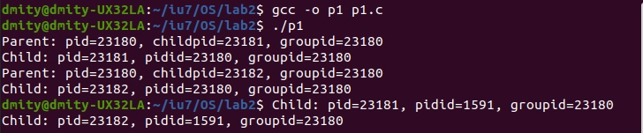

**Задание 2.**

#include <stdio.h>

#include <stdlib.h>

#include <unistd.h>

#include <sys/types.h>

#include <sys/wait.h>

int main()

{

int child1 = fork();

if (child1 == -1)

{

perror("Can't fork");

exit(1);

}

else if (child1 == 0)

{

printf("Child: pid=%d, pidid=%d, groupid=%d\n", getpid(), getppid(), getpgrp());

return 0;

}

printf("Parent: pid=%d, childpid=%d, groupid=%d\n", getpid(), child1, getpgrp());

int child2 = fork();

if (child2 == -1)

{

perror("Can't fork");

exit(1);

}

else if (child2 == 0)

{

printf("Child: pid=%d, pidid=%d, groupid=%d\n", getpid(), getppid(), getpgrp());

return 0;

}

printf("Parent: pid=%d, childpid=%d, groupid=%d\n", getpid(), child2, getpgrp());

if (child1 != 0 && child2 != 0)

{

int status1;

pid\_t return1 = wait(&status1);

if (WIFEXITED(status1))

printf("Parent: child %d finished with %d code.\n", return1, WEXITSTATUS(status1) );

else if (WIFSIGNALED(status1))

printf("Parent: child %d finished from signal with %d code.\n", return1, WTERMSIG(status1));

else if (WIFSTOPPED(status1))

printf("Parent: child %d finished from signal with %d code.\n", return1, WSTOPSIG(status1));

int status2;

pid\_t return2 = wait(&status2);

if (WIFEXITED(status2))

printf("Parent: child %d finished with %d code.\n", return2, WEXITSTATUS(status2) );

else if (WIFSIGNALED(status2))

printf("Parent: child %d finished from signal with %d code.\n", return2, WTERMSIG(status2));

else if (WIFSTOPPED(status2))

printf("Parent: child %d finished from signal with %d code.\n", return2, WSTOPSIG(status2));

}

return 0;

}

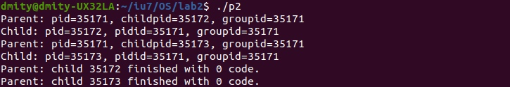

**Задание 3.**

#include <stdio.h>

#include <stdlib.h>

#include <unistd.h>

#include <sys/types.h>

#include <sys/wait.h>

int main()

{

int child1 = fork();

if (child1 == -1)

{

perror("Can't fork");

exit(1);

}

else if (child1 == 0)

{

printf("Child: pid=%d, pidid=%d, groupid=%d\n", getpid(), getppid(), getpgrp());

if (execlp("/bin/ps", "ps", "al", (char\*)NULL) == -1)

{

perror("Child couldn't exec");

exit(1);

}

return 0;

}

printf("Parent: pid=%d, childpid=%d, groupid=%d\n", getpid(), child1, getpgrp());

int child2 = fork();

if (child2 == -1)

{

perror("Can't fork");

exit(1);

}

else if (child2 == 0)

{

printf("Child: pid=%d, pidid=%d, groupid=%d\n", getpid(), getppid(), getpgrp());

if (execlp("/bin/ls", "ls", "-a", (char\*)NULL) == -1)

{

perror("Child couldn't exec");

exit(1);

}

return 0;

}

printf("Parent: pid=%d, childpid=%d, groupid=%d\n", getpid(), child2, getpgrp());

if (child1 != 0 && child2 != 0)

{

int status1;

pid\_t return1 = wait(&status1);

if (WIFEXITED(status1))

printf("Parent: child %d finished with %d code.\n", return1, WEXITSTATUS(status1) );

else if (WIFSIGNALED(status1))

printf("Parent: child %d finished from signal with %d code.\n", return1, WTERMSIG(status1));

else if (WIFSTOPPED(status1))

printf("Parent: child %d finished from signal with %d code.\n", return1, WSTOPSIG(status1));

int status2;

pid\_t return2 = wait(&status2);

if (WIFEXITED(status2))

printf("Parent: child %d finished with %d code.\n", return2, WEXITSTATUS(status2) );

else if (WIFSIGNALED(status2))

printf("Parent: child %d finished from signal with %d code.\n", return2, WTERMSIG(status2));

else if (WIFSTOPPED(status2))

printf("Parent: child %d finished from signal with %d code.\n", return2, WSTOPSIG(status2));

}

return 0;

}

**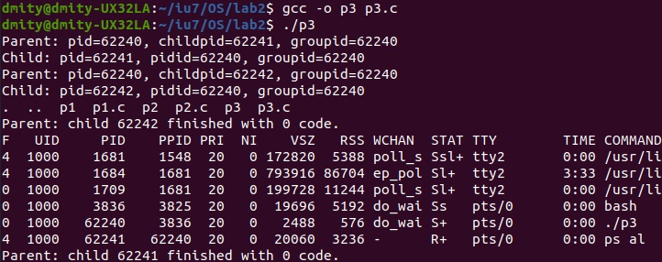**

**Задание 4.**

#include <stdio.h>

#include <stdlib.h>

#include <unistd.h>

#include <sys/types.h>

#include <sys/wait.h>

#include <string.h>

int main()

{

int fd[2];

if (pipe(fd) == -1)

{

perror("Couldn't pipe");

exit(1);

}

int child1 = fork();

if (child1 == -1)

{

perror("Can't fork");

exit(1);

}

else if (child1 == 0)

{

close(fd[0]);

char msg1[] = "Message from child1";

write(fd[1], msg1, 64);

exit(0);

}

int child2 = fork();

if (child2 == -1)

{

perror("Can't fork");

exit(1);

}

else if (child2 == 0)

{

close(fd[0]);

char msg2[] = "Message from child2";

write(fd[1], msg2, 64);

exit(0);

}

if (child1 != 0 && child2 != 0)

{

close(fd[1]);

char msg1[64];

read(fd[0], msg1, 64);

char msg2[64];

read(fd[0], msg2, 64);

printf("Parent: read %s %s\n", msg1, msg2);

int status1;

pid\_t return1 = wait(&status1);

if (WIFEXITED(status1))

printf("Parent: child %d finished with %d code.\n", return1, WEXITSTATUS(status1) );

else if (WIFSIGNALED(status1))

printf("Parent: child %d finished from signal with %d code.\n", return1, WTERMSIG(status1));

else if (WIFSTOPPED(status1))

printf("Parent: child %d finished from signal with %d code.\n", return1, WSTOPSIG(status1));

int status2;

pid\_t return2 = wait(&status2);

if (WIFEXITED(status2))

printf("Parent: child %d finished with %d code.\n", return2, WEXITSTATUS(status2) );

else if (WIFSIGNALED(status2))

printf("Parent: child %d finished from signal with %d code.\n", return2, WTERMSIG(status2));

else if (WIFSTOPPED(status2))

printf("Parent: child %d finished from signal with %d code.\n", return2, WSTOPSIG(status2));

}

return 0;

}

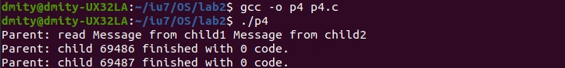

**Задание 5.**

#include <stdio.h>

#include <stdlib.h>

#include <unistd.h>

#include <sys/types.h>

#include <sys/wait.h>

#include <string.h>

#include <signal.h>

int catch\_flag = 0;

void catch\_sig(int sig\_numb)

{

printf("catch signal %d\n", sig\_numb);

catch\_flag = 1;

}

int main()

{

int fd[2];

if (pipe(fd) == -1)

{

perror("Couldn't pipe");

exit(1);

}

void (\*old\_handler)(int) = signal(SIGINT, catch\_sig);

int child1 = fork();

if (child1 == -1)

{

perror("Can't fork");

exit(1);

}

else if (child1 == 0)

{

sleep(5);

if (catch\_flag)

{

close(fd[0]);

char msg1[] = "Message from child1";

write(fd[1], msg1, 64);

}

exit(0);

}

int child2 = fork();

if (child2 == -1)

{

perror("Can't fork");

exit(1);

}

else if (child2 == 0)

{

sleep(5);

if (catch\_flag)

{

close(fd[0]);

char msg2[] = "Message from child2";

write(fd[1], msg2, 64);

}

exit(0);

}

if (child1 != 0 && child2 != 0)

{

int status1;

pid\_t return1 = wait(&status1);

if (WIFEXITED(status1))

printf("Parent: child %d finished with %d code.\n", return1, WEXITSTATUS(status1) );

else if (WIFSIGNALED(status1))

printf("Parent: child %d finished from signal with %d code.\n", return1, WTERMSIG(status1));

else if (WIFSTOPPED(status1))

printf("Parent: child %d finished from signal with %d code.\n", return1, WSTOPSIG(status1));

int status2;

pid\_t return2 = wait(&status2);

if (WIFEXITED(status2))

printf("Parent: child %d finished with %d code.\n", return2, WEXITSTATUS(status2) );

else if (WIFSIGNALED(status2))

printf("Parent: child %d finished from signal with %d code.\n", return2, WTERMSIG(status2));

else if (WIFSTOPPED(status2))

printf("Parent: child %d finished from signal with %d code.\n", return2, WSTOPSIG(status2));

if (catch\_flag)

{

close(fd[1]);

char msg1[64];

read(fd[0], msg1, 64);

char msg2[64];

read(fd[0], msg2, 64);

printf("Parent: read\n %s\n %s\n", msg1, msg2);

}

}

return 0;

}

**Ситуация когда сигнала нет:**

****

**Ситуация когда сигнал есть:**

**