|  |  |
| --- | --- |
| Gerb-BMSTU_01 | **Министерство науки и высшего образования Российской Федерации**  **Федеральное государственное бюджетное образовательное учреждение**  **высшего образования**  **«Московский государственный технический университет**  **имени Н.Э. Баумана**  **(национальный исследовательский университет)»**  **(МГТУ им. Н.Э. Баумана)** |

ФАКУЛЬТЕТ «Информатика и системы управления» (ИУ)

КАФЕДРА «Информационная безопасность» (ИУ8)

ОТЧЁТ

Выполнил: Куликова А. В.,

студент группы ИУ8-31М

г. Москва, 2024 г.

Цель работы

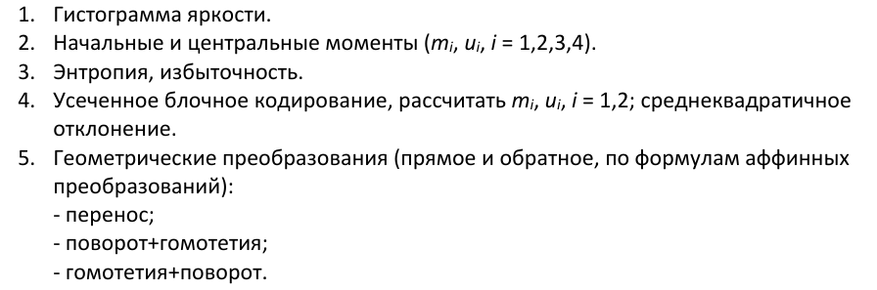

Постановка задачи



Ход работы

Для работы было выбрано следующее изображение

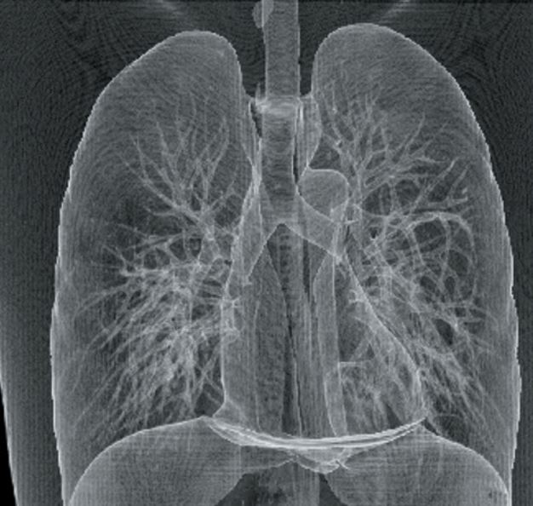

Первым делом происходит конвертация в ЧБ для упрощения

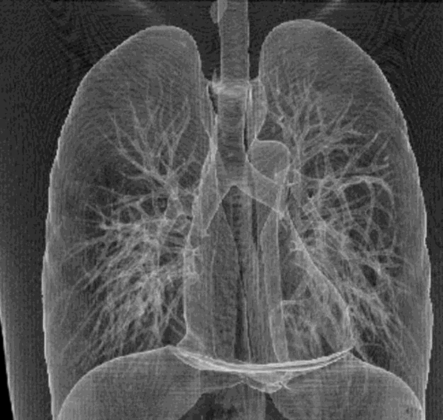

Осуществим гистограмму яркости

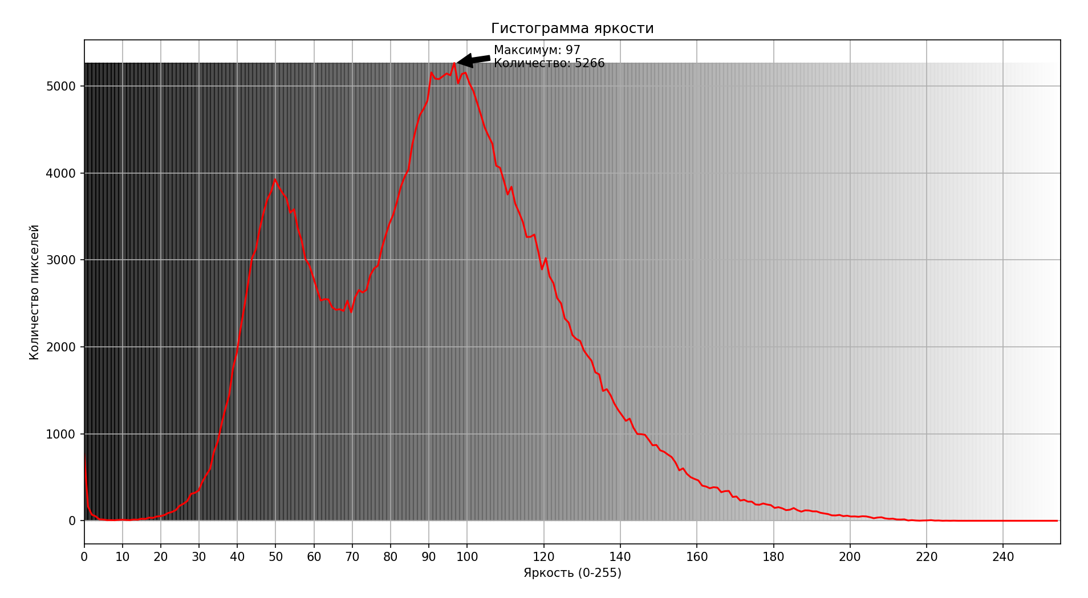

**Первый момент (M1): Σ (x\_i \* p\_i)** = Σ [768 ,164 ,70 ,51 ,16 ,14 ,7 ,7 ,6 ,10 ,12 ,9 ,7 ,14 ,12 ,23 ,21 ,36 ,33 ,49 ,53 ,65 ,89 ,101 ,122 ,172 ,195 ,226 ,309 ,321 ,348 ,451 ,527 ,597 ,791 ,909 ,1110 ,1287 ,1443 ,1753 ,1932 ,2214 ,2467 ,2742 ,3023 ,3121 ,3355 ,3540 ,3698 ,3786 ,3929 ,3842 ,3770 ,3711 ,3543 ,3584 ,3362 ,3225 ,3011 ,2940 ,2809 ,2665 ,2534 ,2549 ,2546 ,2456 ,2427 ,2433 ,2414 ,2531 ,2398 ,2569 ,2653 ,2626 ,2656 ,2825 ,2902 ,2935 ,3130 ,3280 ,3415 ,3520 ,3671 ,3840 ,3956 ,4040 ,4325 ,4515 ,4667 ,4740 ,4833 ,5157 ,5085 ,5080 ,5112 ,5145 ,5124 ,5266 ,5032 ,5139 ,5154 ,5031 ,4945 ,4809 ,4669 ,4523 ,4425 ,4337 ,4084 ,4061 ,3914 ,3753 ,3842 ,3647 ,3546 ,3437 ,3264 ,3266 ,3292 ,3103 ,2891 ,3021 ,2810 ,2734 ,2560 ,2502 ,2325 ,2280 ,2135 ,2091 ,2069 ,1958 ,1896 ,1841 ,1707 ,1684 ,1493 ,1514 ,1444 ,1346 ,1273 ,1212 ,1149 ,1175 ,1069 ,998 ,996 ,989 ,931 ,868 ,872 ,810 ,794 ,762 ,733 ,671 ,580 ,603 ,539 ,501 ,481 ,464 ,404 ,394 ,374 ,386 ,381 ,329 ,341 ,343 ,274 ,279 ,232 ,241 ,220 ,220 ,187 ,184 ,199 ,187 ,180 ,148 ,156 ,143 ,122 ,127 ,146 ,121 ,105 ,120 ,118 ,108 ,108 ,92 ,84 ,77 ,62 ,61 ,67 ,53 ,58 ,49 ,50 ,46 ,52 ,50 ,41 ,29 ,37 ,40 ,27 ,22 ,24 ,15 ,14 ,16 ,3 ,7 ,3 ,1 ,3 ,4 ,7 ,2 ,3 ,0 ,1 ,0 ,1 ,0 ,0 ,0 ,0 ,0 ,0 ,0 ,0 ,0 ,0 ,0 ,0 ,0 ,0 ,0 ,0 ,0 ,0 ,0 ,0 ,0 ,0 ,0 ,0 ,0 ,0 ,0] \* [0 ,1 ,2 ,3 ,4 ,5 ,6 ,7 ,8 ,9 ,10 ,11 ,12 ,13 ,14 ,15 ,16 ,17 ,18 ,19 ,20 ,21 ,22 ,23 ,24 ,25 ,26 ,27 ,28 ,29 ,30 ,31 ,32 ,33 ,34 ,35 ,36 ,37 ,38 ,39 ,40 ,41 ,42 ,43 ,44 ,45 ,46 ,47 ,48 ,49 ,50 ,51 ,52 ,53 ,54 ,55 ,56 ,57 ,58 ,59 ,60 ,61 ,62 ,63 ,64 ,65 ,66 ,67 ,68 ,69 ,70 ,71 ,72 ,73 ,74 ,75 ,76 ,77 ,78 ,79 ,80 ,81 ,82 ,83 ,84 ,85 ,86 ,87 ,88 ,89 ,90 ,91 ,92 ,93 ,94 ,95 ,96 ,97 ,98 ,99 ,100 ,101 ,102 ,103 ,104 ,105 ,106 ,107 ,108 ,109 ,110 ,111 ,112 ,113 ,114 ,115 ,116 ,117 ,118 ,119 ,120 ,121 ,122 ,123 ,124 ,125 ,126 ,127 ,128 ,129 ,130 ,131 ,132 ,133 ,134 ,135 ,136 ,137 ,138 ,139 ,140 ,141 ,142 ,143 ,144 ,145 ,146 ,147 ,148 ,149 ,150 ,151 ,152 ,153 ,154 ,155 ,156 ,157 ,158 ,159 ,160 ,161 ,162 ,163 ,164 ,165 ,166 ,167 ,168 ,169 ,170 ,171 ,172 ,173 ,174 ,175 ,176 ,177 ,178 ,179 ,180 ,181 ,182 ,183 ,184 ,185 ,186 ,187 ,188 ,189 ,190 ,191 ,192 ,193 ,194 ,195 ,196 ,197 ,198 ,199 ,200 ,201 ,202 ,203 ,204 ,205 ,206 ,207 ,208 ,209 ,210 ,211 ,212 ,213 ,214 ,215 ,216 ,217 ,218 ,219 ,220 ,221 ,222 ,223 ,224 ,225 ,226 ,227 ,228 ,229 ,230 ,231 ,232 ,233 ,234 ,235 ,236 ,237 ,238 ,239 ,240 ,241 ,242 ,243 ,244 ,245 ,246 ,247 ,248 ,249 ,250 ,251 ,252 ,253 ,254 ,255] = 33999928

**Второй момент (M2): Σ (x\_i^2 \* p\_i)** = Σ [768 ,164 ,70 ,51 ,16 ,14 ,7 ,7 ,6 ,10 ,12 ,9 ,7 ,14 ,12 ,23 ,21 ,36 ,33 ,49 ,53 ,65 ,89 ,101 ,122 ,172 ,195 ,226 ,309 ,321 ,348 ,451 ,527 ,597 ,791 ,909 ,1110 ,1287 ,1443 ,1753 ,1932 ,2214 ,2467 ,2742 ,3023 ,3121 ,3355 ,3540 ,3698 ,3786 ,3929 ,3842 ,3770 ,3711 ,3543 ,3584 ,3362 ,3225 ,3011 ,2940 ,2809 ,2665 ,2534 ,2549 ,2546 ,2456 ,2427 ,2433 ,2414 ,2531 ,2398 ,2569 ,2653 ,2626 ,2656 ,2825 ,2902 ,2935 ,3130 ,3280 ,3415 ,3520 ,3671 ,3840 ,3956 ,4040 ,4325 ,4515 ,4667 ,4740 ,4833 ,5157 ,5085 ,5080 ,5112 ,5145 ,5124 ,5266 ,5032 ,5139 ,5154 ,5031 ,4945 ,4809 ,4669 ,4523 ,4425 ,4337 ,4084 ,4061 ,3914 ,3753 ,3842 ,3647 ,3546 ,3437 ,3264 ,3266 ,3292 ,3103 ,2891 ,3021 ,2810 ,2734 ,2560 ,2502 ,2325 ,2280 ,2135 ,2091 ,2069 ,1958 ,1896 ,1841 ,1707 ,1684 ,1493 ,1514 ,1444 ,1346 ,1273 ,1212 ,1149 ,1175 ,1069 ,998 ,996 ,989 ,931 ,868 ,872 ,810 ,794 ,762 ,733 ,671 ,580 ,603 ,539 ,501 ,481 ,464 ,404 ,394 ,374 ,386 ,381 ,329 ,341 ,343 ,274 ,279 ,232 ,241 ,220 ,220 ,187 ,184 ,199 ,187 ,180 ,148 ,156 ,143 ,122 ,127 ,146 ,121 ,105 ,120 ,118 ,108 ,108 ,92 ,84 ,77 ,62 ,61 ,67 ,53 ,58 ,49 ,50 ,46 ,52 ,50 ,41 ,29 ,37 ,40 ,27 ,22 ,24 ,15 ,14 ,16 ,3 ,7 ,3 ,1 ,3 ,4 ,7 ,2 ,3 ,0 ,1 ,0 ,1 ,0 ,0 ,0 ,0 ,0 ,0 ,0 ,0 ,0 ,0 ,0 ,0 ,0 ,0 ,0 ,0 ,0 ,0 ,0 ,0 ,0 ,0 ,0 ,0 ,0 ,0 ,0] \* [0 ,1 ,4 ,9 ,16 ,25 ,36 ,49 ,64 ,81 ,100 ,121 ,144 ,169 ,196 ,225 ,256 ,289 ,324 ,361 ,400 ,441 ,484 ,529 ,576 ,625 ,676 ,729 ,784 ,841 ,900 ,961 ,1024 ,1089 ,1156 ,1225 ,1296 ,1369 ,1444 ,1521 ,1600 ,1681 ,1764 ,1849 ,1936 ,2025 ,2116 ,2209 ,2304 ,2401 ,2500 ,2601 ,2704 ,2809 ,2916 ,3025 ,3136 ,3249 ,3364 ,3481 ,3600 ,3721 ,3844 ,3969 ,4096 ,4225 ,4356 ,4489 ,4624 ,4761 ,4900 ,5041 ,5184 ,5329 ,5476 ,5625 ,5776 ,5929 ,6084 ,6241 ,6400 ,6561 ,6724 ,6889 ,7056 ,7225 ,7396 ,7569 ,7744 ,7921 ,8100 ,8281 ,8464 ,8649 ,8836 ,9025 ,9216 ,9409 ,9604 ,9801 ,10000 ,10201 ,10404 ,10609 ,10816 ,11025 ,11236 ,11449 ,11664 ,11881 ,12100 ,12321 ,12544 ,12769 ,12996 ,13225 ,13456 ,13689 ,13924 ,14161 ,14400 ,14641 ,14884 ,15129 ,15376 ,15625 ,15876 ,16129 ,16384 ,16641 ,16900 ,17161 ,17424 ,17689 ,17956 ,18225 ,18496 ,18769 ,19044 ,19321 ,19600 ,19881 ,20164 ,20449 ,20736 ,21025 ,21316 ,21609 ,21904 ,22201 ,22500 ,22801 ,23104 ,23409 ,23716 ,24025 ,24336 ,24649 ,24964 ,25281 ,25600 ,25921 ,26244 ,26569 ,26896 ,27225 ,27556 ,27889 ,28224 ,28561 ,28900 ,29241 ,29584 ,29929 ,30276 ,30625 ,30976 ,31329 ,31684 ,32041 ,32400 ,32761 ,33124 ,33489 ,33856 ,34225 ,34596 ,34969 ,35344 ,35721 ,36100 ,36481 ,36864 ,37249 ,37636 ,38025 ,38416 ,38809 ,39204 ,39601 ,40000 ,40401 ,40804 ,41209 ,41616 ,42025 ,42436 ,42849 ,43264 ,43681 ,44100 ,44521 ,44944 ,45369 ,45796 ,46225 ,46656 ,47089 ,47524 ,47961 ,48400 ,48841 ,49284 ,49729 ,50176 ,50625 ,51076 ,51529 ,51984 ,52441 ,52900 ,53361 ,53824 ,54289 ,54756 ,55225 ,55696 ,56169 ,56644 ,57121 ,57600 ,58081 ,58564 ,59049 ,59536 ,60025 ,60516 ,61009 ,61504 ,62001 ,62500 ,63001 ,63504 ,64009 ,64516 ,65025] = 3503622132

**Третий момент (M3): Σ (x\_i^3 \* p\_i)** = Σ [768 ,164 ,70 ,51 ,16 ,14 ,7 ,7 ,6 ,10 ,12 ,9 ,7 ,14 ,12 ,23 ,21 ,36 ,33 ,49 ,53 ,65 ,89 ,101 ,122 ,172 ,195 ,226 ,309 ,321 ,348 ,451 ,527 ,597 ,791 ,909 ,1110 ,1287 ,1443 ,1753 ,1932 ,2214 ,2467 ,2742 ,3023 ,3121 ,3355 ,3540 ,3698 ,3786 ,3929 ,3842 ,3770 ,3711 ,3543 ,3584 ,3362 ,3225 ,3011 ,2940 ,2809 ,2665 ,2534 ,2549 ,2546 ,2456 ,2427 ,2433 ,2414 ,2531 ,2398 ,2569 ,2653 ,2626 ,2656 ,2825 ,2902 ,2935 ,3130 ,3280 ,3415 ,3520 ,3671 ,3840 ,3956 ,4040 ,4325 ,4515 ,4667 ,4740 ,4833 ,5157 ,5085 ,5080 ,5112 ,5145 ,5124 ,5266 ,5032 ,5139 ,5154 ,5031 ,4945 ,4809 ,4669 ,4523 ,4425 ,4337 ,4084 ,4061 ,3914 ,3753 ,3842 ,3647 ,3546 ,3437 ,3264 ,3266 ,3292 ,3103 ,2891 ,3021 ,2810 ,2734 ,2560 ,2502 ,2325 ,2280 ,2135 ,2091 ,2069 ,1958 ,1896 ,1841 ,1707 ,1684 ,1493 ,1514 ,1444 ,1346 ,1273 ,1212 ,1149 ,1175 ,1069 ,998 ,996 ,989 ,931 ,868 ,872 ,810 ,794 ,762 ,733 ,671 ,580 ,603 ,539 ,501 ,481 ,464 ,404 ,394 ,374 ,386 ,381 ,329 ,341 ,343 ,274 ,279 ,232 ,241 ,220 ,220 ,187 ,184 ,199 ,187 ,180 ,148 ,156 ,143 ,122 ,127 ,146 ,121 ,105 ,120 ,118 ,108 ,108 ,92 ,84 ,77 ,62 ,61 ,67 ,53 ,58 ,49 ,50 ,46 ,52 ,50 ,41 ,29 ,37 ,40 ,27 ,22 ,24 ,15 ,14 ,16 ,3 ,7 ,3 ,1 ,3 ,4 ,7 ,2 ,3 ,0 ,1 ,0 ,1 ,0 ,0 ,0 ,0 ,0 ,0 ,0 ,0 ,0 ,0 ,0 ,0 ,0 ,0 ,0 ,0 ,0 ,0 ,0 ,0 ,0 ,0 ,0 ,0 ,0 ,0 ,0] \* [0 ,1 ,8 ,27 ,64 ,125 ,216 ,343 ,512 ,729 ,1000 ,1331 ,1728 ,2197 ,2744 ,3375 ,4096 ,4913 ,5832 ,6859 ,8000 ,9261 ,10648 ,12167 ,13824 ,15625 ,17576 ,19683 ,21952 ,24389 ,27000 ,29791 ,32768 ,35937 ,39304 ,42875 ,46656 ,50653 ,54872 ,59319 ,64000 ,68921 ,74088 ,79507 ,85184 ,91125 ,97336 ,103823 ,110592 ,117649 ,125000 ,132651 ,140608 ,148877 ,157464 ,166375 ,175616 ,185193 ,195112 ,205379 ,216000 ,226981 ,238328 ,250047 ,262144 ,274625 ,287496 ,300763 ,314432 ,328509 ,343000 ,357911 ,373248 ,389017 ,405224 ,421875 ,438976 ,456533 ,474552 ,493039 ,512000 ,531441 ,551368 ,571787 ,592704 ,614125 ,636056 ,658503 ,681472 ,704969 ,729000 ,753571 ,778688 ,804357 ,830584 ,857375 ,884736 ,912673 ,941192 ,970299 ,1000000 ,1030301 ,1061208 ,1092727 ,1124864 ,1157625 ,1191016 ,1225043 ,1259712 ,1295029 ,1331000 ,1367631 ,1404928 ,1442897 ,1481544 ,1520875 ,1560896 ,1601613 ,1643032 ,1685159 ,1728000 ,1771561 ,1815848 ,1860867 ,1906624 ,1953125 ,2000376 ,2048383 ,2097152 ,2146689 ,2197000 ,2248091 ,2299968 ,2352637 ,2406104 ,2460375 ,2515456 ,2571353 ,2628072 ,2685619 ,2744000 ,2803221 ,2863288 ,2924207 ,2985984 ,3048625 ,3112136 ,3176523 ,3241792 ,3307949 ,3375000 ,3442951 ,3511808 ,3581577 ,3652264 ,3723875 ,3796416 ,3869893 ,3944312 ,4019679 ,4096000 ,4173281 ,4251528 ,4330747 ,4410944 ,4492125 ,4574296 ,4657463 ,4741632 ,4826809 ,4913000 ,5000211 ,5088448 ,5177717 ,5268024 ,5359375 ,5451776 ,5545233 ,5639752 ,5735339 ,5832000 ,5929741 ,6028568 ,6128487 ,6229504 ,6331625 ,6434856 ,6539203 ,6644672 ,6751269 ,6859000 ,6967871 ,7077888 ,7189057 ,7301384 ,7414875 ,7529536 ,7645373 ,7762392 ,7880599 ,8000000 ,8120601 ,8242408 ,8365427 ,8489664 ,8615125 ,8741816 ,8869743 ,8998912 ,9129329 ,9261000 ,9393931 ,9528128 ,9663597 ,9800344 ,9938375 ,10077696 ,10218313 ,10360232 ,10503459 ,10648000 ,10793861 ,10941048 ,11089567 ,11239424 ,11390625 ,11543176 ,11697083 ,11852352 ,12008989 ,12167000 ,12326391 ,12487168 ,12649337 ,12812904 ,12977875 ,13144256 ,13312053 ,13481272 ,13651919 ,13824000 ,13997521 ,14172488 ,14348907 ,14526784 ,14706125 ,14886936 ,15069223 ,15252992 ,15438249 ,15625000 ,15813251 ,16003008 ,16194277 ,16387064 ,16581375] = 395808933910

**Четвертый момент (M4): Σ (x\_i^4 \* p\_i)** = Σ [768 ,164 ,70 ,51 ,16 ,14 ,7 ,7 ,6 ,10 ,12 ,9 ,7 ,14 ,12 ,23 ,21 ,36 ,33 ,49 ,53 ,65 ,89 ,101 ,122 ,172 ,195 ,226 ,309 ,321 ,348 ,451 ,527 ,597 ,791 ,909 ,1110 ,1287 ,1443 ,1753 ,1932 ,2214 ,2467 ,2742 ,3023 ,3121 ,3355 ,3540 ,3698 ,3786 ,3929 ,3842 ,3770 ,3711 ,3543 ,3584 ,3362 ,3225 ,3011 ,2940 ,2809 ,2665 ,2534 ,2549 ,2546 ,2456 ,2427 ,2433 ,2414 ,2531 ,2398 ,2569 ,2653 ,2626 ,2656 ,2825 ,2902 ,2935 ,3130 ,3280 ,3415 ,3520 ,3671 ,3840 ,3956 ,4040 ,4325 ,4515 ,4667 ,4740 ,4833 ,5157 ,5085 ,5080 ,5112 ,5145 ,5124 ,5266 ,5032 ,5139 ,5154 ,5031 ,4945 ,4809 ,4669 ,4523 ,4425 ,4337 ,4084 ,4061 ,3914 ,3753 ,3842 ,3647 ,3546 ,3437 ,3264 ,3266 ,3292 ,3103 ,2891 ,3021 ,2810 ,2734 ,2560 ,2502 ,2325 ,2280 ,2135 ,2091 ,2069 ,1958 ,1896 ,1841 ,1707 ,1684 ,1493 ,1514 ,1444 ,1346 ,1273 ,1212 ,1149 ,1175 ,1069 ,998 ,996 ,989 ,931 ,868 ,872 ,810 ,794 ,762 ,733 ,671 ,580 ,603 ,539 ,501 ,481 ,464 ,404 ,394 ,374 ,386 ,381 ,329 ,341 ,343 ,274 ,279 ,232 ,241 ,220 ,220 ,187 ,184 ,199 ,187 ,180 ,148 ,156 ,143 ,122 ,127 ,146 ,121 ,105 ,120 ,118 ,108 ,108 ,92 ,84 ,77 ,62 ,61 ,67 ,53 ,58 ,49 ,50 ,46 ,52 ,50 ,41 ,29 ,37 ,40 ,27 ,22 ,24 ,15 ,14 ,16 ,3 ,7 ,3 ,1 ,3 ,4 ,7 ,2 ,3 ,0 ,1 ,0 ,1 ,0 ,0 ,0 ,0 ,0 ,0 ,0 ,0 ,0 ,0 ,0 ,0 ,0 ,0 ,0 ,0 ,0 ,0 ,0 ,0 ,0 ,0 ,0 ,0 ,0 ,0 ,0] \* [0 ,1 ,16 ,81 ,256 ,625 ,1296 ,2401 ,4096 ,6561 ,10000 ,14641 ,20736 ,28561 ,38416 ,50625 ,65536 ,83521 ,104976 ,130321 ,160000 ,194481 ,234256 ,279841 ,331776 ,390625 ,456976 ,531441 ,614656 ,707281 ,810000 ,923521 ,1048576 ,1185921 ,1336336 ,1500625 ,1679616 ,1874161 ,2085136 ,2313441 ,2560000 ,2825761 ,3111696 ,3418801 ,3748096 ,4100625 ,4477456 ,4879681 ,5308416 ,5764801 ,6250000 ,6765201 ,7311616 ,7890481 ,8503056 ,9150625 ,9834496 ,10556001 ,11316496 ,12117361 ,12960000 ,13845841 ,14776336 ,15752961 ,16777216 ,17850625 ,18974736 ,20151121 ,21381376 ,22667121 ,24010000 ,25411681 ,26873856 ,28398241 ,29986576 ,31640625 ,33362176 ,35153041 ,37015056 ,38950081 ,40960000 ,43046721 ,45212176 ,47458321 ,49787136 ,52200625 ,54700816 ,57289761 ,59969536 ,62742241 ,65610000 ,68574961 ,71639296 ,74805201 ,78074896 ,81450625 ,84934656 ,88529281 ,92236816 ,96059601 ,100000000 ,104060401 ,108243216 ,112550881 ,116985856 ,121550625 ,126247696 ,131079601 ,136048896 ,141158161 ,146410000 ,151807041 ,157351936 ,163047361 ,168896016 ,174900625 ,181063936 ,187388721 ,193877776 ,200533921 ,207360000 ,214358881 ,221533456 ,228886641 ,236421376 ,244140625 ,252047376 ,260144641 ,268435456 ,276922881 ,285610000 ,294499921 ,303595776 ,312900721 ,322417936 ,332150625 ,342102016 ,352275361 ,362673936 ,373301041 ,384160000 ,395254161 ,406586896 ,418161601 ,429981696 ,442050625 ,454371856 ,466948881 ,479785216 ,492884401 ,506250000 ,519885601 ,533794816 ,547981281 ,562448656 ,577200625 ,592240896 ,607573201 ,623201296 ,639128961 ,655360000 ,671898241 ,688747536 ,705911761 ,723394816 ,741200625 ,759333136 ,777796321 ,796594176 ,815730721 ,835210000 ,855036081 ,875213056 ,895745041 ,916636176 ,937890625 ,959512576 ,981506241 ,1003875856 ,1026625681 ,1049760000 ,1073283121 ,1097199376 ,1121513121 ,1146228736 ,1171350625 ,1196883216 ,1222830961 ,1249198336 ,1275989841 ,1303210000 ,1330863361 ,1358954496 ,1387488001 ,1416468496 ,1445900625 ,1475789056 ,1506138481 ,1536953616 ,1568239201 ,1600000000 ,1632240801 ,1664966416 ,1698181681 ,1731891456 ,1766100625 ,1800814096 ,1836036801 ,1871773696 ,1908029761 ,1944810000 ,1982119441 ,2019963136 ,2058346161 ,2097273616 ,2136750625 ,-2118184960 ,-2077593375 ,-2036436720 ,-1994709775 ,-1952407296 ,-1909524015 ,-1866054640 ,-1821993855 ,-1777336320 ,-1732076671 ,-1686209520 ,-1639729455 ,-1592631040 ,-1544908815 ,-1496557296 ,-1447570975 ,-1397944320 ,-1347671775 ,-1296747760 ,-1245166671 ,-1192922880 ,-1140010735 ,-1086424560 ,-1032158655 ,-977207296 ,-921564735 ,-865225200 ,-808182895 ,-750432000 ,-691966671 ,-632781040 ,-572869215 ,-512225280 ,-450843295 ,-388717296 ,-325841295 ,-262209280 ,-197815215 ,-132653040 ,-66716671] = 48071482690048

**Первый центральный момент (U1): M1 / N** = 33999928 / 371844 = 91.4360000430288

**Второй центральный момент (U2): M2/N - U1^2** = (3503622132 / 371844) - 8360.542103868762 = 9422.290347565107 - 8360.542103868762 = 1061.7482436963455

**Третий центральный момент (U3): M3/N - 3\*U1\*U2 - U1^3** = (395808933910 / 371844) - (3 \* 91.4360000430288 \* 1061.7482436963455) - 764454.5281690882 = 1064448.8923042996 - 291246.0373689144 - 764454.5281690882 = 8748.326766297105

**Четвертый центральный момент (U4): M4/N - 4\*U1\*U3 - 6\*U1^2\*U2 - U2^2** = (48071482690048 / 371844) - (4 \* 91.4360000430288 \* 8748.326766297105) - (6 \* 91.4360000430288 \*\* 2 \* 1061.7482436963455) - 1127309.3329922743 = 129278629.45226493 - 3199648.0263182884 - 53260745.37079204 - 1127309.3329922743 = 71690926.72216235

**Расчет энтропии**

**Общее количество пикселей (N):** Σ [768 ,164 ,70 ,51 ,16 ,14 ,7 ,7 ,6 ,10 ,12 ,9 ,7 ,14 ,12 ,23 ,21 ,36 ,33 ,49 ,53 ,65 ,89 ,101 ,122 ,172 ,195 ,226 ,309 ,321 ,348 ,451 ,527 ,597 ,791 ,909 ,1110 ,1287 ,1443 ,1753 ,1932 ,2214 ,2467 ,2742 ,3023 ,3121 ,3355 ,3540 ,3698 ,3786 ,3929 ,3842 ,3770 ,3711 ,3543 ,3584 ,3362 ,3225 ,3011 ,2940 ,2809 ,2665 ,2534 ,2549 ,2546 ,2456 ,2427 ,2433 ,2414 ,2531 ,2398 ,2569 ,2653 ,2626 ,2656 ,2825 ,2902 ,2935 ,3130 ,3280 ,3415 ,3520 ,3671 ,3840 ,3956 ,4040 ,4325 ,4515 ,4667 ,4740 ,4833 ,5157 ,5085 ,5080 ,5112 ,5145 ,5124 ,5266 ,5032 ,5139 ,5154 ,5031 ,4945 ,4809 ,4669 ,4523 ,4425 ,4337 ,4084 ,4061 ,3914 ,3753 ,3842 ,3647 ,3546 ,3437 ,3264 ,3266 ,3292 ,3103 ,2891 ,3021 ,2810 ,2734 ,2560 ,2502 ,2325 ,2280 ,2135 ,2091 ,2069 ,1958 ,1896 ,1841 ,1707 ,1684 ,1493 ,1514 ,1444 ,1346 ,1273 ,1212 ,1149 ,1175 ,1069 ,998 ,996 ,989 ,931 ,868 ,872 ,810 ,794 ,762 ,733 ,671 ,580 ,603 ,539 ,501 ,481 ,464 ,404 ,394 ,374 ,386 ,381 ,329 ,341 ,343 ,274 ,279 ,232 ,241 ,220 ,220 ,187 ,184 ,199 ,187 ,180 ,148 ,156 ,143 ,122 ,127 ,146 ,121 ,105 ,120 ,118 ,108 ,108 ,92 ,84 ,77 ,62 ,61 ,67 ,53 ,58 ,49 ,50 ,46 ,52 ,50 ,41 ,29 ,37 ,40 ,27 ,22 ,24 ,15 ,14 ,16 ,3 ,7 ,3 ,1 ,3 ,4 ,7 ,2 ,3 ,0 ,1 ,0 ,1 ,0 ,0 ,0 ,0 ,0 ,0 ,0 ,0 ,0 ,0 ,0 ,0 ,0 ,0 ,0 ,0 ,0 ,0 ,0 ,0 ,0 ,0 ,0 ,0 ,0 ,0 ,0] = 371844

**Вероятности (p\_i):** [768 ,164 ,70 ,51 ,16 ,14 ,7 ,7 ,6 ,10 ,12 ,9 ,7 ,14 ,12 ,23 ,21 ,36 ,33 ,49 ,53 ,65 ,89 ,101 ,122 ,172 ,195 ,226 ,309 ,321 ,348 ,451 ,527 ,597 ,791 ,909 ,1110 ,1287 ,1443 ,1753 ,1932 ,2214 ,2467 ,2742 ,3023 ,3121 ,3355 ,3540 ,3698 ,3786 ,3929 ,3842 ,3770 ,3711 ,3543 ,3584 ,3362 ,3225 ,3011 ,2940 ,2809 ,2665 ,2534 ,2549 ,2546 ,2456 ,2427 ,2433 ,2414 ,2531 ,2398 ,2569 ,2653 ,2626 ,2656 ,2825 ,2902 ,2935 ,3130 ,3280 ,3415 ,3520 ,3671 ,3840 ,3956 ,4040 ,4325 ,4515 ,4667 ,4740 ,4833 ,5157 ,5085 ,5080 ,5112 ,5145 ,5124 ,5266 ,5032 ,5139 ,5154 ,5031 ,4945 ,4809 ,4669 ,4523 ,4425 ,4337 ,4084 ,4061 ,3914 ,3753 ,3842 ,3647 ,3546 ,3437 ,3264 ,3266 ,3292 ,3103 ,2891 ,3021 ,2810 ,2734 ,2560 ,2502 ,2325 ,2280 ,2135 ,2091 ,2069 ,1958 ,1896 ,1841 ,1707 ,1684 ,1493 ,1514 ,1444 ,1346 ,1273 ,1212 ,1149 ,1175 ,1069 ,998 ,996 ,989 ,931 ,868 ,872 ,810 ,794 ,762 ,733 ,671 ,580 ,603 ,539 ,501 ,481 ,464 ,404 ,394 ,374 ,386 ,381 ,329 ,341 ,343 ,274 ,279 ,232 ,241 ,220 ,220 ,187 ,184 ,199 ,187 ,180 ,148 ,156 ,143 ,122 ,127 ,146 ,121 ,105 ,120 ,118 ,108 ,108 ,92 ,84 ,77 ,62 ,61 ,67 ,53 ,58 ,49 ,50 ,46 ,52 ,50 ,41 ,29 ,37 ,40 ,27 ,22 ,24 ,15 ,14 ,16 ,3 ,7 ,3 ,1 ,3 ,4 ,7 ,2 ,3 ,1 ,1] / 371844 = [0.0020653822570755476 ,0.00044104516947967426 ,0.0001882509869730317 ,0.0001371542905089231 ,4.302879702240725e-05 ,3.765019739460634e-05 ,1.882509869730317e-05 ,1.882509869730317e-05 ,1.6135798883402716e-05 ,2.689299813900453e-05 ,3.227159776680543e-05 ,2.4203698325104077e-05 ,1.882509869730317e-05 ,3.765019739460634e-05 ,3.227159776680543e-05 ,6.185389571971042e-05 ,5.647529609190951e-05 ,9.681479330041631e-05 ,8.874689385871494e-05 ,0.0001317756908811222 ,0.000142532890136724 ,0.00017480448790352943 ,0.0002393476834371403 ,0.0002716192812039457 ,0.00032809457729585524 ,0.0004625595679908779 ,0.0005244134637105883 ,0.0006077817579415024 ,0.00083099364249524 ,0.0008632652402620454 ,0.0009358763352373576 ,0.0012128742160691043 ,0.0014172610019255387 ,0.0016055119888985705 ,0.002127236152795258 ,0.0024445735308355116 ,0.002985122793429503 ,0.003461128860489883 ,0.0038806596314583533 ,0.004714342573767494 ,0.005195727240455675 ,0.005954109787975602 ,0.006634502640892417 ,0.007374060089715042 ,0.008129753337421068 ,0.008393304719183313 ,0.009022600875636019 ,0.009520121341207603 ,0.009945030711803875 ,0.010181689095427115 ,0.01056625896881488 ,0.01033228988500554 ,0.010138660298404708 ,0.00997999160938458 ,0.009528189240649304 ,0.009638450533019222 ,0.009041425974333323 ,0.008672991899828961 ,0.008097481739654263 ,0.007906541452867332 ,0.0075542431772463725 ,0.007166984004044707 ,0.0068146857284237475 ,0.006855025225632254 ,0.006846957326190553 ,0.006604920342939512 ,0.0065269306483363996 ,0.006543066447219802 ,0.006491969750755693 ,0.006806617828982046 ,0.006448940953733286 ,0.0069088112219102635 ,0.007134712406277902 ,0.007062101311302589 ,0.007142780305719603 ,0.007597271974268779 ,0.0078043480599391145 ,0.007893094953797829 ,0.008417508417508417 ,0.008820903389593486 ,0.009183958864470047 ,0.009466335344929595 ,0.009872419616828563 ,0.01032691128537774 ,0.010638870063790192 ,0.01086477124815783 ,0.01163122169511946 ,0.012142188659760545 ,0.012550962231473414 ,0.012747281117888146 ,0.01299738600058089 ,0.013868719140284636 ,0.013675089553683803 ,0.0136616430546143 ,0.013747700648659116 ,0.01383644754251783 ,0.013779972246425921 ,0.014161852819999784 ,0.01353255666354708 ,0.013820311743634427 ,0.013860651240842934 ,0.013529867363733178 ,0.01329858757973774 ,0.012932842805047277 ,0.012556340831101215 ,0.012163703058271748 ,0.011900151676509504 ,0.011663493292886264 ,0.010983100439969449 ,0.01092124654424974 ,0.010525919471606372 ,0.0100929422015684 ,0.01033228988500554 ,0.009807876421294952 ,0.009536257140091006 ,0.009243123460375856 ,0.008777874592571079 ,0.00878325319219888 ,0.00885317498736029 ,0.008344897322533105 ,0.00777476576198621 ,0.008124374737793268 ,0.007556932477060273 ,0.007352545691203838 ,0.00688460752358516 ,0.006728628134378933 ,0.006252622067318553 ,0.0061316035756930325 ,0.005741655102677467 ,0.005623325910865847 ,0.005564161314960037 ,0.005265649035617086 ,0.005098912447155259 ,0.004951000957390734 ,0.004590634782328073 ,0.004528780886608363 ,0.004015124622153376 ,0.004071599918245286 ,0.0038833489312722538 ,0.0036197975495100097 ,0.0034234786630952764 ,0.0032594313744473487 ,0.00309000548617162 ,0.0031599272813330323 ,0.0028748615010595843 ,0.002683921214272652 ,0.002678542614644851 ,0.002659717515947548 ,0.0025037381267413216 ,0.002334312238465593 ,0.0023450694377211948 ,0.0021783328492593667 ,0.0021353040522369597 ,0.002049246458192145 ,0.001971256763589032 ,0.001804520175127204 ,0.0015597938920622627 ,0.001621647787781973 ,0.001449532599692344 ,0.0013473392067641268 ,0.001293553210486118 ,0.0012478351136498101 ,0.001086477124815783 ,0.0010595841266767784 ,0.0010057981303987693 ,0.001038069728165575 ,0.0010246232290960725 ,0.000884779638773249 ,0.0009170512365400545 ,0.0009224298361678553 ,0.0007368681490087241 ,0.0007503146480782264 ,0.0006239175568249051 ,0.0006481212551500092 ,0.0005916459590580997 ,0.0005916459590580997 ,0.0005028990651993846 ,0.0004948311657576833 ,0.0005351706629661902 ,0.0005028990651993846 ,0.0004840739665020815 ,0.000398016372457267 ,0.00041953077096847064 ,0.00038456987338776475 ,0.00032809457729585524 ,0.0003415410763653575 ,0.0003926377728294661 ,0.0003254052774819548 ,0.00028237648045954756 ,0.00032271597766805437 ,0.00031733737804025345 ,0.0002904443799012489 ,0.0002904443799012489 ,0.00024741558287884167 ,0.00022590118436763805 ,0.00020707608567033486 ,0.00016673658846182808 ,0.00016404728864792762 ,0.00018018308753133035 ,0.000142532890136724 ,0.00015597938920622627 ,0.0001317756908811222 ,0.00013446499069502265 ,0.00012370779143942084 ,0.00013984359032282354 ,0.00013446499069502265 ,0.00011026129236991857 ,7.798969460311313e-05 ,9.950409311431675e-05 ,0.00010757199255601812 ,7.261109497531223e-05 ,5.9164595905809965e-05 ,6.454319553361086e-05 ,4.0339497208506797e-05 ,3.765019739460634e-05 ,4.302879702240725e-05 ,8.067899441701358e-06 ,1.882509869730317e-05 ,8.067899441701358e-06 ,2.689299813900453e-06 ,8.067899441701358e-06 ,1.0757199255601812e-05 ,1.882509869730317e-05 ,5.378599627800906e-06 ,8.067899441701358e-06 ,2.689299813900453e-06 ,2.689299813900453e-06]

**Формула для расчета энтропии: H = -Σ (p\_i \* log2(p\_i))**

- (0.0021 \* log2(0.0021)) = 0.018421919833761985

- (0.0004 \* log2(0.0004)) = 0.004916236104255842

- (0.0002 \* log2(0.0002)) = 0.0023296163083314217

- (0.0001 \* log2(0.0001)) = 0.0017599518720588642

- (0.0000 \* log2(0.0000)) = 0.0006241042143579947

- (0.0000 \* log2(0.0000)) = 0.0005533443127748758

- (0.0000 \* log2(0.0000)) = 0.00029549725508474107

- (0.0000 \* log2(0.0000)) = 0.00029549725508474107

- (0.0000 \* log2(0.0000)) = 0.00025687184088508453

- (0.0000 \* log2(0.0000)) = 0.00040830052045605207

- (0.0000 \* log2(0.0000)) = 0.0004814720840033636

- (0.0000 \* log2(0.0000)) = 0.00037114950542867345

- (0.0000 \* log2(0.0000)) = 0.00029549725508474107

- (0.0000 \* log2(0.0000)) = 0.0005533443127748758

- (0.0000 \* log2(0.0000)) = 0.0004814720840033636

- (0.0001 \* log2(0.0001)) = 0.0008647654615068592

- (0.0001 \* log2(0.0001)) = 0.0007969805387314226

- (0.0001 \* log2(0.0001)) = 0.0012909684351138614

- (0.0001 \* log2(0.0001)) = 0.001194528208055993

- (0.0001 \* log2(0.0001)) = 0.0016985396511905277

- (0.0001 \* log2(0.0001)) = 0.0018210597137456024

- (0.0002 \* log2(0.0002)) = 0.0021819044009203335

- (0.0002 \* log2(0.0002)) = 0.002879018630856654

- (0.0003 \* log2(0.0003)) = 0.0032176363609017233

- (0.0003 \* log2(0.0003)) = 0.003797235606546833

- (0.0005 \* log2(0.0005)) = 0.005124268759591068

- (0.0005 \* log2(0.0005)) = 0.005714537527906423

- (0.0006 \* log2(0.0006)) = 0.0064936369423788266

- (0.0008 \* log2(0.0008)) = 0.00850345401944677

- (0.0009 \* log2(0.0009)) = 0.008786234609879833

- (0.0009 \* log2(0.0009)) = 0.00941622098572482

- (0.0012 \* log2(0.0012)) = 0.011749542306342389

- (0.0014 \* log2(0.0014)) = 0.013411085659800027

- (0.0016 \* log2(0.0016)) = 0.014903567773963657

- (0.0021 \* log2(0.0021)) = 0.018883058567192502

- (0.0024 \* log2(0.0024)) = 0.021209612494855916

- (0.0030 \* log2(0.0030)) = 0.025039192099941016

- (0.0035 \* log2(0.0035)) = 0.028293141955182337

- (0.0039 \* log2(0.0039)) = 0.0310820749535248

- (0.0047 \* log2(0.0047)) = 0.036435869975756374

- (0.0052 \* log2(0.0052)) = 0.03942756100340515

- (0.0060 \* log2(0.0060)) = 0.044012174978075094

- (0.0066 \* log2(0.0066)) = 0.04800590745489467

- (0.0074 \* log2(0.0074)) = 0.05223286501053749

- (0.0081 \* log2(0.0081)) = 0.05644140361149154

- (0.0084 \* log2(0.0084)) = 0.05788480642921772

- (0.0090 \* log2(0.0090)) = 0.061283678842059534

- (0.0095 \* log2(0.0095)) = 0.06392575193516933

- (0.0099 \* log2(0.0099)) = 0.06615243940712057

- (0.0102 \* log2(0.0102)) = 0.06738118921887772

- (0.0106 \* log2(0.0106)) = 0.06936106072308357

- (0.0103 \* log2(0.0103)) = 0.06815897705045317

- (0.0101 \* log2(0.0101)) = 0.06715837590927012

- (0.0100 \* log2(0.0100)) = 0.06633446613643106

- (0.0095 \* log2(0.0095)) = 0.06396828185209441

- (0.0096 \* log2(0.0096)) = 0.06454853980621442

- (0.0090 \* log2(0.0090)) = 0.06138435625818258

- (0.0087 \* log2(0.0087)) = 0.05940352899381645

- (0.0081 \* log2(0.0081)) = 0.056263821241572316

- (0.0079 \* log2(0.0079)) = 0.05520930371970072

- (0.0076 \* log2(0.0076)) = 0.05324606081482294

- (0.0072 \* log2(0.0072)) = 0.051060590919798206

- (0.0068 \* log2(0.0068)) = 0.04904622788016906

- (0.0069 \* log2(0.0069)) = 0.04927818727061296

- (0.0068 \* log2(0.0068)) = 0.04923182285505841

- (0.0066 \* log2(0.0066)) = 0.0478344389274105

- (0.0065 \* log2(0.0065)) = 0.047381467033248144

- (0.0065 \* log2(0.0065)) = 0.047475295133658536

- (0.0065 \* log2(0.0065)) = 0.04717797519617303

- (0.0068 \* log2(0.0068)) = 0.04899979472709269

- (0.0064 \* log2(0.0064)) = 0.04692715067156481

- (0.0069 \* log2(0.0069)) = 0.04958693406586328

- (0.0071 \* log2(0.0071)) = 0.05087712765813066

- (0.0071 \* log2(0.0071)) = 0.05046356388626183

- (0.0071 \* log2(0.0071)) = 0.05092301317929679

- (0.0076 \* log2(0.0076)) = 0.05348709527089399

- (0.0078 \* log2(0.0078)) = 0.05464219104506349

- (0.0079 \* log2(0.0079)) = 0.055134793038276994

- (0.0084 \* log2(0.0084)) = 0.058016759477385556

- (0.0088 \* log2(0.0088)) = 0.06020141190334559

- (0.0092 \* log2(0.0092)) = 0.062144801521763174

- (0.0095 \* log2(0.0095)) = 0.06364196667100912

- (0.0099 \* log2(0.0099)) = 0.06577381662055812

- (0.0103 \* log2(0.0103)) = 0.06813125372188199

- (0.0106 \* log2(0.0106)) = 0.06973259359459942

- (0.0109 \* log2(0.0109)) = 0.07088392308597337

- (0.0116 \* log2(0.0116)) = 0.07474052722416488

- (0.0121 \* log2(0.0121)) = 0.07727079647533297

- (0.0126 \* log2(0.0126)) = 0.0792726081179071

- (0.0127 \* log2(0.0127)) = 0.08022713771773216

- (0.0130 \* log2(0.0130)) = 0.08143687258253797

- (0.0139 \* log2(0.0139)) = 0.08559803461872102

- (0.0137 \* log2(0.0137)) = 0.08468033784922342

- (0.0137 \* log2(0.0137)) = 0.08461646267051555

- (0.0137 \* log2(0.0137)) = 0.08502493467360513

- (0.0138 \* log2(0.0138)) = 0.08544535748223264

- (0.0138 \* log2(0.0138)) = 0.08517791104515673

- (0.0142 \* log2(0.0142)) = 0.08697992138489645

- (0.0135 \* log2(0.0135)) = 0.08400228671329323

- (0.0138 \* log2(0.0138)) = 0.08536897820844269

- (0.0139 \* log2(0.0139)) = 0.08555987550110633

- (0.0135 \* log2(0.0135)) = 0.08398947254906976

- (0.0133 \* log2(0.0133)) = 0.08288455302901156

- (0.0129 \* log2(0.0129)) = 0.08112535306130685

- (0.0126 \* log2(0.0126)) = 0.0792988183248335

- (0.0122 \* log2(0.0122)) = 0.07737664420230587

- (0.0119 \* log2(0.0119)) = 0.07607619676087231

- (0.0117 \* log2(0.0117)) = 0.07490127718160683

- (0.0110 \* log2(0.0110)) = 0.07148428700217886

- (0.0109 \* log2(0.0109)) = 0.07117069109960249

- (0.0105 \* log2(0.0105)) = 0.06915434282843115

- (0.0101 \* log2(0.0101)) = 0.06692134806895518

- (0.0103 \* log2(0.0103)) = 0.06815897705045317

- (0.0098 \* log2(0.0098)) = 0.06543661638738248

- (0.0095 \* log2(0.0095)) = 0.06401080191337181

- (0.0092 \* log2(0.0092)) = 0.06245951788488736

- (0.0088 \* log2(0.0088)) = 0.059969672256340846

- (0.0088 \* log2(0.0088)) = 0.059998656323169766

- (0.0089 \* log2(0.0089)) = 0.060375017833689155

- (0.0083 \* log2(0.0083)) = 0.057620597958264956

- (0.0078 \* log2(0.0078)) = 0.05447766765007655

- (0.0081 \* log2(0.0081)) = 0.05641181940409269

- (0.0076 \* log2(0.0076)) = 0.053261135806619224

- (0.0074 \* log2(0.0074)) = 0.05211146492429111

- (0.0069 \* log2(0.0069)) = 0.04944807304806805

- (0.0067 \* log2(0.0067)) = 0.04855022718587915

- (0.0063 \* log2(0.0063)) = 0.045777465544496375

- (0.0061 \* log2(0.0061)) = 0.04506434224511709

- (0.0057 \* log2(0.0057)) = 0.042742704209928116

- (0.0056 \* log2(0.0056)) = 0.04203076574803331

- (0.0056 \* log2(0.0056)) = 0.04167345407848456

- (0.0053 \* log2(0.0053)) = 0.039856608076768565

- (0.0051 \* log2(0.0051)) = 0.03883125070435827

- (0.0050 \* log2(0.0050)) = 0.037915082474914166

- (0.0046 \* log2(0.0046)) = 0.035655876379268016

- (0.0045 \* log2(0.0045)) = 0.03526408397397621

- (0.0040 \* log2(0.0040)) = 0.031961755197811643

- (0.0041 \* log2(0.0041)) = 0.0323292707568495

- (0.0039 \* log2(0.0039)) = 0.031099733669447214

- (0.0036 \* log2(0.0036)) = 0.0293561066404827

- (0.0034 \* log2(0.0034)) = 0.028039390090624478

- (0.0033 \* log2(0.0033)) = 0.02692669707975292

- (0.0031 \* log2(0.0031)) = 0.02576500613957809

- (0.0032 \* log2(0.0032)) = 0.026246017653586452

- (0.0029 \* log2(0.0029)) = 0.02427041976281393

- (0.0027 \* log2(0.0027)) = 0.02292455728335359

- (0.0027 \* log2(0.0027)) = 0.02288636818537516

- (0.0027 \* log2(0.0027)) = 0.02275258343054495

- (0.0025 \* log2(0.0025)) = 0.021636555297577863

- (0.0023 \* log2(0.0023)) = 0.020408394074479537

- (0.0023 \* log2(0.0023)) = 0.02048688691133387

- (0.0022 \* log2(0.0022)) = 0.019262038636279545

- (0.0021 \* log2(0.0021)) = 0.018943014166824795

- (0.0020 \* log2(0.0020)) = 0.018301186450616194

- (0.0020 \* log2(0.0020)) = 0.017715031219668696

- (0.0018 \* log2(0.0018)) = 0.016446701860830824

- (0.0016 \* log2(0.0016)) = 0.014544187210434217

- (0.0016 \* log2(0.0016)) = 0.015029956747527133

- (0.0014 \* log2(0.0014)) = 0.013669377255474591

- (0.0013 \* log2(0.0013)) = 0.012847783636265816

- (0.0013 \* log2(0.0013)) = 0.01241092498248289

- (0.0012 \* log2(0.0012)) = 0.012037062949218212

- (0.0011 \* log2(0.0011)) = 0.010697591193975328

- (0.0011 \* log2(0.0011)) = 0.010471113537992117

- (0.0010 \* log2(0.0010)) = 0.010015178063742615

- (0.0010 \* log2(0.0010)) = 0.010289223543097662

- (0.0010 \* log2(0.0010)) = 0.01017521645440417

- (0.0009 \* log2(0.0009)) = 0.008973783871261574

- (0.0009 \* log2(0.0009)) = 0.009253698118565423

- (0.0009 \* log2(0.0009)) = 0.009300189617515076

- (0.0007 \* log2(0.0007)) = 0.007668075355331168

- (0.0008 \* log2(0.0008)) = 0.0077884286071505

- (0.0006 \* log2(0.0006)) = 0.006642449031434011

- (0.0006 \* log2(0.0006)) = 0.006864542980906845

- (0.0006 \* log2(0.0006)) = 0.0063442067531704685

- (0.0006 \* log2(0.0006)) = 0.0063442067531704685

- (0.0005 \* log2(0.0005)) = 0.005510488097070693

- (0.0005 \* log2(0.0005)) = 0.0054336301947818235

- (0.0005 \* log2(0.0005)) = 0.0058160813569420435

- (0.0005 \* log2(0.0005)) = 0.005510488097070693

- (0.0005 \* log2(0.0005)) = 0.0053308572327445585

- (0.0004 \* log2(0.0004)) = 0.0044955489966530485

- (0.0004 \* log2(0.0004)) = 0.004706688764169644

- (0.0004 \* log2(0.0004)) = 0.004362740095918085

- (0.0003 \* log2(0.0003)) = 0.003797235606546833

- (0.0003 \* log2(0.0003)) = 0.003933068616629756

- (0.0004 \* log2(0.0004)) = 0.004442505345501316

- (0.0003 \* log2(0.0003)) = 0.003769974619425118

- (0.0003 \* log2(0.0003)) = 0.0033292448103426774

- (0.0003 \* log2(0.0003)) = 0.0037426815671490836

- (0.0003 \* log2(0.0003)) = 0.0036879981937797627

- (0.0003 \* log2(0.0003)) = 0.0034125618546528946

- (0.0003 \* log2(0.0003)) = 0.0034125618546528946

- (0.0002 \* log2(0.0002)) = 0.0029642306802697533

- (0.0002 \* log2(0.0002)) = 0.0027361197861904144

- (0.0002 \* log2(0.0002)) = 0.0025341042477005494

- (0.0002 \* log2(0.0002)) = 0.00209256780465863

- (0.0002 \* log2(0.0002)) = 0.0020626650919213442

- (0.0002 \* log2(0.0002)) = 0.0022411620681723142

- (0.0001 \* log2(0.0001)) = 0.0018210597137456024

- (0.0002 \* log2(0.0002)) = 0.001972571036270955

- (0.0001 \* log2(0.0001)) = 0.0016985396511905277

- (0.0001 \* log2(0.0001)) = 0.0017292845626067194

- (0.0001 \* log2(0.0001)) = 0.0016058231315742974

- (0.0001 \* log2(0.0001)) = 0.001790543101351102

- (0.0001 \* log2(0.0001)) = 0.0017292845626067194

- (0.0001 \* log2(0.0001)) = 0.0014495816108037976

- (0.0001 \* log2(0.0001)) = 0.0010642752127385908

- (0.0001 \* log2(0.0001)) = 0.0013228954353918956

- (0.0001 \* log2(0.0001)) = 0.001418058096712172

- (0.0001 \* log2(0.0001)) = 0.0009983626536138482

- (0.0001 \* log2(0.0001)) = 0.0008309612086792147

- (0.0001 \* log2(0.0001)) = 0.0008984009724731163

- (0.0000 \* log2(0.0000)) = 0.0005888536875191558

- (0.0000 \* log2(0.0000)) = 0.0005533443127748758

- (0.0000 \* log2(0.0000)) = 0.0006241042143579947

- (0.0000 \* log2(0.0000)) = 0.0001365038198842436

- (0.0000 \* log2(0.0000)) = 0.00029549725508474107

- (0.0000 \* log2(0.0000)) = 0.0001365038198842436

- (0.0000 \* log2(0.0000)) = 4.976371265297648e-05

- (0.0000 \* log2(0.0000)) = 0.0001365038198842436

- (0.0000 \* log2(0.0000)) = 0.0001775404521007023

- (0.0000 \* log2(0.0000)) = 0.00029549725508474107

- (0.0000 \* log2(0.0000)) = 9.414882567815205e-05

- (0.0000 \* log2(0.0000)) = 0.0001365038198842436

- (0.0000 \* log2(0.0000)) = 4.976371265297648e-05

- (0.0000 \* log2(0.0000)) = 4.976371265297648e-05

**H =** 0.018421919833761985 + 0.004916236104255842 + 0.0023296163083314217 + 0.0017599518720588642 + 0.0006241042143579947 + 0.0005533443127748758 + 0.00029549725508474107 + 0.00029549725508474107 + 0.00025687184088508453 + 0.00040830052045605207 + 0.0004814720840033636 + 0.00037114950542867345 + 0.00029549725508474107 + 0.0005533443127748758 + 0.0004814720840033636 + 0.0008647654615068592 + 0.0007969805387314226 + 0.0012909684351138614 + 0.001194528208055993 + 0.0016985396511905277 + 0.0018210597137456024 + 0.0021819044009203335 + 0.002879018630856654 + 0.0032176363609017233 + 0.003797235606546833 + 0.005124268759591068 + 0.005714537527906423 + 0.0064936369423788266 + 0.00850345401944677 + 0.008786234609879833 + 0.00941622098572482 + 0.011749542306342389 + 0.013411085659800027 + 0.014903567773963657 + 0.018883058567192502 + 0.021209612494855916 + 0.025039192099941016 + 0.028293141955182337 + 0.0310820749535248 + 0.036435869975756374 + 0.03942756100340515 + 0.044012174978075094 + 0.04800590745489467 + 0.05223286501053749 + 0.05644140361149154 + 0.05788480642921772 + 0.061283678842059534 + 0.06392575193516933 + 0.06615243940712057 + 0.06738118921887772 + 0.06936106072308357 + 0.06815897705045317 + 0.06715837590927012 + 0.06633446613643106 + 0.06396828185209441 + 0.06454853980621442 + 0.06138435625818258 + 0.05940352899381645 + 0.056263821241572316 + 0.05520930371970072 + 0.05324606081482294 + 0.051060590919798206 + 0.04904622788016906 + 0.04927818727061296 + 0.04923182285505841 + 0.0478344389274105 + 0.047381467033248144 + 0.047475295133658536 + 0.04717797519617303 + 0.04899979472709269 + 0.04692715067156481 + 0.04958693406586328 + 0.05087712765813066 + 0.05046356388626183 + 0.05092301317929679 + 0.05348709527089399 + 0.05464219104506349 + 0.055134793038276994 + 0.058016759477385556 + 0.06020141190334559 + 0.062144801521763174 + 0.06364196667100912 + 0.06577381662055812 + 0.06813125372188199 + 0.06973259359459942 + 0.07088392308597337 + 0.07474052722416488 + 0.07727079647533297 + 0.0792726081179071 + 0.08022713771773216 + 0.08143687258253797 + 0.08559803461872102 + 0.08468033784922342 + 0.08461646267051555 + 0.08502493467360513 + 0.08544535748223264 + 0.08517791104515673 + 0.08697992138489645 + 0.08400228671329323 + 0.08536897820844269 + 0.08555987550110633 + 0.08398947254906976 + 0.08288455302901156 + 0.08112535306130685 + 0.0792988183248335 + 0.07737664420230587 + 0.07607619676087231 + 0.07490127718160683 + 0.07148428700217886 + 0.07117069109960249 + 0.06915434282843115 + 0.06692134806895518 + 0.06815897705045317 + 0.06543661638738248 + 0.06401080191337181 + 0.06245951788488736 + 0.059969672256340846 + 0.059998656323169766 + 0.060375017833689155 + 0.057620597958264956 + 0.05447766765007655 + 0.05641181940409269 + 0.053261135806619224 + 0.05211146492429111 + 0.04944807304806805 + 0.04855022718587915 + 0.045777465544496375 + 0.04506434224511709 + 0.042742704209928116 + 0.04203076574803331 + 0.04167345407848456 + 0.039856608076768565 + 0.03883125070435827 + 0.037915082474914166 + 0.035655876379268016 + 0.03526408397397621 + 0.031961755197811643 + 0.0323292707568495 + 0.031099733669447214 + 0.0293561066404827 + 0.028039390090624478 + 0.02692669707975292 + 0.02576500613957809 + 0.026246017653586452 + 0.02427041976281393 + 0.02292455728335359 + 0.02288636818537516 + 0.02275258343054495 + 0.021636555297577863 + 0.020408394074479537 + 0.02048688691133387 + 0.019262038636279545 + 0.018943014166824795 + 0.018301186450616194 + 0.017715031219668696 + 0.016446701860830824 + 0.014544187210434217 + 0.015029956747527133 + 0.013669377255474591 + 0.012847783636265816 + 0.01241092498248289 + 0.012037062949218212 + 0.010697591193975328 + 0.010471113537992117 + 0.010015178063742615 + 0.010289223543097662 + 0.01017521645440417 + 0.008973783871261574 + 0.009253698118565423 + 0.009300189617515076 + 0.007668075355331168 + 0.0077884286071505 + 0.006642449031434011 + 0.006864542980906845 + 0.0063442067531704685 + 0.0063442067531704685 + 0.005510488097070693 + 0.0054336301947818235 + 0.0058160813569420435 + 0.005510488097070693 + 0.0053308572327445585 + 0.0044955489966530485 + 0.004706688764169644 + 0.004362740095918085 + 0.003797235606546833 + 0.003933068616629756 + 0.004442505345501316 + 0.003769974619425118 + 0.0033292448103426774 + 0.0037426815671490836 + 0.0036879981937797627 + 0.0034125618546528946 + 0.0034125618546528946 + 0.0029642306802697533 + 0.0027361197861904144 + 0.0025341042477005494 + 0.00209256780465863 + 0.0020626650919213442 + 0.0022411620681723142 + 0.0018210597137456024 + 0.001972571036270955 + 0.0016985396511905277 + 0.0017292845626067194 + 0.0016058231315742974 + 0.001790543101351102 + 0.0017292845626067194 + 0.0014495816108037976 + 0.0010642752127385908 + 0.0013228954353918956 + 0.001418058096712172 + 0.0009983626536138482 + 0.0008309612086792147 + 0.0008984009724731163 + 0.0005888536875191558 + 0.0005533443127748758 + 0.0006241042143579947 + 0.0001365038198842436 + 0.00029549725508474107 + 0.0001365038198842436 + 4.976371265297648e-05 + 0.0001365038198842436 + 0.0001775404521007023 + 0.00029549725508474107 + 9.414882567815205e-05 + 0.0001365038198842436 + 4.976371265297648e-05 + 4.976371265297648e-05 = 6.995662111107707

**Формула для избыточности (R): R = H\_max - H** = 8.0 - 6.995662111107707 = 1.0043 бит

Вывод результатов

**Начальные моменты (m):** (33999928, 3503622132, 395808933910, 48071482690048)

**Центральные моменты (u):** (91.4360000430288, 1061.7482436963455, 8748.326766297105, 71690926.72216235)

**Энтропия (Н):** 6.995662111107707

**Избыточность (R):** 1.0043378888922927

**Среднеквадратичное отклонение:** 32.5844785702694

**MSE 3x3 (Среднеквадратичная ошибка):** 9.802565054162498**, PSNR (пиковое отношение сигнал/шум):** 38.21740627715605

**MSE 5x5 (Среднеквадратичная ошибка):** 29.544007702154666**, PSNR (пиковое отношение сигнал/шум):** 33.426109530039334

**MSE 7x7 (Среднеквадратичная ошибка):** 43.57953873129592**, PSNR (пиковое отношение сигнал/шум):** 31.737977317340164

Вывод изображений

Фильтр 3х3

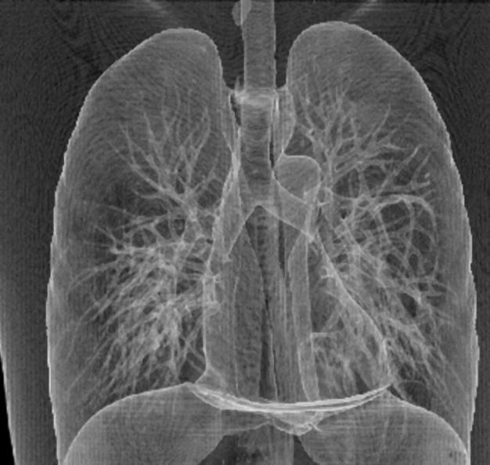

Фильтр 5х5

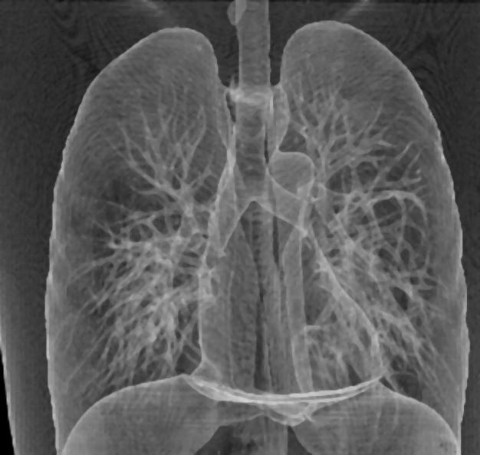

Фильтр 7х7

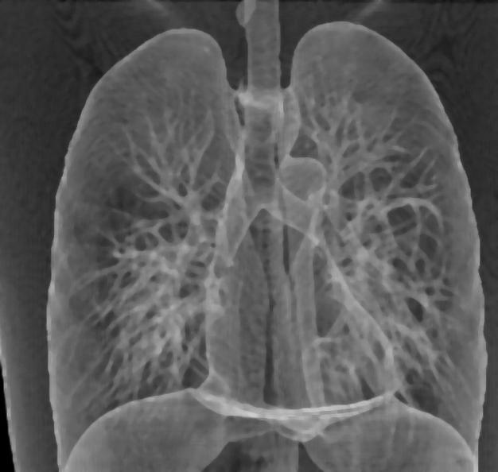

Геометрические преобразования – перенос

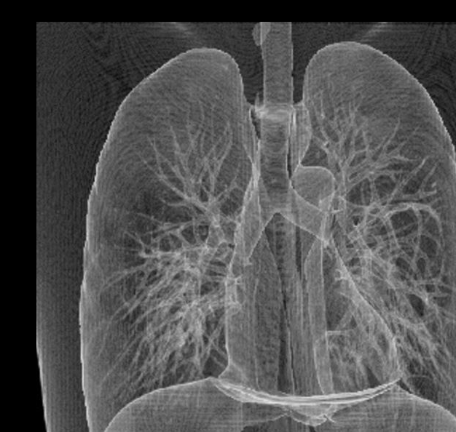

Геометрические преобразования - поворот+гомотетия

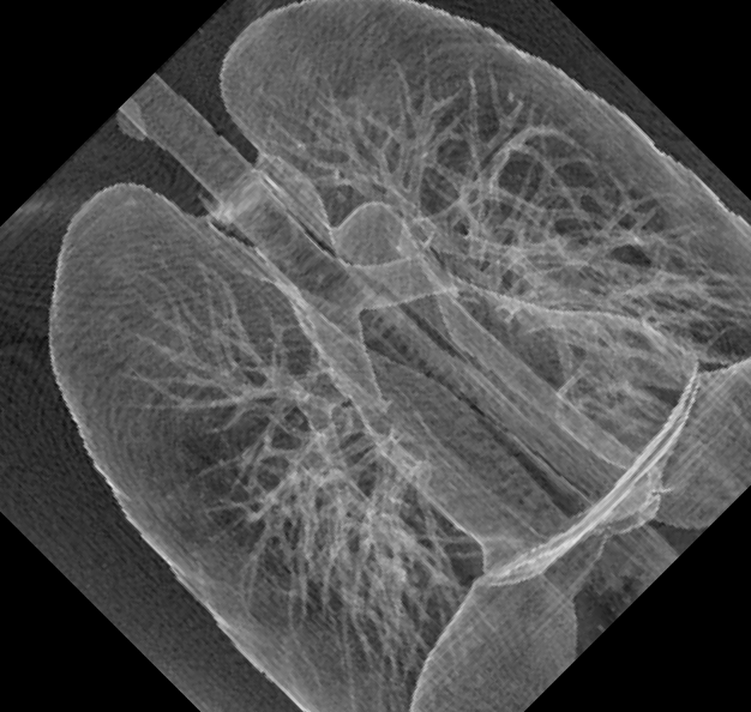

Геометрические преобразования - гомотетия+повот

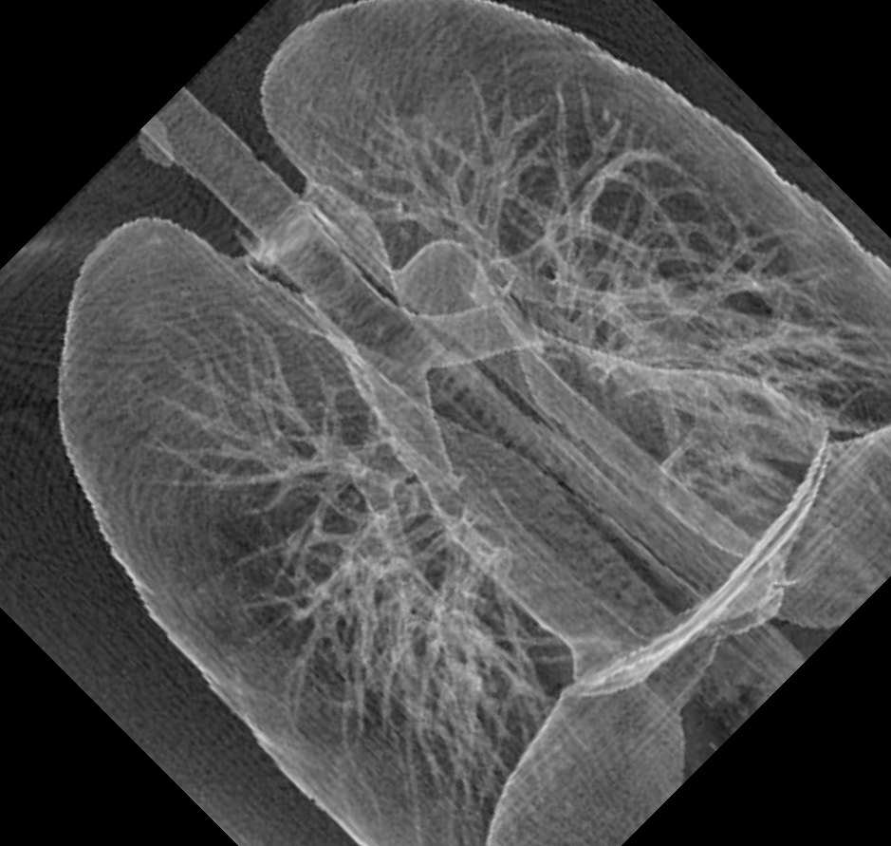

Код программы

import numpy as np

import matplotlib.pyplot as plt

import matplotlib.patches as patches

from PIL import Image, ImageFilter

def convert\_image\_to\_gray\_matrix(image\_path):

    """

    конвертация изображения в градации серого.

    :param image\_path: путь к изображению, которое конвертируется.

    :return: Матрица (numpy array), представляющая изображение в градациях серого.

    """

    img = Image.open(image\_path)

    gray\_img = img.convert('L') # 'L' - режим для градаций серого

    gray\_matrix = np.array(gray\_img)

    return gray\_matrix

def save\_matrix\_as\_image(matrix, output\_image\_path):

    """

    сохранение изображения

    """

    new\_image = Image.fromarray(matrix.astype(np.uint8))

    new\_image.save(output\_image\_path)

def calculate\_moments(histogram):

    """

    вычисление моменты и центральные моменты заданного гистограммы.

    :param histogram: представляющая распределение значений

    :return: кортеж из моментов (m1, m2, m3, m4) и центральных моментов (u1, u2, u3, u4)

    """

    m1 = np.sum(histogram \* np.arange(len(histogram))) # Первый момент (среднее значение)

    print(f"Первый момент (M1): Σ (x\_i \* p\_i) = Σ [{' ,'.join(map(str, histogram))}] \* [{' ,'.join(map(str, np.arange(len(histogram))))}] = {m1}")

    m2 = np.sum(histogram \* (np.arange(len(histogram)) \*\* 2))

    print(f"Второй момент (M2): Σ (x\_i^2 \* p\_i) = Σ [{' ,'.join(map(str, histogram))}] \* [{' ,'.join(map(str, np.arange(len(histogram)) \*\* 2))}] = {m2}")

    m3 = np.sum(histogram \* (np.arange(len(histogram)) \*\* 3))

    print(f"Третий момент (M3): Σ (x\_i^3 \* p\_i) = Σ [{' ,'.join(map(str, histogram))}] \* [{' ,'.join(map(str, np.arange(len(histogram)) \*\* 3))}] = {m3}")

    m4 = np.sum(histogram \* (np.arange(len(histogram)) \*\* 4))

    print(f"Четвертый момент (M4): Σ (x\_i^4 \* p\_i) = Σ [{' ,'.join(map(str, histogram))}] \* [{' ,'.join(map(str, np.arange(len(histogram)) \*\* 4))}] = {m4}")

    u1 = m1 / np.sum(histogram) # Первый центральный момент (среднее значение)

    print(f"Первый центральный момент (U1): M1 / N = {m1} / {np.sum(histogram)} = {u1}")

    u2 = (m2 / np.sum(histogram)) - (u1 \*\* 2) # Второй центральный момент (дисперсия)

    print(f"Второй центральный момент (U2): M2/N - U1^2 = ({m2} / {np.sum(histogram)}) - {u1 \*\* 2} = {m2 / np.sum(histogram)} - {u1 \*\* 2} = {u2}")

    u3 = (m3 / np.sum(histogram)) - (3 \* u1 \* u2) - (u1 \*\* 3) # Третий центральный момент

    print(f"Третий центральный момент (U3): M3/N - 3\*U1\*U2 - U1^3 = ({m3} / {np.sum(histogram)}) - ({3} \* {u1} \* {u2}) - {u1 \*\* 3} = {m3 / np.sum(histogram)} - {3 \* u1 \* u2} - {u1 \*\* 3} = {u3}")

    u4 = (m4 / np.sum(histogram)) - (4 \* u1 \* u3) - (6 \* u1 \*\* 2 \* u2) - (u2 \*\* 2) # Четвертый центральный момент

    print(f"Четвертый центральный момент (U4): M4/N - 4\*U1\*U3 - 6\*U1^2\*U2 - U2^2 = ({m4} / {np.sum(histogram)}) - ({4} \* {u1} \* {u3}) - ({6} \* {u1} \*\* {2} \* {u2}) - {u2 \*\* 2} = {m4 / np.sum(histogram)} - {4 \* u1 \* u3} - {6 \* u1 \*\* 2 \* u2} - {u2 \*\* 2} = {u4} ")

    return (m1, m2, m3, m4), (u1, u2, u3, u4)

def calculate\_entropy(histogram):

    """

    вычисление энтропии

    :param histogram: представляющая распределение значений

    :return: энтропия (entropy)

    """

    total\_pixels = np.sum(histogram) # сумма общее количество пикселей в гистограмме

    probabilities = histogram[histogram > 0] / total\_pixels # вероятность для каждого ненулевого значения гистограммы

    entropy = -np.sum(probabilities \* np.log2(probabilities))

    print("Расчет энтропии")

    print(f"Общее количество пикселей (N): Σ [{' ,'.join(map(str, histogram))}] = {total\_pixels}")

    print(f"Вероятности (p\_i): [{' ,'.join(map(str, histogram[histogram > 0]))}] / {total\_pixels} =  [{' ,'.join(map(str, probabilities))}]")

    print("Формула для расчета энтропии: H = -Σ (p\_i \* log2(p\_i))")

    results = []

    for p in probabilities:

        print(f"- ({p:.4f} \* log2({p:.4f})) = {- (p \* np.log2(p))}")

        results.append(- (p \* np.log2(p)))

    print(f"H = {' + '.join(map(str, results))} = {entropy}")

    return entropy

def calculate\_redundancy(entropy):

    """

    избыточность на основе энтропии

    :param entropy: энтропия

    :return: float: избыточность

    """

    max\_entropy = np.log2(256) # max энтропия для 256 градаций серого (8 бит)

    redundancy = max\_entropy - entropy # избыточность

    print(f"Формула для избыточности (R): R = H\_max - H = {max\_entropy} - {entropy} = {redundancy:.4f} бит")

    return redundancy

def plot\_brightness\_histogram(gray\_matrix):

    histogram, bin\_edges = np.histogram(gray\_matrix, bins=256, range=(0, 255))

    plt.figure(figsize=(10, 5))

    plt.title("Гистограмма яркости")

    plt.xlabel("Яркость (0-255)")

    plt.ylabel("Количество пикселей")

    plt.xlim([0, 255])

    plt.plot(bin\_edges[0:-1], histogram, color='red')

    max\_brightness = np.argmax(histogram)

    max\_count = histogram[max\_brightness]

    plt.annotate(f'Максимум: {max\_brightness}\nКоличество: {max\_count}',

                 xy=(max\_brightness, max\_count),

                 xytext=(max\_brightness + 10, max\_count - 50),

                 arrowprops=dict(facecolor='black', shrink=0.05))

    x\_ticks = np.concatenate((np.arange(0, 100, 10), np.arange(100, 256, 20)))

    plt.xticks(x\_ticks)

    for i in range(256):

        plt.gca().add\_patch(patches.Rectangle((i, 0), 1, max(histogram), color=str(i/255), alpha=0.8))

    plt.grid()

    plt.show()

def truncated\_block\_coding(gray\_matrix, block\_size=8):

    """

    усеченное блочное кодирование к матрице

    :param: gray\_matrix (numpy.ndarray): матрица градаций серого изображения, block\_size (int): размер блока для кодирования

    :return: numpy.ndarray: Кодированная матрица градаций серого.

    """

    height, width = gray\_matrix.shape # высота и ширина входной матрицы

    coded\_matrix = np.zeros\_like(gray\_matrix)

    for i in range(0, height, block\_size):

        for j in range(0, width, block\_size):

            block = gray\_matrix[i:i+block\_size, j:j+block\_size]

            coded\_block = np.clip(block // 16 \* 16, 0, 255)

            coded\_matrix[i:i+block\_size, j:j+block\_size] = coded\_block

    return coded\_matrix

def calculate\_standard\_deviation(u2):

    return np.sqrt(u2)

# Геометрические преобразования

def translate(image, tx, ty):

    """Перенос изображения на (tx, ty)."""

    translated\_image = Image.new("L", image.size)

    for x in range(image.width):

        for y in range(image.height):

            if 0 <= x + tx < image.width and 0 <= y + ty < image.height:

                translated\_image.putpixel((x + tx, y + ty), image.getpixel((x, y)))

    return translated\_image

def rotate\_and\_scale(image, angle, scale):

    """Поворот и гомотетия изображения."""

    rotated\_image = image.rotate(angle)

    width, height = rotated\_image.size

    scaled\_image = rotated\_image.resize((int(width \* scale), int(height \* scale)), Image.LANCZOS)

    return scaled\_image

def scale\_and\_rotate(image, scale, angle):

    """Гомотетия и поворот изображения"""

    scaled\_image = image.resize((int(image.width \* scale), int(image.height \* scale)), Image.LANCZOS)

    rotated\_image = scaled\_image.rotate(angle)

    return rotated\_image

def apply\_filter(image, kernel):

    """свертка с заданным ядром"""

    kernel\_size = int(np.sqrt(len(kernel)))  # размер ядра

    return image.filter(ImageFilter.Kernel((kernel\_size, kernel\_size), np.array(kernel).flatten(), scale=None))

def median\_filter(image, size):

    """медианный фильтр"""

    return image.filter(ImageFilter.MedianFilter(size=size))

def calculate\_mse(original, filtered):

    """ среднеквадратичную ошибку (MSE) между оригинальным и отфильтрованным изображениями"""

    original\_np = np.array(original)

    filtered\_np = np.array(filtered)

    difference = original\_np - filtered\_np

    mse\_value = np.mean(difference \*\* 2)

    # print(f"Среднеквадратичная ошибка (MSE): (1 / N) \* Σ ( [{' ,'.join(map(str, original\_np))}] - [{' ,'.join(map(str, filtered\_np))}]) ^ 2")

    return mse\_value

def calculate\_psnr(original, filtered):

    """ пиковое отношение сигнал/шум (PSNR) между оригинальным и отфильтрованным изображениями"""

    mse = calculate\_mse(original, filtered)

    # Если MSE равно 0, изображения идентичны, PSNR бесконечно велико

    if mse == 0:

        return float('inf')

    max\_pixel = 255.0 # max значение пикселя для 8-битного изображения

    psnr\_value = 20 \* np.log10(max\_pixel / np.sqrt(mse))

    # print(f"Пиковое отношение сигнал/шум (PSNR): 20 \* log10({max\_pixel} / {np.sqrt(mse)}) = 20 \* {np.log10(max\_pixel / np.sqrt(mse))} = {20 \* np.log10(max\_pixel / np.sqrt(mse))} дБ")

    return psnr\_value

image\_path = 'image.jpg'

gray\_matrix = convert\_image\_to\_gray\_matrix(image\_path)

# Построение гистограммы яркости

plot\_brightness\_histogram(gray\_matrix)

# Вычисление моментов

histogram, \_ = np.histogram(gray\_matrix, bins=256, range=(0, 255))

(moments\_m, moments\_u) = calculate\_moments(histogram)

# Вычисление энтропии и избыточности

entropy = calculate\_entropy(histogram)

redundancy = calculate\_redundancy(entropy)

coded\_matrix = truncated\_block\_coding(gray\_matrix) # Усеченное блочное кодирование

# Вычисление среднеквадратичного отклонения

std\_dev = calculate\_standard\_deviation(moments\_u[1])

# Вывод результатов

print("Вывод результатов")

print("Начальные моменты (m):", moments\_m)

print("Центральные моменты (u):", moments\_u)

print("Энтропия (Н):", entropy)

print("Избыточность (R):", redundancy)

print("Среднеквадратичное отклонение:", std\_dev)

save\_matrix\_as\_image(coded\_matrix, 'coded\_image.png')

# Применение геометрических преобразований

original\_image = Image.open(image\_path).convert('L')

# Перенос

translated\_image = translate(original\_image, tx=50, ty=30)

translated\_image.save('translated\_image.png')

# Поворот и гомотетия

rotated\_scaled\_image = rotate\_and\_scale(original\_image, angle=45, scale=1.5)

rotated\_scaled\_image.save('rotated\_scaled\_image.png')

# Гомотетия и поворот

scaled\_rotated\_image = scale\_and\_rotate(original\_image, scale=1.5, angle=45)

scaled\_rotated\_image.save('scaled\_rotated\_image.png')

# Применение фильтров

filtered\_median\_3x3 = median\_filter(original\_image, size=3)

filtered\_median\_5x5 = median\_filter(original\_image, size=5)

filtered\_median\_7x7 = median\_filter(original\_image, size=7)

# Сохранение отфильтрованных изображений

filtered\_median\_3x3.save("filtered\_median\_3x3.jpg")

filtered\_median\_5x5.save("filtered\_median\_5x5.jpg")

filtered\_median\_7x7.save("filtered\_median\_7x7.jpg")

# Сравнение

mse\_3x3 = calculate\_mse(original\_image, filtered\_median\_3x3)

psnr\_3x3 = calculate\_psnr(original\_image, filtered\_median\_3x3)

mse\_5x5 = calculate\_mse(original\_image, filtered\_median\_5x5)

psnr\_5x5 = calculate\_psnr(original\_image, filtered\_median\_5x5)

mse\_7x7 = calculate\_mse(original\_image, filtered\_median\_7x7)

psnr\_7x7 = calculate\_psnr(original\_image, filtered\_median\_7x7)

print(f"MSE 3x3 (Среднеквадратичная ошибка): {mse\_3x3}, PSNR (пиковое отношение сигнал/шум): {psnr\_3x3}")

print(f"MSE 5x5 (Среднеквадратичная ошибка): {mse\_5x5}, PSNR (пиковое отношение сигнал/шум): {psnr\_5x5}")

print(f"MSE 7x7 (Среднеквадратичная ошибка): {mse\_7x7}, PSNR (пиковое отношение сигнал/шум): {psnr\_7x7}")