# 0. Cover Sheet

Project Name:

|  |  |  |
| --- | --- | --- |
| **Team Member Name** | **Team Member Email** | **Individual Contributions** |
| Raheel Ahmed Farooqui | rfarooqu@uncc.edu |  |
| Adwait Kulkarni | akulka14@uncc.edu |  |
| Gloria Szilasi | gszilasi@uncc.edu |  |
| Pragathi Reddy Velivarthi | pvelivar@uncc.edu |  |
| Yongkang Liu | lyongkan@uncc.edu | Quiz Module / XML Editor |

# 1. Project Overview

# 2. Architectural Overview

## 2.1. Architectural Styles

### Quiz Module

The quiz module uses MVC architectural style of Android framework because Android system is a mature framework implementing MVC pattern. The MVC pattern is good for interactive applications with a flexible human-computer interface. The users have to change the quiz answers, so the MVC architectural style is applicable in quiz module.

### XML Editor

The XML Editor uses layered architectural style because the XML Editor doesn't change xml files frequently when the users are editing the xml files. There are three layers in XML Editor: UI layer, data layer and xml file layer. Each layer just implements corresponding logics. The layered architectural style is good for modification without changing any other layers if no changes to interface or semantics.

## 2.2. Major Modules

### Quiz Module

There are three packages:   
Package: android.app  
 This package is the Controller of MVC, which extends Android's Activity class.  
Package: com.discoveryplace.app.quiz

This package stores the quizzes and the user's quiz answers. The Quiz class grades the result.  
Package: com.discoveryplace.xmleditor.files

This package reads the quiz questions which are in XML files.

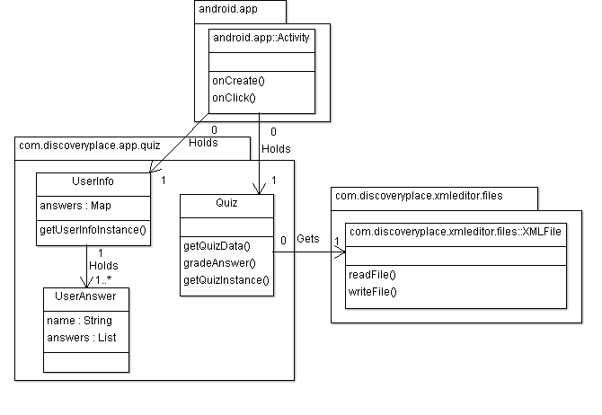

### XML Editor

There are three packages and three layers. Each package includes classes implementing related layer.

Package: com.discoveryplace.xmleditor.ui  
 This package is UI layer implementing UI for user to edit xml nodes. The Class JTree can display the xml file in tree format. Users can edit nodes information in Class JEdit objects in UI.  
  
Package: com.discoveryplace.xmleditor.data  
 This package is Data layer storing all nodes information. The Class DataQuiz stores quiz information. The Class DataQuestion stores question information of the quiz. The class DataOption stores option information of the question.  
  
Package: com.discoveryplace.xmleditor.files  
 This package is File layer writing and reading XML files.

### 

## 2.3. Deployment

### Quiz Module

Quiz Module will run on a single processor.

### XML Editor

XML Editor will run on a single processor.

## 2.4 Persistent Data Storage

### Quiz Module

This software does not require persistent data storage.

### XML Editor

The XML Editor stores the quiz questions with options information in XML file.

## 2.5 Global Control Flow

### Quiz Module

Quiz Module is procedure-driven and executes in a “linear” fashion. It is single thread and isn't time dependcy.

### XML Editor

XML Editor is procedure-driven and executes in a “linear” fashion. It is single thread and isn't time dependcy.