Analysis Of YACS Logs

# Analysis of Jobs

## RANDOM Scheduling algorithm:

1. Mean Completion Time : 6.2046 seconds  
 2. Median Completion Time : 6.1181 seconds

## RR Scheduling algorithm:

1. Mean Completion Time : 6.5546 seconds  
 2. Median Completion Time : 6.7417 seconds

## LL Scheduling algorithm:

1. Mean Completion Time : 6.1611 seconds  
 2. Median Completion Time : 6.7926 seconds

# Mean Comparison

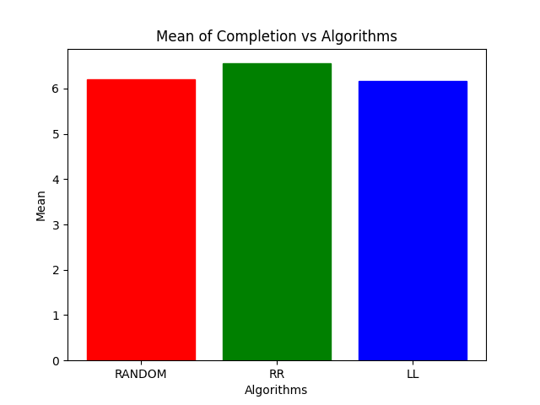

# Median Comparison

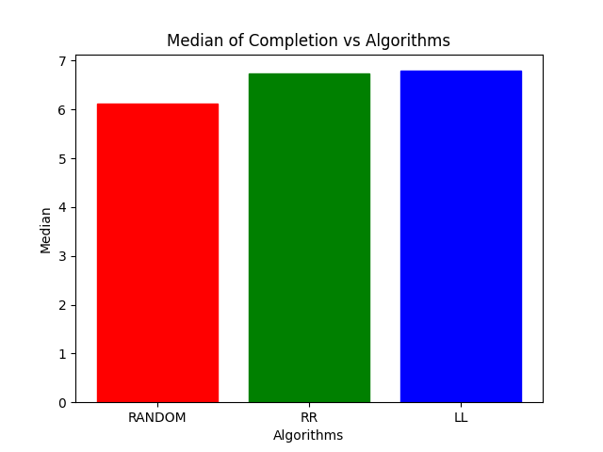

# Analysis of Tasks

## RANDOM Scheduling algorithm:

1. Mean Completion Time : 2.6071 seconds  
 2. Median Completion Time : 3.0010 seconds

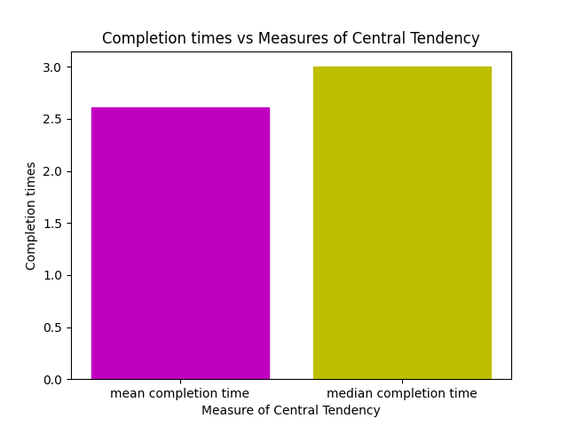

**Plot**

DATE ARRIVAL TIME X-AXIS EQUIVALENTS  
2020-12-01 20:49:41.113287 1  
2020-12-01 20:49:41.165216 2  
2020-12-01 20:49:41.217191 3  
2020-12-01 20:49:42.525255 4  
2020-12-01 20:49:42.576697 5  
2020-12-01 20:49:42.671919 6  
2020-12-01 20:49:42.723766 7  
2020-12-01 20:49:42.775985 8  
2020-12-01 20:49:42.827761 9  
2020-12-01 20:49:42.905347 10  
2020-12-01 20:49:42.957276 11  
2020-12-01 20:49:45.265559 12  
2020-12-01 20:49:45.266063 13  
2020-12-01 20:49:45.360719 14  
2020-12-01 20:49:45.669091 15  
2020-12-01 20:49:45.669514 16  
2020-12-01 20:49:45.715692 17  
2020-12-01 20:49:45.767369 18  
2020-12-01 20:49:46.053181 19  
2020-12-01 20:49:46.873947 20  
2020-12-01 20:49:47.502648 21  
2020-12-01 20:49:47.554522 22  
2020-12-01 20:49:47.606363 23  
2020-12-01 20:49:47.658384 24  
2020-12-01 20:49:48.357701 25  
2020-12-01 20:49:48.415502 26  
2020-12-01 20:49:48.504162 27  
2020-12-01 20:49:48.769898 28  
2020-12-01 20:49:48.857414 29  
2020-12-01 20:49:49.691739 30  
2020-12-01 20:49:49.846063 31  
2020-12-01 20:49:49.877696 32  
2020-12-01 20:49:49.878036 33  
2020-12-01 20:49:50.958627 34  
2020-12-01 20:49:50.959003 35  
2020-12-01 20:49:51.561832 36  
2020-12-01 20:49:53.937641 37  
2020-12-01 20:49:53.938032 38

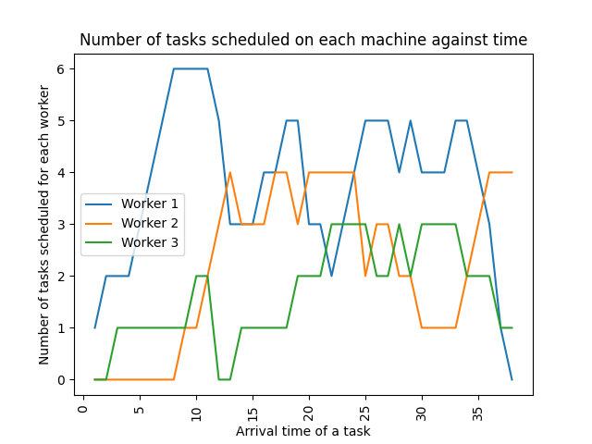

## RR Scheduling algorithm:

1. Mean Completion Time : 2.5852 seconds  
 2. Median Completion Time : 3.0010 seconds

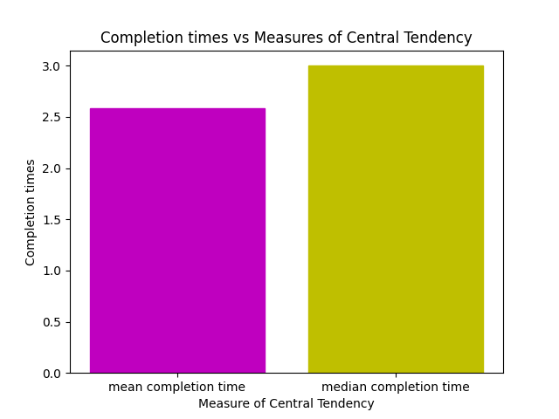

**Plot**

DATE ARRIVAL TIME X-AXIS EQUIVALENTS  
2020-12-01 21:10:33.736770 1  
2020-12-01 21:10:33.796727 2  
2020-12-01 21:10:33.813123 3  
2020-12-01 21:10:33.813544 4  
2020-12-01 21:10:33.813974 5  
2020-12-01 21:10:33.814348 6  
2020-12-01 21:10:34.490693 7  
2020-12-01 21:10:34.542149 8  
2020-12-01 21:10:34.593814 9  
2020-12-01 21:10:35.265547 10  
2020-12-01 21:10:35.812389 11  
2020-12-01 21:10:36.878315 12  
2020-12-01 21:10:37.838318 13  
2020-12-01 21:10:37.838671 14  
2020-12-01 21:10:38.666701 15  
2020-12-01 21:10:38.732988 16  
2020-12-01 21:10:38.785056 17  
2020-12-01 21:10:39.366615 18  
2020-12-01 21:10:40.109213 19  
2020-12-01 21:10:40.161036 20  
2020-12-01 21:10:40.212854 21  
2020-12-01 21:10:40.782369 22  
2020-12-01 21:10:40.916532 23  
2020-12-01 21:10:41.066600 24  
2020-12-01 21:10:41.066927 25  
2020-12-01 21:10:43.238015 26  
2020-12-01 21:10:43.289880 27  
2020-12-01 21:10:43.541567 28  
2020-12-01 21:10:43.593397 29  
2020-12-01 21:10:43.645635 30  
2020-12-01 21:10:44.305197 31  
2020-12-01 21:10:44.880774 32  
2020-12-01 21:10:46.323153 33  
2020-12-01 21:10:46.323153 34  
2020-12-01 21:10:47.694347 35  
2020-12-01 21:10:47.694526 36

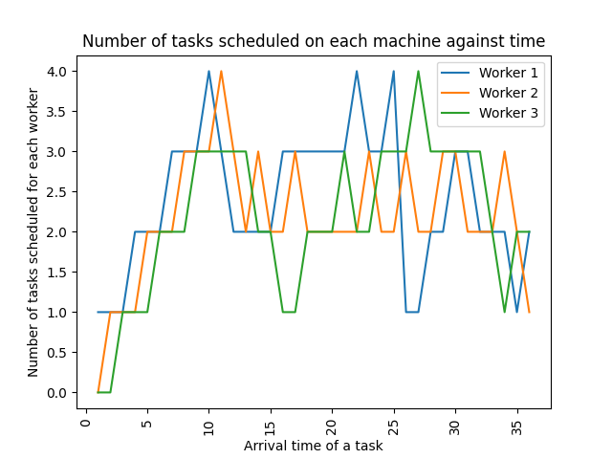

## LL Scheduling algorithm:

1. Mean Completion Time : 2.6777 seconds  
 2. Median Completion Time : 3.0011 seconds

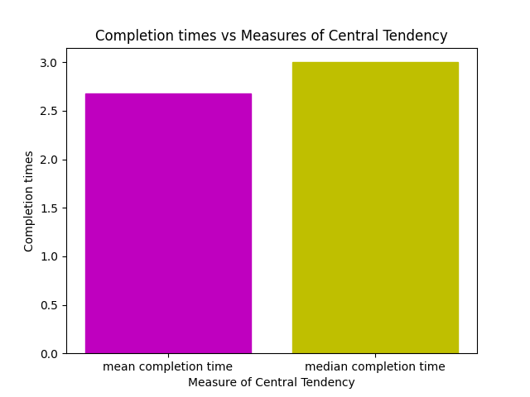

**Plot**

DATE ARRIVAL TIME X-AXIS EQUIVALENTS  
2020-12-01 21:11:26.608816 1  
2020-12-01 21:11:26.660679 2  
2020-12-01 21:11:27.795968 3  
2020-12-01 21:11:27.847723 4  
2020-12-01 21:11:28.732654 5  
2020-12-01 21:11:28.733480 6  
2020-12-01 21:11:28.743583 7  
2020-12-01 21:11:30.133424 8  
2020-12-01 21:11:30.169889 9  
2020-12-01 21:11:30.211824 10  
2020-12-01 21:11:30.886647 11  
2020-12-01 21:11:30.980079 12  
2020-12-01 21:11:31.088724 13  
2020-12-01 21:11:31.161599 14  
2020-12-01 21:11:31.249341 15  
2020-12-01 21:11:31.250225 16  
2020-12-01 21:11:31.845916 17  
2020-12-01 21:11:31.901858 18  
2020-12-01 21:11:32.488435 19  
2020-12-01 21:11:32.540220 20  
2020-12-01 21:11:32.602741 21  
2020-12-01 21:11:32.654702 22  
2020-12-01 21:11:32.997172 23  
2020-12-01 21:11:34.315625 24  
2020-12-01 21:11:34.717288 25  
2020-12-01 21:11:34.768816 26  
2020-12-01 21:11:34.890089 27  
2020-12-01 21:11:35.211281 28  
2020-12-01 21:11:36.574994 29  
2020-12-01 21:11:36.733597 30  
2020-12-01 21:11:38.782866 31  
2020-12-01 21:11:38.993370 32  
2020-12-01 21:12:11.479986 33  
2020-12-01 21:12:11.531936 34  
2020-12-01 21:12:12.286390 35  
2020-12-01 21:12:12.338540 36  
2020-12-01 21:12:12.385500 37  
2020-12-01 21:12:12.767122 38  
2020-12-01 21:12:12.818758 39  
2020-12-01 21:12:12.870492 40  
2020-12-01 21:12:12.922577 41  
2020-12-01 21:12:13.247885 42  
2020-12-01 21:12:13.997746 43  
2020-12-01 21:12:14.049519 44  
2020-12-01 21:12:14.101574 45  
2020-12-01 21:12:14.343211 46  
2020-12-01 21:12:15.582969 47  
2020-12-01 21:12:15.583568 48  
2020-12-01 21:12:16.017223 49  
2020-12-01 21:12:16.604694 50  
2020-12-01 21:12:16.604841 51  
2020-12-01 21:12:18.472153 52  
2020-12-01 21:12:19.227532 53  
2020-12-01 21:12:19.279512 54  
2020-12-01 21:12:19.330489 55  
2020-12-01 21:12:19.382129 56  
2020-12-01 21:12:19.536966 57  
2020-12-01 21:12:19.568047 58  
2020-12-01 21:12:19.619782 59  
2020-12-01 21:12:19.671861 60  
2020-12-01 21:12:20.105546 61  
2020-12-01 21:12:20.991342 62  
2020-12-01 21:12:21.044191 63  
2020-12-01 21:12:22.482312 64  
2020-12-01 21:12:22.482536 65  
2020-12-01 21:12:23.090786 66  
2020-12-01 21:12:23.090802 67  
2020-12-01 21:12:23.181804 68  
2020-12-01 21:12:23.789291 69  
2020-12-01 21:12:26.870198 70  
2020-12-01 21:12:26.943327 71  
2020-12-01 21:12:27.123130 72  
2020-12-01 21:12:29.969862 73  
2020-12-01 21:12:29.970222 74

