/*
Mihir Kulkarni
33132 L9
Assignment 3 : Matrix multiplication using pthreads
*/

Method 1: Complete Static

#include<stdio.h>
#include<unistd.h>
#include<stdlib.h>
#include<pthread.h>
#include<string.h>
#include<malloc.h>
#define MAX 4
#define MAX_THREADS 4

int mat1[MAX][MAX],mat2[MAX][MAX],mat3[MAX][MAX];
int r1,r2,c1,c2;

void *Multiply(void *args)
{
for (int i = 0; i < r1; i++)
{
for (int j = 0; j < c2; j++)
{
mat3[i][j]=0;
for (int k = 0; k < c1; k++)
{
mat3[i][j] += mat1[i][k] * mat2[k][j];
}
}
}

}

int main()
{
int i,j;
printf("\nEnter the rows of matrix 1 :");
scanf("%d",&r1);

printf("\nEnter the columns of matrix 1 :");
scanf("%d",&c1);

printf("\nEnter the rows of matrix 2 : ");
scanf("%d",&r2);

if(c1 != r2){
printf("\nMatrix multiplication is not possible!!");
exit(0);
}

printf("\nEnter the columns of matrix 2 : ");
scanf("%d",&c2);

//Input mat1
printf("\nEnter matrix 1 :\n");
for(int i = 0; i < r1;i++){
for(int j = 0; j < c1;j++){
printf("Enter element matrix [%d][%d] :: ",i+1,j+1);
scanf("%d",&mat1[i][j]);
}
}
//Input mat2
printf("\nEnter matrix 2 :\n");
for(int i = 0; i < r2;i++){
for(int j = 0; j < c2;j++){
printf("Enter element matrix [%d][%d] :: ",i+1,j+1);
scanf("%d",&mat2[i][j]);
}
}

printf("The matrix 1 is \n");
for(int i = 0; i < r1;i++){
for(int j = 0; j < c1;j++){
printf("%d\t",mat1[i][j]);
}
printf("\n");
}
printf("The matrix 2 is \n");
for(int i = 0; i < r2;i++){
for(int j = 0; j < c2;j++){
printf("%d\t",mat2[i][j]);
}
printf("\n");
}
//Declaring pthreads
pthread_t threads[MAX_THREADS];

// Creating threads, each evaluating its own part
for (int i = 0; i < MAX_THREADS; i++) {
int* result;
pthread_create(&threads[i], NULL, Multiply, (void*)(result));
}
// joining and waiting for all threads to complete
for (int i = 0; i < MAX_THREADS; i++)
pthread_join(threads[i], NULL);

printf("The multiplied matrix is \n");

for(int i = 0; i < r1;i++){
for(int j = 0; j < c2;j++){
printf("%d\t",mat3[i][j]);
}
printf("\n");
}
return 0;

}

Output:
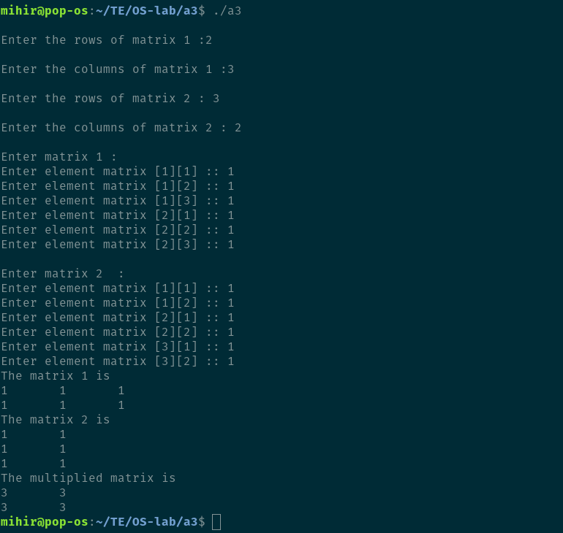

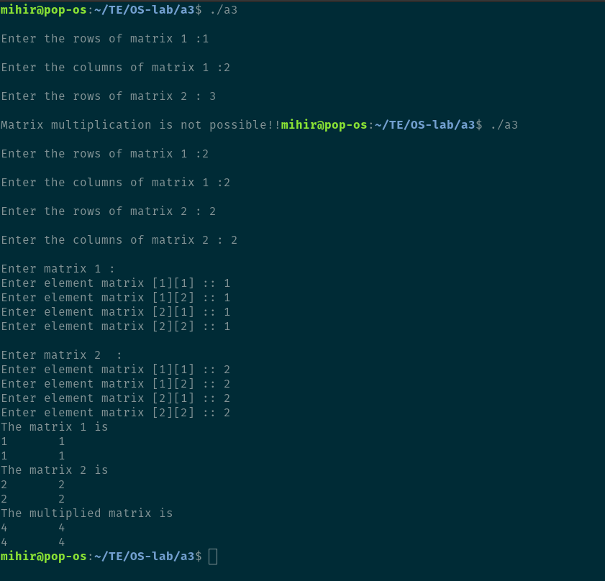

Method 2: r1*c2 threads

/*
Mihir Kulkarni
33132 L9
Assignment 3 : Matrix multiplication using pthreads
*/

#include<stdio.h>
#include<unistd.h>
#include<stdlib.h>
#include<pthread.h>
#include<string.h>
#include<malloc.h>
#define MAX 4
/* 9 thread solution for a 3*3 matrix */

//Each thread computes single element in the resultant matrix
void *mult(void* arg)
{
int *data = (int *)arg;
int k = 0, i = 0;

int x = data[0];
//r1=c2=x number of sumations of multiplications in array
for (i = 1; i <= x; i++)
k += data[i]*data[i+x];

int *p = (int*)malloc(sizeof(int));
*p = k;

//Used to terminate a thread and the return value is passed as a pointer
pthread_exit(p);
}

//Driver code
int main()
{
int r1,c1,r2,c2,i,j,k;

printf("\nEnter the number of rows of columns for matrix matA:\n");
scanf("%d %d", &r1, &c1);

//Initialize matA
int matA[r1][c1];

printf("\n");

//Input of matrix A
for(int i=0; i<r1; i++)
{
for(int j=0; j<c1; j++)
{
printf("Enter the [%d][%d] element of matrix matA:", i, j);
scanf("%d", &matA[i][j]);
}
}

printf("\nEnter the number of rows of columns for matrix matB:\n");
scanf("%d %d", &r2, &c2);

//Initialize matA
int matB[r2][c2];

printf("\n");

//Input of matrix B
for(int i=0; i<r2; i++)
{
for(int j=0; j<c2; j++)
{
printf("Enter the [%d][%d] element of matrix matB:", i, j);
scanf("%d", &matB[i][j]);
}
}

int max = r1*c2;

//declaring array of threads of size r1*c2
pthread_t *threads;
threads = (pthread_t*)malloc(max*sizeof(pthread_t));

int count = 0;
int* data = NULL;
for (i = 0; i < r1; i++)
{
for (j = 0; j < c2; j++)
{

//storing row and column elements in data
data = (int *)malloc((r1*c2)*sizeof(int));

//number of sumations of multiplications in array
data[0] = c1;

//Inserting row
for (k = 0; k < c1; k++)
data[k+1] = matA[i][k];

//Inserting column after row elements
for (k = 0; k < r2; k++)
data[k+c1+1] = matB[k][j];

//creating threads
pthread_create(&threads[count++], NULL, mult, (void*)(data));

}
}
printf("---------------------------------------------\n");
printf("RESULTANT MATRIX IS :- \n");
for (i = 0; i < max; i++)
{
void *k;

//Joining all threads and collecting return value
pthread_join(threads[i], &k);

int *p = (int *)k;
printf("%d ",*p);
if ((i + 1) % c2 == 0)
printf("\n");
}
printf("---------------------------------------------\n");
return 0;
}

Output:

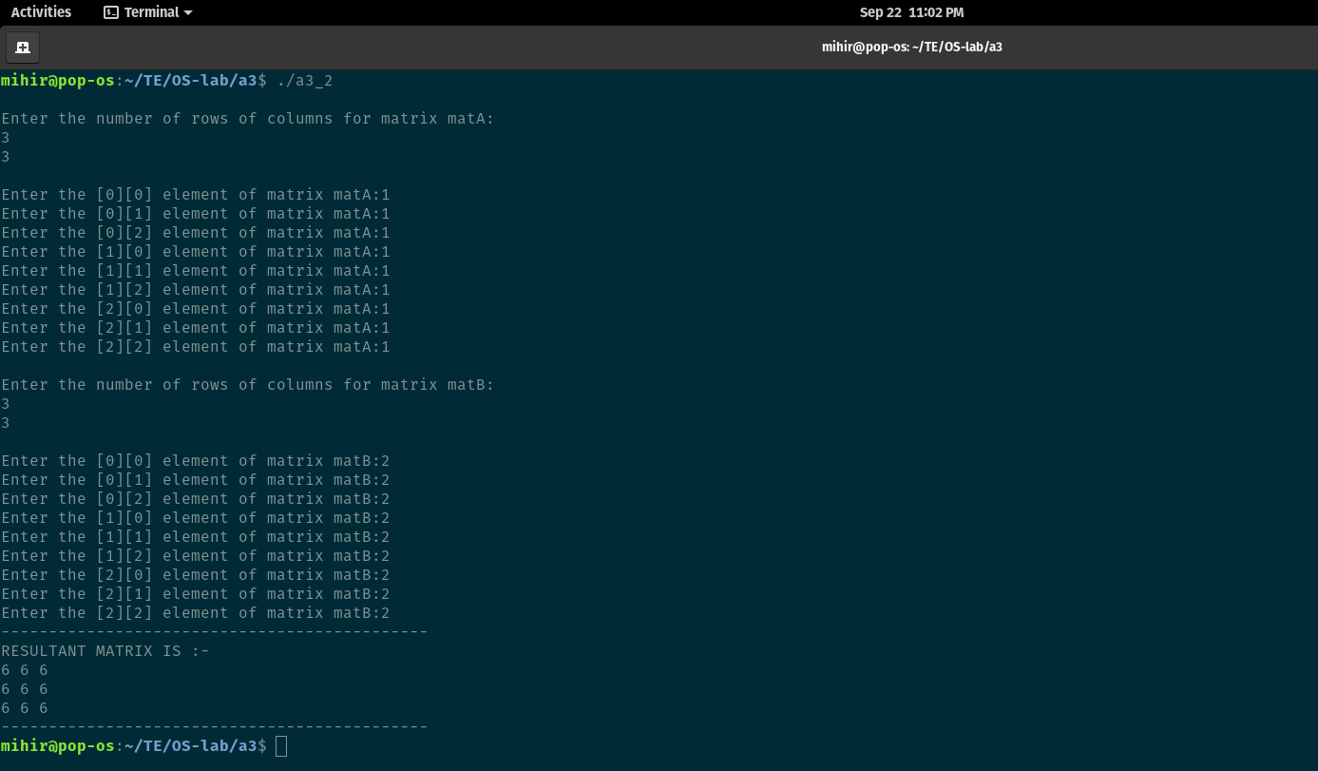

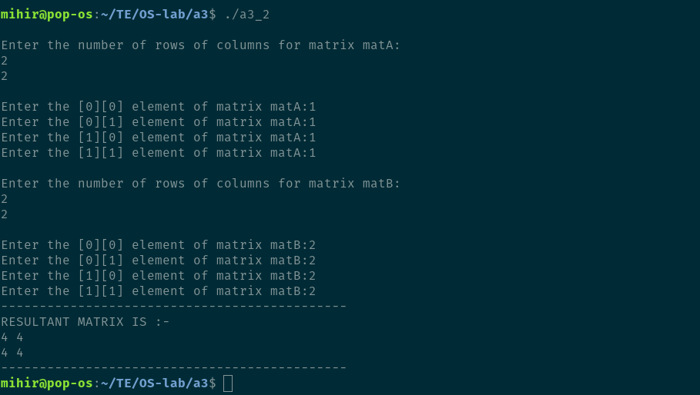

Method 2: r1*c2*c1 threads(27 threads)

/*
Mihir Kulkarni
33132 L9
Assignment 3 : Matrix multiplication using pthreads
*/

#include<stdio.h>
#include<stdlib.h>
#include<pthread.h>
#include<unistd.h>

// 3*3 matrix solution using 27 threads

void *multiply(void *arg)
{
//Function to multiply element by element of each row in matrix A
//with each element in columns of matrix B
int *data = (int *)arg;
int k = 0;

k = data[0] * data[1];

int *p = (int *)malloc(sizeof(int));
*p = k;

pthread_exit(p);
}

int main()
{
int res, r1, c1, r2, c2, max, count = 0;
pthread_t *threads;

printf("\nEnter the number of rows of columns for matrix matA:\n");
scanf("%d %d", &r1, &c1);

//Initialize matA
int matA[r1][c1];

printf("\n");
//Input of matrix A

for(int i=0; i<r1; i++)
{
for(int j=0; j<c1; j++)
{
printf("Enter the [%d][%d] element of matrix matA:", i, j);
scanf("%d", &matA[i][j]);
}
}

printf("\nEnter the number of rows of columns for matrix matB:\n");
scanf("%d %d", &r2, &c2);

//Initialize matB
int matB[r2][c2];

printf("\n");

//Input of matrix B
for(int i=0; i<r2; i++)
{
for(int j=0; j<c2; j++)
{
printf("Enter the [%d][%d] element of matrix matB:", i, j);
scanf("%d", &matB[i][j]);
}
}

//each row will take r1*c2 traversals for c1 in columns
//for e.g. in 3*3 matrices each resultant element requires sumation of 3 multiplications
//i.e. 3 threads and for 9 resultant elements : 9*3= 27 threads

max = r1 * c2 * c1;
threads = (pthread_t *)malloc(max*sizeof(pthread_t));

int *data = NULL;
for(int i=0; i<r1; i++)
{
for(int j=0; j<c2; j++)
{
for(int k=0; k<c1; k++)
{
//taking 2 elements at a time
data = (int *)malloc(2*sizeof(int));
data[0] = matA[i][k];
data[1] = matB[k][j];
//thread creation
res = pthread_create(&threads[count++], NULL, multiply, (void *)data);

if (res != 0)
{
perror("\nThread creation failed!\n");
exit(EXIT_FAILURE);
}
}
}
}

printf("\n---------------------------------------------------------\n");
printf("\nThe resultant matrix is:\n\n");

for(int i=0; i<max; i++)
{
void *k;
int ans;
//Joining threads
res = pthread_join(threads[i], &k);

if (res != 0)
{
perror("\nThread joining failed!\n");
exit(EXIT_FAILURE);
}
//if first sub-part of r1*c2
if(i % 3 == 0)
{
ans = *(int *)k;
}
//if second sub-part of r1*c2
else if(i % 3 == 1)
{
ans += *(int *)k;
}
//added all three elements and print value of resultant matrix element
else
{
ans += *(int *)k;
printf("%d ", ans);
//if all elements in a rows are over of resultant marix => next line
if((i+1) % (r1*c2) == 0)
printf("\n");
}
}

return 0;
}

Output:

