**Task-2**

I have created a Ubuntu 20.04 LTS instance on the AWS and linked it with my session in MobaXTerm , and all the commands in this file will be Ubuntu based.

Installing Docker:-

To install docker we need to write these commands –

Firstly, we will perform all available updates.

*sudo apt-get update*

Now we will write this command to install docker.

*sudo apt-get install docker*

In my case, just installing docker didn’t work, so I had to install this docker.io as well in my system.

*sudo apt-get install docker.io*

Now after installing both, we will check the version of installed docker.

*docker --version*

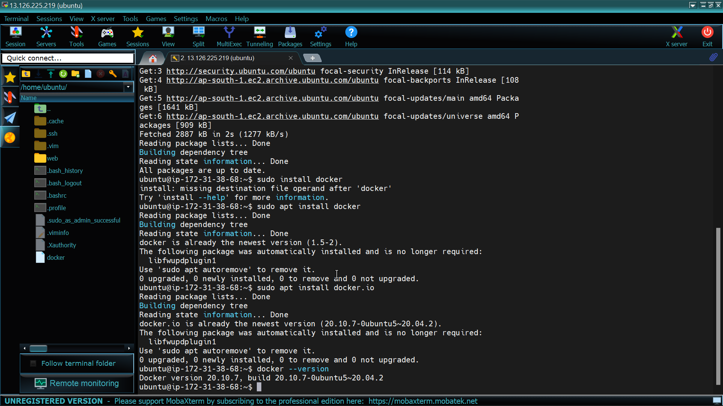

Practicing Basic Commands of Docker:-

Some basic commands of Docker are as follows,

Firstly, we will become a root user so that we don’t have to write sudo again and again.

*sudo su*

Now to display all the images in the docker -

*docker image ls*

To check the status of our docker -

*systemctl status docker*

To start our docker -

*systemctl start docker*

To just enable the docker , instead of running it –

*systemctl enable docker*

To pull some OS image in our system-

*docker pull ubuntu:latest*

To run this pulled Image –

*docker run ubuntu:latest*

To run this in interactively , so that we can type commands in the image-

*docker run it ubuntu:latest*

To display the containers in running state-

*docker ps*

To display all the containers -

*docker ps -a*

To give a name to the image -

*docker run it --name os1 ubuntu:latest*

To stop any image if it is in running state-

*docker stop os1*

To remove image only if image is stopped before-

*docker rm os1*

To remove Image forcefully, even if the image is in running state-

*docker rm os1 -f*

If we want to run a command in a running container -

*docker exec -it os1 bash*

Pulling image from Docker Hub:-

To pull the image we will type this command

*docker pull hackcoderr/apache:v1*

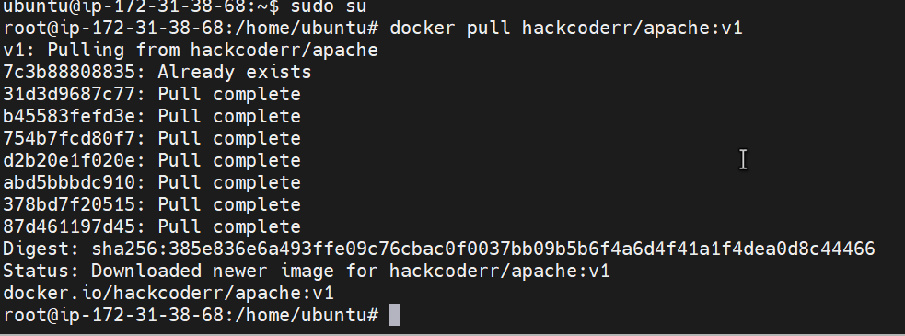

To run this image, we will type this command

*docker run -dit --name kulmeet1 -p 8080:80 hackcoderr/apache:v1*

I am using port 8080 in this case because my port 80 was already in use.

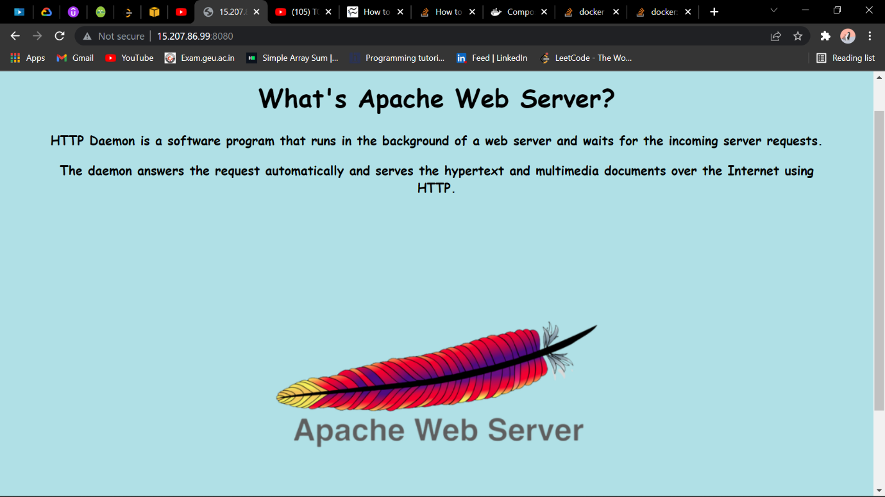

This was the output on the IP address linked with my instance.