Controls In Java Swings Are components that allow a user to interact with your application in various ways- for Example

JButton
JLabel
JCheckBox
JRadioButton
JList
JComboBox
JTextFiled
JTextArea
JScrollBar
JTable

JButton Class

The class JButton is an implementation of a push button. This component has a label and generates an event when pressed. It can have Image also.

JButton(Icon icon)
Creates a button with an icon

JButton(String text)
Creates a button with text.

JButton(String text,Icon icon)
Creates a button with initial text and an icon

JTextField Class

The class JTextField is a component which allows the editing of a single line of text.

JTextField(int columns)
Constructs a new empty TextField with the specified number of columns.
JTextField(String text)
Constructs a new TextField initialized with the specified text.
JTextField(String text, int columns)
Constructs a new TextField initialized with the specified text and columns.

JLABEL Class

Java Swing Tutorial Explaining the JLabel Component. JLabel, descended from JComponent, is used to create text labels.

A JLabel object provides text instructions or information on a GUI — display a single line of read-only text, an image or both text and image.

JLabel(Icon image)
Creates a JLabel instance with the specified image.

JLabel(Icon image, int horizontalAlignment)
Creates a JLabel instance with the specified image and horizontal alignment.

JLabel(String text)
Creates a JLabel instance with the specified text.

JLabel(String text, Icon icon, int horizontalAlignment)
Creates a JLabel instance with the specified text, image, and horizontal alignment.

JLabel(String text, int horizontalAlignment)
Creates a JLabel instance with the specified text and horizontal alignment.

JCheckBox Class
The class JCheckBox is an implementation of a check box - an item that can be selected or deselected, and which displays its state to the user.
JCheckBox()
Creates an initially unselected check box button with no text, no icon.

JCheckBox(Icon icon)
Creates an initially unselected check box with an icon.

JCheckBox(Icon icon, boolean selected)
Creates a check box with an icon and specifies whether or not it is initially selected.

JCheckBox(String text)
Creates an initially unselected check box with text.

JCheckBox(String text, boolean selected)
Creates a check box with text and specifies whether or not it is initially selected.

JRadioButton Class
The class JRadioButton is an implementation of a radio button - an item that can be selected or deselected, and which displays its state to the user.
JRadioButton()
Creates an initially unselected radio button with no set text.

JRadioButton(Icon icon)
Creates an initially unselected radio button with the specified image but no text

JRadioButton(Icon icon, boolean selected)
Creates a radio button with the specified image and selection state, but no text.

JRadioButton(String text, boolean selected)
Creates a radio button with the specified text and selection state.

JComboBox Class
The class JComboBox is a component which combines a button or editable field and a drop-down list.

JComboBox()
Creates a JComboBox with a default data model.

JComboBox(Object[] items)
Creates a JComboBox that contains the elements in the specified array.
Methods

void addItem(Object anObject)
Adds an item to the item list.

int getSelectedIndex()
Returns the first item in the list that matches the given item.

Object getSelectedItem()
Returns the current selected item.

Object[] getSelectedObjects()
Returns an array containing the selected item.

JList Class
The class JList is a component which displays a list of objects and allows the user to select one or more items. A separate model, ListModel, maintains the contents of the list.

JList()
Constructs a JList with an empty, read-only, model.

JList(Object[] listData)
Constructs a JList that displays the elements in the specified array.

Methods
int getSelectedIndex()
Returns the smallest selected cell index; the selection when only a single item is selected in the list.

Object getSelectedValue()
Returns the value for the smallest selected cell index; the selected value when only a single item is selected in the list.

Object[] getSelectedValues()
Returns an array of all the selected values, in increasing order based on their indices in the list.

void setSelectionModel(ListSelectionModel selectionModel)
Sets the selectionModel for the list to a non-null ListSelectionModel implementation.
1. setSelectionMode(ListSelectionModel.SINGLE_SELECTION)
2. setSelectionMode(ListSelectionModel.MULTIPLE_INTERVAL_SELECTION)
void setVisibleRowCount(int visibleRowCount)
Sets the visibleRowCount property, which has different meanings depending on the layout orientation: For a VERTICAL layout orientation, this sets the preferred number of rows to display without requiring scrolling; for other orientations, it affects the wrapping of cells.

Program1

import javax.swing.*;
import java.awt.*;
public class Guiprog1 extends JFrame
{

Guiprog1()
{
JLabel one,two;
JTextField tname,tsalary;
JButton buttonSave,buttonExit ;
one=new JLabel("Enter Name");
tname=new JTextField(20);
two=new JLabel("Enter Salary");
tsalary=new JTextField(20);
buttonSave=new JButton("Save");
buttonExit=new JButton("Exit");
one.setBounds(20,20,80,80);
two.setBounds(20,80,80,80);
tname.setBounds(100,40,170,40);
tsalary.setBounds(100,100,170,40);
buttonSave.setBounds(50,150,100,40);
buttonExit.setBounds(180,150,100,40);
add(one);
add(tname);
add(two);
add(tsalary);
add(buttonSave);
add(buttonExit);
setSize(500,500); // Setting size of JFrame
setLayout(null);
setVisible(true);

}
public static void main(String args[])
{
new Guiprog1();
}

}

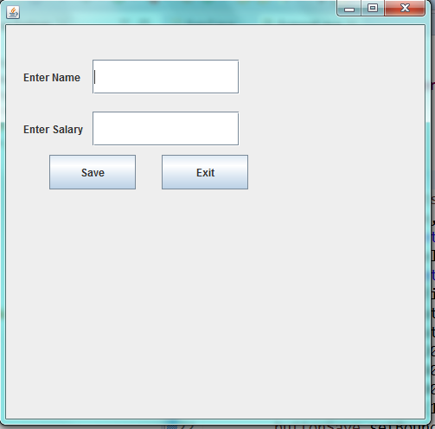

Progam2

import javax.swing.*;
import java.awt.*;
public class Guiprog2 extends JFrame
{
Guiprog2()
{
setTitle("Mywindow") ;
JCheckBox rd,gr,bl,bk;
rd=new JCheckBox("Red");
gr=new JCheckBox("Green");
bl=new JCheckBox("Blue");
bk=new JCheckBox("Black");
rd.setBounds(20,20,80,40);
gr.setBounds(100,20,80,40);
bl.setBounds(180,20,80,40);
bk.setBounds(260,20,80,40);
add(rd);
add(gr);
add(bl);
add(bk);

JRadioButton os1 = new JRadioButton("UNIX");
JRadioButton os2 = new JRadioButton("LINUX");
JRadioButton os3 = new JRadioButton("MACINTOSH");
JRadioButton os4 = new JRadioButton("WINDOWS");
ButtonGroup group = new ButtonGroup();
group.add(os1);
group.add(os2);
group.add(os3);
group.add(os4);
add(os1);
add(os2);
add(os3);
add(os4);
os1.setBounds(20,80,80,40);
os2.setBounds(100,80,80,40);
os3.setBounds(180,80,100,40);
os4.setBounds(290,80,100,40);

JComboBox country = new JComboBox();
//Adding Item to JComboBox
country.addItem("India");
country.addItem("Nepal");
country.addItem("China");
country.addItem("Japan");
country.addItem("Bhutan");
country.setBounds(20,150,100,20);
add(country);

setSize(500,500); // Setting size of JFrame
setLayout(null);
setVisible(true);

}

public static void main(String args[])
{
new Guiprog2();
}

}

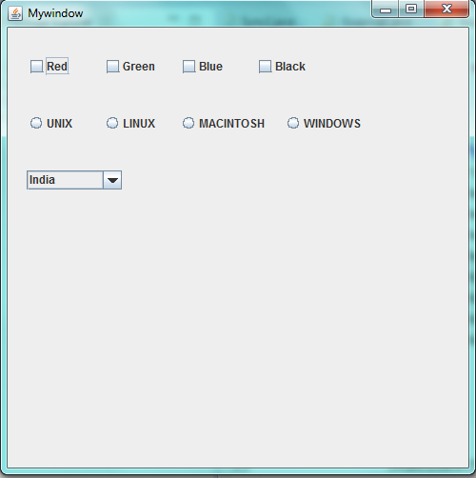

Event Handling

Event
An event is an Object that describes a state change in a source.
Some of the activities that causes event to be generated are:
- Pressing a Button.
- Entering a character through Key Board.
- Selecting an item form a list etc.

The Delegation Event Model

The modern approach to handling events is based on the delegation event model, which defines standard and consistent mechanisms to generate and process events. Its concept is quite simple: a source generates an event and sends it to one or more listeners. In this scheme, the listener simply waits until it receives an event. Once received, the listener processes the event and then returns. The advantage of this design is that the application logic that processes events is cleanly separated from the user interface logic that generates those events. A user interface element is able to “delegate” the processing of an event to a separate piece of code.

In the delegation event model, listeners must register with a source in order to receive an event notification. This provides an important benefit: notifications are sent only to listeners that want to receive them.

The event handling involves four types of classes.
1. Event Sources
2. Event classes
3. Event Listeners
4. Event Adapters

1. Event Sources
Event sources are components, subclasses of java.awt.Component, capable to generate events. The event source can be a Button, TextField or a Frame etc.
A source must register listeners in order for the listeners to receive notifications about a specific type of event. Each type of event has its own registration method.

Here is the general form:
public void addTypeListener(TypeListener el)
Example
The method that registers a keyboard event listener is called addKeyListener( ).

Themethod that registers a mouse motion listener is called addMouseMotionListener( ).

2. Event classes
Almost every event source generates an event and is named by some Java class. For example, the event generated by button is known as ActionEvent and that of Checkbox is known as ItemEvent. All the events are listed in java.awt.event package. Following list gives a few components and their corresponding listeners.
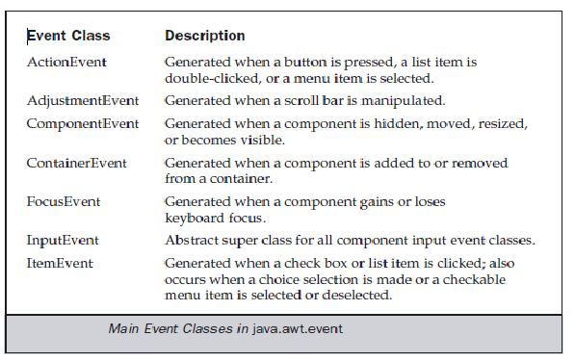
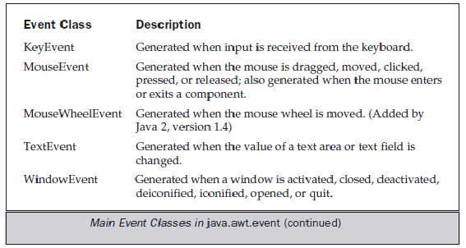

3. Event Listeners
The events generated by the GUI components are handled by a special group of interfaces known as "listeners". Note, Listener is an interface. Every component has its own listener, say, AdjustmentListener handles the events of scrollbar Some listeners handle the events of multiple components. For example, ActionListener handles the events of Button, TextField, List and Menus. Listeners are from java.awt.event package.

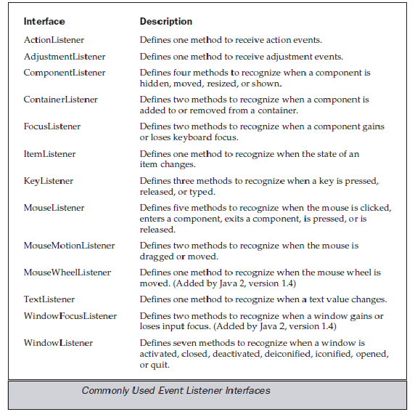
- The ActionListener Interface

This interface defines the actionPerformed( ) method that is invoked when an action
event occurs. Its general form is shown here:

void actionPerformed(ActionEvent ae)

- The AdjustmentListener Interface

This interface defines the adjustmentValueChanged( ) method that is invoked when an adjustment event occurs.

Its general form is shown here:

void adjustmentValueChanged(AdjustmentEvent ae)

- The FocusListener Interface

This interface defines two methods. When a component obtains keyboard focus,
focusGained( ) is invoked. When a component loses keyboard focus, focusLost( ) is called.
Their general forms are shown here:

void focusGained(FocusEvent fe)

void focusLost(FocusEvent fe)

- The ItemListener Interface

This interface defines the itemStateChanged( ) method that is invoked when the state of an item changes. Its general form is shown here:

void itemStateChanged(ItemEvent ie)

- The KeyListener Interface

This interface defines three methods. The keyPressed( ) and keyReleased( ) methods are invoked when a key is pressed and released, respectively. The keyTyped( ) method is invoked when a character has been entered.
The general forms of these methods are shown here:

void keyPressed(KeyEvent ke)

void keyReleased(KeyEvent ke)

void keyTyped(KeyEvent ke)

- The MouseListener Interface

This interface defines five methods. If the mouse is pressed and released at the
same point, mouseClicked( ) is invoked. When the mouse enters a component, the mouseEntered( ) method is called. When it leaves, mouseExited( ) is called. The mousePressed( ) and mouseReleased( ) methods are invoked when the mouse is pressed and released, respectively.

The general forms of these methods are shown here:

void mouseClicked(MouseEvent me)

void mouseEntered(MouseEvent me)

void mouseExited(MouseEvent me)

void mousePressed(MouseEvent me)

void mouseReleased(MouseEvent me)

(7) The MouseMotionListener Interface

This interface defines two methods. The mouseDragged( ) method is called multiple times as the mouse is dragged. The mouseMoved( ) method is called multiple times as the mouse is moved.
Their general forms are shown here:
void mouseDragged(MouseEvent me)

void mouseMoved(MouseEvent me)

(8) The TextListener Interface

This interface defines the textChanged( ) method that is invoked when a change occurs in a text area or text field.

Its general form is shown here:

void textChanged(TextEvent te)

(9)The WindowListener Interface

This interface defines seven methods. The windowActivated( ) and windowDeactivated( ) methods are invoked when a window is activated or deactivated, respectively. If a window is iconified, the windowIconified( ) method is called. When a window is deiconified, the windowDeiconified( ) method is called. When a window is opened or closed, the windowOpened( ) or windowClosed( ) methods are called, respectively. The windowClosing( ) method is called when a window is being closed.

The general forms of these methods are

void windowActivated(WindowEvent we)
void windowClosed(WindowEvent we)
void windowClosing(WindowEvent we)
void windowDeactivated(WindowEvent we)
void windowDeiconified(WindowEvent we)
void windowIconified(WindowEvent we)
void windowOpened(WindowEvent we)

Event Handling Examples

ActionListener program1

import javax.swing.*;
import java.awt.*;
import java.awt.event.*;
public class Guiprog3 extends JFrame implements ActionListener
{
JLabel one,two;
JTextField user,pass;
JButton b1,b2,b3;
Guiprog3()
{

one=new JLabel("User Name");
user=new JTextField(20);
two=new JLabel("Password");
pass=new JTextField(20);
b1=new JButton("Check");
b2=new JButton("Reset");
b3=new JButton("!!!!!!!");
one.setBounds(20,20,80,80);
two.setBounds(20,80,180,80);
user.setBounds(100,40,170,40);
pass.setBounds(100,100,170,40);
b1.setBounds(50,150,100,40);
b2.setBounds(180,150,100,40);
b3.setBounds(300,150,100,40);
b3.setBackground(Color.blue);
b1.addActionListener(this);
b2.addActionListener(this);
add(one);
add(user);
add(two);
add(pass);
add(b1);
add(b2);
add(b3);

setSize(500,500); // Setting size of JFrame
setLayout(null);
setVisible(true);

}

public void actionPerformed(ActionEvent ae)
{
String u1,p1;
u1=user.getText();
p1=pass.getText();
if(ae.getSource()==b1)
if(u1.equals("admin")&& p1.equals("geu"))
{
b3.setBackground(Color.green);
JOptionPane.showMessageDialog(this,"successful");

}
else
{
b3.setBackground(Color.red);
JOptionPane.showMessageDialog(this,"Unsuccessful");

}
if(ae.getSource()==b2)
{
user.setText("");
pass.setText("");
b3.setBackground(Color.blue);
user.setRequestFocusEnabled(true);

}
}
public static void main(String args[])
{
new Guiprog3();
}

}

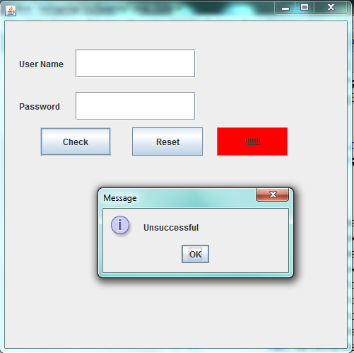

ActionListener program2

import javax.swing.*;
import java.awt.*;
import java.awt.event.*;
public class Guiprog5 extends JFrame implements ActionListener
{
JLabel one,two,three;
JTextField t1,t2,t3;
JButton b1,b2,b3,b4;
Guiprog5()
{

one=new JLabel("First No.");
t1=new JTextField(20);
two=new JLabel("Second No.");
t2=new JTextField(20);
three=new JLabel("Result");
t3=new JTextField(20);
b1=new JButton(" + ");
b2=new JButton(" * ");
b3=new JButton(" / ");
b4=new JButton("Reset");
one.setBounds(20,20,80,80);
two.setBounds(20,80,180,80);
t1.setBounds(100,40,170,40);
t2.setBounds(100,100,170,40);
three.setBounds(20,140,180,80);
t3.setBounds(100,160,170,40);

b1.setBounds(50,300,100,40);
b2.setBounds(180,300,100,40);
b3.setBounds(300,300,100,40);
b4.setBounds(430,300,100,40);
b1.addActionListener(this);
b2.addActionListener(this);
b3.addActionListener(this);
b4.addActionListener(this);
add(one);
add(t1);
add(two);
add(t2);
add(three);
add(t3);

add(b1);
add(b2);
add(b3);
add(b4);

setSize(600,500); // Setting size of JFrame
setLayout(null);
setVisible(true);

}

public void actionPerformed(ActionEvent ae)
{

int n1,n2,res;
try
{
n1=Integer.parseInt(t1.getText());
n2=Integer.parseInt(t2.getText());
if(ae.getSource()==b1)
{
res=n1+n2;
t3.setText(res+"");

}
else if(ae.getSource()==b2)
{
res=n1*n2;
t3.setText(res+"");

}
else if(ae.getSource()==b3)
{
res=n1/n2;
t3.setText(res+"");

}
else if(ae.getSource()==b4)
{
t1.setText("");
t2.setText("");
t3.setText("");
t1.requestFocus();
}
}catch(Exception ob){}
}
public static void main(String args[])
{
new Guiprog5();
}

}

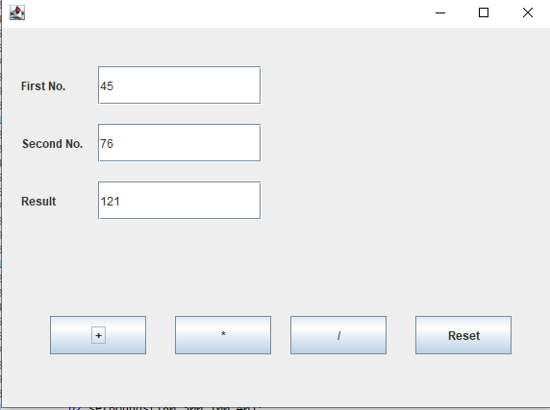

ActionListener program3

import javax.swing.*;

import java.awt.*;
import java.awt.event.*;

public class Guiprog4 extends JFrame implements ActionListener
{
JButton b1,b2,b3,b4 ;
Guiprog4()
{

b1=new JButton("Red");
b2=new JButton("Green");
b3=new JButton("Blue");
b4=new JButton("Magic");
b1.setBounds(50,150,100,40);
b2.setBounds(180,150,100,40);
b3.setBounds(300,150,100,40);
b4.setBounds(150,50,100,40);
b1.addActionListener(this);
b2.addActionListener(this);
b3.addActionListener(this);
add(b1);
add(b2);
add(b3);
add(b4);
setSize(500,500); // Setting size of JFrame
setLayout(null);
setVisible(true);

}

public void actionPerformed(ActionEvent ae)
{
if(ae.getSource()==b1)
{
b4.setBackground(Color.red);
}
else if(ae.getSource()==b2)
{
b4.setBackground(Color.green);
}
if(ae.getSource()==b3)
{
b4.setBackground(Color.blue);
}

}

public static void main(String args[])
{
new Guiprog4();
}

}

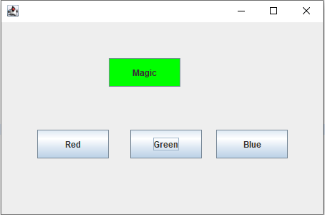

MouseListener program1
MouseListener

Interface methods
S.N. | Method & Description
1 | void mouseClicked(MouseEvent e)  Invoked when the mouse button has been clicked (pressed and released) on a component.
2 | void mouseEntered(MouseEvent e)  Invoked when the mouse enters a component.
3 | void mouseExited(MouseEvent e)  Invoked when the mouse exits a component.
4 | void mousePressed(MouseEvent e)  Invoked when a mouse button has been pressed on a component.
5 | void mouseReleased(MouseEvent e)  Invoked when a mouse button has been released on a component.

import javax.swing.*;
import java.awt.*;
import java.awt.event.*;
public class Guiprog6 extends JFrame implements MouseListener
{
JButton b1 ;
Guiprog6()
{
b1=new JButton("Magic After Entry Mouse pointer On Button");
b1.setBounds(50,150,300,140);
b1.addMouseListener(this);
b1.setBackground(Color.green);
add(b1);
setSize(500,500); // Setting size of JFrame
setLayout(null);
setVisible(true);
}

public void mousePressed(MouseEvent fe)
{

}
public void mouseClicked(MouseEvent fe)
{
}
public void mouseReleased(MouseEvent fe)
{
}
public void mouseEntered(MouseEvent fe)
{
b1.setBackground(Color.red);

}
public void mouseExited(MouseEvent fe)
{
b1.setBackground(Color.green);

}

public static void main(String args[])
{
new Guiprog6();
}

}

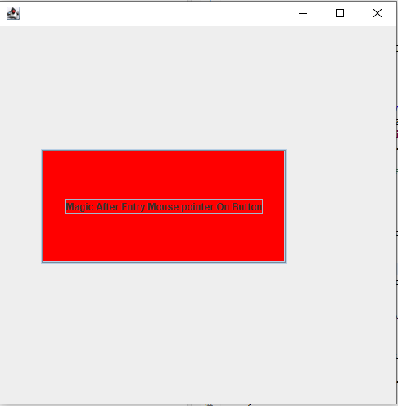

ItemListener Progam1
import javax.swing.*;
import java.awt.*;
import java.awt.event.*;
public class ItemListenerDemo extends JFrame implements ItemListener
{

JComboBox weekday;
String day;
Label one;
ItemListenerDemo()
{
FlowLayout layout = new FlowLayout();
JPanel p=new JPanel();
p.setLayout(layout);
one=new Label("Today Is: Sunday ");
String[] week = {"Sunday","Monday","Tuesday","Wednesday","Thursday","Friday","Saturday"};
weekday = new JComboBox(week);
weekday.addItemListener(this);
p.add(weekday);
p.add(one);
add(p);
setVisible(true);
this.setSize(500, 300);
}

public void itemStateChanged(ItemEvent ae)
{
day="Today Is: "+ weekday.getSelectedItem();
one.setText(day);

}

public static void main(String args[])
{
new ItemListenerDemo();
}

}

