Java Database Connectivity

What is JDBC?
JDBC stands for Java Database Connectivity, which is a standard Java API for database-independent connectivity between the Java programming language and a wide range of databases.
The JDBC library includes APIs for each of the tasks mentioned below that are commonly associated with database usage.
- Making a connection to a database.
- Creating SQL or MySQL statements.
- Executing SQL or MySQL queries in the database.
- Viewing & Modifying the resulting records.
Fundamentally, JDBC is a specification that provides a complete set of interfaces that allows for portable access to an underlying database. Java can be used to write different types of executables, such as −
- Java Applications
- Java Applets
- Java Servlets
- Java ServerPages (JSPs)
- Enterprise JavaBeans (EJBs).
All of these different executables are able to use a JDBC driver to access a database, and take advantage of the stored data.

JDBC Architecture
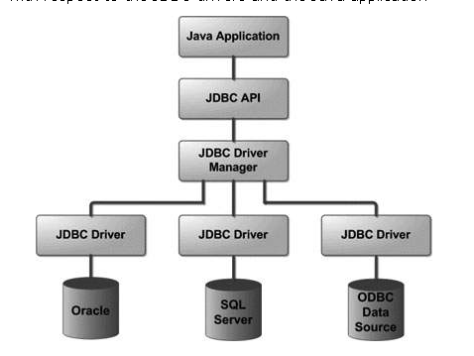

The JDBC API supports both two-tier and three-tier processing models for database access but in general, JDBC Architecture consists of two layers −
- JDBC API:
This provides the application-to-JDBC Manager connection.
- JDBC Driver API:
This supports the JDBC Manager-to-Driver Connection.
The JDBC API uses a driver manager and database-specific drivers to provide transparent connectivity to heterogeneous databases.
The JDBC driver manager ensures that the correct driver is used to access each data source. The driver manager is capable of supporting multiple concurrent drivers connected to multiple heterogeneous databases.
Following is the architectural diagram, which shows the location of the driver manager with respect to the JDBC drivers and the Java application −

Common JDBC Components
The JDBC API provides the following interfaces and classes −
- DriverManager: This class manages a list of database drivers. Matches connection requests from the java application with the proper database driver using communication sub protocol. The first driver that recognizes a certain subprotocol under JDBC will be used to establish a database Connection.
- Driver: This interface handles the communications with the database server. You will interact directly with Driver objects very rarely. Instead, you use DriverManager objects, which manages objects of this type. It also abstracts the details associated with working with Driver objects.
- Connection: This interface with all methods for contacting a database. The connection object represents communication context, i.e., all communication with database is through connection object only.
- Statement: You use objects created from this interface to submit the SQL statements to the database. Some derived interfaces accept parameters in addition to executing stored procedures.
- ResultSet: These objects hold data retrieved from a database after you execute an SQL query using Statement objects. It acts as an iterator to allow you to move through its data.
- SQLException: This class handles any errors that occur in a database application.

Interface/Class/Exception |  | Description
Interfaces:
 | java.sql.Connection | Interface used to establish a connection to a database. SQL statements run within the context of a connection.
 | java.sql.Driver | Interface used to locate the driver for a particular database management system.
 | java.sql.PreparedStatement | Interface used to send precompiled SQL statements to the database server and obtain results.
 | java.sql.ResultSet | Interface used to process the results returned from executing an SQL statement.
 | java.sql.Statement | Interface used to send static SQL statements to the database server and obtain results.
Classes:
 | java.sql.Date | Subclass of java.util.Date used for the SQL DATE data type.
 | java.lang.DriverManager | Class used to manage a set of JDBC drivers.
 | java.sql.Time | Subclass of java.util.Date used for the SQL TIME data type.
 | java.sql.Types | Class used to define constants that are used to identify standard SQL data types, such as CHAR, INTEGER, and DECIMAL.
Exception classes:
 | java.sql.SQLException | Exception that provides information about a database error.
 | java.sql.SQLWarning | Exception that provides information about a database warning.

JDBC Driver
A JDBC driver is a software component enabling a Java application to interact with a database.
To connect with individual databases, JDBC (the Java Database Connectivity API) requires drivers for each database. The JDBC driver gives out the connection to the database and implements the protocol for transferring the query and result between client and database.
JDBC Drivers

Type 1 Driver - JDBC-ODBC bridge

Type 2 Driver - Native-API Driver specification

Type 3 Driver - Network-Protocol Driver

Type 4 Driver - Native-Protocol Driver

Type 1 Driver - JDBC-ODBC bridge

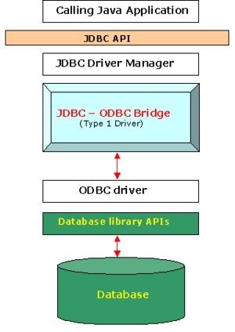
The JDBC type 1 driver, also known as the JDBC-ODBC bridge, is a database driver implementation that employs the ODBC driver to connect to the database. The driver converts JDBC method calls into ODBC function calls.
The driver is platform-dependent as it makes use of ODBC which in turn depends on native libraries of the underlying operating system the JVM is running upon. Also, use of this driver leads to other installation dependencies; for example, ODBC must be installed on the computer having the driver and the database must support an ODBC driver. The use of this driver is discouraged if the alternative of a pure-Java driver is available. The other implication is that any application using a type 1 driver is non-portable given the binding between the driver and platform. This technology isn't suitable for a high-transaction environment. Type 1 drivers also don't support the complete Java command set and are limited by the functionality of the ODBC driver.

Advantages
- Easy to connect.
- Directly connected to the database.

Disadvantages
- Performance overhead since the calls have to go through the jdbc Overhead bridge to
the ODBC driver, then to the native db connectivity interface.
- The ODBC driver needs to be installed on the client machine.
- Considering the client-side software needed, this is not suitable for applets.
- Compared to other driver types it's slow.

Type 4 Driver - Native-Protocol Driver

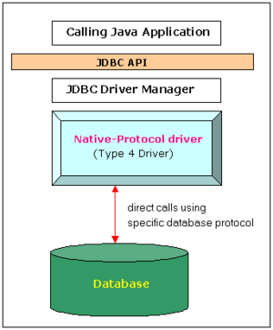
The JDBC type 4 driver, also known as the Direct to Database Pure Java Driver, is a database driver implementation that converts JDBC calls directly into a vendor-specific database protocol.Therefore it is called a THIN driver.
Written completely in Java, type 4 drivers are thus platform independent. They install inside the Java Virtual Machine of the client. This provides better performance than the type 1 and type 2 drivers as it does not have the overhead of conversion of calls into ODBC or database API calls. Unlike the type 3 drivers, it does not need associated software to work.

Functions
- Type 4 drivers, coded entirely in Java, communicate directly with a vendor's database, usually through
socket connections. No translation or middleware layers are required, improving performance.
- The driver converts JDBC calls into the vendor-specific database protocol so that client applications can communicate directly with the database server.
- Completely implemented in Java to achieve platform independence.
- This type includes (for example) the widely-used Oracle thin driver - oracle.jdbc.driver.OracleDriver which connects using a format configuration of jdbc:oracle:thin:@URL
- Client -> Native-protocol JDBC Driver -> database server.

Disadvantages
- Drivers are database dependent.

Seven Basic Steps in Using JDBC

- 1. Load the driver
- 2. Define the Connection URL
- 3. Establish the Connection
- 4. Create a Statement object
- 5. Execute a query
- 6. Process the results
- 7. Close the connection

Before you can create a java jdbc connection to the database, you must first import the java.sql package.
import java.sql.*; The star ( * ) indicates that all of the classes in the package java.sql are to be imported.
1. Loading a database driver,
In this step of the jdbc connection process, we load the driver class by calling Class.forName() with the Driver class name as an argument. Once loaded, the Driver class creates an instance of itself. A client can connect to Database Server through JDBC Driver.
Class.forName("com.mysql.jdbc.Driver");
2. Creating a JDBC Connection
The JDBC DriverManager class defines objects which can connect Java applications to a JDBC driver. DriverManager is considered the backbone of JDBC architecture. DriverManager class manages the JDBC drivers that are installed on the system. Its getConnection() method is used to establish a connection to a database. It uses a username, password, and a jdbc url to establish a connection to the database and returns a connection object. A jdbc Connection represents a session/connection with a specific database. Within the context of a Connection, SQL, PL/SQL statements are executed and results are returned. An application can have one or more connections with a single database, or it can have many connections with different databases. A Connection object provides metadata i.e. information about the database, tables, and fields. It also contains methods to deal with transactions.
Connection con =DriverManager.getConnection(url,”loginName”,”Password”)

Connection

This is an interface in java.sql that specifies connection with specific database like MYSQL,MS-Access ,Oracle etc and java files.

Add the JDBC mysql driver to an Eclipse project before running jdbc program. 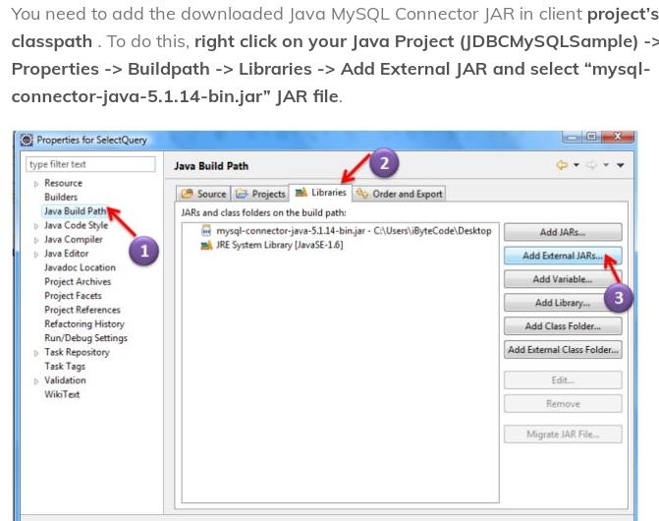

Program1

import java.sql.*;
class Jdbcprog1
{
public static void main(String s[])
{
try
{
Connection conn;
Class.forName("com.mysql.jdbc.Driver");
conn=DriverManager.getConnection("jdbc:mysql://localhost:3306/mydb","root","geu");
System.out.println("Connection Successful");
conn.close();
}
catch(ClassNotFoundException e)
{

e.printStackTrace();
}
catch(SQLException w)
{
w.printStackTrace();

}
}
}

Program2
Java Program for Retrieving Record from Database

import java.sql.*;
class Jdbcprog2
{
public static void main(String s[])
{
int mcode,msal;
String mname,mdesig;
try
{
Connection conn;
Statement stmt;
ResultSet rs;
Class.forName("com.mysql.jdbc.Driver");
conn=DriverManager.getConnection("jdbc:mysql://localhost:3306/mydb","root","geu");
stmt=conn.createStatement();
rs=stmt.executeQuery("SELECT * FROM emp");
while(rs.next())
{
mname=rs.getString(1);
mcode=rs.getInt(2);
mdesig=rs.getString(3);
msal=rs.getInt(4);
System.out.println(mcode+" "+mname+" "+mdesig+" "+msal);
}
rs.close();
stmt.close();
conn.close();

} //end of try block
catch(ClassNotFoundException e)
{

e.printStackTrace();

}
catch(SQLException w)
{
w.printStackTrace();

}

} //End of main
} //End of class

Program3
Java Program for Inserting Record Into Database

import java.sql.*;
import java.io.*;
public class Jdbcprog3
{
public static void main(String st[])
{

int mcode,msal;
String mname,mdesig;
try
{
BufferedReader br=new BufferedReader(new InputStreamReader(System.in));
System.out.println("Enter Employee Code");
mcode=Integer.parseInt(br.readLine());
System.out.println("Enter Employee Name");
mname=br.readLine();
System.out.println("Enter Employee Designation");
mdesig=br.readLine();
System.out.println("Enter Employee Salary");
msal=Integer.parseInt(br.readLine());

PreparedStatement inst;
Connection conn;
Class.forName("com.mysql.jdbc.Driver");
conn=DriverManager.getConnection("jdbc:mysql://localhost:3306/mydb","root","geu");
inst=conn.prepareStatement("INSERT INTO emp VALUES(?,?,?,?)");
inst.setString(1,mname);
inst.setInt(2,mcode);
inst.setString(3,mdesig);
inst.setInt(4,msal);
int n=inst.executeUpdate();
if(n>0)
System.out.println("Record Inserted");
else
System.out.println("Record Not Inserted");

inst.close();
conn.close();

} //end of try block
catch(ClassNotFoundException e)
{

e.printStackTrace();
}
catch(SQLException w)
{
w.printStackTrace();

}
catch(IOException p)
{

p.printStackTrace();
}
} //End Of main
} //End Of Class

Program4
Java Program for Updating Record using PreparedStatment

import java.util.*;
import java.sql.*;
public class Jdbcprog4
{
public static void main(String st[])
{
int mcode,msal;
Scanner sr=new Scanner(System.in);
System.out.println("Enter Code For Searching");
mcode=sr.nextInt();
System.out.println("Enter updated salary");
msal=sr.nextInt();

Connection conn;
PreparedStatement pst;
int rt;
try
{
Class.forName("com.mysql.jdbc.Driver");
conn=DriverManager.getConnection("jdbc:mysql://localhost:3306/mydb","root","geu");
pst=conn.prepareStatement("UPDATE emp SET salary=? WHERE code=?");
pst.setInt(1,msal);
pst.setInt(2,mcode);
rt=pst.executeUpdate();
System.out.println("Number Of Rows Updated====> "+rt);
pst.close();
conn.close();

} //end of try block
catch(ClassNotFoundException e)
{
e.printStackTrace();
}
catch(SQLException w)
{
w.printStackTrace();
}
} //End of main
} //End of class

Program5
Java Program for deleting Record using PreparedStatment

import java.util.*;
import java.sql.*;
public class Jdbcprog5
{
public static void main(String st[])
{
int mcode,msal;
Scanner sr=new Scanner(System.in);
System.out.println("Enter Code For Searching");
mcode=sr.nextInt();
Connection conn;
PreparedStatement pst;
int rt;
try
{
Class.forName("com.mysql.jdbc.Driver");
conn=DriverManager.getConnection("jdbc:mysql://localhost:3306/mydb","root","geu");
pst=conn.prepareStatement("Delete from emp WHERE code=?");
pst.setInt(1,mcode);
rt=pst.executeUpdate();
System.out.println("Number Of Rows deleted====> "+rt);
pst.close();
conn.close();

} //end of try block
catch(ClassNotFoundException e)
{
e.printStackTrace();
}
catch(SQLException w)
{
w.printStackTrace();
}
} //End of main
} //End of class

Types Of Statements interfaces
(1)Statement
(2)PreparedStatement
(3) CallableStatement
Statement
public interface Statement extends Wrapper
The object used for executing a static SQL statement and returning the results it produces.
By default, only one ResultSet object per Statement object can be open at the same time. Therefore, if the reading of one ResultSet object is interleaved with the reading of another, each must have been generated by different Statement objects. All execution methods in the Statement interface implicitly close a statment's current ResultSet object if an open one exists.

Creating Statement Object:
Before you can use a Statement object to execute a SQL statement, you need to create one using the Connection object's createStatement( ) method, as in the following example:
Statement stmt = null;
try
{
stmt = conn.createStatement( );
}
catch(SQLException e)
{
. . .
}
finally {
. . .
}

Methods Of Statement interfaces
(1) boolean execute(String sql) throws SQLException
Executes the given SQL statement, which may return multiple results.

Returns:
true if the first result is a ResultSet object; false if it is an update count or there are no results

(2) ResultSet executeQuery(String sql) throws SQLException
Executes the given SQL statement, which returns a single ResultSet object.

Returns:
a ResultSet object that contains the data produced by the given query; never null

(3) int executeUpdate(String sql) throws SQLException
Executes the given SQL statement, which may be an INSERT, UPDATE, or DELETE statement or an SQL statement that returns nothing, such as an SQL DDL statement.

Returns:
either (1) the row count for SQL Data Manipulation Language (DML) statements or (2) 0 for SQL statements that return nothing

(4) void close() throws SQLException
Releases this Statement object's database and JDBC resources immediately instead of waiting for this to happen when it is automatically closed. It is generally good practice to release resources as soon as you are finished with them to avoid tying up database resources.
Calling the method close on a Statement object that is already closed has no effect.
Note:When a Statement object is closed, its current ResultSet object, if one exists, is also closed.
Throws:
SQLException - if a database access error occurs

PreparedStatement
public interface PreparedStatement extends Statement
An object that represents a precompiled SQL statement.
A SQL statement is precompiled and stored in a PreparedStatement object. This object can then be used to efficiently execute this statement multiple times.
PreparedStatement in Java allows you to write parameterized query which gives better performance than Statement interface in java
In case of PreparedStatement, Database use an already compiled and defined access plan, this allows prepared statement query to run faster than normal query.

To use PreparedStatement interface in source code, first we need to create object of PreparedStatement by calling prepareStatement() method. The prepareStatement() is available in java.sql.Connection interface.

Example
PreparedStatement pst;
pst=con.prepareStatement("INSERT INTO emp VALUES(?,?,?,?)");

Methods Of PreparedStatement

(1) ResultSet executeQuery() throws SQLException

Executes the SQL query in this PreparedStatement object and returns the ResultSet object generated by the query.
Returns:
a ResultSet object that contains the data produced by the query; never null

(2)int executeUpdate() throws SQLException
Executes the SQL statement in this PreparedStatement object, which must be an SQL Data Manipulation Language (DML) statement, such as INSERT, UPDATE or DELETE; or an SQL statement that returns nothing, such as a DDL statement.
(3)boolean execute() throws SQLException

Executes the SQL statement in this PreparedStatement object, which may be any kind of SQL statement.

Returns:
true if the first result is a ResultSet object; false if the first result is an update count or there is no result

ResultSet

public interface ResultSet extends Wrapper

ResultSet: These objects hold data retrieved from a database after you execute an SQL query using Statement objects. It acts as an iterator to allow you to move through its data

ResultSet Methods
(1) void close() throws SQLException
Releases this ResultSet object's database and JDBC resources immediately instead of waiting for this to happen when it is automatically closed.

(2) boolean first() throws SQLException
Moves the cursor to the first row in this ResultSet object.

(3) boolean last() throws SQLException
Moves the cursor to the last row in this ResultSet object.

Returns: true if the cursor is on a valid row; false if there are no rows in the result set

(4) boolean next() throws SQLException
Moves the cursor froward one row from its current position. A ResultSet cursor is initially positioned before the first row; the first call to the method next makes the first row the current row; the second call makes the second row the current row, and so on.

