**Mini Project Report on**



**Online Voting through Mobile Phone**



**Submitted in partial fulfillment of the requirement for the award of the degree of**

**BACHELOR OF TECHNOLOGY**

**IN**

**COMPUTER SCIENCE & ENGINEERING**

**Submitted by:**

Kulmeet Singh 2016827

***Under the Mentorship of***

**Dr. Surendra Kumar Shukla**



**Department of Computer Science and Engineering**

**Graphic Era (Deemed to be University)**

**Dehradun, Uttarakhand**

**January 2023**



**CANDIDATE’S DECLARATION**

I hereby certify that the work which is being presented in the project report entitled **“Title of the project”** in partial fulfillment of the requirements for the award of the Degree of Bachelor of Technology in Computer Science and Engineeringof the Graphic Era (Deemed to be University), Dehradun shall be carried out by the under the mentorship of **Dr.Surendra Kumar Shukla**, Department of Computer Science and Engineering, Graphic Era (Deemed to be University), Dehradun.

Kulmeet Singh 2016827 **signature**

**Table of Contents**

|  |  |  |
| --- | --- | --- |
| **Chapter No.** | **Description** | **Page No.** |
| Chapter 1 | Introduction   * 1. Purpose   2. Existing System   3. Proposed System      1. Saved Ballot Templates      2. Reduced Costs   4. Product Scope |  |
| Chapter 2 | Literature Survey |  |
| Chapter 3 | Methodology |  |
| Chapter 4 | Result and Discussion |  |
| Chapter 5 | Conclusion and Future Work |  |
|  | References |  |

**Chapter 1**

**Introduction**

* 1. Purpose  
     The word "vote" means to choose, select, or specify from a list. The main purpose of voting (in scenarios involving citizens of a particular country) is to find leaders of their choice. And the process of voting in an election is called a poll. The Online Voting System is an online website with key features related to the GUI and database properties that determine software requirements for this project. This project is intended for small voting processes such as college elections and feedback forms. This project provides an online tool to vote on various questions submitted by admins/organizers. The purpose of this document is to help you understand the practical and non-functional requirements of an online survey system. It also works for the purpose of clarifying functionality to the end user.  
       
     1.2 Existing System

The existing system consists of methods such as paper-based voting, lever voting machines, punch cards and optical voting machines. A major problem with existing systems was time consumption, which took a lot of time to adjust. The existing system used paper-based voting methods and provided bogus ballot results.

* 1. Proposed system  
     This system overcomes the problems of the existing system  
     1.3.1 Saved Voting Templates Eliminates the need to configure  
     elections from scratch. Just do it once, then save this voting configuration and enter only the candidate's name next year.  
     1.3.2 Cost Reductions  
     We would benefit if the costs of printing, mailing and counting ballots were reduced or eliminated entirely from the election process.  
       
     1.4 PRODUCT SCOPE

The software products are independent programs and are not part of a larger program. The system consists of two parts. Before Election Day, the system will be used for general purposes, such as viewing participant profiles and past voting results. Voters can access the system via  XAMPP. The system can be used for general research in any institution or community.

**Chapter 2**

**Literature Survey**

In [1], the authors Kohno T., Stubblefield A., Rubin A., and Wallach DS (2004) describe the security features of electronic voting systems and argue that electronic voting systems are superior to manual voting systems. increase. Additionally, the authors show that voters without insider privileges can vote indefinitely without being recognized by mechanisms within the voting terminal software.  
In  
[2], the author Ciprian Stănică-Ezeanu (2008) reviewed it by describing the advantages and disadvantages of the electronic voting process. He mainly dealt with security measures such as firewalls and SSL communication, which are necessary but not sufficient to guarantee the specific security requirements of electronic voting. The author also describes an additional layer of performance improvement with pseudo-random His One-Time His Password (OTP) in online voting systems. Professional security technologies to address the specific risks of electronic voting and ensure key security requirements such as voter privacy, vote integrity, and voter verifiability. The author suggested using biometrics and smart cards to authenticate users as well. An important issue highlighted by the authors is the difference between biometrics and "traditional" authentication such as smart cards. Proposed electronic voting system. [2] doesn't interact with the actual user's biometrics at all, but smartly authenticates the user using the user's authentication certificate on his card.  
  
[3] Manish K., Suresh K.T , Hanuman Tappa. M, Evangeline G.D. (2005) The authors primarily specified voting system backup from manual voting systems to electronic voting systems. Author Rosler TG (2011).  
  
[4] proposed the use of remote Internet voting to improve voting comfort and increase voter confidence and turnout. In the study, the authors suggest that remote electronic voting is the best move forward, as it offers more convenience to voters without compromising security. Author Avi Rubin (2001) examines the security measures required for a remote online voting system, focusing on two cases, the Democratic Elementary School in Arizona in 2000 and the Student Council at the University of Virginia. selection. The author argues that a secure voting system must fully meet her four main requirements: authentication, availability, confidentiality, and integrity.

**Chapter 3**

**Methodology**

Class Diagram

UML class diagrams show the static structure of a model. A class diagram is a graphical collection of static modeling elements such as classes, their interconnected relationships, and their contents. Class diagrams are a key building block of object-oriented modeling. It is used both for general conceptual modeling of the architecture of the application and for detailed modeling where the model is translated into programming code. Data Modelling can also be done with the help of Class Diagrams. Classes in class diagrams represent both the main objects and interactions of the application and the objects being programmed.

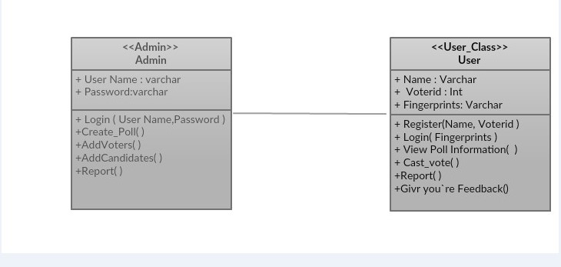

Use Case Diagram

A use case defines a goal-oriented set of interactions between external entities and the system under consideration. The external entities which interact with the system are the actors it have. A set of use cases describe the complete functionality of the system at a particular level of detail and it can be graphically denoted by the use case diagram.

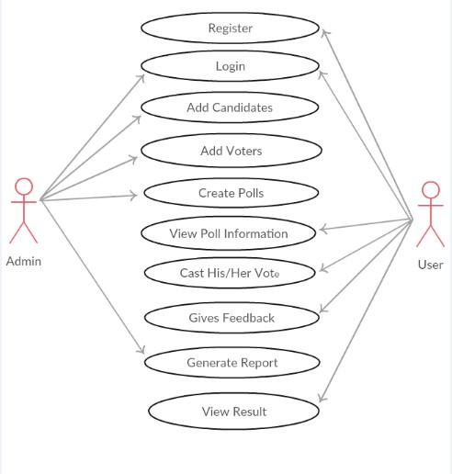

Data Flow Diagram

A data flow diagram (DFD) is a graphical representation of the "flow" of data in an information system. Data flow diagrams can also be used to visualize data processing (structured design). It is common for a designer to first draw her DFD at her level of context, which shows interactions between the system and external entities. DFD describes the flow of data from external entities into a system, how data moves from one process to another, and its logical storage. There are only 4 symbols:

1. Squares representing external entities that are sources and destinations of information entering and leaving the system.

2. Rounded rectangles representing processes are sometimes called "activities", "actions", "procedures", "subsystems", etc. in other methodologies that take data as input, process it and output it.

3. Arrows represent the data flow of electronic data or physical objects. Data can only flow from data store to data store through processes; external devices cannot access data stores directly.

4. Flat three-sided rectangles represent data stores intended to receive information for storage and to provide information for further processing.

**Chapter 4**

**Result and Discussion**

Sequence diagram are an easy and intuitive way of describing the behavior of a system by viewing the interaction between the system and the environment. A sequence diagram shows an interaction arranged in a time sequence. A sequence diagram has two dimensions: vertical dimension represents time , the horizontal dimension represents the objects existence during the interaction. Basic elements:

• Vertical rectangle: Represent the object is active (method is being performed).

• Vertical dashed line: Represent the life of the object.

• X: represents the life end of an object. (Being destroyed from memory)

• Horizontal line with arrows: Messages from one object to another.

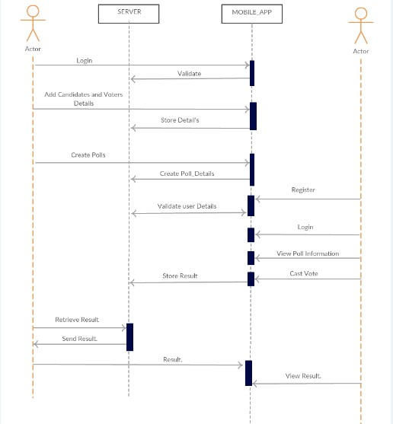

Activity diagrams show a series of steps that make up a complex process. Activities are represented as round boxes containing the name of the operation. A solid outward arrow at the end of the activity icon indicates a completion-triggered transition. Activity diagrams are another important UML diagram that describes the dynamic aspects of a system. An activity diagram is basically a flow chart that shows the flow from one activity to another. Activities can be described as operations on the system. Control flow is drawn from one operation to another. An activity is a specific operation of the system. Activity diagrams are not only used to visualize the dynamic nature of systems, but they are also used to build viable systems using forward and reverse engineering techniques. The only thing missing from the activity diagram is the news part.Diagram

**Chapter 5**

**Conclusion and Future Work**

This Online Voting system will manage the Voters information by which voter can login and use his voting rights. The system will incorporate all features of Voting system. It provides the tools for maintaining voters vote to every party and it count total no. of votes of every party. There is a DATABASE which is maintained by the ELECTION COMMISION OF INDIA in which all the names of voter with complete information is stored. In this user who is above 18 years register his/her information on the database and when he/she want to vote he/she has to login by his id and password and can vote to any party only single time. Voting detail store in database and the result is displayed by calculation. By online voting system percentage of voting is increases. It decreases the cost and time of voting process. It is very easy to use and It is vary less time consuming. It is very easy to debug.

This project was my first implementation of a system of this nature. We identify that the work done both in terms of analyzing and implementing the system is by no means complete. In this section we list the things that were either left open by this project or were opened by the analysis performed and the lessons learned during our interaction with the subject. The complete system can be established with a proper significance of fingerprint hardware device. This will bring good security for the system. Since security issues are the most important part of any system. We are going with fingerprint authentication. In addition to this system we can implement same with face authentication algorithms. But it will be difficult to make proper face matching strategies.

**References**

[1] Avi Rubin (2001), “Security Considerations for Remote Electronic Voting over the Internet”, AT&T Labs – Research Florham Park, NJ. Available at http://avirubin. com/evoting.security.html

[2] Dr. Aree Ali Mohammed, Ramyar Abdolrahman Timour, “Efficient E-Voting Android Based System”, Volume 3, Issue 11, November 2013, ISSN: 2277, 128X

[3] About Android operating system https://en.wikipedia.org/wiki/Android_ (operating_system)

[4]About Android Studio on Wikipedia https://en.wikipedia.org/wiki/ Android_Studio