**COE 9**

**Lab Evaluation**: Assignment 1

1. Solve the following **8-puzzle problem using genetic algorithm**.

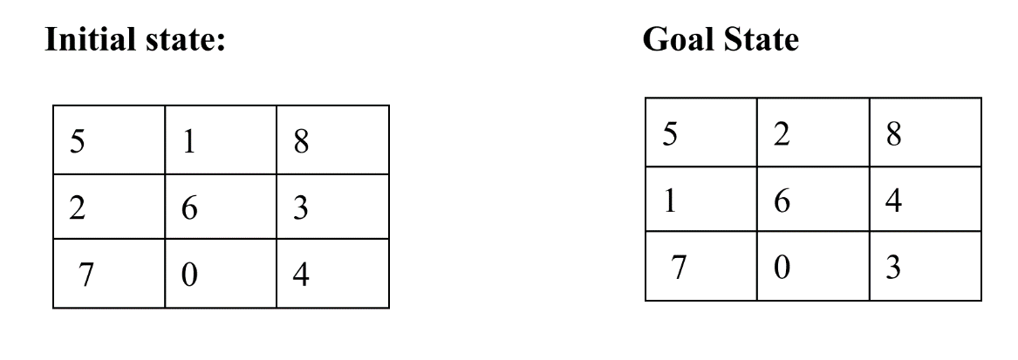

The number of misplaced tiles in the current state as compared to the goal state is to be considered as the fitness function. Apply **single-point crossover** followed by **two-bit flip mutation** for offspring generation. Also show how many iterations it took to reach goal state?

**CODE:**

import numpy as np  
import random as rd  
from random import randint  
  
# start state as 1d array  
initial_arr = [5,1,8,2,6,3,7,0,4]  
# goal state as 1d array  
final_arr = [5,2,8,1,6,4,7,0,3]  
  
# population size  
solutions_per_pop = 4  
# population size as a 2d array  
pop_size = (solutions_per_pop, len(initial_arr))  
print('Population size = {}'.format(pop_size))  
  
# initial population (here I repeated same initial array 4 times as mutation will eventually evolve the population)  
initial_population = np.array([[5,1,8,2,6,3,7,0,4], [5,1,8,2,6,3,7,0,4], [5,1,8,2,6,3,7,0,4], [5,1,8,2,6,3,7,0,4]])  
print('Initial population: \n{}'.format(initial_population))  
  
  
# heuristic function which helps in evaluating the fitness of each chromosome as the number of misplaced tiles  
# when compared with the goal state  
def heuristic(initial_arr, final_arr):  
 # count represents the total number of mismatch  
 count = 0  
 for p in range(9):  
 if initial_arr[p]!=0:  
 # whenever there is a mismatch in the current state and goal state it is added to the count  
 if initial_arr[p]!=final_arr[p]:  
 count = count+1  
 return count  
  
  
# cal_fitness function which calculates the fitness of population at each iteration  
def cal_fitness(final_arr, population):  
 # fitness is a 1d array which has the fitness value as no of misplaced tiles for each chromosome of the population  
 fitness = np.empty(population.shape[0])  
 for i in range(population.shape[0]):  
 # for each chromosome we find the fitness value using heuristic function  
 # lower the fitness value, better the solution  
 fitness[i] = heuristic(population[i], final_arr)  
 return fitness.astype(int)  
  
  
# selection function which is used to select parents for crossover and mutation based on their fitness value  
def selection(fitness, num_parents, population):  
 fitness = list(fitness)  
 # parents will contain the chromosomes which are selected as fittest, and further evolve by crossover and mutation  
 parents = np.empty((num_parents, population.shape[1]))  
 for i in range(num_parents):  
 # here lower the fitness value better the solution  
 max_fitness_idx = np.where(fitness == np.min(fitness))  
 parents[i,:] = population[max_fitness_idx[0][0], :]  
 fitness[max_fitness_idx[0][0]] = +99999  
 return parents  
  
  
# crossover function performs the 1-point crossover of the parents to generate offsprings for the next generation  
def crossover(parents, num_offsprings):  
 offsprings = np.empty((num_offsprings, parents.shape[1]))  
 # here we will perform 1-point crossover from the middle of the chromosome  
 crossover_point = int(parents.shape[1] / 2)  
 # crossover_rate will define how frequent we want crossover to happen  
 crossover_rate = 0.8  
 x = rd.random()  
 # here we compare the crossover_rate with a random value,  
 # if it is greater than the random value, then only we perform crossover,  
 # otherwise we return the parents as it is  
 if x > crossover_rate:  
 return parents  
 # first half of the first offspring as it is from the first parent  
 offsprings[0, 0:crossover_point] = parents[0, 0:crossover_point]  
 j=0  
 k=0  
 for i in parents[1]:  
 if i not in parents[0, 0:crossover_point]:  
 # remaining half of the first offspring from the second parent in orderly fashion  
 offsprings[0, crossover_point+j] = i  
 j += 1  
 else:  
 # first half of the second offspring from the remaining elements of the second parent in orderly fashion  
 offsprings[1,k] = i  
 k += 1  
 # second half of the second offspring as it is from the second half of the first parent  
 offsprings[1, crossover_point:] = parents[0, crossover_point:]  
 return offsprings  
  
  
# mutation function which performs 2-bit flip mutation of the offsprings generated after crossover  
def mutation(offsprings):  
 # mutation rate will define how frequent we want mutation to happen  
 mutation_rate = 0.4  
 mutants = np.empty((offsprings.shape))  
 for i in range(mutants.shape[0]):  
 random_value = rd.random()  
 mutants[i, :] = offsprings[i, :]  
 # here we compare mutation rate with a random value,  
 # if mutation rate is higher than the random value, then only perform mutation,  
 # otherwise keep offsprings as it is  
 if random_value > mutation_rate:  
 continue  
 # here we select two random bits for 2-bit flip mutation  
 int_random_value1 = randint(0, offsprings.shape[1] - 1)  
 int_random_value2 = randint(0, offsprings.shape[1] - 1)  
 # here we flip the bits  
 temp = mutants[i][int_random_value1]  
 mutants[i][int_random_value1] = mutants[i][int_random_value2]  
 mutants[i][int_random_value2] = temp  
 return mutants  
  
  
# optimize function handles all the operations to generate a new generation  
# which takes the population closer to the goal state  
def optimize(final_arr, population, pop_size):  
 final_state = []  
 # here we consider half the population as number of parents  
 num_parents = int(pop_size[0] / 2)  
 # remaining population will be formed by the offsprings from these parents  
 num_offsprings = pop_size[0] - num_parents  
 # iter represents the number of iteration taken to reach the goal state  
 iter = 0  
  
 # we keep iterating till goal state is achieved  
 while True:  
 # calculating fitness of the population  
 fitness = cal_fitness(final_arr, population)  
 # checking if goal state is achieved  
 if np.min(fitness) == 0:  
 break  
 # selecting fittest chromosomes as parents  
 parents = selection(fitness, num_parents, population)  
 # generating offsprings from the above parents  
 offsprings = crossover(parents, num_offsprings)  
 # performing mutation of the above offsprings  
 mutants = mutation(offsprings)  
 # we keep the parents as it is in the population  
 population[0:parents.shape[0], :] = parents  
 # we keep the newly generated offsprings in the population, discarding the previous unfit chromosomes  
 population[parents.shape[0]:, :] = mutants  
 iter = iter + 1  
  
  
 print("\nIterations are:", iter)  
 # printing the last generation and its fitness  
 print('Last generation: \n{}\n'.format(population))  
 fitness_last_gen = cal_fitness(final_arr, population)  
 print('Fitness of the last generation: \n{}\n'.format(fitness_last_gen))  
 # the chromosome which will be the fittest is actually our goal state  
 max_fitness = np.where(fitness_last_gen == np.min(fitness_last_gen))  
 final_state.append(population[max_fitness[0][0], :])  
 # we return the goal state and the number of iterations  
 return final_state, iter  
  
  
# calling the optimize function  
final_state, iter = optimize(final_arr, initial_population, pop_size)  
# printing the result  
print('The optimized current state is: \n{}\nachieved in {} iterations.'.format(final_state, iter))

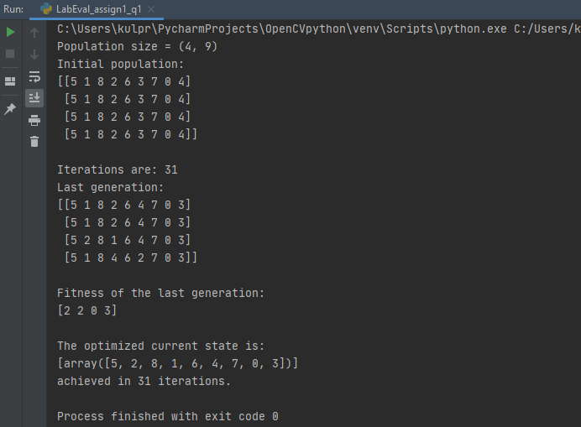**OUTPUT:**

1. Missionaries and Cannibals is a problem in which 3 missionaries and 3 cannibals want to cross from the left bank of a river to the right bank of the river. There is a boat on the left bank, but it only carries at most two people at a time (and can never cross with zero people). If cannibals ever outnumber missionaries on either bank, the cannibals will eat the missionaries. Solve this problem using DFS.

**CODE:**

import copy  
  
# state representation  
# [missionaries on left, cannibals on left, side of river]  
initial_state = [3,3,0] # 0 means boat is on left side  
goal_state = [0,0,1] # 1 means boat is on right side  
  
# all possible moves  
possible_moves = [(2,0), (0,2), (1,1), (1,0), (0,1)]  
# move's first element represent number of missionaries on the boat  
# move's second element represent number of cannibals on the boat  
  
# negative sign represents boat going from left to right  
# positive sign represents boat going from right to left  
sign = (-1, +1) # direction  
  
stack = [] # stack to implement DFS  
visited = [] # list to keep track of all visited states  
stack.append(initial_state) # initial state added to stack initially  
count = 0 # No. of moves in DFS to attain goal state  
  
  
# compare function which compares the states  
# to determine whether or not goal state has been reached  
def compare(arr, goal_state):  
 for i in range(len(arr)):  
 if arr[i] != goal_state[i]:  
 return False  
 return True  
  
  
# isValid function determines whether a given state is valid or not  
def isValid(arr):  
 # all missionaries on left side of river  
 if arr[0] == 3 and ((arr[1] >= 0) and arr[1] <= 3):  
 return True  
 # missionaries and cannibals in equal number on both sides  
 elif arr[0] == arr[1] and ((arr[1] >= 0) and arr[1] <= 3):  
 return True  
 # all missionaries on right side of the river  
 elif arr[0] == 0 and ((arr[1] >= 0) and arr[1] <= 3):  
 return True  
 # otherwise not a valid move  
 else:  
 return False  
  
  
# genChildren function generates children of a given state  
# by performing all valid moves  
def genChildren(arr):  
 children = []  
 # sign determines the direction of move  
 # based on the current position of the boat  
 s = sign[arr[2]]  
 for move in possible_moves:  
 temp = copy.deepcopy(arr)  
 # here we perform all possible moves  
 temp[0] = temp[0] + (s * move[0])  
 temp[1] = temp[1] + (s * move[1])  
 if temp[2] == 0:  
 temp[2] = 1  
 else:  
 temp[2] = 0  
 # here we check if the performed move is valid or not  
 if isValid(temp):  
 # all valid moves generates states  
 # if those states have not yet been visited,  
 # we add that state to the children of current state  
 if temp not in visited and temp not in stack:  
 children.append(temp)  
 return children  
  
  
# dfs() performs the Depth First Search  
def dfs():  
 global count  
 # iterate till stack is not empty  
 while len(stack)!=0:  
 # by default it pops the element from the end,  
 # i.e. most recently added element  
 arr = stack.pop()  
 # add this state to the visited[]  
 visited.append(copy.deepcopy(arr))  
 # check if the goal state has been reached  
 if compare(arr,goal_state):  
 print(f"No. of Moves: {count}")  
 print("Path:")  
 for i in visited:  
 print(i)  
 break  
 else:  
 # generate children of the current state  
 child = genChildren(arr)  
 # add the children into the stack  
 for c in child:  
 stack.append(copy.deepcopy(c))  
 count += 1  
  
if __name__ == '__main__':  
 dfs()

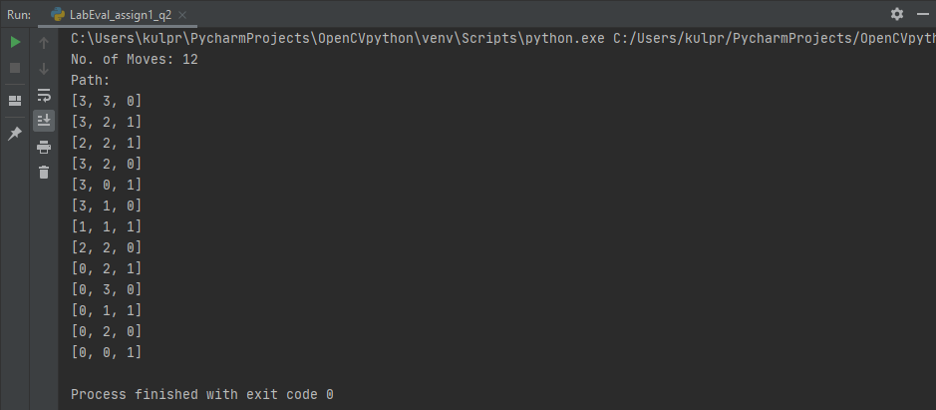**OUTPUT:**