**INDEX**

Date:-05/08

1. **language and Applications**
2. **Java Features**

**Why java is platform independent**

**OOps**

**Exception handling**

**Multithreading**

**Web Applications**

**Open Source**

**Secure**

**Support Networking**

**Memory Management(Garbage Collector)**

1. **JDK ,JRE ,JVM**
2. **Basic Java Programming**
3. **Packages**

**Date:06/08/2024**

1. **Nested Loops**

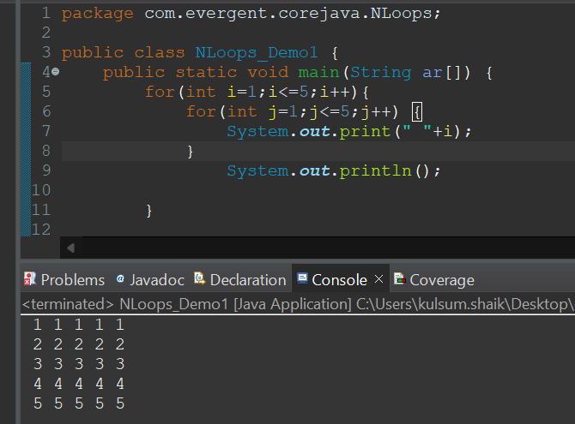

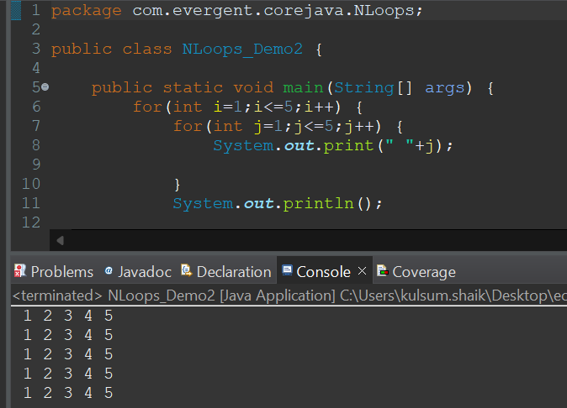

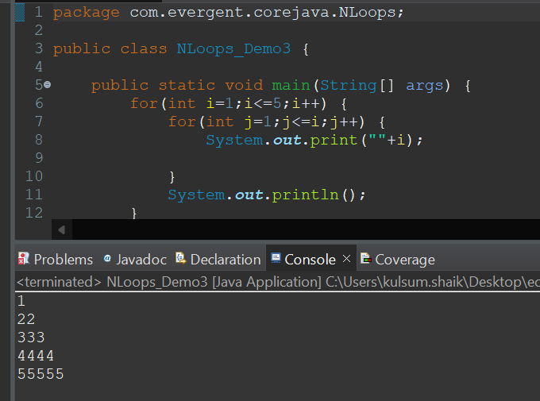

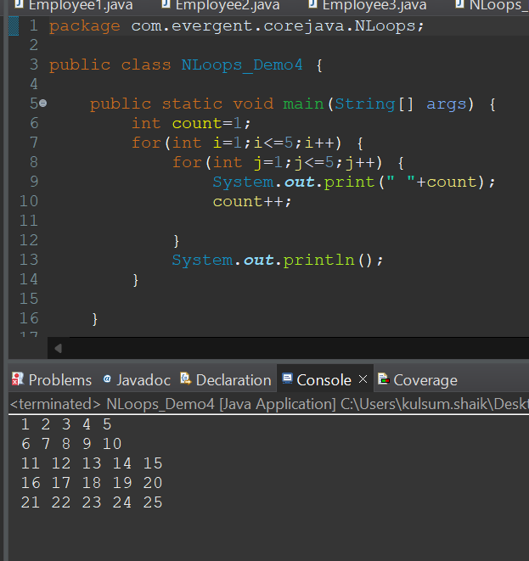

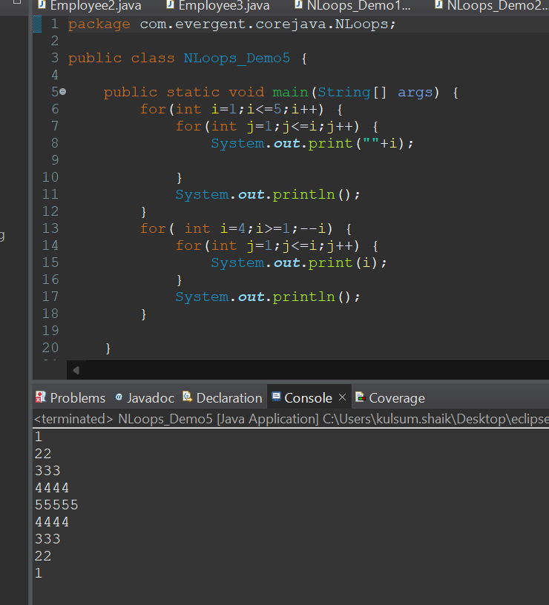

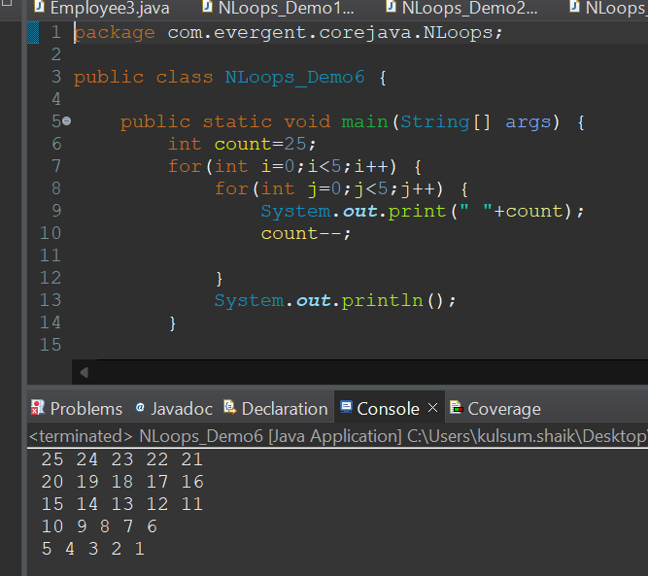

1. **Single Array**
2. **Two Dimensional Array**
3. **Logical Programming**

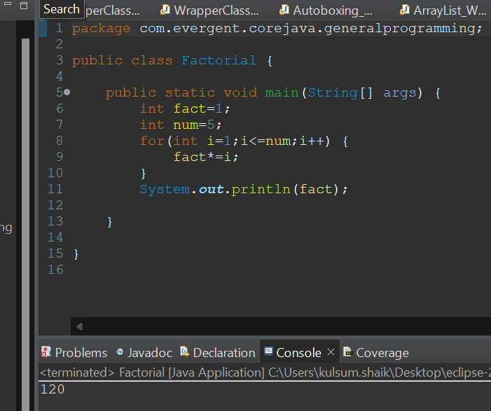

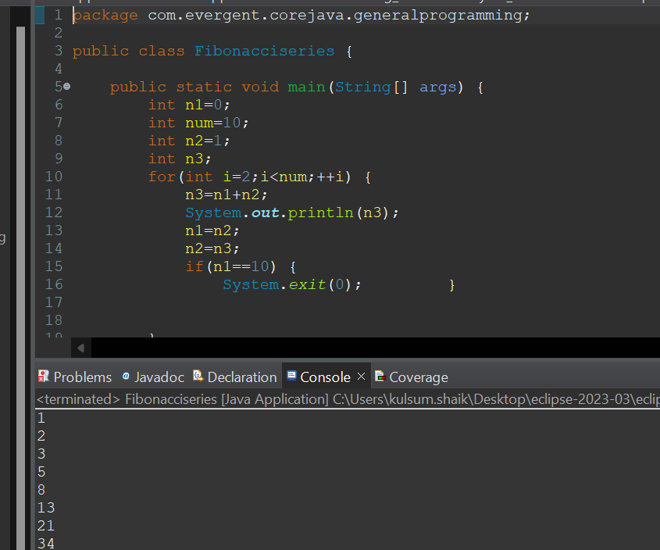

1. **Switch Cases**
2. **enum**
3. **Scanner**
4. **Object class**
5. **Event Management Application.**

**Date:07/08/24**

**OOps concept**

**1) Encapsulation**

**Calculation Class**

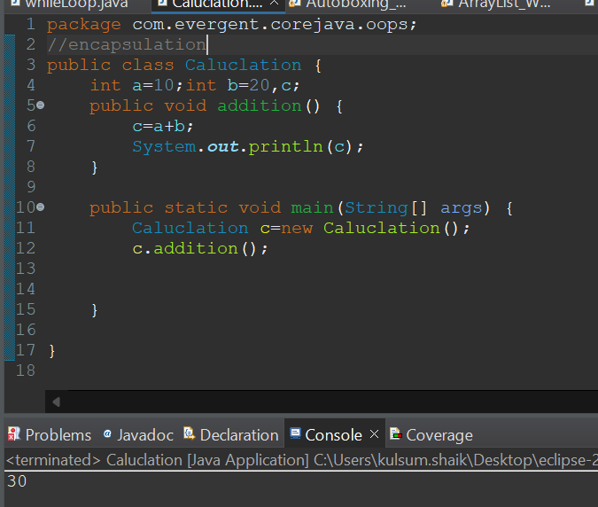

**Person Class**

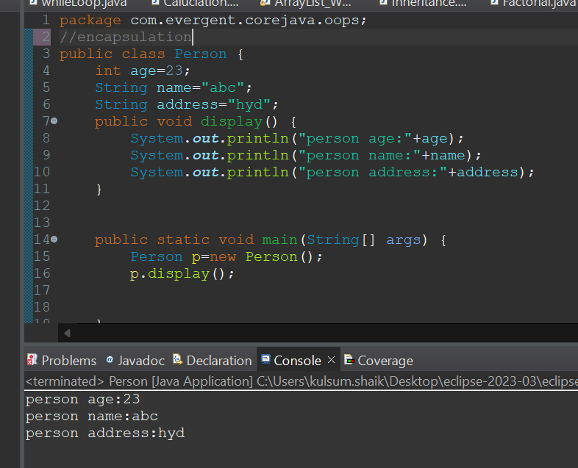

**Method flow**

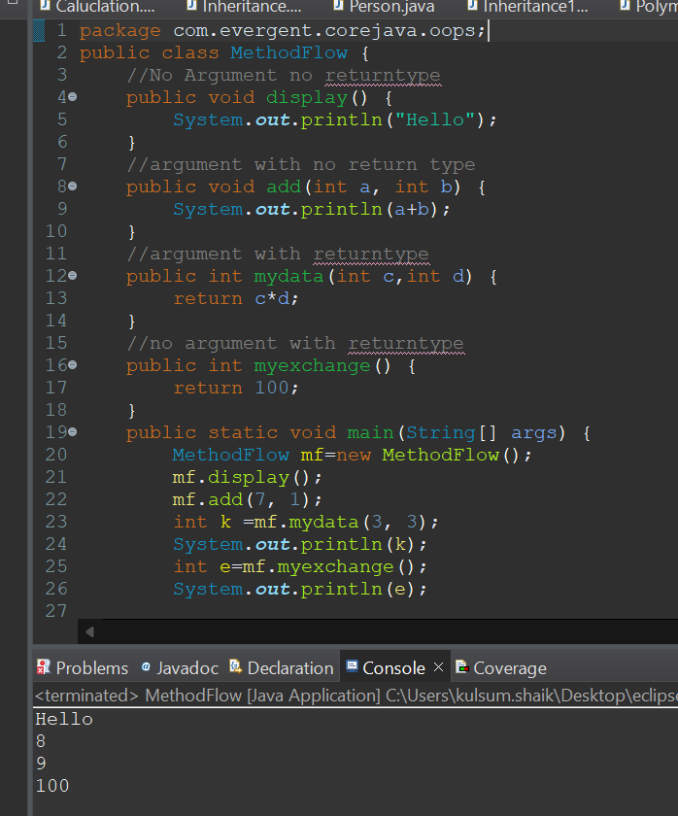

1. **About System.out.println**
2. **Inheritance**

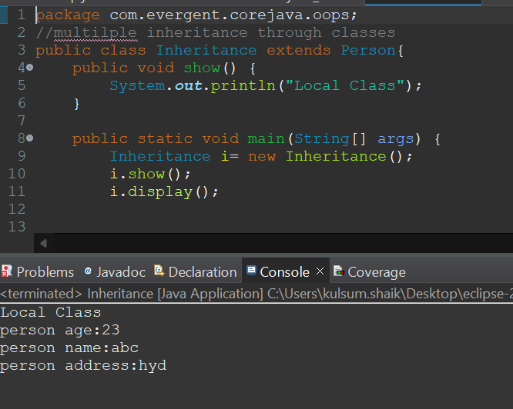

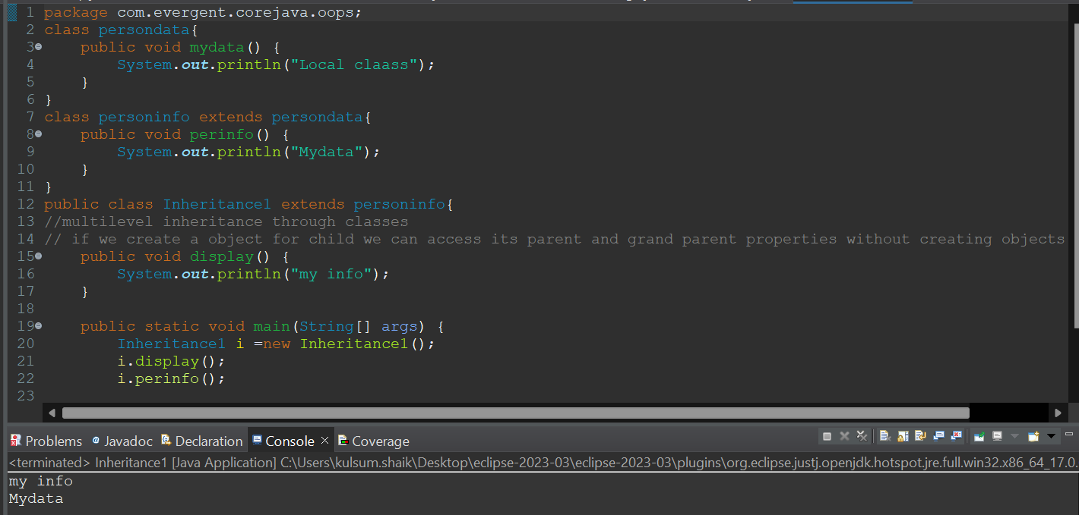

1. **Polymorphism**
2. **Overloading**

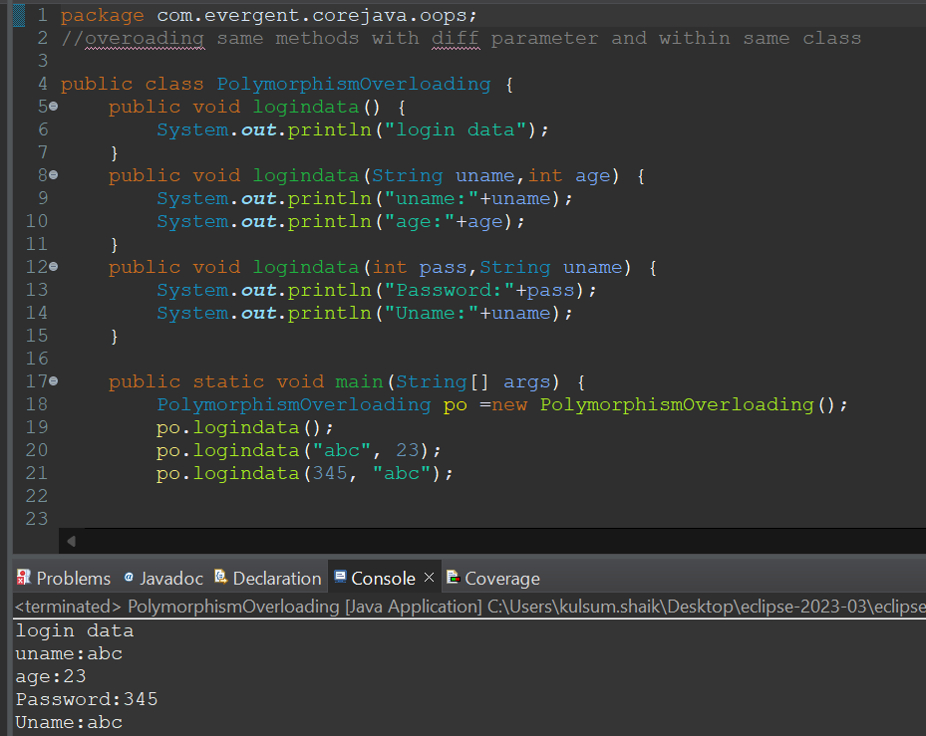

1. **Overriding**

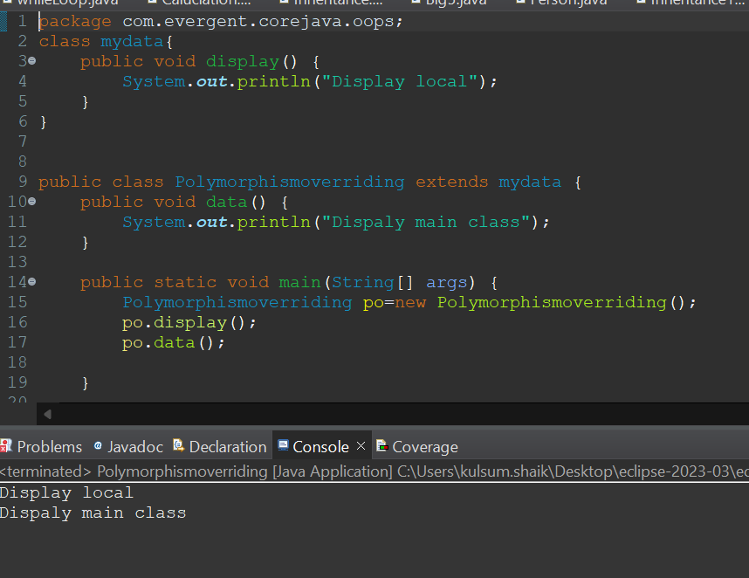

1. **Abstract**
2. **Is_A_Relation**
3. **Has_A_Relation**

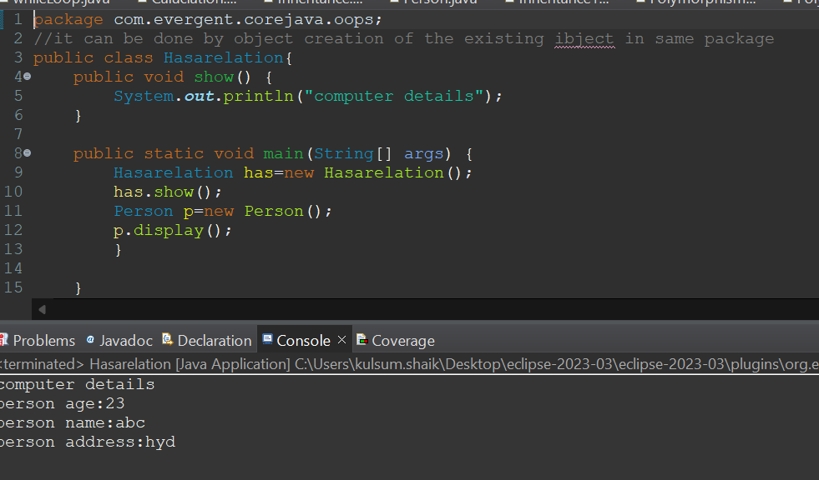

**Date:08/08/24**

**Constructor**

**1) Types of constructors**

**a. Default constructor**

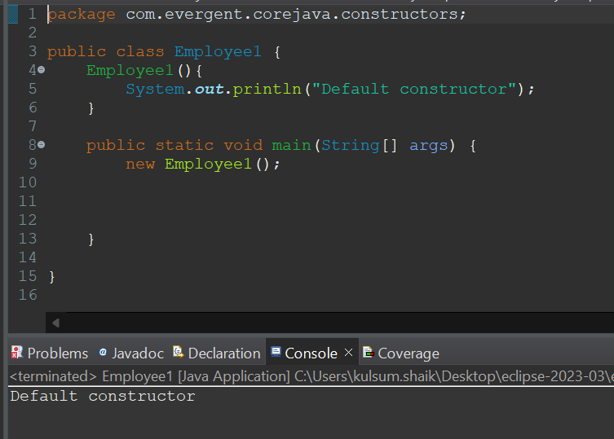

**b. Prameterized constructor**

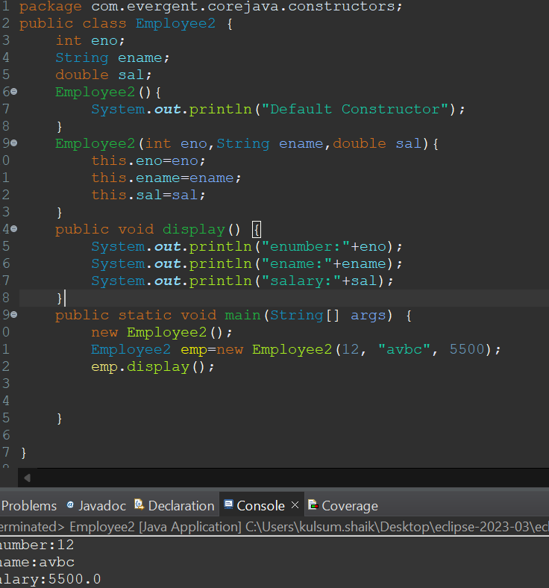

1. **Accessing Constructor through object creation**

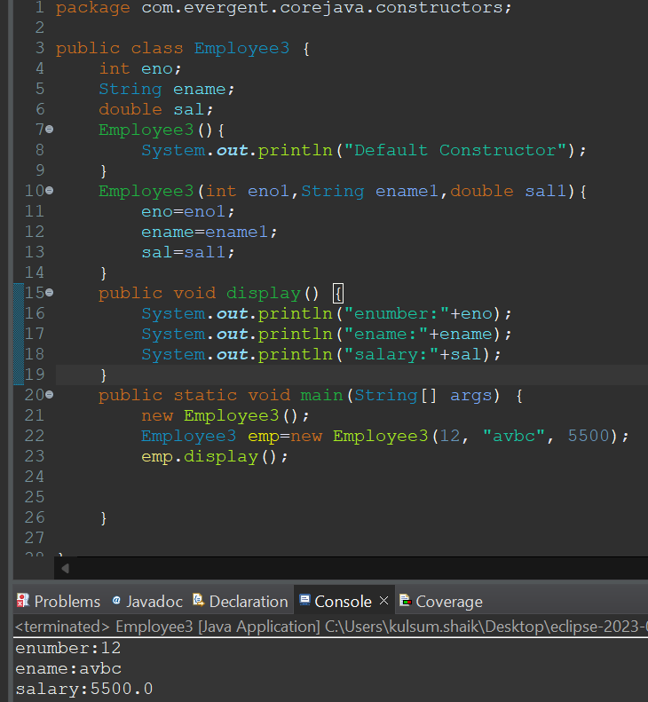

**3)Difference between constructor and method**

**4)Intializing variables using constructor**

**5)this keyword super keyword**

**6)Constructor overloading**

**7)Copy constructor**

**Date:09/08/2024**

1. **Static is a keyword**
2. **Static can declare variables and methods**

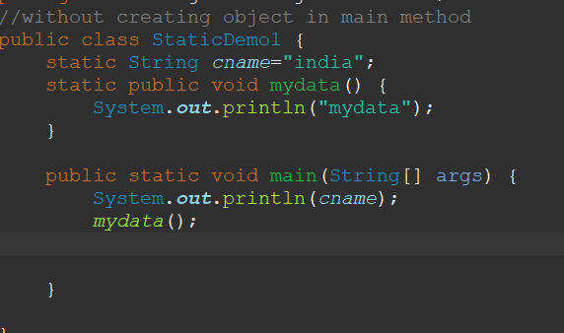

**3)Static can declare as variables and methods through classname.methodname and class nname.variablename**

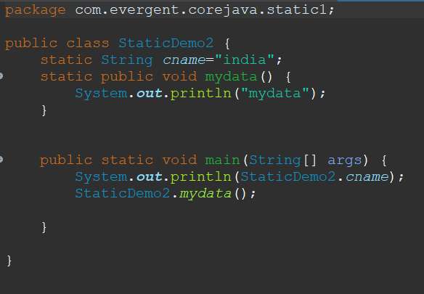

**4)Static methods can access static variables and methods**

**5)Static methods cannot access non static methods and variables**

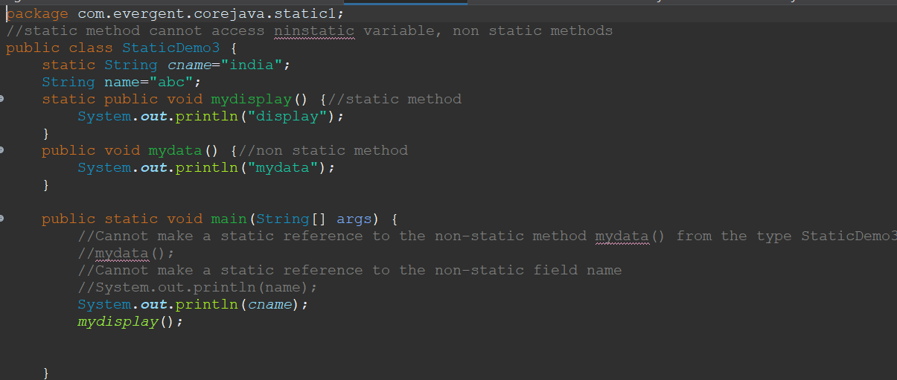

6)Non static methods can acess static methods and variables

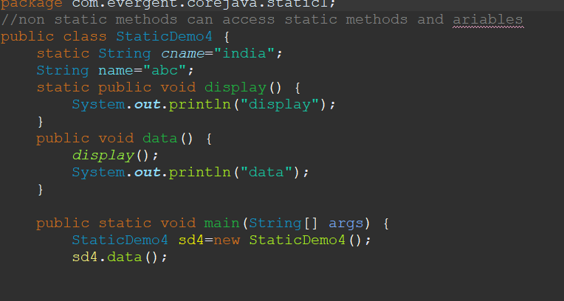

Static block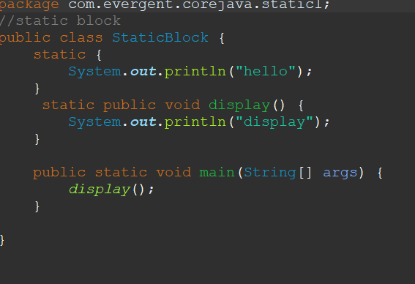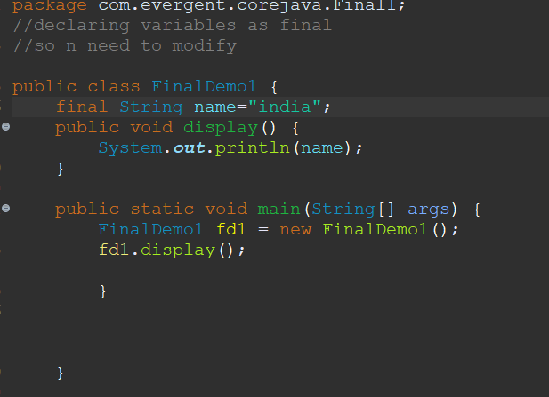

If we change static varible locally,it effects globally

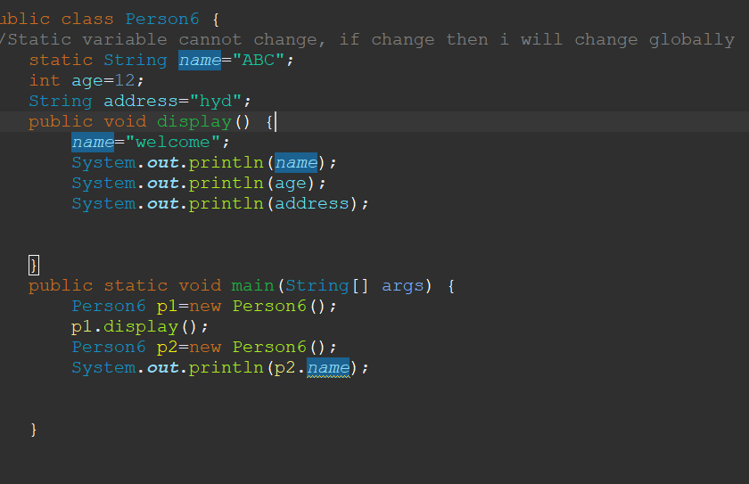

**FINAL keyword**

**1)Final as a variable -we cannont modify variable**

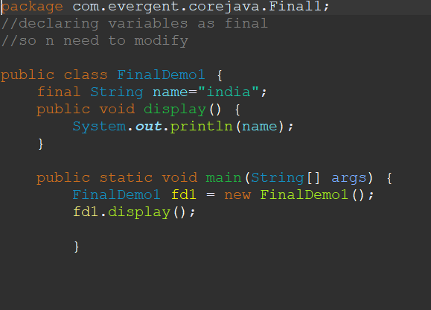

1. Final methods-we cannot override method (we can inherit class but cannont override method)

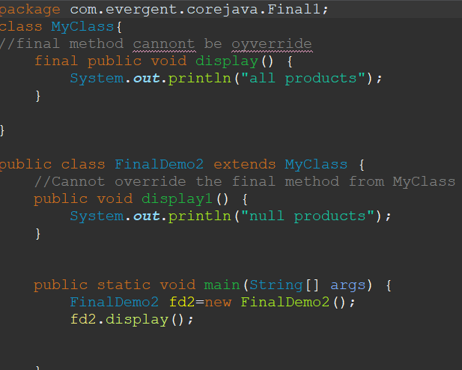

**Final class-we cannont even inherit the classs using extends keyword**

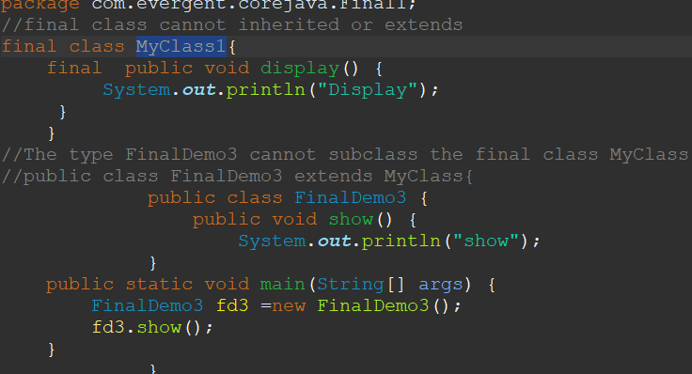

**STRINGS**

**String class String Buffer**

(Disadcv) (advantage) (advan) (disadv)

Immutable non synchronization mutable synchron

String BUILDER(JDK1.5)

**12/08**

**1)String Class:**

**String is final class**

**String is immutable**

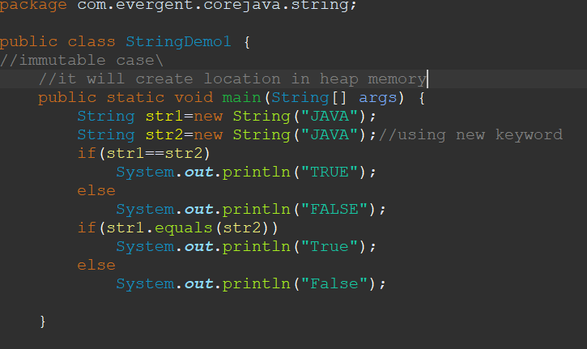

**String class having methods**

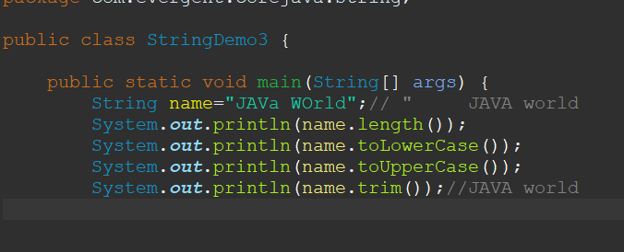

**String class methods are non-Synchronised**

1. **String Buffer**

**String as final**

**String buffer is mutable**

**String Buffer having methods**

**Program1**

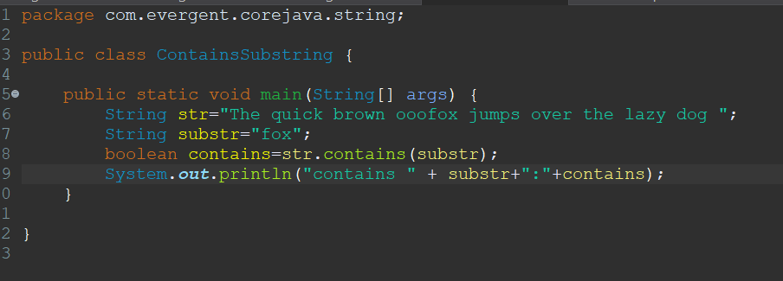

**Proram2**

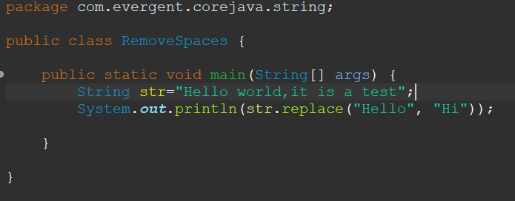

**Program3**

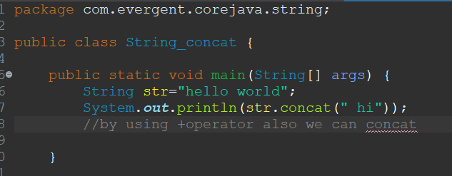

**Program 4**

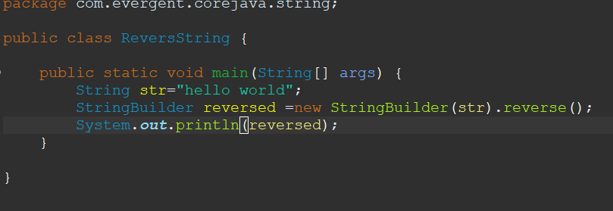

**Program5**

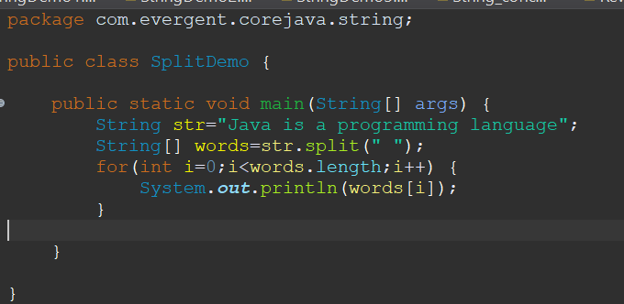

**Program 6**

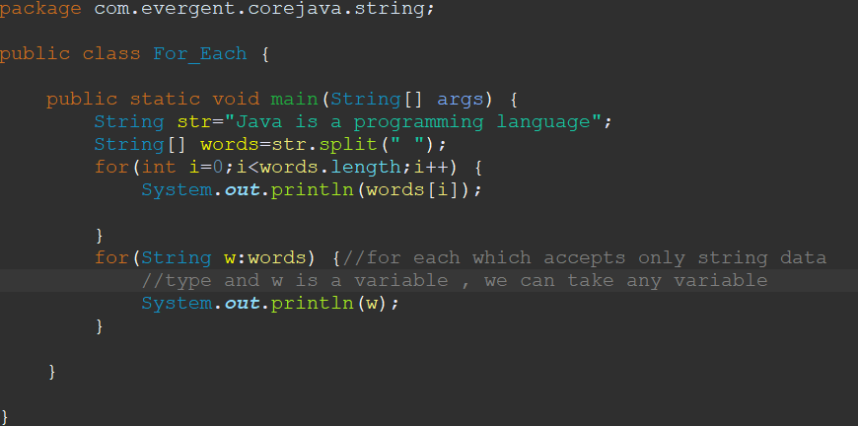

**Program 7**

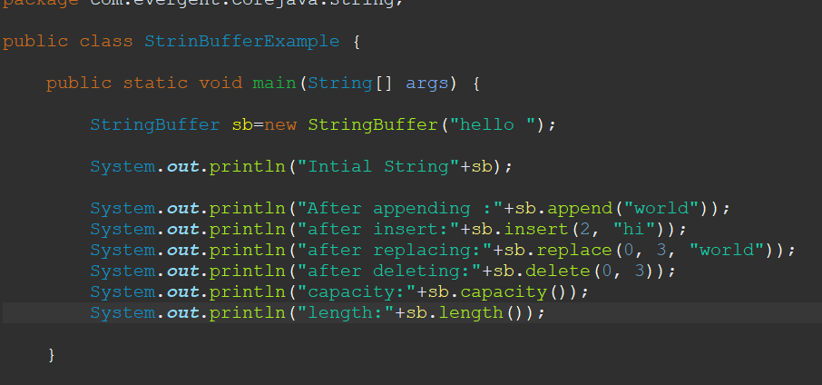

**String Buffer are Synchronization**

1. **String Builder**

**String as final**

**String Builder is mutable**

**String Builder having methods**

**Program 1**

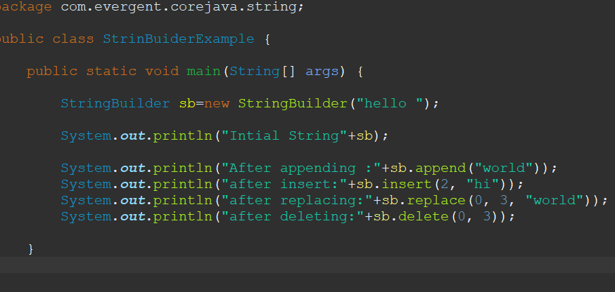

**Program 2**

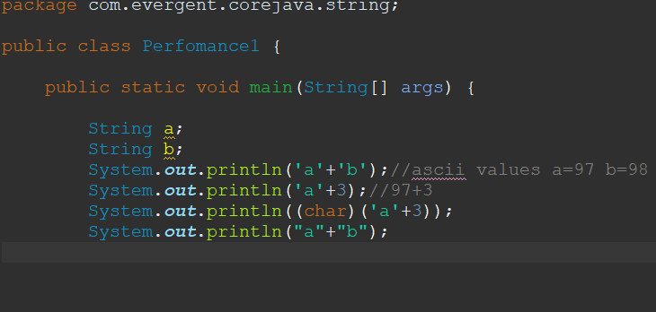

**Program 3**

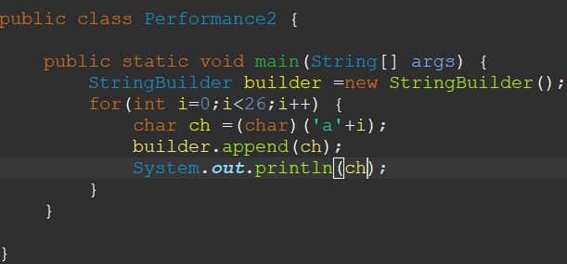

**String Builder are non Synchronization**

**Can we make class as Immutable?**

**Yes, when we declare class as final and declaring variables final and private**

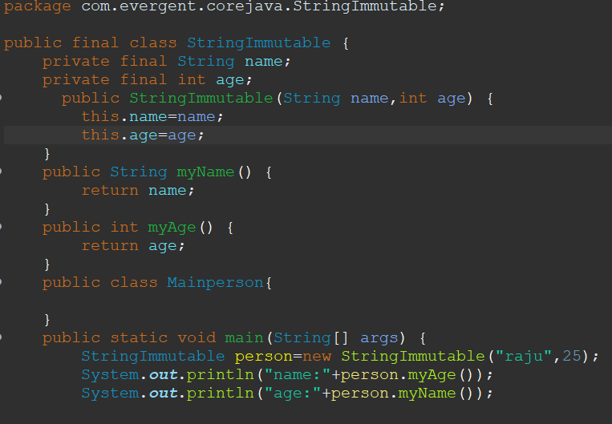

**Object class-**

1. **tostring()**
2. **Hash code**

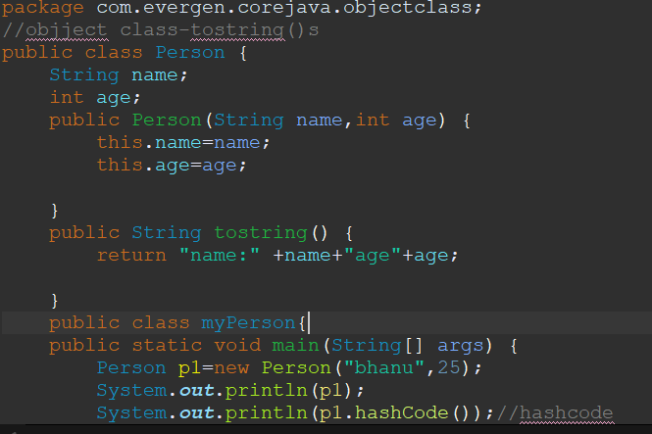

**INTERFACE**

1. **interface is a keyword**
2. **We can declare only method signature but, not implementation in interface**

**THE BELOW PICTURE CAN COVER POINTS OF 1 2 3 4 6 8**

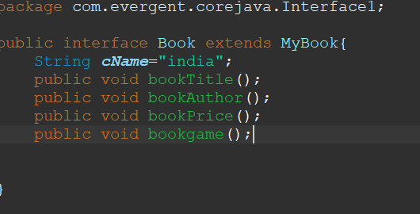

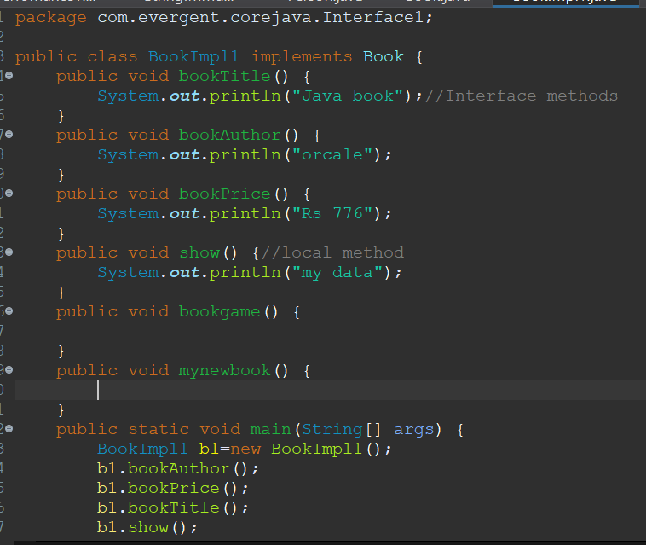

1. **By default all interface methods are abstract**
2. **If any class implements interface then the class should override all methods of interface or else its shows compile time error.**
3. **We cannot create object to interface , but we can create a reference to interface**

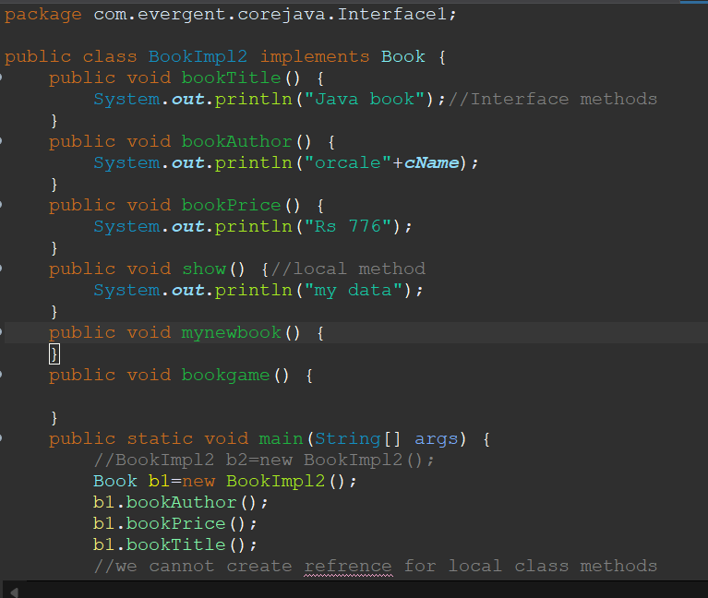

1. **Java support multiple inheritance through interfaces**

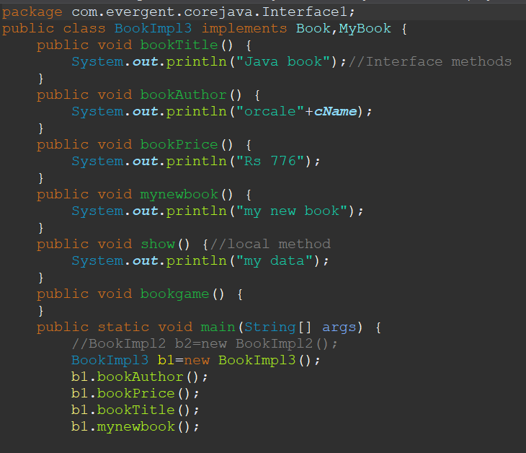

1. **One class can have more than one interfaces**
2. **One interface can extends other interface.**

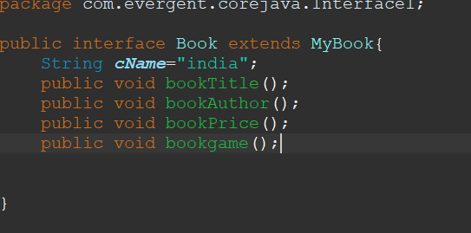

**Use of interface in software industry:**

**Its acts as templates for the project**

**And everyone should follow the same structure**

**ABSTRACT**

1. **Abstract is a keyword**

**19/08/24**

**EXCEPTION HANDLING**

1. **exception handling is mechanism**
2. **Exceptions are inbuilt mechanism of java**
3. **All exception are executed while abnormal conditions only**
4. **Normal flow it wont execute any exceptions**
5. **Once any exceptions are occurring in java then remains lines of code is unreadable.**
6. **Java.lang.Throwble is super class for exception and error**
7. **There are two types of exception in java**
8. **checked exception**
9. **Unchecked exception**
10. **all checked exceptions are compile time exceptions**
11. **All unchecked exceptions are runtkme exceptions**
12. **there are 5 keywords**

**try()**

**Catch()**

**Finally()**

**Throws()**

**Throw()**

1. **try is for businesss logic**
2. **Catch is for handling exceptions**
3. **Finally is block,if exceptions is occur or not finally block will executed**
4. **Throws an exception will be executed methodby method**
5. **Throw is for runtime exceptions and will call predefined exceptions or not user defined exceptions**
6. **Try followed by either catch or finally block**
7. **We should follow exceptions hirerachy**
8. **We can create our own exceptions(user defined)**
9. **Our own exceptions extends exception or runtime.**
10. **All exceptions classes are in to java.lang package**
11. **There is two exception in class developer should be handle one after one**
12. **Developer cant handle errors**

**Program1**

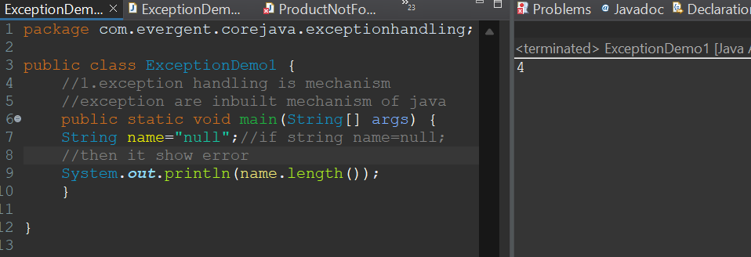

**Program2**

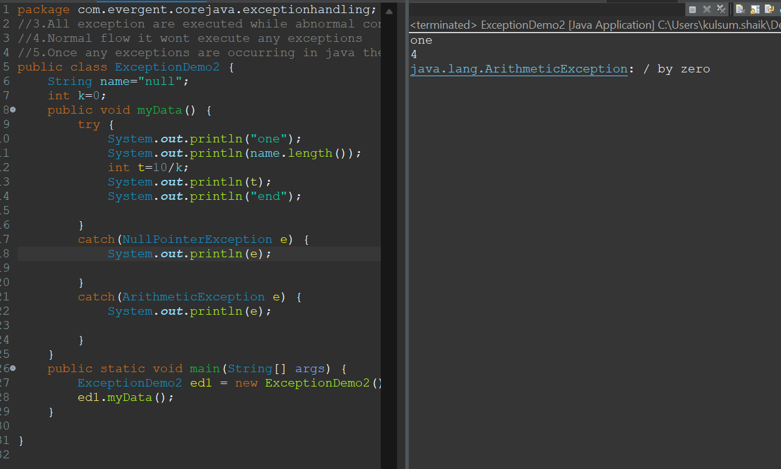

**Program3**

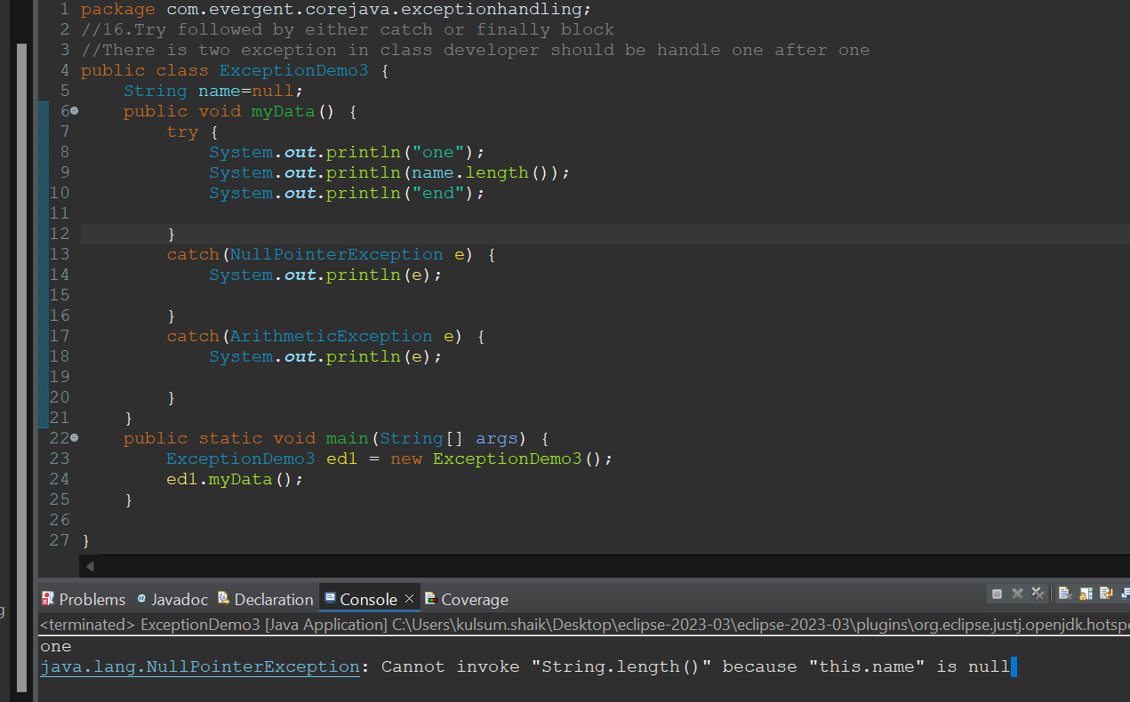

**Program4**

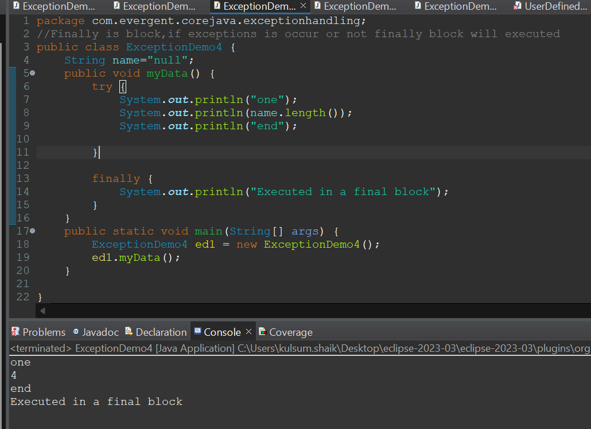

**Program5**

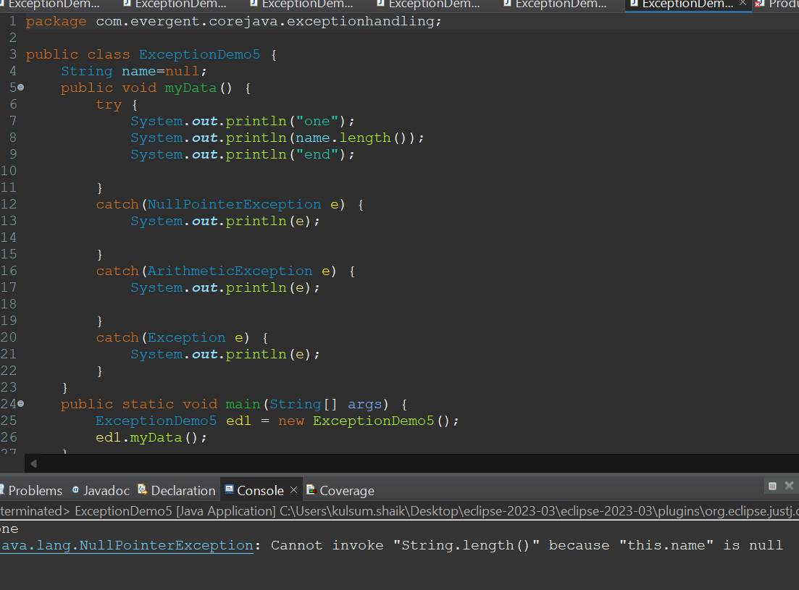

**Program6**

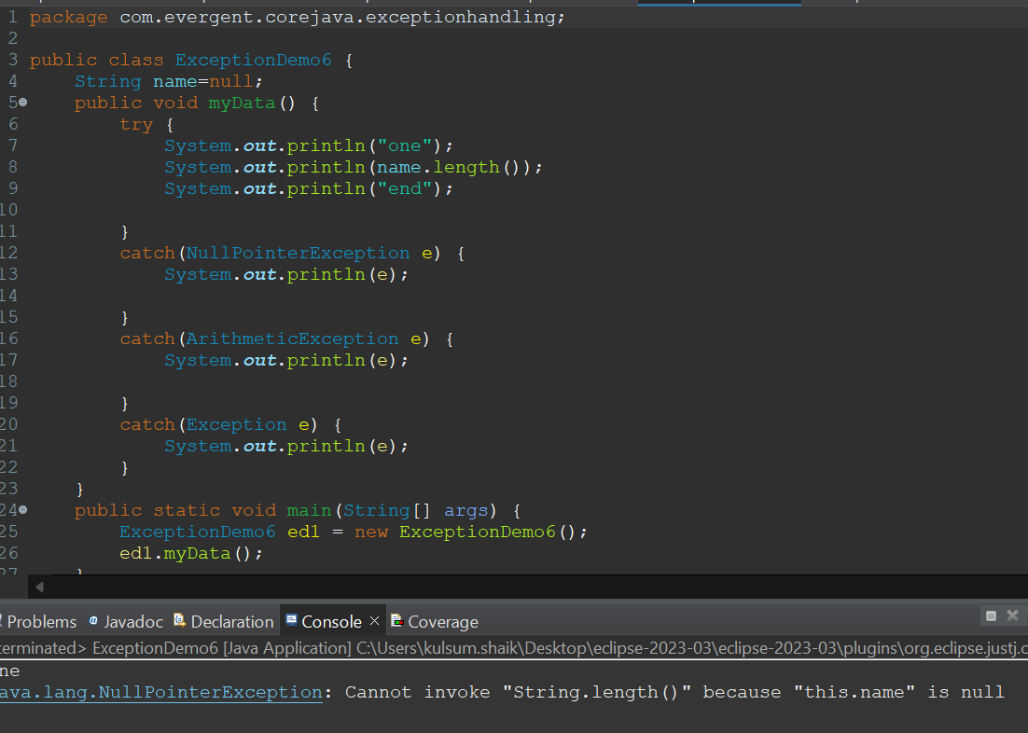

**Program7**

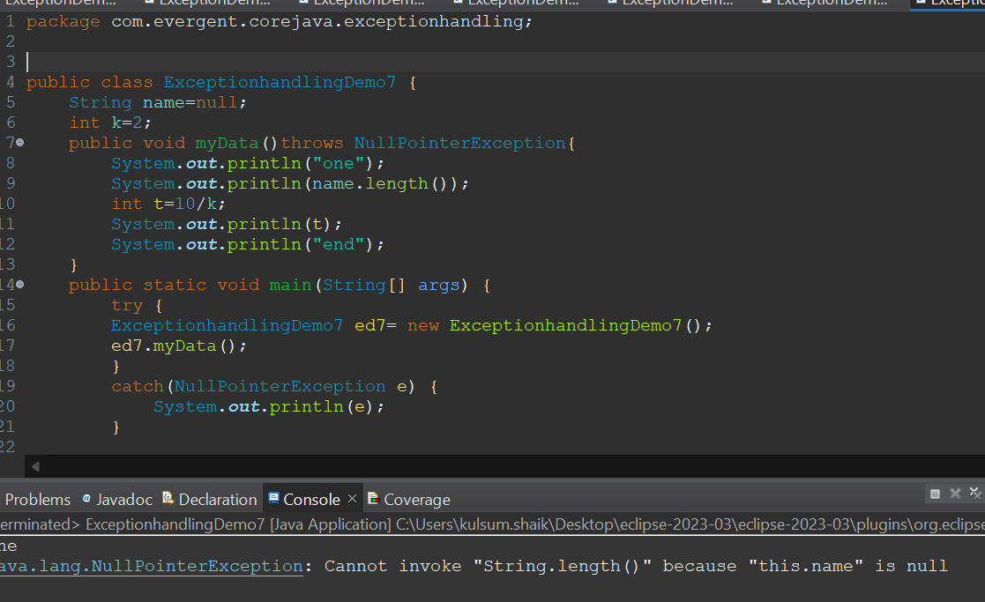

**Program8**

**(using throws keyword)**

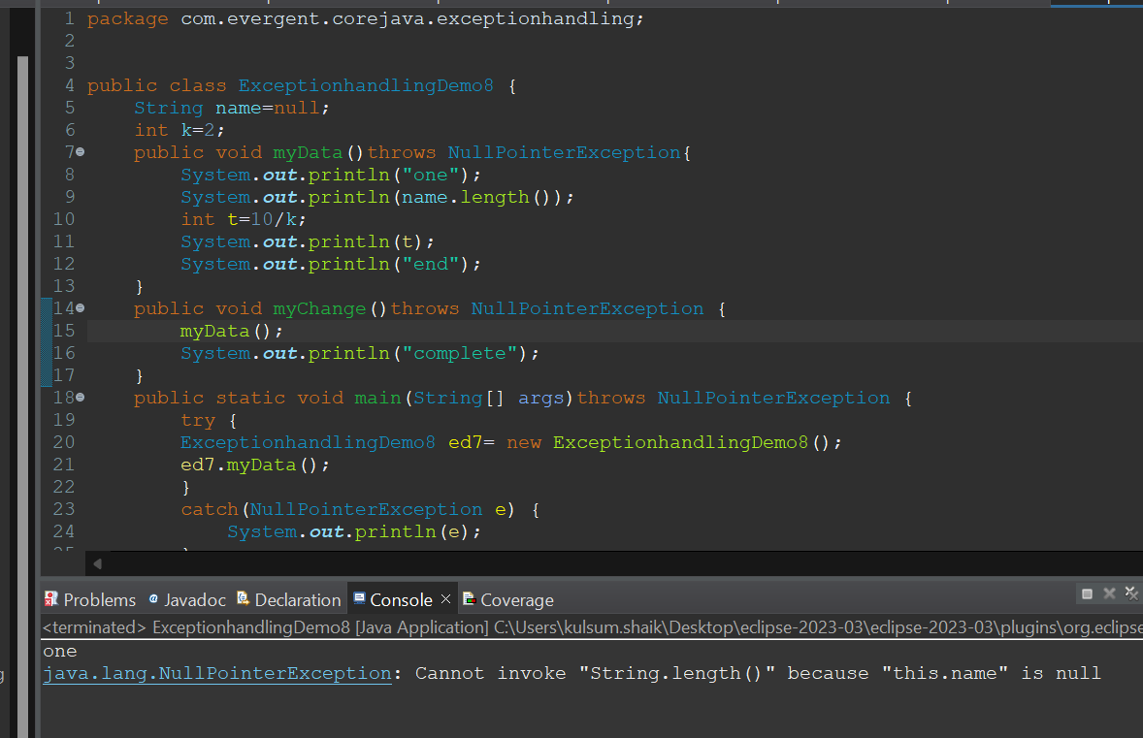

Program9

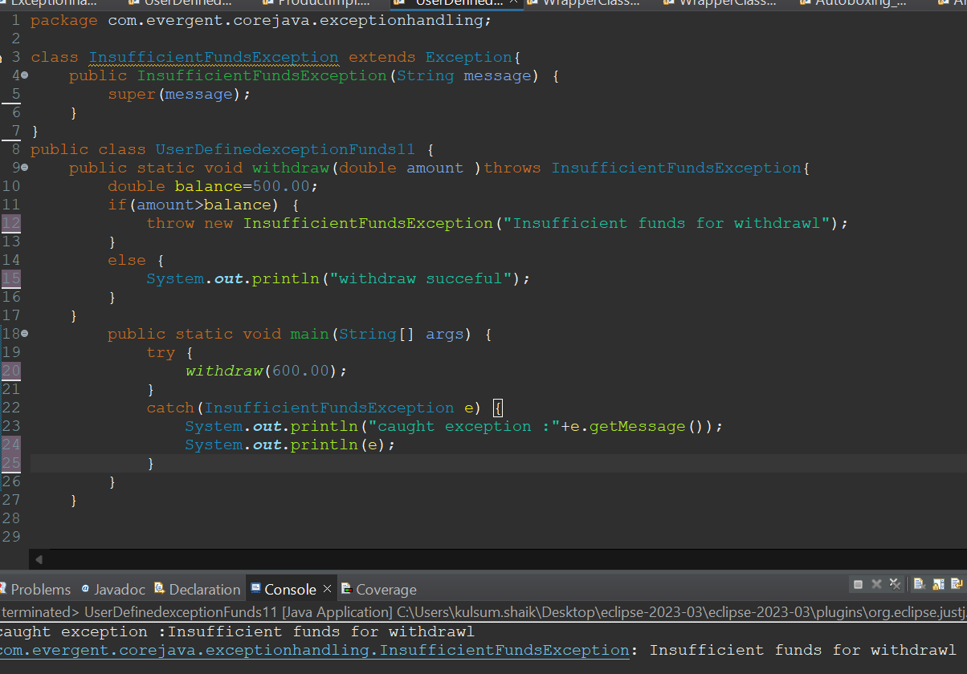

Program 10

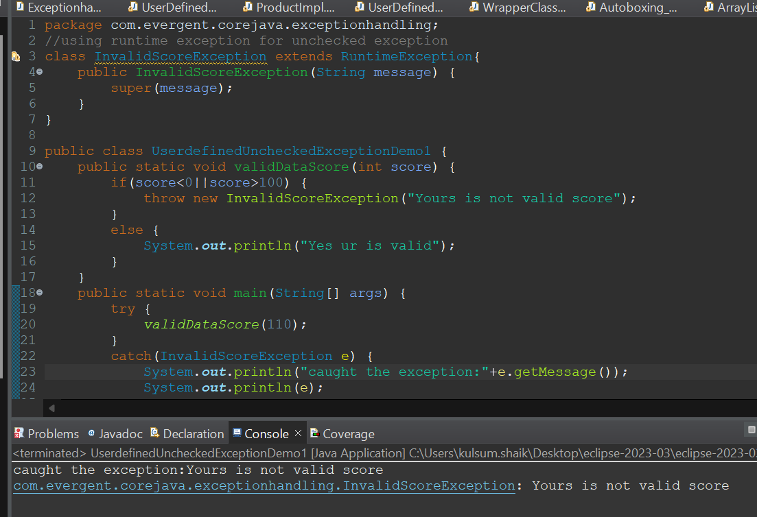

Program 11

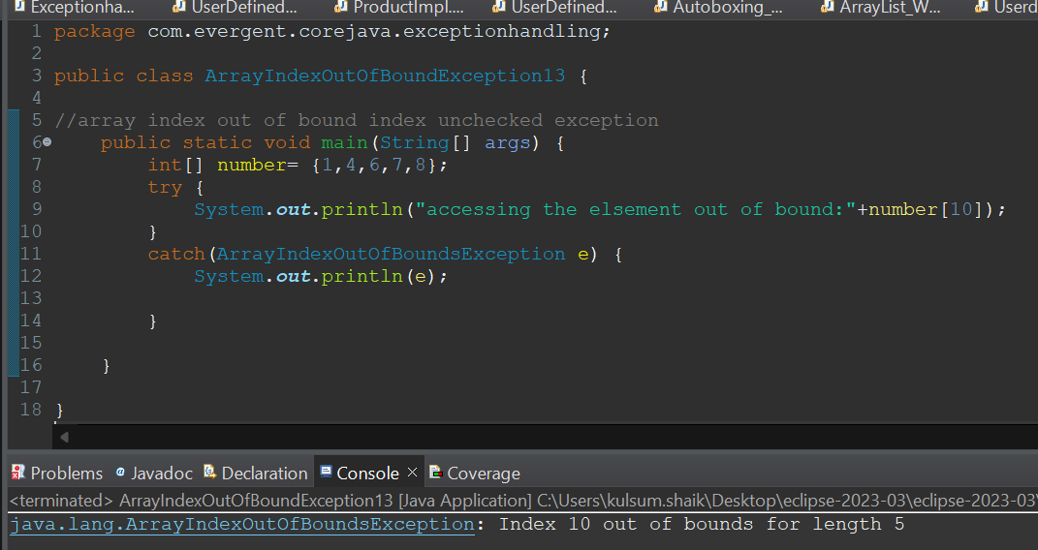

Program12

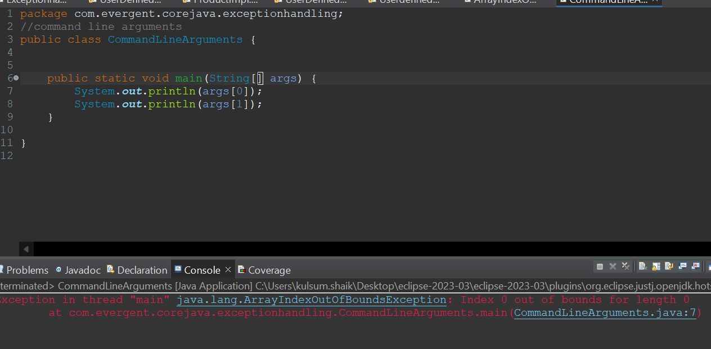

Program13

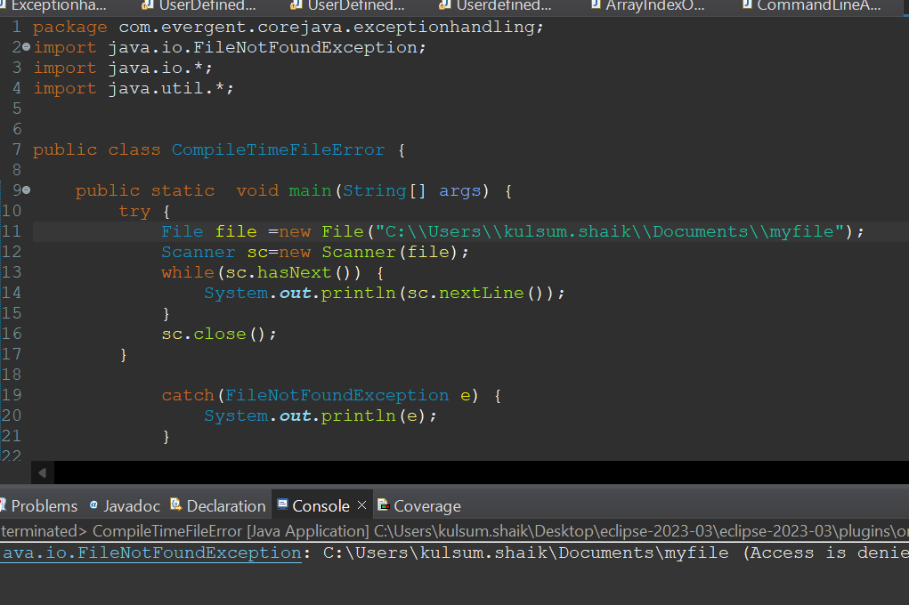

JAVA BEANS  
1)JAVA bean is lightweight

1. java bean is a mechanism
2. All attributes are private and get/set methods are public implements java.io.serializable interface
3. We can achieve tightly encapsulation through java beans

Program 1

Intializing getter and setter methods

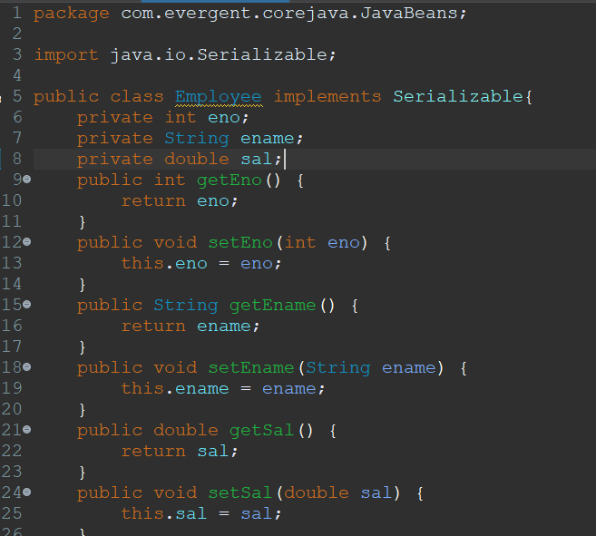

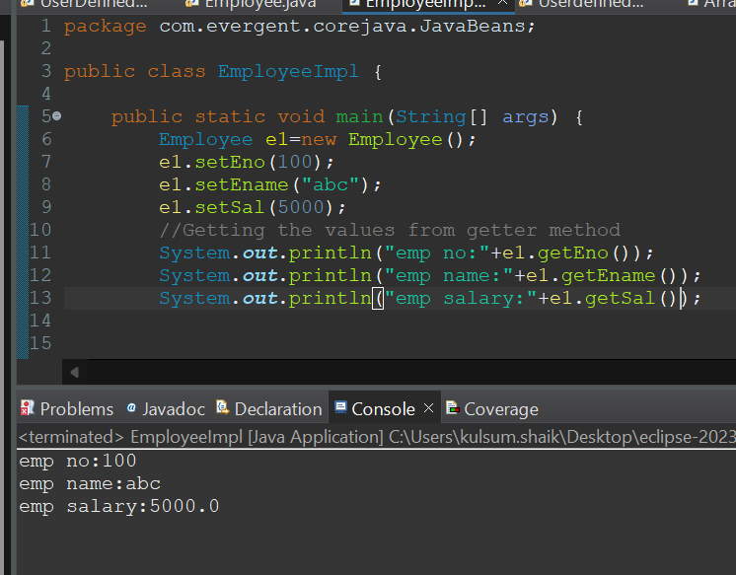

Program2

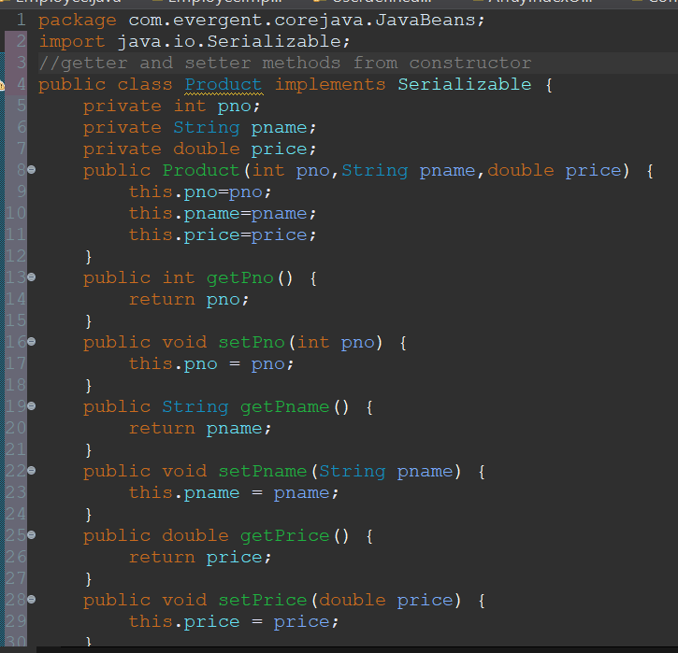

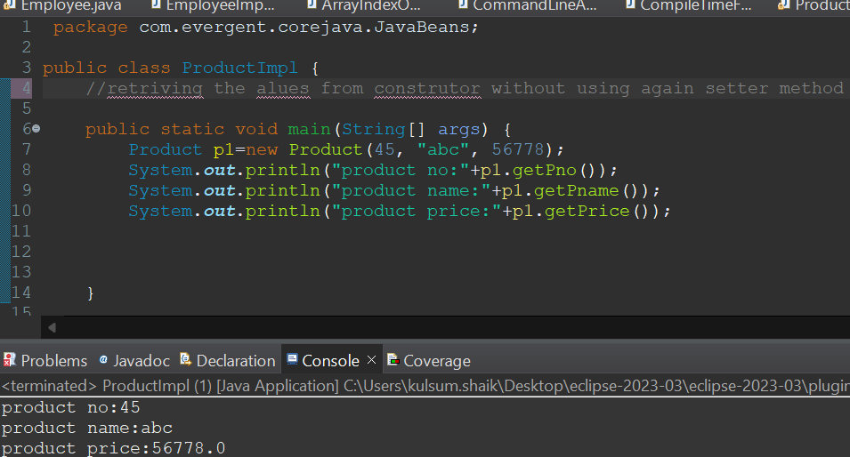

Program 3

Using tostring

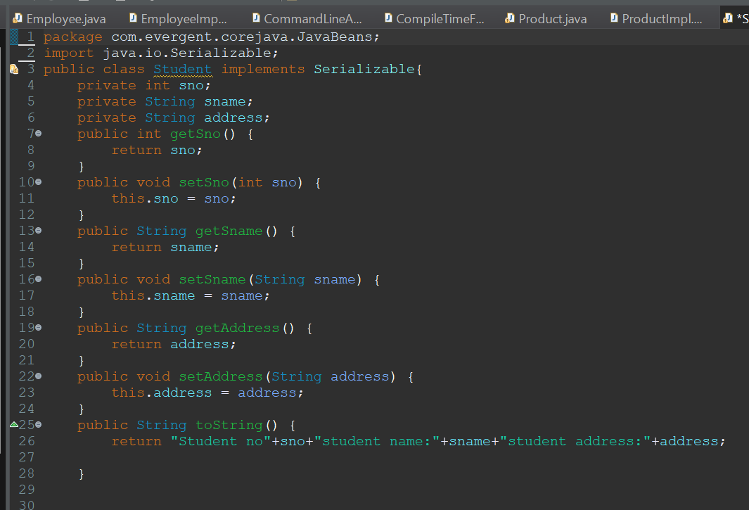

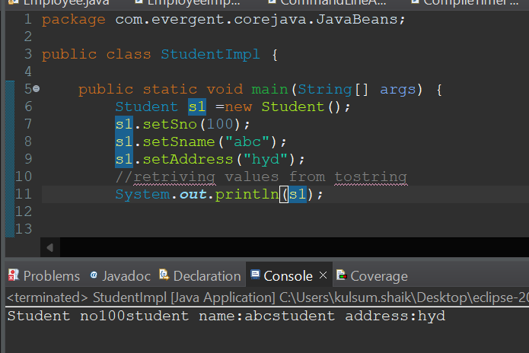

WRAPPER CLASSES

Program 1

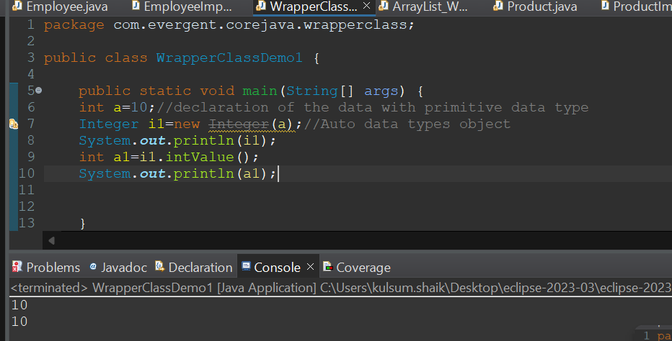

Program 2

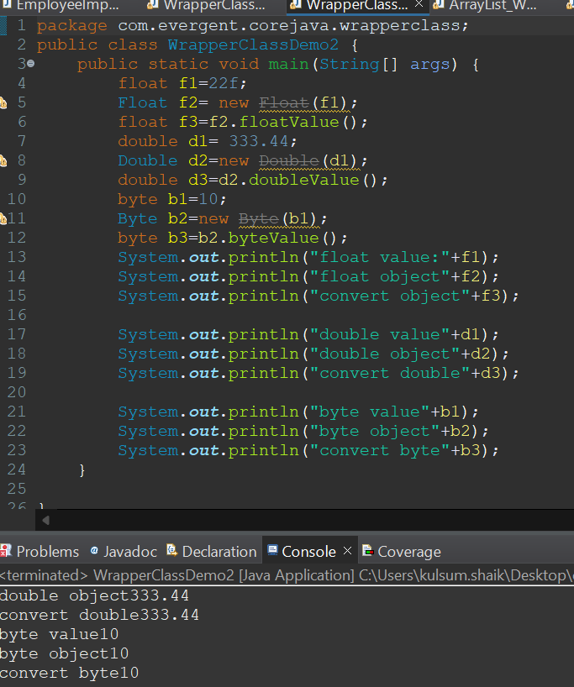

Program 3

