ZAMBIA UNIVERSITY COLLEGE OF TECHNOLOGY
School of Information and Communication Technology

UniVote: Designing and Developing a Multi-Tenant Digital Voting Ecosystem for Higher Learning Institutions in Zambia

By

TAONGA SIKALUMBI
Student Number: 2300104

A Project submitted to Zambia University College of Technology in
Partial fulfilment for the award of a Bachelor of Software Engineering

Supervisor:
Mr. Silwizya

NDOLA, ZAMBIA
©2025

NOTICE OF COPYRIGHT

I do hereby declare that the content of this document is my own and all other works by other people have been only referenced and that this work has not been previously presented to another University for the same purpose.

Simon Ng’and (Candidate) ______________________
Date _______________________
Mr Silwizya (Supervisor) _______________________
Date _______________________
ACKNOWLEDGEMENTS
I am sincerely grateful to my supervisor, Mr. Silwizya, for his guidance, constructive criticism and patience throughout this project. His direction shaped both the system and this report.
I also thank my family for their support, encouragement and patience throughout my studies. This work would not have been possible without them.

ABSTRACT
Student elections at many Zambian higher learning institutions still depend on manual, paper-based procedures that are slow, costly and open to disputes over voter verification and vote counting. Existing electronic voting systems are usually built for a single institution and cannot be adopted by others without redevelopment. This project designed, developed and evaluated UniVote, a multi-tenant web-based digital voting system for higher learning institutions in Zambia.
The study had three objectives: to design a multi-tenant architecture in which institutions run isolated voting environments on shared infrastructure; to implement secure session management with JSON Web Tokens and data integrity measures against unauthorised access and ballot tampering; and to provide identity assurance through device-native user verification. The system was built as a React progressive web application with a Node.js and Express API and a PostgreSQL database that uses a separate schema for each institution. Ballots are stored without a voter identifier and with a SHA-256 hash, and voters verify their identity through WebAuthn using a fingerprint, face unlock or device PIN, so UniVote stores no biometric data.
The system was evaluated between 23 October and 6 November 2026 through a manual end-to-end walkthrough of the election workflow and through automated tests. Every implemented feature operated as expected. The unit tests (21 tests) and integration tests (5 tests), which covered tenant isolation, ballot hashing and rejection of a repeated vote, all passed, and one of three end-to-end tests passed while two were skipped. Scalability, availability, usability and resistance to attack were not measured.
The study concludes that UniVote works as a complete multi-tenant election prototype. It recommends further automated and adversarial testing, load testing and a supervised pilot at a participating institution before it is used for a real election.
Keywords: Electronic voting; multi-tenancy; WebAuthn; student elections; higher learning institutions; Zambia

TABLE OF CONTENTS
CHAPTER ONE: INTRODUCTION 4
1.1 Background of the Study 4
1.2 Problem Statement 5
1.3 Aim and Objectives 6
1.3.1 Research Aim 6
1.3.2 Research Objectives 6
1.4 Research Questions 7
1.5 Scope and Limitations 7
1.6 Significance of the Study 8
1.7 Conceptual Framework 8
1.7.1 The Security Pillar 9
1.7.2 The Multi-Tenancy Pillar 10
1.7.3 The Automation Pillar 10
1.8 Organisation of the Report 10
1.9 Summary 11
CHAPTER TWO: LITERATURE REVIEW 13
2.1 Introduction 13
2.2 Related Works 13
2.3 Review of Related Works 14
2.3.1 E-Voting using Blockchain Technology — Yadav et al. (2020) 14
2.3.2 Multi-Tenant SaaS Architectures — Kumar (2020) 15
2.3.3 Security Challenges of an E-Voting System — Atuah et al. (2024) 16
2.3.4 Digital Rights and Elections in Zambia — Bloggers of Zambia (2021) 17
2.4 Proposed System 17
2.5 Summary 19
CHAPTER THREE: RESEARCH METHODOLOGY 21
3.1 Introduction 21
3.2 Software Development Methodology 21
3.3 Requirements Specification 22
3.3.1 Identify the Stakeholders 22
3.3.2 Requirements Gathering 23
3.3.3 Requirements Analysis 24
3.4 Summary 29
CHAPTER FOUR: SYSTEM DESIGN AND IMPLEMENTATION 31
4.1 Introduction 31
4.2 Architectural Design 31
4.2.1 Presentation Tier 32
4.2.2 Logic Tier 33
4.2.3 Data Tier 34
4.3 Software Design 34
4.3.1 Software Design Tools 35
4.3.2 Component Design 35
4.4 Software Development 40
4.4.1 Software Development Tools 40
4.4.2 Component Development 42
4.4.3 Evaluation and Testing Techniques 43
4.5 Deployment 44
4.6 Summary 45
CHAPTER FIVE: RESULTS AND DISCUSSION 46
5.1 Introduction 46
5.2 Evaluation Environment and Method 47
5.2.1 Evaluation Environment 47
5.2.2 Evaluation Method 48
5.2.3 Automated Test Suites 48
5.3 Results 48
5.3.1 Functional Verification 48
5.3.2 Results Mapped to Objectives and Requirements 49
5.3.3 Automated Test Summary 50
5.3.4 Assessment Against Non-Functional Requirements 50
5.3.5 Screenshots of the Implemented System 51
5.4 Discussion 51
5.4.1 Findings Against the Research Objectives 51
5.4.2 Findings Against the Research Questions 52
5.4.3 WebAuthn Design: Proposal Versus Implementation53
5.4.4 Differences from the Proposal and Scope Limitations 54
5.4.5 Comparison with the Reviewed Literature 54
5.4.6 Limitations 55
5.5 Chapter Summary 56
CHAPTER SIX: CONCLUSION AND RECOMMENDATIONS 58
6.1 Introduction 58
6.2 Summary of Findings 58
6.3 Conclusions 58
6.4 Contributions of the Study 59
6.5 Limitations 59
6.6 Recommendations and Future Work 59
6.7 Chapter Summary 60
REFERENCES 60

CHAPTER ONE: INTRODUCTION

1.1 Background of the Study
The rapid evolution of Information and Communication Technologies (ICTs) has fundamentally altered the landscape of organizational governance and democratic participation globally. In the context of higher education, student representation acts as a critical pillar for institutional stability and academic freedom. Traditionally, these democratic exercises have relied on manual, paper-based systems. However, as noted by researchers, manual voting systems are increasingly characterized by high administrative costs, susceptibility to human error, and significant delays in result tabulation [3]. In emerging economies, the shift toward "E-Democracy" is no longer a luxury but a functional necessity to ensure that the voices of a tech-savvy youth population are accurately captured.
In the Zambian academic landscape, the digital divide remains a significant challenge, yet the demand for transparency is at an all-time high. Institutions like the University of Zambia (UNZA) and the Zambia University College of Technology (ZUT) represent two ends of the digital transformation spectrum. While some institutions have attempted to implement localized electronic voting (e-voting) solutions, these systems are often developed as "siloed" applications [2]. A siloed application is designed to serve a single entity, making it difficult or impossible to scale across multiple campuses or different organizational structures without substantial redevelopment. This lack of interoperability results in a duplication of effort and high financial barriers for smaller colleges that cannot afford custom-built software.
Furthermore, the integrity of an election rests on reliable voter registration and controlled access to the ballot. In many Zambian colleges, officials verify student identities against paper registers at the polling station, a process that can be slow and may lead to disputes. UniVote addresses the administrative burden by allowing a School Admin to register and manage the voter roll; access to a ballot is then limited to an active registered account, an open election, and a voter who has not already participated.
The concept of "Multi-Tenancy" in software architecture offers a viable solution to the scalability problem. Multi-tenancy allows a single instance of a software application to serve multiple "tenants" (institutions), where each tenant's data is logically isolated from the others [2]. This approach reduces the cost of deployment and maintenance while providing a high-standard security framework that can be shared across the academic sector. This study, therefore, explores the development of UniVote, a multi-tenant digital voting ecosystem designed to provide a secure, transparent, and scalable solution for Zambian higher learning institutions.

1.2 Problem Statement
Despite the global trend toward digitalization, many higher learning institutions in Zambia continue to utilize antiquated manual voting methods or inefficient hybrid systems. At institutions like Zambia University College of Technology (ZUT), the reliance on manual verification at the polling station leads to long queues, logistical bottlenecks, and frequent disenfranchisement. This issue is mirrored on a national scale; a report by Bloggers of Zambia [4] identifies that the lack of transparent, accessible digital infrastructure in the country contributes significantly to "student voting suppression," where procedural hurdles prevent the youth from exercising their democratic rights.
Furthermore, manual counting of physical ballots remains a significant point of failure. It is time-consuming and may lead to allegations of ballot stuffing or tabulation errors, which can result in campus unrest and loss of confidence in student leadership [1]. Existing digital solutions may also retain manual backups or physical verification where institutions do not trust the system or where procedures for managing voter access are unclear.
These proprietary systems are built for specific institutional environments and cannot be easily adopted by other colleges, leaving smaller institutions reliant on manual, error-prone processes. The core problem is the absence of a unified, secure, multi-tenant digital voting platform that supports institutional onboarding, voter-roll administration, secure ballot casting, and result tabulation. Without such a system, student elections remain exposed to human error, high costs, and limited transparency. Atuah et al. [3] document related vulnerabilities in institutional e-voting systems in Ghana, including weak authentication, insider threats, and inadequate voter verification, further supporting the need for a secure digital voting solution.

1.3 Aim and Objectives

1.3.1 Research Aim
The primary aim of this project is to design, develop, and implement a multi-tenant digital voting platform, "UniVote," that provides a secure, transparent, and automated electoral environment for various higher learning institutions in Zambia.

1.3.2 Research Objectives
To achieve the stated aim, the following specific objectives have been identified:
i. To design a multi-tenant software architecture that allows different institutions to operate isolated voting environments within a shared infrastructure.
ii. To implement secure session management using JSON Web Tokens (JWT) and data integrity protocols to prevent unauthorized access and ballot tampering.
iii. To strengthen identity assurance by requiring device-native user verification through WebAuthn (biometric or device PIN) before a ballot token is issued to a student signed in with registered account credentials.

1.4 Research Questions
This study seeks to answer the following questions:
i. How can a multi-tenant architecture be optimized to ensure complete data isolation between different institutions while maintaining high system performance?
ii. How will security protocols be most effective in ensuring the "one-student-one-vote" principle in a remote, web-based environment?
iii. How can device-native authentication via the WebAuthn protocol enhance identity assurance and mitigate the risk of voter impersonation in a multi-tenant digital voting environment?

1.5 Scope and Limitations
The scope of this project is focused on the software engineering aspects of developing a voting ecosystem. The implemented web application uses React 18 with Vite for the front end and Node.js for the back-end services. It features a Super Admin portal for institutional onboarding, a School Admin portal for managing elections, candidates and voters, and a Student Portal for casting ballots.
Geographically and contextually, the study is limited to higher learning institutions in Zambia. The system provides administrative tools for each institution to register voters and manage their active status; it does not require access to institutional student records.
In terms of limitations, the study acknowledges that the findings and system design are specific to the Zambian higher education context and may require adaptation before deployment in other institutional environments. Voter access depends on the accuracy of the voter roll maintained by the School Admin, and adoption and digital literacy among students and administrative staff may influence the effectiveness of the platform in practice.

1.6 Significance of the Study
This study is significant for several stakeholders in the Zambian education and governance sectors. For students, the platform provides a convenient and accessible way to participate in democracy, potentially increasing voter turnout and ensuring that their voices are heard regardless of their physical location.
For educational institutions, UniVote offers a cost-effective alternative to manual voting and expensive proprietary software. By adopting a multi-tenant model, colleges can share the overhead costs of digital infrastructure while maintaining control over their electoral rules. The School Admin can manage the voter roll and active status through the platform, reducing reliance on paper-based processes.
From a technological perspective, this research contributes to the body of knowledge regarding the application of multi-tenant architectures in governance software. It demonstrates how modern web technologies, including React, Node.js and secure token-based authentication, can be combined to build voting systems for multiple institutions. Finally, the study provides a basis for further work on digital governance initiatives in Zambia.

1.7 Conceptual Framework
The conceptual framework for UniVote is built upon three theoretical pillars: Security, Multi-Tenancy, and Automation. These pillars interact to create a "Trustless" electoral environment where the integrity of the result is guaranteed by the system's architecture rather than the honesty of individual officials. Figure 1 below illustrates how these pillars converge into the UniVote platform and serve the key stakeholder groups.
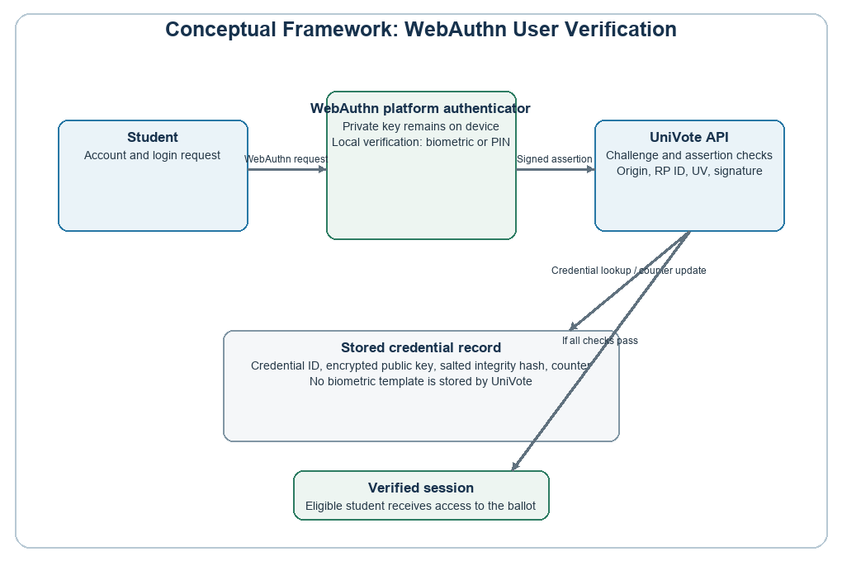
Figure 1: UniVote Conceptual Framework (updated to include WebAuthn user verification in the Security Pillar)

1.7.1 The Security Pillar
Security in e-voting is often defined by the CIA Triad: Confidentiality, Integrity, and Availability [1]. In this project, Confidentiality is maintained by ensuring that a student's vote cannot be linked back to their identity once cast. Integrity is supported through cryptographic hashing and JWTs; a submitted vote is timestamped and hashed so that a later alteration can be detected. Availability is a design objective supported by the Node.js architecture, but it was not measured in this evaluation. Identity assurance is added through WebAuthn after account sign-in. The device authenticator performs user verification locally (biometric or device PIN) before returning a cryptographic response that the server verifies against the registered credential. UniVote does not receive the biometric sample and cannot establish which local method was used. This provides an additional verification step, but it does not prove that the account holder is the physical owner of the device or establish that impersonation has been eliminated.

1.7.2 The Multi-Tenancy Pillar
The framework employs a "Shared Schema" or "Database-per-Tenant" approach to achieve multi-tenancy. This allows the application to serve ZUT, UNZA, and other colleges simultaneously. Each institution is assigned a unique "Tenant ID," which acts as a filter for every database query. This ensures that a student logged into the ZUT portal cannot see the candidates for UNZA, effectively creating a private "virtual" voting system for every school on a unified platform [2].

1.7.3 The Automation Pillar
The automation pillar focuses on digitising administrative and electoral processes. The School Admin maintains the voter roll and can activate or deactivate registered accounts. During voting, the system checks that the account is active, the election is open, and the voter has not already participated before allowing ballot access. This replaces repeated paper-based checks within the voting workflow while leaving voter registration under institutional administration.

1.8 Organisation of the Report
This report is organized into six chapters. Chapter One provides the introduction, background, problem statement, objectives, research questions, scope, significance, and the conceptual framework. Chapter Two presents a comprehensive literature review of related works in the field of e-voting, multi-tenant architectures, and security systems. Chapter Three details the research methodology, including the software development methodology, requirements gathering, and system specifications. Chapter Four covers system design and implementation, presenting the architectural and component design alongside the development tools used. Chapter Five presents the results and discussion, including screenshots of the implemented system. Finally, Chapter Six concludes the report with a summary of findings and recommendations for future work.

1.9 Summary
This chapter has outlined the need for a modern, multi-tenant digital voting platform within the Zambian higher education sector. By identifying limitations in manual and localised digital systems, including scalability, human error and paper-based voter administration, the study establishes the context for UniVote.
The project is grounded in the need for a secure voting workflow that uses the School Admin-managed voter roll, authenticated accounts and controls against repeat participation. The objectives and research questions defined in this chapter guide the technical design and implementation phases. Chapter Two examines research on e-voting, multi-tenant security and related institutional challenges.
The significance of this work extends beyond the immediate technical output; it contributes to the digital transformation of Zambian higher education by providing a platform for more transparent and efficient student elections. UniVote is intended to support confidence in academic elections through secure account access, ballot handling and result reporting.

CHAPTER TWO: LITERATURE REVIEW

2.1 Introduction
This chapter presents a review of existing literature relevant to the development of UniVote, a multi-tenant digital voting platform for higher learning institutions in Zambia. The review is guided by the three core pillars of the UniVote conceptual framework: security, multi-tenancy, and automation. By examining what researchers and practitioners have accomplished in each of these areas, this chapter identifies the technical gaps and institutional challenges that justify the proposed system.
The literature was selected from peer-reviewed journal articles and conference proceedings that directly address electronic voting systems, multi-tenant software architecture, and the security vulnerabilities inherent in institutional e-voting deployments. The chapter is organized as follows: Section 2.2 lists the related works reviewed, Section 2.3 provides a critical analysis of each work, Section 2.4 presents the proposed UniVote system as a direct response to the identified gaps, and Section 2.5 summarizes the chapter.

2.2 Related Works
The following works were identified as directly relevant to the research topic. Each source contributes to one or more of the three foundational pillars of UniVote and forms the basis of the critical review in Section 2.3:
1. Yadav, A. S., Thombare, A. U., Urade, Y. V., and Patil, A. A. (2020). "E-Voting using Blockchain Technology." International Journal of Engineering Research & Technology (IJERT), vol. 9, no. 7, pp. 375-380.
2. Kumar, R. (2020). "Multi-Tenant SaaS Architectures: Design Principles and Security Considerations." Journal of Software Engineering and Simulation, vol. 6, no. 5, pp. 28-41.
3. Atuah, J., Azaabi, C., Laar, D. S., and Mahamadu, R. S. (2024). "Exploring the Security Challenges of an E-Voting System (EVS): A Case Study in the Bolgatanga Senior High School." Asian Journal of Research in Computer Science, vol. 17, no. 10, pp. 132-140.
4. Bloggers of Zambia (2021). "Digital Rights and Elections in Zambia: Assessing Youth Participation and Tech-Governance." Tech. Rep. BZ-2021-04. Lusaka, Zambia.

2.3 Review of Related Works
This section provides a detailed critical analysis of each related work identified in Section 2.2. Each source is examined for its contributions, methodological approach, relevance to UniVote, and its limitations — particularly where gaps exist that the proposed system seeks to address.

2.3.1 E-Voting using Blockchain Technology — Yadav et al. (2020)
Yadav et al. [1] developed and tested a blockchain-based electronic voting application deployed on the Ethereum network using smart contracts written in the Solidity programming language. The system addressed fundamental problems in traditional voting, including ballot tampering, low voter turnout, result delays, and a general distrust of election bodies — challenges directly mirrored in the context of Zambian higher learning institutions. The authors demonstrated that blockchain's inherent properties of immutability and transparency can be leveraged to create a tamper-resistant audit trail in which every cast vote is permanently recorded and publicly verifiable.
The study implemented a token-based gas mechanism to enforce the one-voter-one-vote principle, whereby a voter's wallet is depleted of its allocated token upon casting, making a second vote technically impossible. This principle is relevant to UniVote's controls against repeat participation. From a security standpoint, the paper employed an asymmetric encryption model and a Model-View-Controller (MVC) architectural pattern, providing a layered approach to data management that informs the structural design of UniVote's back end.
UniVote directly adapts this core finding from Yadav & Thombare [1] on the principle of Immutability. Rather than adopting a full blockchain — which introduces cryptocurrency costs and infrastructure complexity impractical in the Zambian academic context — UniVote implements cryptographic hashing for every ballot cast. Each submitted vote is timestamped and hashed using a one-way function; any subsequent alteration of that vote record would produce a detectably different hash, making tampering immediately evident. This provides the transparent, verifiable audit trail that Yadav & Thombare identify as essential for eliminating distrust in the election body, without any of the cost or accessibility barriers of blockchain deployment.

2.3.2 Multi-Tenant SaaS Architectures — Kumar (2020)
Kumar [2] provided a comprehensive technical examination of multi-tenant Software-as-a-Service (SaaS) architectures, comparing three primary database partitioning strategies: Database-per-Tenant, Schema-per-Tenant, and Table-per-Tenant. The paper established that multi-tenancy — where a single application instance serves multiple isolated client organisations — is the dominant paradigm for delivering scalable, cost-efficient cloud software. By sharing computing infrastructure while enforcing strict logical data separation through tenant-specific identifiers, multi-tenant systems eliminate the prohibitive cost and maintenance overhead of deploying a separate application for each client institution.
For UniVote, Kumar's [2] work directly informs the adoption of the Schema-per-Tenant model as the primary database architecture. This model ensures strict Logical Data Isolation between institutions: a student at ZUT is physically and logically unable to access the voting environment of UNZA or any other institution sharing the platform. Each tenant's schema acts as a self-contained electoral environment, making the system both secure and independently auditable per institution. This architecture directly resolves the financial barriers that currently prevent Zambian colleges from adopting high-end, purpose-built e-voting software — by sharing application infrastructure costs across all tenants while keeping all data rigorously separated.

2.3.3 Security Challenges of an E-Voting System — Atuah et al. (2024)
Atuah et al. [3] conducted an exploratory case study of the SaproSoft e-voting system deployed at Bolgatanga Senior High School in Ghana. Using a mixed-methods approach involving surveys, expert interviews, and system testing, the study systematically identified the practical security vulnerabilities present in an institutional e-voting deployment within a developing-country educational context. The findings are highly relevant to UniVote as they represent a documented, empirically verified account of exactly the class of problems this project seeks to solve.
The study identified six critical vulnerability categories: potential voter manipulation through unauthorised ballot access; insider threats from privileged users exploiting their access; weak authentication, where the system relied solely on system-generated username-password pairs that could easily be shared or stolen; a lack of robust voter verification, since the system did not use biometrics or multi-factor authentication; susceptibility to physical attacks, since all devices had to reside on the same local network; and encryption vulnerabilities that could expose vote data in transit. The paper's experts unanimously called for the implementation of stronger authentication mechanisms, end-to-end encryption, real-time system monitoring, and — notably — automated voter identity verification as the most critical improvement needed.
The security findings of Atuah et al. [3] inform UniVote's use of authenticated accounts and WebAuthn user verification. In the implemented system, a School Admin registers voters and manages their active status. Ballot access is checked against that local account status, the election status and prior participation. The code also supports optional external roster import and status checks when an institution configures a compatible service; no live institutional service was demonstrated in the reported evaluation.

2.3.4 Digital Rights and Elections in Zambia — Bloggers of Zambia (2021)
The Bloggers of Zambia technical report [4] assessed the state of digital participation among Zambian youth, with a specific focus on barriers to civic engagement in student electoral processes. The report identified that the absence of transparent, accessible digital infrastructure contributes significantly to what the authors termed 'student voting suppression' — a condition in which procedural and technical hurdles prevent eligible students from exercising their democratic rights. The report documented that institutions relying on manual verification processes consistently experienced low voter participation, long queuing times, and frequent disputes over voter eligibility.
The report is significant not as a technical contribution but as a contextual and policy document. It establishes the real-world demand for the kind of system UniVote proposes, grounding the research in the specific socio-institutional landscape of Zambia rather than in a purely theoretical or foreign context. It confirms that the problems identified in the broader e-voting literature — inefficiency, distrust, and disenfranchisement — are actively present in Zambian academic institutions and that stakeholders, including students and advocacy groups, recognise the need for digital reform. The limitation of this source is that it does not engage with the technical requirements or architectural decisions needed to build such a system; it speaks to the need, not the solution.

2.4 Proposed System
The critical review in Section 2.3 reveals a consistent pattern of gaps across the existing body of work. Yadav et al. [1] demonstrated that digital voting can be made tamper-resistant and trustworthy but produced a system that is inaccessible, single-institution, and economically impractical for Zambian students. Kumar [2] established the architectural blueprint for serving multiple institutions efficiently and securely on shared infrastructure but did not apply these principles to the governance domain. Atuah et al. [3] documented precisely the authentication and verification failures that plague real-world institutional e-voting deployments but stopped short of providing a scalable technical solution. Bloggers of Zambia [4] confirmed that these problems are active and urgent in the Zambian higher education context, providing the civic mandate for this research.
UniVote is proposed as a unified ecosystem that combines these findings for Zambian higher education. From Kumar [2], it adopts the Schema-per-Tenant architecture to reduce the cost of institutional adoption. From Yadav et al. [1], it adapts cryptographic hashing to support detection of ballot-record changes. In response to the authentication concerns described by Atuah et al. [3], UniVote provides authenticated accounts and WebAuthn user verification, while the School Admin manages the voter roll.
UniVote addresses voter administration through a School Admin-managed voter roll and checks account status, election status and prior participation during the voting workflow. The code also supports optional import from and status checks against a configured external roster service. This capability is configurable and was not demonstrated against a live institutional service in the reported evaluation. The system is further motivated by the documented need established by Bloggers of Zambia [4], ensuring that the proposed platform responds to the Zambian higher education context.
UniVote incorporates identity assurance through WebAuthn as described in the Security Pillar. After the student signs in, the device authenticator performs user verification locally (biometric or device PIN) and returns a cryptographic response for server verification against the registered credential. UniVote receives no biometric sample. Because the authenticator may use a device PIN, the system can confirm user verification but cannot establish that a particular biometric was used. This feature adds a verification step to account credentials in response to weak-authentication concerns documented by Atuah et al. [3], without claiming to eliminate impersonation.
In summary, UniVote combines multi-institutional scalability through multi-tenancy, electoral security through authenticated sessions and cryptographic integrity measures, voter-roll administration, and contextual relevance through design for the Zambian academic environment. Chapter Three details the methodology used to develop and evaluate the platform.

2.5 Summary
This chapter reviewed four key sources that collectively define the problem space and theoretical foundations for UniVote. Yadav et al. [1] established the viability of secure, tamper-resistant digital voting but exposed the scalability and accessibility limitations of blockchain-based approaches. Kumar [2] provided the architectural framework for multi-tenant SaaS systems, demonstrating how logical data isolation and RBAC can serve multiple institutions efficiently and securely on shared infrastructure. Atuah et al. [3] offered empirical evidence of the authentication and verification vulnerabilities that undermine institutional e-voting in a comparable developing-country context, directly validating UniVote's design priorities. Bloggers of Zambia [4] contextualised these technical challenges within the Zambian higher education landscape, confirming the civic necessity of the proposed system.
Together, these works establish that no single existing system addresses all dimensions of security, multi-tenancy and voter administration relevant to institutional e-voting in Zambia. UniVote is proposed to address this gap. The following chapter details the research methodology and software development approach used to design and implement the platform.

CHAPTER THREE: RESEARCH METHODOLOGY

3.1 Introduction
This chapter presents the research methodology that underpins the design, development, and validation of UniVote — a multi-tenant digital voting ecosystem for Zambian higher learning institutions. It serves as the procedural roadmap for the entire software development lifecycle, defining how requirements are elicited, analysed, and verified to ensure the system meets its security, scalability, and institutional integrity objectives.
Given the security-critical nature of electoral systems — where a single undetected fault can compromise the democratic rights of an entire institution’s student body — the methodology adopted for UniVote must provide more than a development framework. It must provide a systematic assurance mechanism that links every design decision directly to a corresponding verification activity. This chapter justifies the chosen Software Development Methodology, identifies the key project stakeholders, specifies both functional and non-functional requirements, and outlines the requirements validation strategy. All terminology and design decisions are consistent with the technical foundations established in Chapters One and Two.

3.2 Software Development Methodology
The V-Model (Verification and Validation Model) has been selected as the software development methodology for the UniVote project. The V-Model is a sequential development lifecycle in which each phase of development on the left side of the ’V’ has a directly corresponding testing and validation phase on the right side. This symmetrical structure ensures that verification activities are planned concurrently with development activities, rather than being treated as a downstream afterthought.
The V-Model was chosen over the Waterfall methodology for a specific and deliberate reason: UniVote is a security-critical system operating in a live electoral context, where the cost of a defect discovered late in development — particularly one affecting the WebAuthn credential-verification component, the JWT session management layer, or the Schema-per-Tenant data isolation logic — is disproportionately high. In a Waterfall process, testing occurs only after all development is complete, creating a significant risk that fundamental architectural flaws are discovered only when reversal is expensive. The V-Model eliminates this risk by mandating that unit tests, integration tests, and system acceptance criteria are defined at the moment each corresponding design decision is made.
For UniVote, the V-Model is applied as follows. At the Requirements phase, acceptance criteria are defined for multi-tenant isolation, WebAuthn authentication, session management and ballot integrity. At the Architectural Design phase, system integration tests are specified for interactions between the application, tenant database schemas and authentication components. At the Detailed Design phase, unit tests are planned for password hashing, WebAuthn verification, token issuance and ballot-integrity logic. This links the principal design components to corresponding verification activities.

3.3 Requirements Specification
Requirements specification is a foundational phase in the UniVote development lifecycle. This section documents the processes and techniques used to define, document, and validate the requirements that govern the system. The specification process follows three sequential steps: stakeholder identification, requirements gathering, and requirements analysis.

3.3.1 Identify the Stakeholders
Prior to gathering requirements, all individuals and groups who will influence, interact with, or be affected by UniVote were identified. Three primary stakeholder groups have been established, each corresponding to a distinct portal within the system architecture:
Super Administrator — The Super Admin is a platform-level role responsible for institutional onboarding and system governance. This stakeholder registers new higher learning institutions onto the UniVote platform, provisions their tenant environments, and manages platform-wide configurations. Their requirements drive the multi-tenancy architecture and the administrative isolation between institutions.
School Administrator — The School Admin operates within a single institution's tenant environment. This stakeholder configures election parameters, registers candidates, manages the voter roll and monitors election results. These requirements drive voter-roll management, election management and result reporting.
Student (Voter) — The student is the primary end-user of the system. The student signs in, completes WebAuthn user verification (biometric or device PIN) when ballot access is requested, and casts a ballot when the account is active, the election is open and no prior participation is recorded. These needs drive the authentication and ballot-casting interfaces.

3.3.2 Requirements Gathering
Requirements for UniVote were gathered using two complementary techniques: Technical Consultations and Document Analysis. These methods were selected because the project addresses a domain — institutional electoral management — where operational processes are partly undocumented, partly institutional knowledge, and partly observable through existing artefacts.
Technical Consultations involved structured discussions with academic stakeholders familiar with current student election processes at the Zambia University College of Technology (ZUT) and the University of Zambia (UNZA). These consultations surfaced operational pain points including manual voter verification queues, the absence of cross-institutional platform sharing, and the reliance on physical ballot counting — all of which directly informed the system’s functional requirements. Consultation findings were consistent with the institutional challenges documented by Bloggers of Zambia [4] and the authentication vulnerabilities identified by Atuah et al. [3].
Document Analysis involved a systematic review of electoral documentation, including voter registration forms and election scheduling documents. This analysis informed the voter-roll management, election configuration and ballot-casting requirements.

3.3.3 Requirements Analysis
The gathered requirements were systematically analysed and categorised into functional and non-functional requirements. Functional requirements define what the system must do; non-functional requirements define the quality standards to which it must perform those functions. A requirements validation strategy was then defined to confirm that the specified requirements accurately reflect stakeholder needs before development begins.

3.3.3.1 Functional Requirements
Functional requirements specify the features and behaviours UniVote must exhibit to fulfil its intended purpose. They were derived from stakeholder consultations, document analysis and the architectural decisions established in the Conceptual Framework (Section 1.7). Table 1 presents the four retained functional requirements.
Table 1: UniVote Functional Requirements
FR# | Requirement | Description | Related System Component
FR-01 | Multi-Tenant Isolation | The system shall implement a Schema-per-Tenant database architecture ensuring complete Logical Data Isolation between institutions. No tenant’s data shall be accessible to another tenant under any query condition. | Database Layer / Tenant Manager
FR-02 | WebAuthn Identity Assurance | The system shall require device-native user verification through WebAuthn (biometric or device PIN) before issuing a ballot token. The server shall accept only a cryptographically verified response associated with the voter's registered credential. | WebAuthn Credential Registration / Credential Verifier
FR-03 | JWT Session Management | The system shall issue signed JSON Web Tokens (JWT) upon successful authentication. Each ballot token shall be scoped to a single election session, cryptographically signed, and invalidated upon use to enforce the one-student-one-vote principle. | Session Manager / JWT Handler
FR-04 | Cryptographic Ballot Hashing | The system shall apply a one-way cryptographic hash to every submitted ballot. Each vote record shall be timestamped and hashed on submission; any subsequent alteration of the stored record shall produce a detectable hash mismatch, providing a tamper-evident audit trail consistent with the Immutability principle adapted from Yadav et al. [1]. | Ballot Integrity Engine / Cryptographic Layer

3.3.3.2 Non-Functional Requirements
Non-functional requirements define the quality and operational standards to which UniVote must perform its functions. They are critical to the system’s long-term reliability, security, and institutional trustworthiness, and are directly informed by the architectural principles established in Chapters One and Two.
Table 2: UniVote Non-Functional Requirements
NFR# | Category | Requirement | Justification
NFR-01 | Scalability | The system shall support a minimum of 1,000 concurrent voter sessions without performance degradation, utilising Node.js stateless architecture and horizontal scaling to distribute load across multiple application instances. | The Node.js stateless back-end (Section 1.7.1) enables horizontal scaling without session affinity, ensuring performance is maintained during peak voting windows such as election day at large institutions like UNZA.
NFR-02 | User Verification Privacy (Local Processing) | The system shall not store or process raw biometric data. User verification shall be performed locally by the voter's authenticator. | WebAuthn user verification is performed by the authenticator on the device. UniVote receives a cryptographic response rather than a biometric sample and does not store raw biometric data. This limits the collection of sensitive identity data while allowing an authenticator to use a biometric or device PIN.
NFR-03 | Availability | The system shall target 99.5% uptime during active election periods. The stateless Node.js back-end and cloud-native deployment shall enable automatic failover and load balancing, ensuring that no single server failure can disrupt an ongoing election. | Availability is a core component of the CIA Triad as defined in Section 1.7.1. An unavailable voting system during a live election constitutes a critical failure that disenfranchises voters and undermines institutional trust.
NFR-04 | Security | All data in transit between the client and server shall be encrypted using TLS 1.3. All stored ballot data shall be protected by cryptographic hashing (FR-04). JWT tokens shall be short-lived (maximum 30 minutes) and single-use. | Reflects the CIA Triad Security Pillar and directly addresses the network-based attack vulnerabilities (DDoS, man-in-the-middle) documented by Atuah et al. [3].
NFR-05 | Usability | The student-facing ballot interface shall be completable within three minutes by a first-time user on a standard Android or iOS device with a minimum screen size of 4.7 inches, without requiring prior technical training. | Accessibility is a core democratic requirement. Overly complex interfaces suppress voter participation, as documented by the Bloggers of Zambia [4] report on procedural barriers to student voting.
NFR-06 | Credential Data Protection | Credential data held by the system shall be protected so that a database leak does not allow a credential to be used to authenticate. | WebAuthn uses a key pair: the server verifies a response using the registered public key, while the authenticator retains the private signing key. UniVote encrypts the stored public key and keeps a salted integrity hash so that a database disclosure alone does not provide the private key needed to create an authenticator response.

3.3.3.4 Requirements Validation
Requirements validation is the process of confirming that the specified requirements accurately and completely represent the needs of all stakeholders, and that they are free from internal inconsistencies or ambiguities that could lead to scope creep or defects during development. For UniVote, validation is carried out through a structured User Acceptance Testing (UAT) plan, defined concurrently with the requirements specification phase in accordance with the V-Model methodology.
The planned validation strategy anticipated a representative group of students and administrative staff using a range of device types and operating systems. WebAuthn credentials may be synchronized by a passkey provider or provisioned separately on another authenticator. Cross-device authentication was not evaluated, so the report does not claim that a credential enrolled on one device was available on another.
The primary validation activity is the WebAuthn authentication test, which verifies that a registered credential can complete the challenge and that an unsuccessful verification does not proceed to ballot access. The test plan also covers ballot casting and the use of an authenticated session.
Secondary validation activities include a Multi-Tenant Isolation Test, which verifies that a student authenticated under one institution cannot access another institution's election data, and a Ballot Integrity Test, which checks whether alteration of a stored ballot record can be detected.
All UAT outcomes will be documented against the acceptance criteria defined at the Requirements phase of the V-Model. Any requirement that fails its acceptance test will trigger a formal defect report and a targeted design revision before the system is cleared for institutional deployment. This closed-loop validation process ensures that no known defect in a security-critical component is carried forward into a live electoral environment.

3.4 Summary
This chapter has established the methodological foundation for the development of UniVote. The V-Model was adopted to link design decisions with verification activities for the Schema-per-Tenant database layer, WebAuthn authentication, session management and cryptographic ballot-integrity mechanisms.
Three stakeholder groups were identified — Super Administrators, School Administrators, and Students — whose distinct operational needs drive the system's three-tier portal architecture. Requirements were gathered through Technical Consultations and Document Analysis of existing processes at ZUT and UNZA. The identity-assurance requirement in FR-02 uses WebAuthn and local user verification as an additional step after account sign-in. A device authenticator may verify locally with a biometric or PIN and signs a challenge with the credential's private key; UniVote verifies the returned response against the registered credential. Availability of a passkey on another device depends on synchronization or separate provisioning. The evaluation did not assess cross-device use, so device-independent authentication is not claimed.
Four functional requirements were specified, directly traceable to the conceptual framework established in Chapter One: Multi-Tenant Isolation (FR-01), WebAuthn Identity Assurance (FR-02), JWT Session Management (FR-03), and Cryptographic Ballot Hashing (FR-04). Six non-functional requirements define the system's quality standards. The requirements validation strategy centres on WebAuthn authentication, multi-tenant isolation and ballot integrity.
Chapter Four will build directly upon this specification, presenting the architectural design and implementation approach through which the requirements defined here are realised in the UniVote system.

CHAPTER FOUR: SYSTEM DESIGN AND IMPLEMENTATION

4.1 Introduction
Chapter Four marks the transition from specification to realisation. Building on the requirements established in Chapter Three, it presents UniVote's architecture, software design, component specifications, development toolchain and deployment strategy. Section 4.2 presents the three-tier architecture; Section 4.3 covers WebAuthn registration and authentication; Section 4.4 describes development and testing; Section 4.5 describes the credential store and deployment; and Section 4.6 summarises the design.
The design decisions documented herein are governed by two overarching principles derived from the V-Model methodology adopted in Chapter Three. First, every architectural component must be directly traceable to a functional or non-functional requirement; no design element is introduced without a corresponding specification justification. Second, every component identified in the System Design phase has a pre-defined verification activity — unit test, integration test, or user acceptance test — defined in Section 3.3.3.4. This chapter is organised as follows: Section 4.2 presents the three-tier architectural design; Section 4.3 covers software design including the WebAuthn registration and authentication flow and component models; Section 4.4 specifies the development toolchain and testing strategy; Section 4.5 addresses deployment; and Section 4.6 provides a summary.

4.2 Architectural Design
UniVote is architected as a Three-Tier Progressive Web Application (PWA). The three-tier model separates the system into a Presentation Tier, a Logic Tier, and a Data Tier, each with a distinct responsibility boundary and a defined communication interface. This separation of concerns ensures that each tier can be independently scaled, tested, and maintained — a property that is particularly important for a multi-tenant system serving institutions with significantly different voter volumes and election schedules. The PWA deployment model was selected because it enables the system to function as a native-quality application on both mobile devices and desktop computers without requiring platform-specific binaries, which is essential for accessibility in the heterogeneous device landscape of Zambian higher education documented in NFR-05.

4.2.1 Presentation Tier
The Presentation Tier is implemented using React.js, a component-based JavaScript library that enables the construction of a dynamic, responsive user interface from reusable UI components. React.js was selected for its virtual DOM architecture, which minimises unnecessary re-renders and ensures smooth performance on entry-level mobile hardware — a key consideration given NFR-05’s requirement that the ballot interface be completable within three minutes on a standard Android device.
The interface is styled using Tailwind CSS, a utility-first CSS framework that enables responsive layouts to be defined declaratively in the component markup. Tailwind CSS enforces a mobile-first design philosophy, meaning all UI components are optimised for small screen sizes by default and progressively enhanced for larger displays. This directly supports NFR-05 and ensures accessibility across the full range of student devices. The PWA layer is implemented via a Service Worker and a Web App Manifest, which enable the application to be installed to the home screen of any compatible device, support offline caching of static assets, and receive push notifications for election status updates — all without requiring submission to a commercial application store.
Three distinct portal views are implemented within the Presentation Tier, corresponding to the stakeholder groups identified in Section 3.3.1: the Super Admin Portal for institutional onboarding and tenant provisioning; the School Admin Portal for election configuration, candidate management, voter registration and result monitoring; and the Student Voter Portal for sign-in, WebAuthn user verification and ballot casting. Ballot access requires an active registered account, an open election and no prior participation.

4.2.2 Logic Tier
The Logic Tier is implemented as a RESTful API using Node.js and the Express.js framework. This tier is responsible for all business logic execution, multi-tenant routing, cryptographic verification, and communication between the Presentation Tier and the Data Tier. Node.js was selected for its event-driven, non-blocking I/O architecture, which enables the server to handle a high volume of concurrent requests without spawning a new thread per connection. This property directly supports NFR-01’s scalability requirement of 1,000 or more concurrent voter sessions and the Availability requirement of NFR-03.
Multi-tenant routing is implemented through a Tenant Resolution Middleware component that intercepts every incoming API request and resolves the requesting institution’s Tenant ID from the request’s subdomain or authentication token before any business logic is executed. All subsequent database queries within that request context are automatically scoped to the resolved tenant’s schema, implementing the logical data isolation defined in FR-01 at the API layer. This middleware is the primary enforcement mechanism for the Schema-per-Tenant isolation model adopted from Kumar [2].
The Logic Tier exposes principal API endpoint groups for authentication and WebAuthn credential operations, tenant-scoped election and voter management, election lookup, optional external roster configuration and import, voter-status checks, and ballot submission. By default, voter access is based on the local active status set through voter administration, an active election and the absence of prior participation. When configured, the external roster functions can import voter records and status data; this is an optional capability, not evidence of a live institutional connection.

4.2.3 Data Tier
The Data Tier is implemented using PostgreSQL, a relational database management system selected for its robust support for schema-level isolation, transactional integrity, and advanced data types. PostgreSQL’s native schema namespacing feature is the technical foundation for the Schema-per-Tenant isolation model: each registered institution is provisioned with a dedicated database schema within the shared PostgreSQL instance. All tables described in Section 4.3.2.6 exist as independent objects within each tenant’s schema, ensuring that queries executed in one tenant’s context are structurally incapable of accessing another tenant’s data, regardless of application-level access control configurations.
Database access from the Logic Tier is mediated exclusively through Prisma ORM, which enforces type-safe query construction and prevents raw SQL injection. The Tenant Resolution Middleware sets the active schema context on each database connection before queries are executed, ensuring schema isolation is maintained at the connection level rather than relying solely on application-level filtering. Figure 2 provides a high-level overview of the three-tier PWA architecture and the communication flows between tiers.
Figure 2: UniVote Three-Tier PWA Architectural Overview
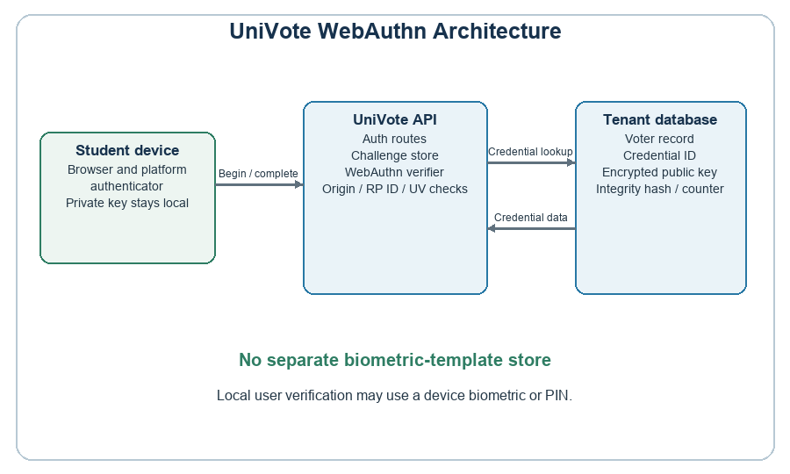

4.3 Software Design
Software design encompasses the detailed specification of UniVote's components, interfaces and data structures. This section presents the WebAuthn registration and authentication flow, the software design tools, component models and core database schema.

4.3.1 Software Design Tools
The following tools were employed in the software design phase to model, visualise, and document the UniVote system architecture and component interactions.
Tool | Category | Purpose in UniVote Design
draw.io | Diagramming | Creation of the Contextual Model, Use Case Diagram, Activity Diagrams, and the Three-Tier Architecture overview (Figure 2).
Lucidchart | UML Modelling | Sequence diagram for WebAuthn registration and authentication, and the state-machine diagram for the ballot lifecycle.
dbdiagram.io | Database Design | Visual specification of the Schema-per-Tenant database structure and entity relationships prior to Prisma schema definition.
Postman | API Design | Design and documentation of all RESTful API endpoint contracts, including request/response schemas and authentication header specifications.
Figma | UI/UX Prototyping | High-fidelity prototype of the Student Voter Portal, School Admin Portal, and Super Admin Portal across mobile and desktop breakpoints.
Table 3: Software Design Tools

4.3.2 Component Design
Component design decomposes UniVote into its constituent software components and specifies their interfaces, behaviours, and interactions through a suite of UML models. The subsections below present each model in turn, with emphasis on the components that implement the security-critical requirements defined in Chapter Three.

4.3.2.1 Contextual Model
The Contextual Model defines UniVote's boundaries and its interactions with external entities. The system interacts with the student's browser and device authenticator for WebAuthn user verification, and with institutional administrators who manage the voter roll and elections. Optional external roster services support voter import and status checks when configured. The application uses tenant-specific routing and tenant-scoped database access. The device authenticator performs user verification locally; UniVote receives the cryptographic response and does not receive biometric samples.

4.3.2.2 Use Case Model
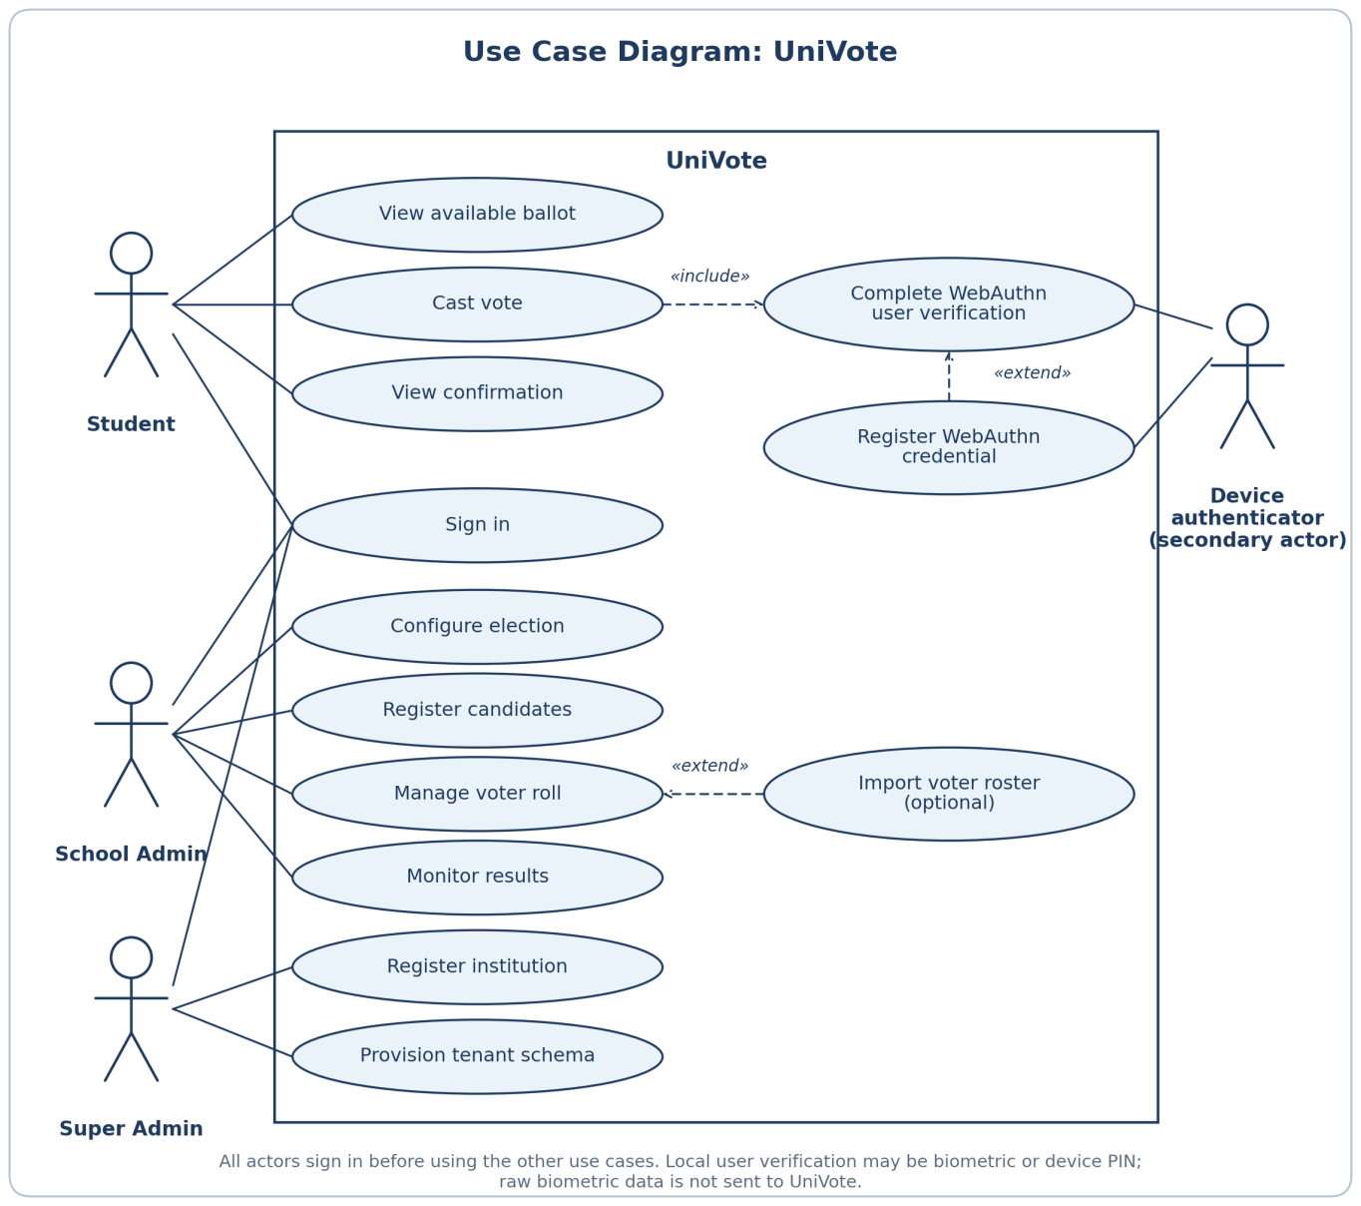
The Use Case Model captures the interactions between the three stakeholder actor groups and UniVote. The Super Admin registers institutions and provisions tenant schemas. The School Admin configures elections, registers candidates, manages the voter roll, and monitors results. The Student signs in, completes WebAuthn user verification, views an available ballot, casts a vote, and views a confirmation. Optional external roster import is an administrative capability when a compatible endpoint is configured.

4.3.2.3 Sequence Diagram — WebAuthn Registration and Authentication Flow
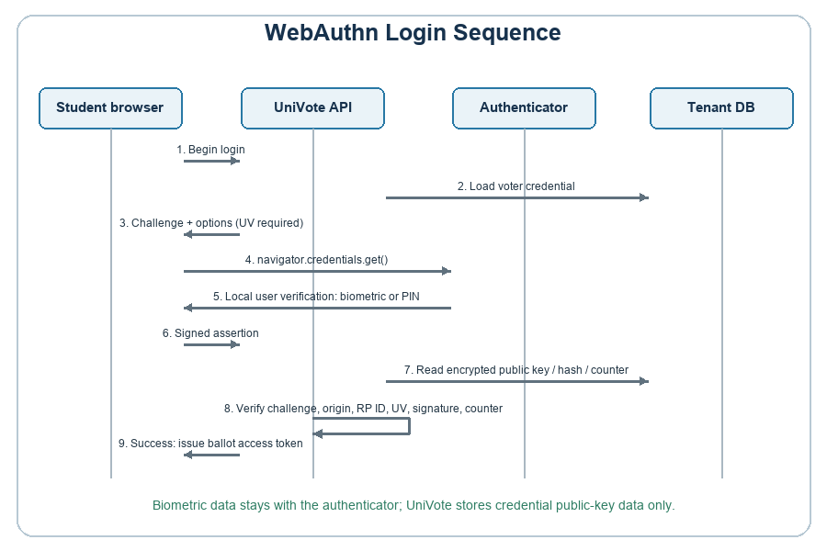
The sequence diagram describes the student's authenticated session and the WebAuthn steps used for credential registration and ballot authorization. It relates to FR-02 (WebAuthn Identity Assurance), NFR-02 (local user verification and data minimisation), and NFR-06 (credential data protection) as specified in Chapter Three.
After the student signs in, the Student Portal starts WebAuthn registration or, when ballot authorization is required, authentication. The API generates options with the configured RP ID and user verification set to required. The WebAuthn library generates a random challenge. The API stores the challenge in memory under the voter ID and operation, with a five-minute expiry. The browser passes the options to navigator.credentials.create() for registration or navigator.credentials.get() for authentication. The device authenticator performs local user verification (biometric or device PIN) and returns an attestation or signed assertion. UniVote receives the WebAuthn response, not the biometric sample.
On completion, the API consumes the matching challenge once and verifies the response against the expected challenge, configured origin and RP ID. The server-side WebAuthn library rejects registration or authentication responses whose authenticator data does not contain the user-verified flag. During registration, UniVote stores CredentialID, VoterID, a salted SHA-256 integrity hash for the public key, the AES-256-encrypted public key, SignCount, CreatedAt and LastUsedAt. During authentication, the API decrypts the public key, recomputes its integrity hash, verifies the signature and checks the counter when it is non-zero. The counter and last-used time are then updated. A ballot token is issued only after WebAuthn verification and the eligibility check.

4.3.2.4 State Machine Diagram — Ballot Lifecycle
The State Machine Diagram models the lifecycle of a single ballot from its initial issuance through to its final immutable state in the database. The ballot exists in one of five states: Pending (token issued, ballot not yet presented to voter); Active (ballot presented, voter making selection); Submitted (voter confirmed selection, ballot transmitted to server); Hashed (server applied cryptographic hash and timestamp, ballot written to the Ballot Table); and Finalised (election closed, ballot sealed into the immutable result set). Valid transitions exist only in the forward direction; the system design contains no transition that permits a ballot to revert from Submitted or Hashed to an earlier state. An additional Expired state is reachable from Pending or Active if the JWT ballot token’s time-to-live elapses before the voter completes their selection, enforcing the session security requirement of NFR-04.

4.3.2.5 Activity Diagram — Voter Authentication and Ballot Casting
The Activity Diagram models the voter workflow from sign-in to vote confirmation. The School Admin first registers the voter and controls the account's active status. During voting, the system checks that the voter account exists and is active, the election is active, and the voter has not already participated. A configured external status service may also be queried where enabled. The voter then completes WebAuthn authentication, selects and submits a candidate choice, and the system records the ballot and participation. The flow therefore includes local account status and election checks, with an optional external status check when configured.

4.3.2.6 Class Diagram — Core Database Schema
The core database schema defines the persistent data structures that underpin UniVote’s electoral, identity, and audit functions. All tables described below exist within each tenant’s dedicated PostgreSQL schema, enforcing the Schema-per-Tenant isolation model (FR-01). Table 4 presents the four core entities and their attributes.
Table 4: UniVote Core Database Schema
Table | Attributes | Key Constraints | Purpose
Tenant | TenantID (UUID, PK), SchoolName (VARCHAR), DomainURL (VARCHAR UNIQUE), SchemaName (VARCHAR), CreatedAt (TIMESTAMP) | TenantID is system-generated UUID. DomainURL must be globally unique — used by the Tenant Resolution Middleware for subdomain routing. | Master registry of all onboarded institutions. Exists in the shared public schema, outside all tenant schemas.
Voter | VoterID (UUID, PK), TenantID (UUID, FK), StudentID (VARCHAR), PasswordHash (BCRYPT), EnrolledAt (TIMESTAMP), IsActive (BOOLEAN) | TenantID is a foreign key enforcing schema-level association. StudentID + TenantID must be unique together. PasswordHash stored using BCrypt (cost factor 12). | Stores voter account data within the tenant schema. IsActive is set when an administrator creates the account or changes its status; an optional roster import can also update this value.
Credential | CredentialID (VARCHAR, PK), VoterID (UUID, FK), Salted_PublicKey_Hash (TEXT), Encrypted_PublicKey (TEXT), SignCount (BIGINT), CreatedAt (TIMESTAMP), LastUsedAt (TIMESTAMP) | CredentialID is the WebAuthn credential ID returned during registration. SignCount must be monotonically increasing; a non-increasing value triggers a credential cloning alert. | Stores the WebAuthn credential public key in encrypted form, with a salted SHA-256 integrity hash. The private signing key remains with the authenticator; no biometric sample is stored.
Ballot | BallotID (UUID, PK), ElectionID (UUID, FK), CandidateID (UUID, FK), Ballot_Hash (TEXT), Encrypted_Timestamp (TEXT), IsVerified (BOOLEAN) | BallotID is system-generated. Ballot_Hash is the SHA-256 hash of (CandidateID + BallotID + Timestamp). Encrypted_Timestamp uses AES-256. No VoterID is stored on the ballot row — preserving vote anonymity (Confidentiality, CIA Triad). | Immutable record of each cast vote. No column links the ballot back to the voter, ensuring ballot secrecy while the Ballot_Hash provides tamper-evidence (FR-04).

4.4 Software Development
This section specifies the development toolchain selected for the UniVote project, the approach to component development, and the evaluation and testing techniques that correspond to the V-Model verification activities defined in Chapter Three. All tool selections are justified with reference to the specific technical requirements they support.

4.4.1 Software Development Tools
Table 5 presents the complete development toolchain organised by layer, with justifications linking each tool to the system requirements it enables.
Table 5: UniVote Software Development Toolchain
Layer | Tool | Version | Role and Requirement Justification
Frontend | React.js | 18.x | Component-based UI framework for the Presentation Tier. Supports PWA Service Worker integration and dynamic rendering of tenant-specific ballot interfaces. Supports NFR-05 (Usability).
Frontend | Tailwind CSS | 3.x | Utility-first CSS framework enforcing mobile-first responsive design. Ensures the ballot interface is accessible on entry-level Android devices (NFR-05).
Frontend | Workbox | 7.x | Google PWA library for Service Worker generation and offline caching strategy. Enables PWA installation and offline asset availability.
Backend | Node.js | 20 LTS | Asynchronous, event-driven runtime for the Logic Tier. Stateless architecture supports horizontal scaling and 1,000+ concurrent connections (NFR-01, NFR-03).
Backend | Express.js | 4.x | Minimal RESTful API framework. Used for route definition, Tenant Resolution Middleware, and request lifecycle management.
Backend | Prisma ORM | 5.x | Type-safe database client with schema-per-tenant support. Prevents SQL injection and enforces typed query construction against the PostgreSQL Data Tier (FR-01).
Database | PostgreSQL | 16.x | Relational DBMS providing native schema namespacing for tenant isolation. ACID-compliant transactions ensure ballot integrity (FR-01, FR-04).
Security | SimpleWebAuthn | 9.x | FIDO2/WebAuthn library for generating options and challenges and verifying registration and authentication responses, including user verification.
Security | BCrypt | 5.x | Password hashing library (cost factor 12) for PasswordHash generation in the Voter Table. Prevents credential recovery in the event of a data breach.
Security | Node.js crypto | Built-in | SHA-256 for Ballot_Hash and the salted public-key integrity hash; AES-256 encryption for Encrypted_Timestamp and Encrypted_PublicKey.
Testing | Jest | 29.x | Unit testing framework. Used for isolated testing of password hashing, authentication and token logic, ballot-integrity functions and tenant-scoped database behaviour.
Testing | Playwright | 1.x | Browser automation framework with virtual WebAuthn authenticator support. The repository includes a scenario that models passkey synchronization by copying a credential to a second virtual authenticator; no execution result or real-device synchronization is claimed.
DevOps | Docker | 25.x | Containerisation of the Node.js application and PostgreSQL instance for consistent development, testing, and production environments.
DevOps | GitHub Actions | Cloud | CI/CD pipeline automation: triggers Jest unit tests and Playwright e2e tests on every pull request, preventing regression in security-critical components.

4.4.2 Component Development
Component development follows the V-Model methodology adopted in Chapter Three. Each component is developed in alignment with its corresponding design specification and is verified against its pre-defined unit test suite before integration with adjacent components. The development sequence respects the dependency hierarchy: Data Tier schema provisioning and Prisma client generation precede Logic Tier API development, which in turn precedes Presentation Tier portal development.
The Tenant Provisioning component is developed first, as all other components depend on the Schema-per-Tenant structure it creates. A PostgreSQL stored procedure is used to atomically create a new schema, apply the standard table migrations (Voter, Credential, Election, Candidate, Ballot), and register the new tenant in the public Tenant Table. This procedure is invoked by the Super Admin Portal and is the subject of the Multi-Tenant Isolation integration test defined in Section 3.3.3.4.
The WebAuthn Credential component encapsulates registration and assertion verification. Registration verifies the authenticator response, encrypts the credential public key, and stores the credential ID, voter association, salted integrity hash and counter. Assertion verification decrypts the public key, checks its integrity hash, and verifies the challenge, origin, RP ID, user-verified flag, signature and counter before returning a result to the Authentication API.
The Ballot Integrity component implements FR-04 as a single-responsibility module that accepts a confirmed candidate selection and ballot token, constructs the hash input string (CandidateID + BallotID + ISO 8601 timestamp), applies SHA-256 hashing via Node’s built-in crypto module, AES-256 encrypts the timestamp, and writes the immutable ballot record to the Ballot Table within a PostgreSQL transaction. The VoterID is explicitly excluded from the ballot record at the component level, preserving the anonymity constraint of the CIA Triad Confidentiality requirement.

4.4.3 Evaluation and Testing Techniques
UniVote’s testing strategy is derived directly from the V-Model verification activities established in Chapter Three. Testing is organised into three levels, each corresponding to a phase on the right-hand side of the V.
Unit Testing, implemented using Jest, targets individual functions and modules in isolation. Critical unit tests include BCrypt password verification, SHA-256 ballot hashing, the credential public-key integrity check, JWT signing and expiry validation, and tenant-resolution behavior. The report contains no recorded automated test results.
Integration Testing verifies the correct interaction between components. The repository includes tests for voter-status decisions, optional roster synchronisation and tenant-scoped database behaviour. These files describe test cases; the report does not claim that they were executed or passed without recorded runner output.
The repository contains a Playwright scenario that models a passkey copied to a second virtual authenticator in an isolated browser context. This simulates passkey synchronization; it does not test synchronization across physical devices. No recorded execution result is reported, so cross-device authentication is not claimed as tested.

4.5 Deployment
UniVote is deployed using a containerised cloud architecture managed via Docker and orchestrated for scalability. The Node.js application server and the PostgreSQL database instance are each packaged as Docker containers, enabling consistent environment parity between the development, testing, and production environments. In production, the application container is deployed behind a reverse proxy (Nginx) that terminates TLS 1.3 connections and load-balances traffic across multiple Node.js instances, supporting the horizontal scaling requirement of NFR-01 and the availability requirement of NFR-03.
Tenant schema provisioning is performed on-demand at the point of institutional onboarding by the Super Admin and does not require downtime or redeployment of the application container. Each new institution’s schema is created atomically within the running PostgreSQL instance, and the new Tenant record is immediately available to the Tenant Resolution Middleware without a service restart. This zero-downtime onboarding capability is an operational realisation of the Scalable Onboarding requirement defined in the Multi-Tenancy pillar of the Conceptual Framework (Section 1.7.2).
The Credential table is stored within each institution's tenant schema. It contains CredentialID, VoterID, Salted_PublicKey_Hash, Encrypted_PublicKey, SignCount, CreatedAt and LastUsedAt. The public key is encrypted with AES-256 and its salted SHA-256 hash is used as an integrity check. The private signing key remains with the authenticator, and UniVote does not store biometric samples.

4.6 Summary
This chapter has translated the functional and non-functional requirements of Chapter Three into a complete, traceable system design and implementation specification for UniVote. The Three-Tier PWA architecture — React.js Presentation Tier, Node.js/Express.js Logic Tier, and PostgreSQL Data Tier with Schema-per-Tenant isolation — provides the structural foundation required to serve multiple Zambian institutions simultaneously while maintaining rigorous data sovereignty between tenants.
The WebAuthn credential flow implements FR-02, NFR-02 and NFR-06. The authenticator performs user verification locally, while the server checks the signed response, challenge, expected origin and RP ID, user-verified flag, stored-key integrity and signature counter. Cross-device availability depends on passkey synchronization or separate provisioning and was not evaluated.
The core database schema — Tenant, Voter, Credential, and Ballot — implements the data-isolation, identity-assurance and ballot-integrity requirements of FR-01 through FR-04. The Credential record contains WebAuthn credential data rather than biometric samples. Chapter Five presents the recorded local manual evaluation and distinguishes it from automated test specifications for which no execution results were available.

CHAPTER FIVE: RESULTS AND DISCUSSION

5.1 Introduction
Chapter Four described how UniVote was designed and implemented. This chapter presents the evidence collected on how the implemented system behaved when it was evaluated, and discusses what that evidence shows in relation to the aim, objectives and research questions set out in Chapter One and the requirements specified in Chapter Three.
The evidence presented here is an end-to-end manual evaluation of the system, carried out locally between 23 October and 6 November 2026. During this evaluation every feature that had been implemented was tested manually, and each operated as intended. The web client and API ran locally. It was not a user study, a survey, a formal security assessment or a performance benchmark, and no stakeholder participants were involved. Automated unit, integration and end-to-end test runs are reported separately from the manual evaluation (Section 5.3.3). The chapter therefore distinguishes four categories of statement throughout: what was implemented, what was observed during manual evaluation, what was documented as a design intention, and what remains future work.
The chapter is organised as follows. Section 5.2 describes the evaluation environment and method. Section 5.3 presents the results. Section 5.4 discusses the results against the objectives, research questions, requirements and reviewed literature, including the differences between the original proposal and the final implementation, and states the limitations of the work. Section 5.5 summarises the chapter.

5.2 Evaluation Environment and Method

5.2.1 Evaluation Environment
The web client and API ran locally on the development machine, and the PostgreSQL database was hosted by Supabase. The evaluation was therefore not a production deployment. Table 6 summarises the environment. Credentials, secrets and connection strings are deliberately excluded.

Table 6: Evaluation Environment
Item | Detail
Evaluation date | Manual evaluation: 23 October 2026 (first voter) and 6 November 2026 (second voter). Automated tests: 6 November 2026
Deployment mode | Web client and API ran locally; the PostgreSQL database was hosted by Supabase
Build identifier | Not recorded
Operating system | Windows (exact version not recorded)
Browser | Google Chrome (exact version not recorded)
Authenticator used for enrolment | WebAuthn user verification was tried with fingerprint, face unlock and device PIN (device or model not recorded; the methods were not necessarily all tried on the same device)
Node.js version | Not recorded
PostgreSQL version | Supabase-hosted PostgreSQL (exact server version not recorded)
Test data | One school with its School Admin account, registered student voters, two elections (student union elections, in which two students voted, and School Patron Elections, in which one student voted), and multiple candidates with their political parties (exact numbers of candidates and offices not recorded)

5.2.2 Evaluation Method
The system was evaluated through a single end-to-end manual walkthrough that followed the normal life of an election, from the creation of an institution to the casting and counting of a vote. The evaluation followed the normal election workflow through the application’s own interfaces, taking the roles of the platform operator, the School Admin and the student in turn. At each step, the behaviour of the system was compared with the expected outcome. This corresponds to the system-level verification activity of the V-Model adopted in Chapter Three. All features that had been implemented were exercised in this way. A separate feature-by-feature test log was not retained, so the results in Section 5.3 are based on the manual evaluation conducted in the local development environment.

5.2.3 Automated Test Suites
The repository contains unit tests (Jest), integration tests and Playwright end-to-end tests, as described in Section 4.4.3. The unit suite (npm run test:unit) and the integration suite (npm run test:integration) were run, and their results are reported in Section 5.3.3. The first run of the integration suite timed out; the timeout was increased and the suite was run again, and the results reported are those of the successful run. The Playwright end-to-end suite (npm run test:e2e) was run against a disposable test tenant prepared by a seeding script (npm run seed:e2e). Of its three tests, one passed, two were skipped and none failed. The skipped tests are not counted as passes, and no claim is made about their outcome [TO CONFIRM: why the two tests were skipped, and whether earlier end-to-end attempts failed or the tests were changed before this run]. The automated results are presented separately from the manual evaluation.

5.3 Results
This section reports what was observed, with interpretation kept to a minimum. Interpretation follows in Section 5.4.

5.3.1 Functional Verification
Table 7 lists the scenarios of the end-to-end workflow completed between 23 October and 6 November 2026 and the outcome observed at each step. In every step the system behaved as expected. These are manual evaluation results, not automated test results.
Table 7: End-to-End Functional Verification (Manual, 23 October to 6 November 2026)
Scenario | Expected result | Observed result | Outcome
Create school and School Admin account | School and administrator account are created. | Creation completed successfully. | Passed (manual)
Register student/voter | Student account is available for sign-in. | Registration completed successfully. | Passed (manual)
Create election and add candidates/parties | Election configuration and candidate information are saved. | Election and candidates with political parties were added successfully. | Passed (manual)
Student login and WebAuthn enrolment | Student signs in and registers a credential using supported user verification. | Login and credential enrolment completed using WebAuthn user verification; fingerprint, face unlock and PIN were tried. | Passed (manual)
Cast vote and view results | Valid vote is accepted and the School Admin tally reflects it. | Vote was accepted; the School Admin view count updated in real time. | Passed (manual)
Close election and view final results | Election is closed and final results with the winner are shown to the School Admin and published to students. | Election closed; the School Admin view and the student view showed the final results and the winner (Figures 17 and 18). | Passed (manual)

Beyond these steps, every other feature that had been implemented was exercised during the same evaluation and operated as intended. Some features that were planned in the proposal were not implemented; these are scope limitations and are discussed in Section 5.4.4. They were not tested and are not counted as passes.
The real-time count update in the “Cast vote and view results” scenario of Table 7 was observed in a local run with two voters. It shows that the administrator view reflected the new vote. It is not a performance measurement and does not show how the system behaves under load or in a hosted environment.

5.3.2 Results Mapped to Objectives and Requirements
Table 8 relates the observed workflow to the research objectives and the functional requirements. The final column states how much of each requirement the evaluation actually exercised, so that the table is not read as proof of more than was tested.
Table 8: Evaluation Evidence Mapped to Objectives and Functional Requirements
Objective / Requirement | Design mechanism (Chapter Four) | What the evaluation showed | Extent of evidence
Objective (i) / FR-01 Multi-tenant isolation | Schema-per-tenant PostgreSQL design with tenant resolution middleware | A school was created and its administrator, voter, election and candidates were set up and used within it (Table 7) | Happy path demonstrated in the manual walkthrough. An integration test showed that a query scoped to one tenant schema cannot see data created in another (Figure 6); this was not part of the manual walkthrough.
Objective (ii) / FR-03, FR-04 Sessions and ballot integrity | JWT sessions and ballot tokens; hashed ballot records | Authenticated student session and a successfully recorded vote (Table 7, student login and cast vote scenarios) | Happy path in the manual walkthrough. An integration test confirmed a correct SHA-256 ballot hash with no voter identifier and rejection of a second vote by the same voter in the same election (Figure 6). Unit tests for JWT handling, the token blocklist and the authorisation guard passed (Figure 5). Token reuse and expiry in the running system were not part of the manual walkthrough.
Objective (iii) / FR-02 Identity assurance | WebAuthn registration and authentication; the client options require user verification and the server verifier requires the user-verified flag. | Credential registration and vote casting by the enrolled student (Table 7). The code-review check of the user-verified flag was not a separate evaluation scenario. | Happy path on one device. Code inspection confirmed the user-verification request and server check, but no negative test for a missing user-verified flag was reported. An automated end-to-end test in which a voter enrolled a passkey and voted from a second device passed (Figure 7); real-device cross-device authentication was not tested [TO CONFIRM: how the second device was simulated].

5.3.3 Automated Test Summary
Table 9: Automated Test Suite Status
Level | Repository location | Command | Executed / passed / failed / skipped | Status
Unit | apps/api/tests/unit/ | npm run test:unit | 9 test suites, 21 tests: 21 passed, 0 failed, 0 skipped. | Passed (Figure 5).
Integration | apps/api/tests/integration/ | npm run test:integration | 3 test suites, 5 tests: 5 passed, 0 failed, 0 skipped. | Passed (Figure 6). The first attempt timed out; the timeout was increased and the suite rerun.
Automated end-to-end (Playwright) | apps/api/tests/e2e/ | npm run test:e2e | 3 tests: 1 passed, 0 failed, 2 skipped. | Partly run: 1 passed, 2 skipped (Figure 7).
Figure 5 shows the output of the unit test run, in which 9 test suites and 21 tests passed. Figure 6 shows the output of the integration test run, in which 3 test suites and 5 tests passed. The three runs were completed on 6 November 2026. The integration tests cover the writing of a ballot without a voter identifier and with a correct SHA-256 hash, the rejection of a second vote by the same voter in the same election, the isolation of a query scoped to one tenant schema from data in another, and the eligibility rules implemented in the system. They were run against a test database. Figure 7 shows the output of the end-to-end run, in which one of three Playwright tests passed and two were skipped. The passing test changes the temporary password of a voter imported from the SIS roster, enrols a passkey and votes from a second device.
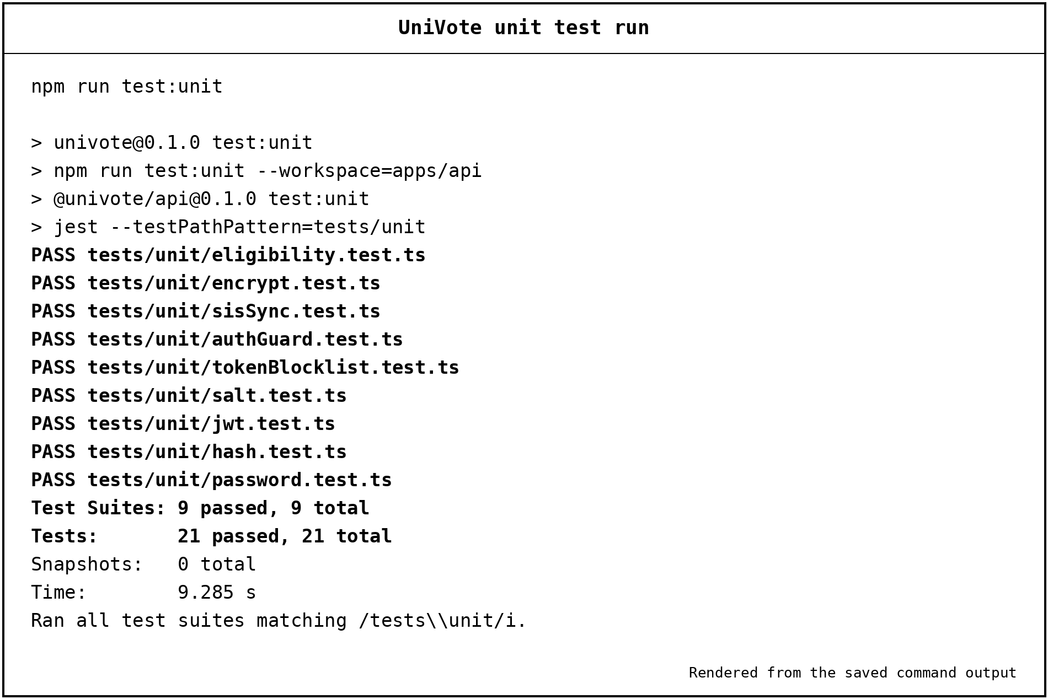
Figure 5: Unit Test Run Output (npm run test:unit)
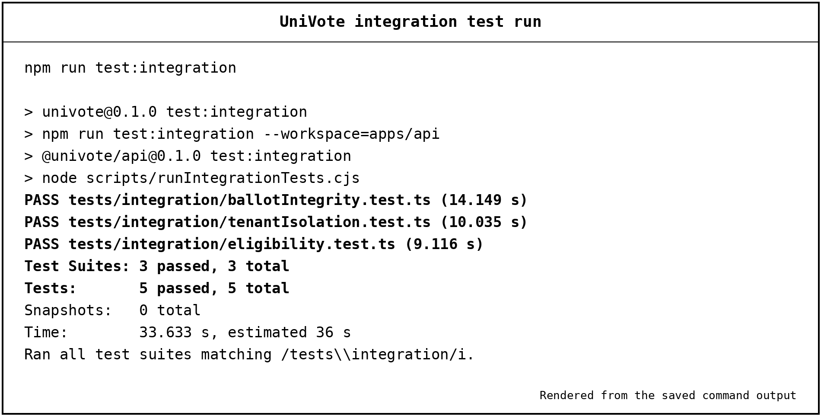
Figure 6: Integration Test Run Output (npm run test:integration)
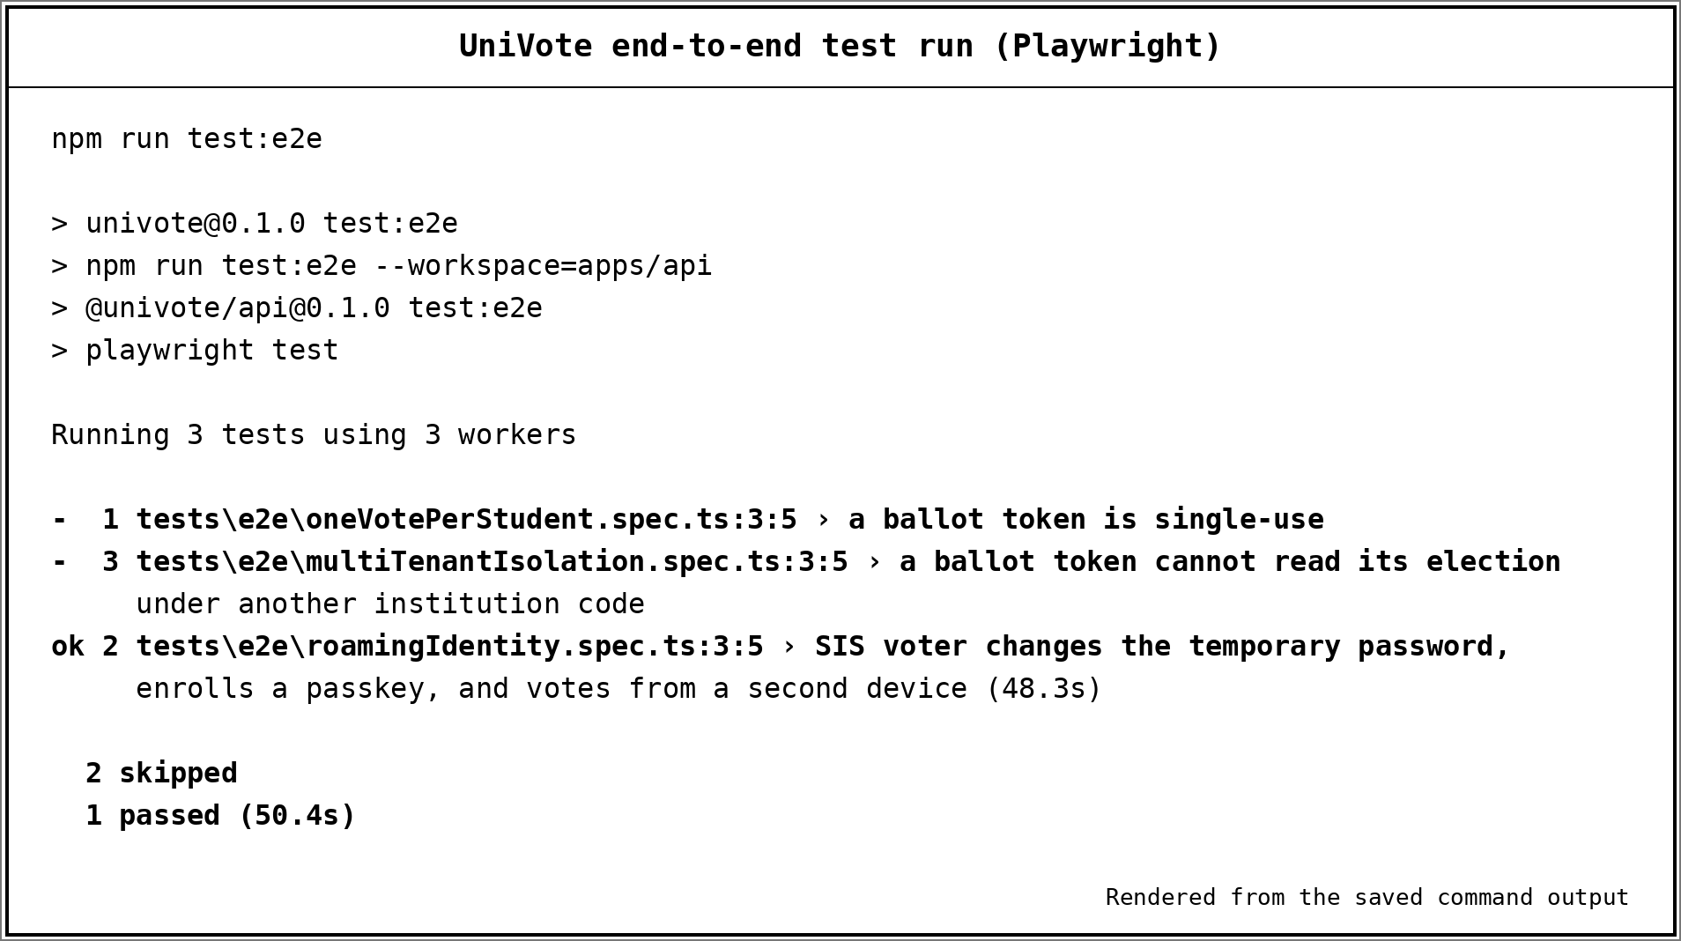
Figure 7: End-to-End Test Run Output (npm run test:e2e)

5.3.4 Assessment Against Non-Functional Requirements
The non-functional requirements of Chapter Three set measurable targets. The local evaluation was not designed to measure them, and Table 10 states this plainly rather than implying that they were met.

Table 10: Status of Non-Functional Requirements in this Evaluation
Requirement | Target in Chapter Three | Status in this evaluation
NFR-01 Scalability | At least 1,000 concurrent voter sessions | Not measured. No load test was performed
NFR-02, NFR-06 User-verification privacy and credential protection | Local user verification with no raw biometric data stored or processed; credential data protected so a database disclosure alone does not provide an authenticator signing key. | Code inspection confirms required WebAuthn user verification and encrypted public-key storage with a salted integrity hash. No separate missing-UV or database-disclosure test was reported.
NFR-03 Availability | 99.5% uptime during elections | Not measured. The evaluation was a short local run
NFR-04 Security | TLS 1.3 in transit; short-lived, single-use tokens (30 minutes maximum) | Not verified in the local run
NFR-05 Usability | Ballot completable within three minutes by a first-time user | Not measured. No usability study with first-time users was carried out

5.3.5 Screenshots of the Implemented System
Figures 8 to 18 show the interface of the implemented system, following the workflow evaluated in Table 7: the platform home page, institution onboarding by the platform administrator, voter registration by the School Admin, election and ballot setup, student sign-in, biometric verification set-up, the student ballot, ballot confirmation, the School Admin results view, the final results after the election closed, and the results published to students.

Figure 8: UniVote Platform Home Page
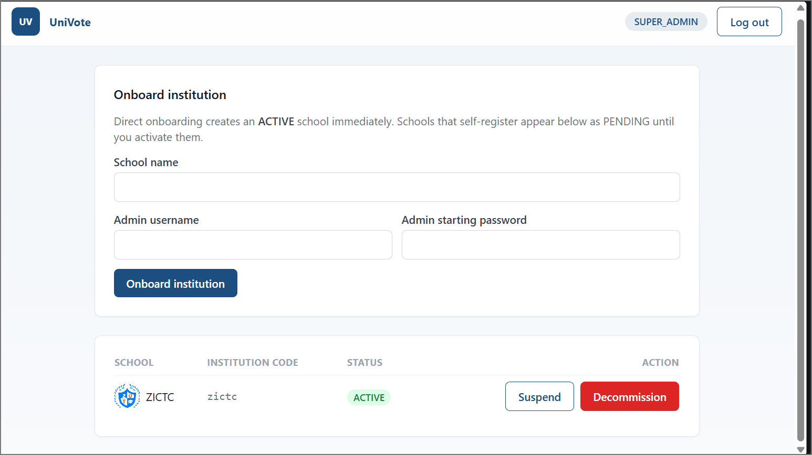
Figure 9: Platform Administrator Institution Onboarding Screen
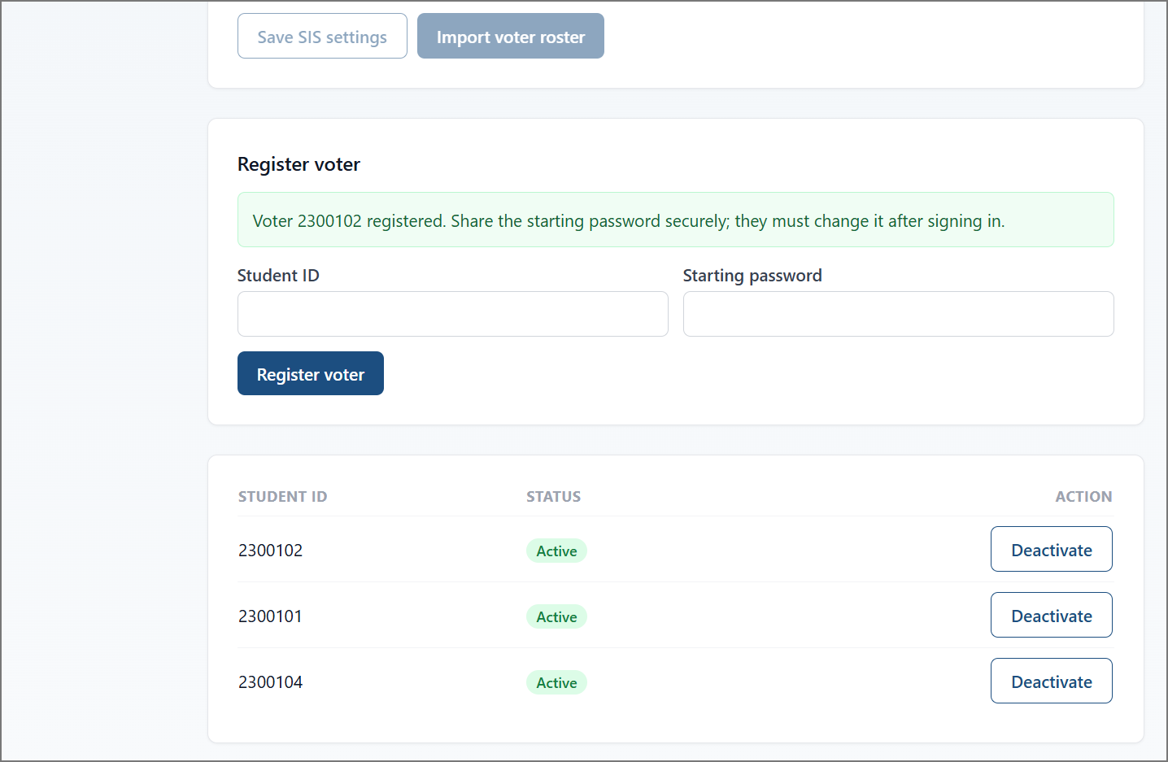
Figure 10: School Admin Voter Registration Screen
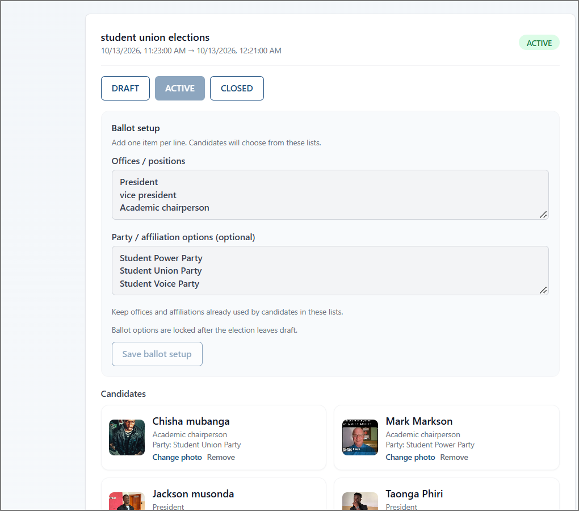
Figure 11: School Admin Election, Ballot Setup and Candidate Management Screen
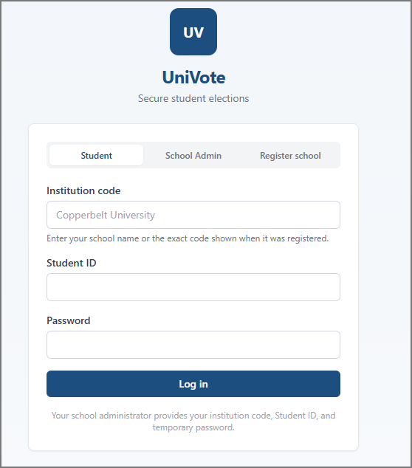
Figure 12: Student Sign-in Screen
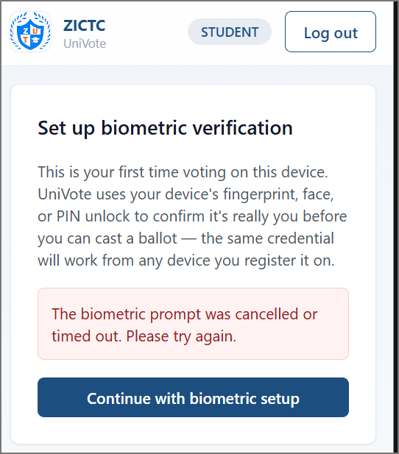
Figure 13: Biometric Verification Set-up Screen
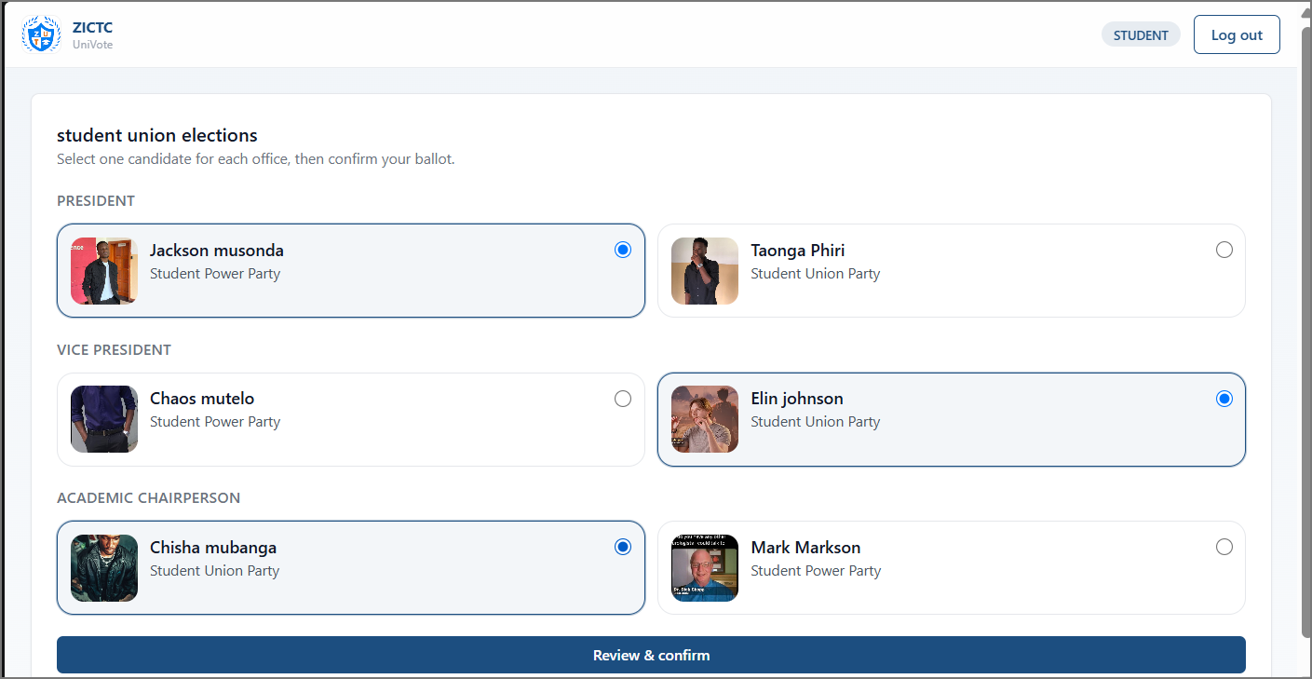
Figure 14: Student Ballot Screen
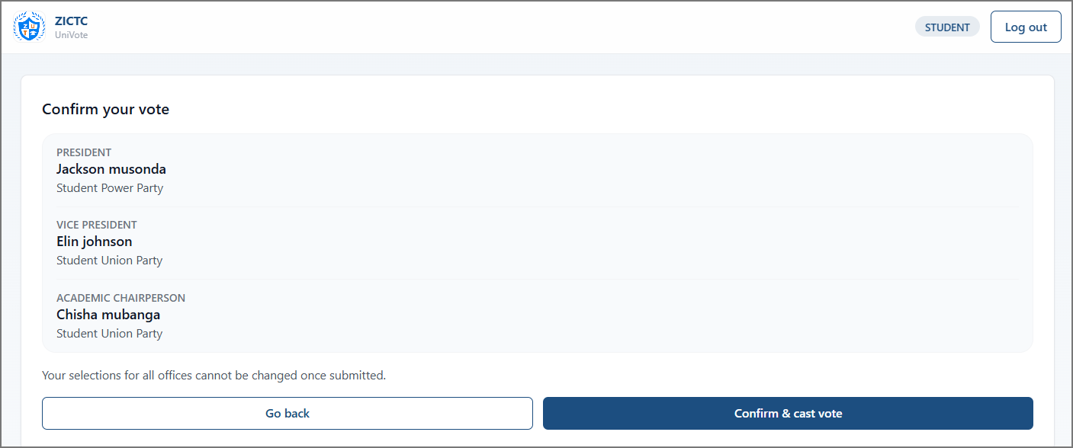
Figure 15: Ballot Confirmation Screen
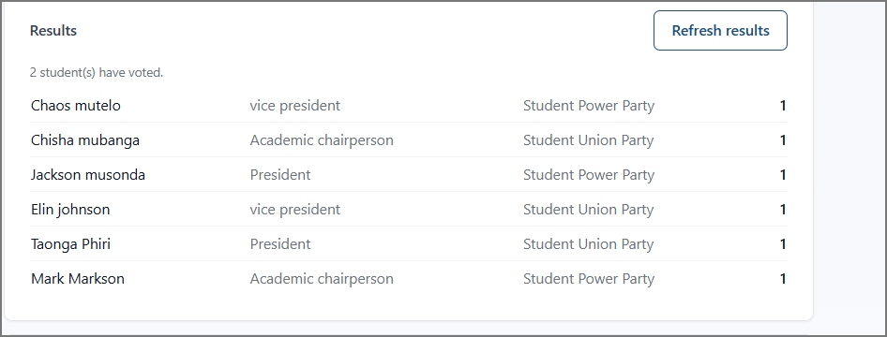
Figure 16: School Admin Results View Showing the Updated Count
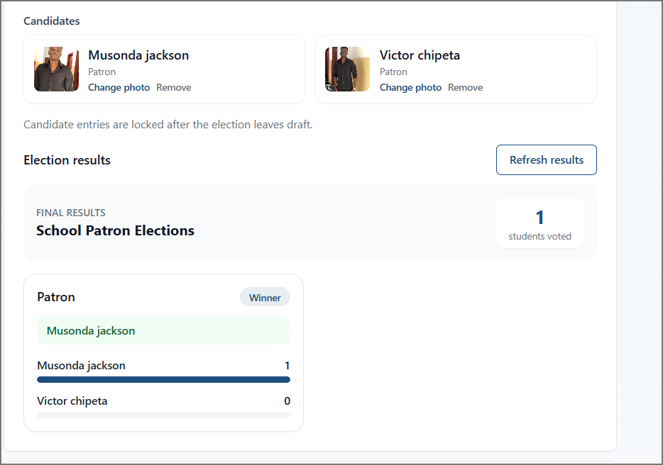
Figure 17: School Admin Final Results View After the Election Closed
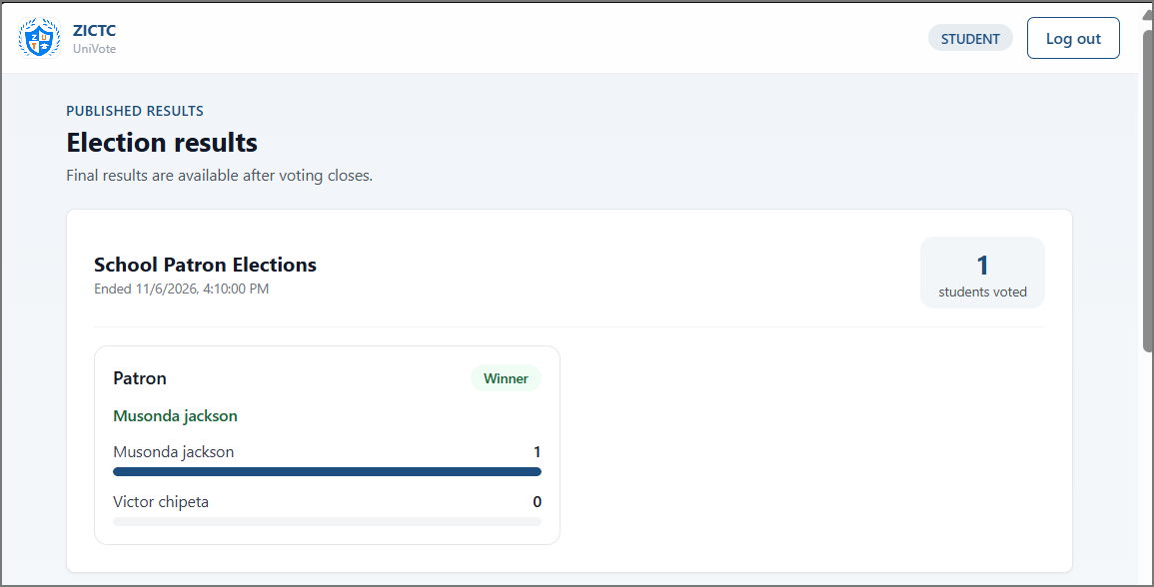
Figure 18: Student Published Election Results View

5.4 Discussion

5.4.1 Findings Against the Research Objectives
Objective (i) was to design a multi-tenant architecture in which institutions operate isolated voting environments on shared infrastructure. The evaluation shows that a new institution could be created and that its administrator, voter, election and candidates could be set up and used end to end within it. This is consistent with the schema-per-tenant design of Chapter Four and with the approach recommended by Kumar [2]. The manual walkthrough did not place two institutions side by side, but an integration test showed that a query scoped to one tenant schema cannot see data created in another schema. Together, these results show working multi-tenant provisioning and isolation at the data-access level for the case tested. They do not show isolation under every access path or under load.
Objective (ii) was secure session management with JWTs and data-integrity measures. A student session was established and a vote was recorded successfully. An integration test confirmed that a ballot is stored without a voter identifier and with a correct SHA-256 hash, and that a second vote from the same voter in the same election is rejected. Unit tests for JWT handling, the token blocklist and the authorisation guard also passed. Failure cases beyond these, such as a modified stored ballot, were not tested.
Objective (iii) was identity assurance through device-native authentication. The manual walkthrough completed WebAuthn credential registration and voting on one device, providing evidence of the legitimate-user path. Code inspection confirmed that registration and authentication options require user verification and that the server verifier rejects responses without the user-verified flag. This is a code-review finding; the manual evaluation did not separately test the missing-flag case or cross-device authentication, although the automated end-to-end test of enrolment and voting from a second device passed (Figure 7).
Taken together, the evidence supports the conclusion that the implemented system delivers the election workflow evaluated, from institution creation through to a counted vote, and that the three retained objectives were pursued through working features. It does not support stronger claims about security strength, scalability or use of live institutional records.

5.4.2 Findings Against the Research Questions
Research Question 1 asked how a multi-tenant architecture can ensure data isolation while maintaining performance. The architecture answers the isolation part by design, using separate PostgreSQL schemas for each institution and tenant-scoped data access. An integration test confirmed that a query scoped to one schema cannot see data created in another. Performance was not measured, so the second part of the question remains unanswered by this evaluation.
Research Question 2 asked which security protocols are most effective in ensuring one student, one vote in a remote web environment. The implemented system combines an authenticated session, WebAuthn user verification, ballot-access checks and a database record of participation per voter per election. The manual evaluation confirmed the workflow for a legitimate voter, and an integration test confirmed that a second vote from the same voter in the same election is rejected. Other attempts to bypass a control were not tested, so the relative effectiveness of these mechanisms is not established by the evidence presented.

5.4.3 WebAuthn Design: Proposal Versus Implementation
The proposal's FR-02, NFR-02 and NFR-06 described hashing a biometric signature on the device and keeping the result in encrypted cloud storage. The implemented system instead uses WebAuthn: the authenticator performs user verification locally (biometric or device PIN) and returns a cryptographic response for server verification against a registered credential. Each tenant's Credential record holds CredentialID, VoterID, a salted SHA-256 integrity hash for the public key, an AES-256-encrypted public key, SignCount, CreatedAt and LastUsedAt. UniVote receives and stores no biometric sample.
Code inspection confirms that registration and authentication options request user verification and that the server-side WebAuthn verifiers reject responses without the user-verified flag. The manual evaluation completed the supported user-verification path, but it did not separately test rejection of a response with the flag unset. This is a code-review finding, not an end-to-end security test.
The proposal's use of roaming referred to cross-device authentication. In WebAuthn, a passkey may be available on multiple devices if synchronized by its provider, or a credential may be provisioned separately. An automated end-to-end test in which a voter enrolled a passkey and voted from a second device passed (Figure 7) [TO CONFIRM: how the second device was simulated, for example with a virtual authenticator], but real-device passkey synchronization was not tested. A device PIN may satisfy user verification, so the system cannot establish that a biometric was used.

5.4.4 Differences from the Proposal and Scope Limitations
Several differences between the proposal and the final system should be stated plainly. Chapter One named Next.js for the front end, whereas the implemented client is a React 18 progressive web application built with Vite, as described in Chapter Four. Some features planned in the proposal were also not implemented. In addition, the user acceptance testing programme planned in Section 3.3.3.4, with a pilot group of ZUT students and staff, was not carried out as part of this evaluation. These are limitations of the completed work and not defects found in testing.

5.4.5 Comparison with the Reviewed Literature
Yadav et al. [1] showed that tamper evidence can be built into an electronic voting system, and Chapter Two proposed cryptographic hashing of each ballot as a lighter alternative to a blockchain. UniVote implements hashed ballot records. The hash makes alteration of a stored record detectable, but it does not by itself prove that a vote is correct, and the detection of tampering was not tested here.
Kumar [2] compared tenant partitioning strategies and the schema-per-tenant model adopted by UniVote follows that analysis. The successful setup and use of a new institution in this evaluation is consistent with the cost and onboarding advantages Kumar describes, although no cost or onboarding-time data was gathered.
Atuah et al. [3] identified weak authentication, lack of robust voter verification and insider threats as the main weaknesses of an institutional e-voting system. UniVote addresses the first two through an eligibility check and WebAuthn user verification, both of which operated in the evaluated workflow. These measures reduce reliance on shared passwords but cannot be said to eliminate impersonation, and the evaluation did not include adversarial testing. Insider risk is only partly addressed. The ballot table has no direct voter identifier, which separates participation from vote choice, but practical anonymity still depends on timing, logging and the privileges of those with database access.
Bloggers of Zambia [4] established the civic need for accessible digital elections in Zambian institutions. This study did not measure turnout or access, so it offers no direct evidence on whether UniVote improves participation. It shows only that a working platform now exists that could be tested for that purpose.

5.4.6 Limitations
The following limitations apply to the evidence presented in this chapter:
•The manual evaluation was small, carried out in a local environment with two voters. It cannot reveal rare faults, concurrency problems or behaviour under load.
•The system was evaluated by the same person who built it, so the evaluation is not independent, and no contemporaneous formal test record was retained [TO CONFIRM].
•Few rejection and attack scenarios were exercised. Duplicate voting and cross-tenant data visibility were covered by integration tests, but invalid or expired tokens, failed WebAuthn verification and access attempts through the application by a user of another institution were not tested in the evaluation. The security design is therefore only partly demonstrated.
•No formal penetration test, accessibility assessment, usability study or performance test was carried out.
•Production concerns such as key management, monitoring, backup and recovery, and automated election scheduling were not evaluated, and no production deployment is claimed.
•The unit and integration suites passed. Of the three Playwright end-to-end tests, one passed and two were skipped (single-use ballot token and cross-institution access), so no automated end-to-end result is available for those two. User verification may be satisfied by a device PIN, so UniVote cannot prove a biometric was used; synchronised passkeys may exist on more than one of a user's devices; cross-device authentication was not tested.
These limitations point directly to future work: enabling and running the skipped Playwright tests, adding negative and adversarial tests, load testing against the targets in NFR-01 and NFR-03, a usability study with first-time voters, and a hosted deployment with the transport and operational controls specified in Chapter Three. Section 6 develops these recommendations.

5.5 Chapter Summary
This chapter presented the results of the local end-to-end manual evaluation of UniVote, carried out between 23 October and 6 November 2026. The evaluation covered the creation of a school and its School Admin account, the registration of a student, the creation of an election, the addition of candidates with their parties, the enrolment of the student’s device authenticator, the casting of a vote the real-time update of the School Admin count, and the display of final results to the School Admin and to students after an election closed. All implemented features operated as intended.
The discussion related these results to the three objectives and two research questions. The evidence shows that the implemented system delivers an election workflow on a multi-tenant design with WebAuthn-based identity assurance. The automated unit and integration suites passed, and one of three Playwright end-to-end tests passed while two were skipped. The evidence does not establish resistance to attack, scalability, usability or effects on electoral disputes, and these remain untested. Isolation between institutions and the rejection of a repeated vote were confirmed only by integration tests. The chapter also recorded that the final authentication design differs from the proposal and that some planned features and the planned user-acceptance programme were not completed. The next chapter concludes the report and sets out recommendations for future work.

CHAPTER SIX: CONCLUSION AND RECOMMENDATIONS

6.1 Introduction
This chapter concludes the report by summarising findings against each research objective, answering the research questions within the limits of the evidence presented in Chapter Five, stating the study's contributions and limitations, and recommending further work needed before UniVote could be considered for use in a live institutional election.

6.2 Summary of Findings
The study set out to design and implement UniVote, a multi-tenant web-based electronic voting system for higher learning institutions. The system was evaluated through an end-to-end manual walkthrough on 23 October 2026. The walkthrough covered school and School Admin creation, voter registration, election and candidate setup, student login, WebAuthn credential enrolment, vote casting, and an update to the School Admin results count. The observed steps produced the expected outcomes in that local evaluation.
Objective (i) was to design a multi-tenant architecture in which institutions operate voting environments on shared infrastructure. The system provisions tenant-specific PostgreSQL schemas. During the evaluation, a school and its administrator, voter, election and candidates were set up and used end to end. Cross-tenant isolation was not separately tested; the evaluation therefore demonstrates tenant provisioning and the intended isolation design, not verified isolation between institutions.
Objective (ii) was to implement secure session management using JSON Web Tokens and data-integrity measures. The system issued an authenticated student session and recorded a vote. The repository also contains mechanisms for ballot hashing and single-use ballot tokens, but the evaluation did not exercise failure cases such as token reuse, token expiry or ballot-record alteration.
Objective (iii) was to provide identity assurance through device-native authentication. The implemented system uses WebAuthn: the authenticator verifies the user locally (biometric or device PIN), and the server validates a cryptographic response against the registered credential. The manual walkthrough completed enrolment and voting on one device. Code inspection confirmed the required user-verification option and server-side flag check; the evaluation did not separately test the missing-flag case or cross-device authentication.

6.3 Conclusions
The study achieved its aim at the level of a working prototype. UniVote supports an election workflow from institution creation to a counted vote, using tenant-specific data schemas, authenticated sessions, ballot-integrity mechanisms and WebAuthn-based identity assurance. The evaluation does not establish that the system is secure against attack, scalable under load or ready for production use, because those properties were not measured.
The first research question asked how a multi-tenant architecture can support data isolation while maintaining performance. The schema-per-tenant design provides a structural approach to separating institutional data, and the evaluation confirmed that an institution could be provisioned and used. Performance under load and isolation between two institutions were not measured, so these aspects remain to be verified.
The second research question asked which security protocols are most effective in supporting the one-student-one-vote principle in a remote web environment. UniVote combines authenticated sessions, WebAuthn user verification, ballot-access checks, a single-use ballot token and a database record of participation for each voter and election. The evaluated workflow worked for a legitimate voter. Since attempts to vote twice or bypass a control were not tested, the study cannot rank the mechanisms by effectiveness.

6.4 Contributions of the Study
The practical contributions of the study are as follows:
•A working multi-tenant voting prototype with institution-specific voter, election and candidate administration.
A WebAuthn-based approach to identity assurance that performs user verification locally and does not require UniVote to receive or store raw biometric data.
•A documented system architecture, data model and test specifications that provide a basis for further evaluation.
•An evaluation record that distinguishes observed results from design claims and identifies areas requiring further evidence.

6.5 Limitations
The limitations discussed in Section 5.4.6 also apply to the conclusions in this chapter. The evaluation consisted of one manual run in a local environment with one voter. It was not an independent evaluation and did not include adversarial, load, usability or accessibility testing. The repository's automated test suites had no recorded results in the report. User verification may be satisfied by a device PIN, so UniVote cannot prove a biometric was used; synchronised passkeys may exist on more than one of a user's devices; cross-device authentication was not tested.
The default voter-access workflow relies on the School Admin-managed voter roll and the local active status of each account. Although the repository contains optional external roster import and status-check code, the report does not demonstrate that a live institutional service was configured or evaluated. The proposal described storing biometric-derived data, whereas the implementation uses WebAuthn credentials; the planned user-acceptance programme was not carried out.

6.6 Recommendations and Future Work
The following work is recommended before UniVote is considered for operational use:
•Run the unit, integration and Playwright suites against a disposable test database, retain the runner output, and add negative tests for inactive accounts, duplicate voting, expired or reused tokens, failed WebAuthn verification and cross-tenant access.
•Commission an independent security assessment, including adversarial and penetration testing, before using the system for an election.
•Load-test the application against the scalability and availability targets specified in Chapter Three, and measure ballot-completion time with first-time voters.
•Evaluate WebAuthn across devices and authenticator types, including synchronised passkeys and security keys, and assess accessibility for voters who cannot use a particular verification method.
•If an institution chooses to use the optional roster connector, configure and validate it against that institution's test service before enabling it for an election.
•Move from local evaluation to a hosted deployment with verified transport security, key management, monitoring, backup and recovery controls.
•Conduct a supervised pilot with a willing institution alongside its existing process, collecting turnout, dispute and satisfaction data to evaluate the claims that motivated the study.
Until these steps are completed, UniVote should be treated as a prototype. Institutions preparing a pilot should establish how voter lists will be prepared and checked, because the reliability of local voter status depends on the accuracy of the list managed by the institution.

6.7 Chapter Summary
This chapter summarised the findings against the three research objectives, answered the two research questions within the limits of the available evidence, and stated the study's contributions and limitations. It concluded that UniVote operates as a multi-tenant election prototype with authenticated sessions, ballot-integrity mechanisms and WebAuthn-based identity assurance, while security, scalability and usability require further evaluation. The chapter recommended recorded automated testing, independent security assessment, performance and usability evaluation, and a supervised institutional pilot.

REFERENCES
[1] A. S. Yadav, A. U. Thombare, Y. V. Urade, and A. A. Patil, "E-Voting using Blockchain Technology," International Journal of Engineering Research & Technology (IJERT), vol. 9, no. 7, pp. 375–380, Jul. 2020. [Online]. Available: https://www.ijert.org/e-voting-using-blockchain-technology
[2] R. Kumar, "Multi-Tenant SaaS Architectures: Design Principles and Security Considerations," Journal of Software Engineering and Simulation, vol. 6, no. 5, pp. 28–41, 2020. DOI: 10.35629/3795-06052841
[3] J. Atuah, C. Azaabi, D. S. Laar, and R. S. Mahamadu, "Exploring the Security Challenges of an E-Voting System (EVS): A Case Study in the Bolgatanga Senior High School," Asian Journal of Research in Computer Science, vol. 17, no. 10, pp. 132–140, Oct. 2024. DOI: https://doi.org/10.9734/ajrcos/2024/v17i10514
[4] Bloggers of Zambia, "Digital Rights and Elections in Zambia: Assessing Youth Participation and Tech-Governance," Lusaka, Zambia, Tech. Rep. BZ-2021-04, 2021. [Online]. Available: https://bloggersofzambia.org/reports/ [Accessed: March 27, 2026].

