**Experiment Name :- Half Wave Folded Dipole with Reflector**

*Student Name :- Mr.*

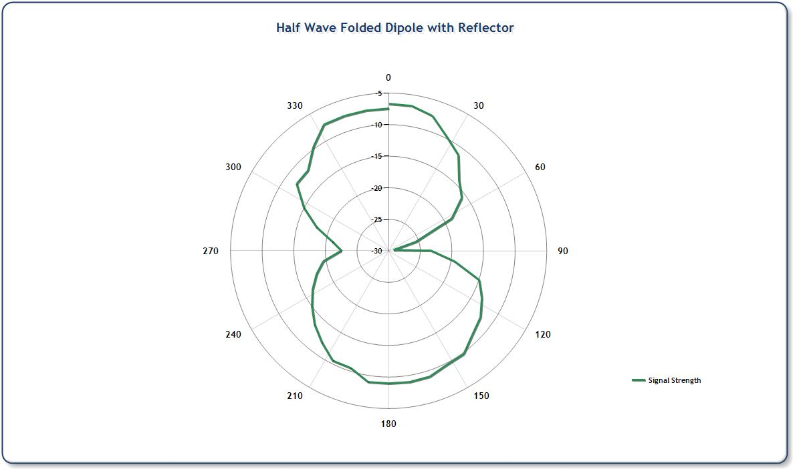

*signature of class teacher*