**Experiment Name :- Half Wave Folded Dipole _3**

*Student Name :- Mr.Shirsh*

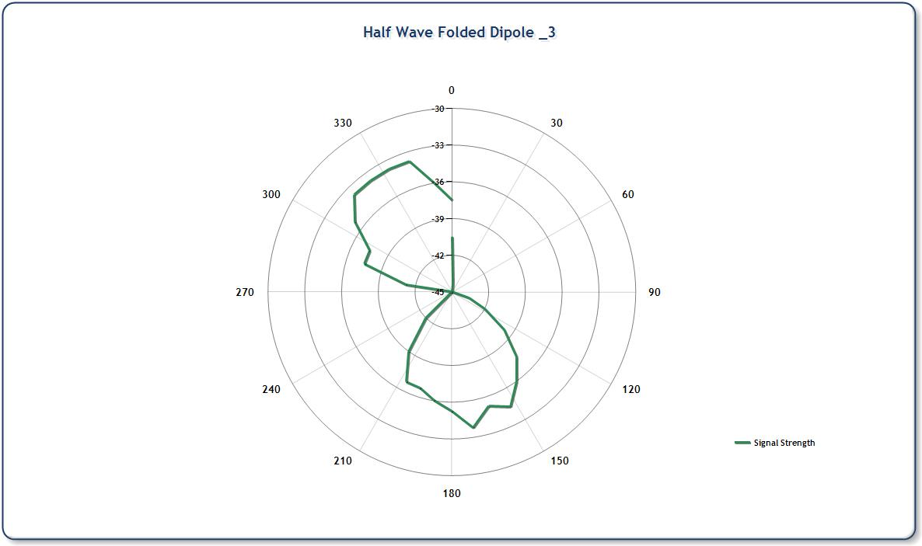

*signature of class teacher*