**Experiment Name :- Half-Wave Simple Dipole**

*Student Name :- Mr.*

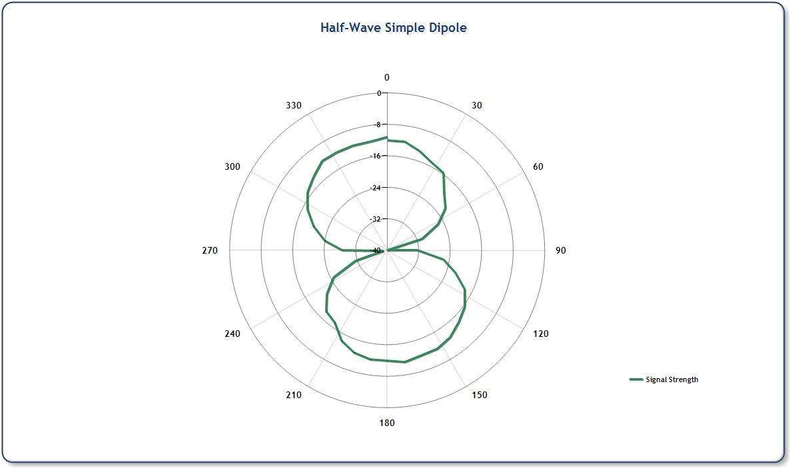

*signature of class teacher*