**Experiment Name :- Half_Wave_Folded_Dipole_Antenna_Pattern**

*Student Name :- Mr.Sunil*

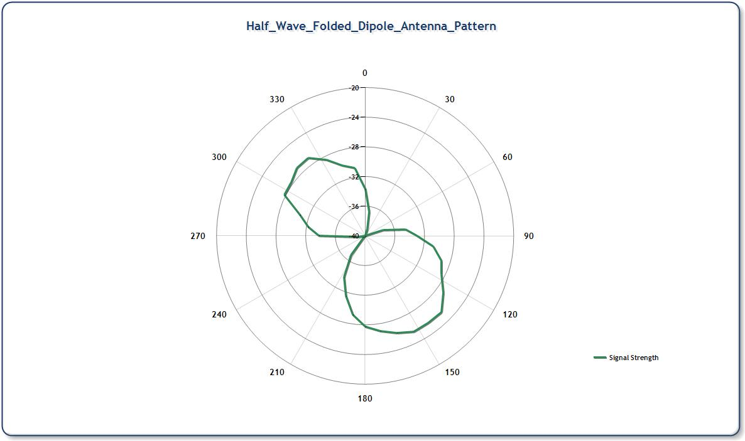

*signature of class teacher*