**Experiment Name :- Half Wave Folded Dipole With Reflector**

*Student Name :- Mr.Sunil*

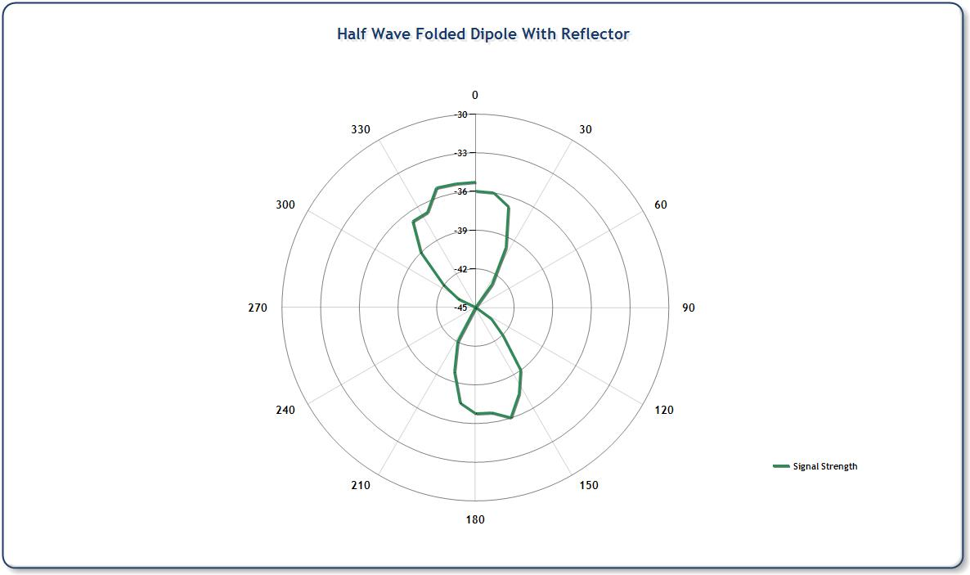

*signature of class teacher*