**Experiment Name :- Quarter Wave Simple Dipole Antenna Pattern**

*Student Name :- Mr.Sunil*

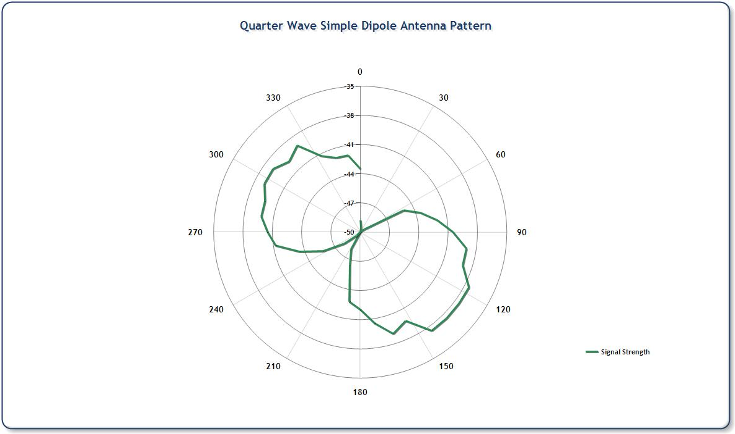

*signature of class teacher*