**Experiment Name :- Yagi Yuda 3 Element Antenna Pattern**

*Student Name :- Mr.Sunil*

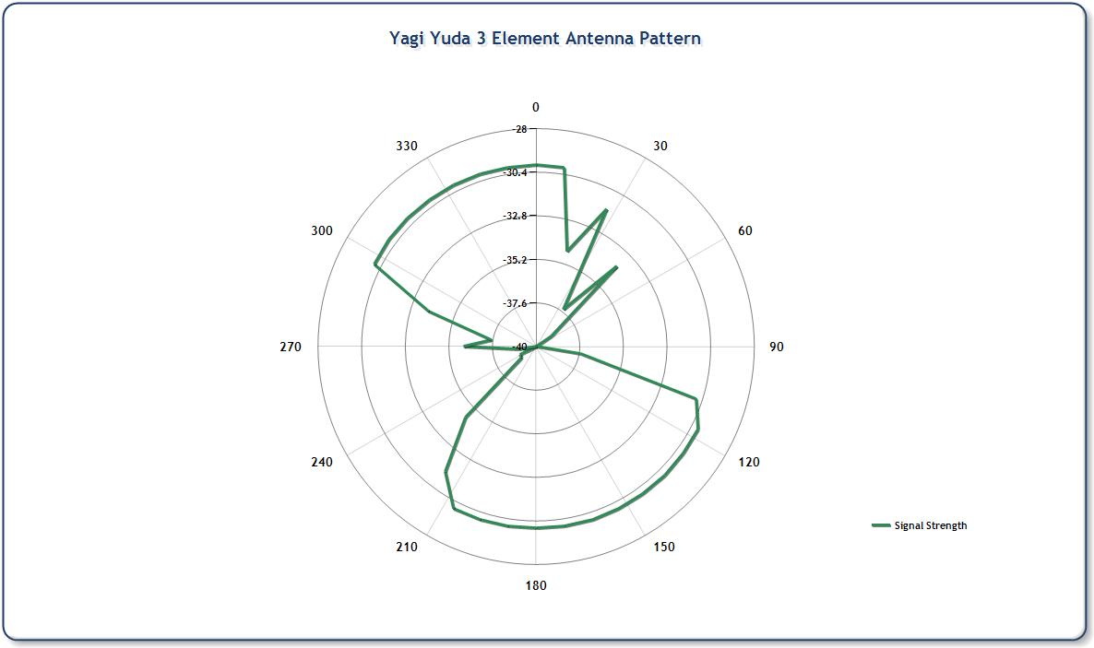

*signature of class teacher*