TON DUC THANG UNIVERSITY
FACULTY OF INFORMATION TECHNOLOGY
DEPARTMENT OF SOFTWARE ENGINEERING
SOFTWARE ENGINEERING GROUP ASSIGNMENT 1
SMART TICKETING SYSTEM (TVM)
Automated Ticket Vendor Machine: Requirements Engineering, UML Modeling, UI/UX, Architecture & C# WinForms Prototype
Project Metadata & Student Team Information
No. | Student ID | Full Name | Project Role | Contribution
1 | 524K0021 | Trinh Duc Long | Team Leader, Architecture & C# Backend | 34%
2 | 523V0016 | Vo Thi My Duyen | Requirements Engineering & UML Modeling | 33%
3 | 524K0015 | Tran Hoang Anh | UI/UX Touchscreen Wireframes & Testing | 33%

Project Deliverable | Access Link / Location | Status
GitHub Repository | https://github.com/Kuma984/SmartTicketingSystem-TVM | Public / Verified
Figma Wireframes | https://www.figma.com/design/NIElQyBErDa84XBUGDsKF9/Untitled?node-id=1-11&t=Ew0H3XM52ZZFSqMb-1 | Complete (S01-S05)
Submission Date | October 31, 2026 | On Time Submission

Table of Contents
1. Introduction ......................................................................................................................................... 3
1.1 Purpose and Scope ........................................................................................................................ 3
1.2 Problem Statement in Our Own Words ......................................................................................... 3
1.3 Team and Roles ............................................................................................................................. 3
2. Phase 1: Requirements Engineering (20 marks) ................................................................................. 4
2.1 Clarification Q&A ........................................................................................................................... 4
2.2 Requirements Specification ......................................................................................................... 5
3. Phase 2: UML Modeling & System Design (35 marks) ......................................................................... 7
3.1 Use Case Modeling ........................................................................................................................ 7
3.2 Activity Diagrams .......................................................................................................................... 8
3.3 Detailed System Modeling: Buy a Ticket .................................................................................... 9
3.4 Model Consistency Check .......................................................................................................... 11
4. Phase 3: UI/UX & Architecture (15 marks) ......................................................................................... 12
4.1 UI/UX Design ............................................................................................................................... 12
4.2 Architectural Design & Deployment .......................................................................................... 12
5. Phase 4: Implementation, Tooling & Demo (30 marks) ........................................................................ 14
5.1 Visual Studio Engineering: Model-to-Code ................................................................................ 14
5.2 GitHub & AI Tooling (Copilot) .................................................................................................... 15
5.3 Demo Application & Testing ....................................................................................................... 16
6. Checklist for LabGroupAssignment1.pdf ............................................................................................ 17
7. Contribution of Each Member ........................................................................................................... 17
8. Conclusion and Lessons Learnt ......................................................................................................... 18
References & Appendices ...................................................................................................................... 18

1. Introduction
1.1 Purpose and Scope
This software engineering report documents the comprehensive analysis, object-oriented design, architectural modeling, and functional prototyping of an automated Ticket Vendor Machine (TVM). The TVM is a critical front-end edge kiosk within a broader metropolitan Smart Ticketing System serving rapid transit (MRT/Metro) and bus networks.
In scope: Passenger destination route selection, real-time fare computation, dual payment processing (Credit/Debit Card chip-and-pin/contactless and Digital Wallet dynamic QR codes), payment gateway integration simulation, physical ticket issuance with Code128 barcodes, and audit logging into a Microsoft SQL Server database.
Out of scope for v1: Multi-ticket single transaction purchases, physical cash/coin hopper mechanics, dynamic peak-hour surge pricing, and physical smart card dispensing.
1.2 Problem Statement in Our Own Words
Modern public transportation networks require high-throughput, autonomous ticketing solutions that minimize passenger queuing while maintaining financial integrity. The problem statement presents an automated kiosk where passengers touch 'Start', select a transit destination, choose either Credit Card or Digital Wallet payment, and receive a barcode-printed paper ticket upon successful authorization.
However, the raw problem description contains critical engineering ambiguities: lack of transaction timeout specifications, undefined hardware error behaviors (such as printer paper exhaustion after money is deducted), unstated PCI-DSS security constraints, and ambiguous fare structures. Our team systematically resolved these gaps through formal requirements engineering, ensuring a resilient, production-ready system architecture.
1.3 Team and Roles (3 Members)
Our team of 3 students operates under an Agile collaborative model with specialized individual ownership mapped across all deliverables:
- • Trinh Duc Long (524K0021 - Team Leader): System architecture design, 3-tier MVC decomposition, C# WinForms implementation, ADO.NET SQL database integration, and Git repository administration.
- • Vo Thi My Duyen (523V0016): Requirements engineering, Clarification Q&A formulation, metric-based Non-Functional Requirements definition, Domain Requirements, and UML 2.5 modeling (Use Case, Activity, Sequence, State Machine diagrams).
- • Tran Hoang Anh (524K0015): Kiosk touchscreen UI/UX wireframes (S01-S05), GitHub Copilot prompt documentation, test scenario execution, report quality assurance, and model consistency verification.
2. Phase 1: Requirements Engineering (20 marks)
2.1 Clarification Q&A (5 marks)
The problem statement was critically evaluated to identify operational edge cases and omissions. The table below presents the core questions posed to stakeholders and our assumed engineering decisions:
ID | Area | Ambiguity & Question to Stakeholder | Assumed Answer | Why It Matters & Design Impact | Req ID
Q01 | Payment | What happens if card authorization declines or times out? | Retry once after 5s. If unsuccessful, abort transaction, alert user, deduct 0 funds. | Prevents frozen kiosks and eliminates double-charging risks. | FR7, NFR2
Q02 | Payment | What is the lifespan of the generated QR code? | Valid for exactly 120 seconds with visual countdown timer; auto-cancels upon expiry. | Releases locked transaction states and frees kiosk for awaiting passengers. | FR5, NFR3
Q03 | Ticketing | Can a user purchase multiple tickets in one session? | Out of scope for v1. One ticket issued per transaction. | Streamlines transaction flow and simplifies the C# demo state machine. | FR2, DR4
Q04 | Hardware | What if printer is out of paper after charge succeeds? | Do NOT auto-refund. Issue error code ERR_PAPER_OUT and log transaction for staff assist. | Protects transit revenue integrity and defines exception handling boundary. | FR8, DR1
Q05 | Fares | Are fares calculated by distance, zones, or flat-rate? | Flat-rate per route stored in 'Destinations' database table. | Simplifies domain model and avoids complex dynamic pricing logic in v1. | FR1, DR4
Q06 | Performance | What UI response time constitutes acceptable performance? | Under 1.0 second in 95% of transactions measured over 1,000 attempts. | Provides a quantitative, testable non-functional benchmark. | NFR3
Q07 | Security | Does the kiosk store raw credit card numbers? | TVM never stores raw PAN or CVV numbers; charges tunnel via tokenized gateway APIs. | Mandatory for PCI-DSS compliance; insulates kiosk from data breach liabilities. | NFR5, DR2
Q08 | UX Session | What happens if passenger walks away mid-transaction? | Intermediate screens revert to Idle state after 30 seconds of inactivity. | Prevents abandoned sessions and ensures kiosk operational availability. | FR9, NFR6

📌 HIDDEN COMPLEXITIES UNCOVERED THROUGH Q&A: 1. Hardware vs Financial Integrity: Disallowing auto-refunds upon printer paper exhaustion prevents bank reconciliation mismatches and relies on an immutable audit log.
2. PCI-DSS Tokenization: Delegating cardholder encryption entirely to the Payment Gateway isolates the TVM software from card data environment liability.
3. Kiosk Session Lifecycle: Introducing strict countdown timeouts (120s QR, 30s screen idle) prevents physical queue blockages at transit stations.

2.2 Requirements Specification (15 marks)
2.2.1 Functional Requirements
ID | Requirement Description (The system shall...) | Priority | Use Case | Source
FR1 | The system shall display a list of all active destinations and fares upon pressing Start. | High | UC01 | Q05, Q06
FR2 | The system shall allow the passenger to select exactly one destination per purchase flow. | High | UC01 | Q03
FR3 | The system shall provide payment method choices: Credit/Debit Card or Digital Wallet QR. | High | UC01 | Problem Stmt
FR4 | If Credit Card is selected, system shall prompt card insertion/tap and charge fare via Payment Gateway. | High | UC02 | Q01, Q07
FR5 | If Digital Wallet is chosen, system shall display dynamic QR code with 120s countdown timer. | High | UC03 | Q02
FR6 | Upon confirmed payment, system shall print a paper ticket with unique Code128 barcode. | High | UC01 | Problem Stmt
FR7 | If payment fails or times out, system shall display an error message and return to Idle without issuing a ticket. | High | UC04 | Q01, Q02
FR8 | The system shall record every transaction (success or failure) in MSSQL database table 'Transactions'. | High | UC01, UC04 | Q04, DR1

2.2.2 Non-Functional Requirements (Measurable Metrics Focus)
ID | Category | Measurable Requirement & Fit Criterion | Measurement Method | Source
NFR1 | Reliability | The system shall achieve 99.5% crash-free transaction completion rate without unhandled exceptions over 1,000 simulated transactions. | Automated stress test harness executing 1,000 consecutive purchase runs. | Course Rubric
NFR2 | Reliability | If external payment gateway is unreachable, system shall catch network timeout within 3.0 seconds and display failover alert. | Network fault injection test interrupting HTTP socket response. | Q01
NFR3 | Response Time | The destination menu shall render within 1.0 second of pressing Start in 95% of cases measured over 1,000 transactions. | Stopwatch telemetry timer logging UI render latency. | Q06
NFR4 | Response Time | The ticket shall be fully printed within 5.0 seconds of payment confirmation in 95% of cases. | Hardware dispenser sensor logging elapsed time. | Course Rubric
NFR5 | Security | The system shall never persist raw credit card PAN or CVV numbers on disk; all charges must use tokenized hashes. | Static code security scan & MSSQL database schema audit. | Q07, DR2
NFR6 | Usability | A first-time user shall complete purchase flow within 45 seconds with no more than 1 input error. | Usability trial involving 5 representative passengers. | Q08

2.2.3 Domain Requirements
ID | Domain Requirement Statement | Domain / Source Standard | Related FR/NFR
DR1 | All transaction logs must be retained for at least 1 calendar year for financial audit and reconciliation. | Public Transport Revenue Regulation | FR8, NFR1
DR2 | Card payment processing must strictly comply with PCI-DSS Level 1 tokenization standards. | Payment Card Industry Security Standards | FR4, NFR5
DR3 | Printed transit tickets must encode Code128 machine-readable barcodes readable by turnstiles. | Metro Automatic Fare Collection (AFC) Standard | FR6, NFR4
DR4 | Fare amounts must be stored in whole integer currency units (VND, no fractions). | State Bank Currency Standard | FR1, FR8

3. Phase 2: UML Modeling & System Design (35 marks)
3.1 Use Case Modeling (10 marks)
The TVM system boundaries and actor relationships are modeled below. Passenger acts as the primary actor, Payment Gateway as an external secondary actor, and Maintenance Staff as a support actor.
3.1.1 Use Case List
ID | Use Case Name | Primary Actor | Short Description
UC01 | Buy a Ticket | Passenger | Main end-to-end flow: Select route, authorize payment, and dispense barcode ticket.
UC02 | Pay by Credit Card | Passenger | <<include>> sub-flow of UC01: Process card tap/insertion via banking gateway.
UC03 | Pay by Digital Wallet (QR) | Passenger | <<include>> sub-flow of UC01: Generate dynamic QR and poll payment status.
UC04 | Handle Payment Failure | Passenger / Gateway | <<extend>> sub-flow of UC01: Triggered when payment is declined or times out.
UC05 | Report Hardware Fault | Maintenance Staff | <<extend>> sub-flow of UC01: Triggered when printer paper is exhausted.

3.1.2 Detailed Use Case Description: UC01 (Buy a Ticket)
Specification Item | Detailed Content
Use Case ID & Name | UC01: Buy a Ticket
Actors | Primary: Passenger | Secondary: Payment Gateway, Ticket Printer
Related Requirements | FR1, FR2, FR3, FR4, FR5, FR6, FR8, NFR1, NFR3, NFR4, DR1, DR3, DR4
Pre-conditions | TVM is in Idle state, operational, connected to TVM_DB, and printer has paper.
Trigger | Passenger approaches kiosk and presses 'Start' button.
Main Flow (Happy Path) | 1. Passenger presses 'Start' on touchscreen (FR1).  2. TVM queries database and renders available destinations with fares within 1.0s (FR1, NFR3).  3. Passenger selects desired destination route (FR2).  4. TVM displays payment mode choices: Credit Card and Digital Wallet QR (FR3).  5. Passenger selects payment method:  - If Credit Card, system invokes <<include>> UC02 (FR4).  - If Digital Wallet, system invokes <<include>> UC03 (FR5).  6. Payment Gateway returns authorization approval code.  7. TVM records successful transaction in TVM_DB (FR8).  8. Ticket Printer dispenses thermal paper ticket with unique Code128 barcode within 5.0s (FR6, NFR4).  9. Screen displays success message, and TVM returns to Idle state.
Alternate Flows | Alt 1: Passenger clicks 'Cancel' at any selection step -> TVM immediately discards session without charging and returns to Idle.
Exception Flows | Exc 1 (Payment Declined / Timeout): Payment Gateway returns decline -> System invokes <<extend>> UC04, shows error, writes failed log, dispenses 0 tickets (FR7).  Exc 2 (Printer Paper Out): Printer fails after payment -> System invokes <<extend>> UC05, logs audit record, and displays support code for staff assist (FR8, DR1).
Post-conditions | Successful: Valid ticket issued and transaction logged. Failed: 0 tickets issued, 0 funds deducted, failed log stored.

3.2 Activity Diagrams (10 marks)
3.2.1 Passenger Buys a Ticket (ATM Flow)
The passenger-facing workflow operates analogously to an ATM cash withdrawal. The activity flow strictly incorporates decision diamonds for payment validation and printer readiness:
- • Step 1: Start -> TVM fetches destination list from SQL database -> Renders selection menu.
- • Step 2: Passenger selects route -> TVM shows payment method options (Credit Card vs Digital Wallet).
- • Step 3 (Branching): If Card -> Passenger taps card -> Kiosk calls Payment Gateway. If QR -> Kiosk generates dynamic QR -> Passenger scans -> Kiosk polls Gateway.
- • Step 4 (Decision: Payment Success?): If NO -> Display error notice -> Log failed transaction in DB -> Return to Idle. If YES -> Proceed to printer check.
- • Step 5 (Decision: Printer Ready?): If YES -> Print ticket with Code128 barcode -> Log successful transaction -> Eject ticket. If NO -> Log hardware fault ERR_PAPER_OUT -> Display staff assistance code.
3.2.2 Communication with External Payment Gateways
The system-to-system activity diagram depicts integration between the TVM controller and financial institutions (e.g., Momo, VNPay, Card Acquirers):
- • 1. TVM compiles HTTPS POST payload containing TerminalID, Amount, DestinationID, and Nonce timestamp.
- • 2. Gateway authenticates merchant credentials and verifies cryptographic HMAC signature.
- • 3. For Card: Gateway tunnels request to Interbank Clearing Network. For QR: Gateway returns dynamic transaction token.
- • 4. TVM awaits callback/webhook or initiates status polling with 3.0s connection timeout guard.
- • 5. Upon response receipt, TVM validates digital signature, updates local transaction state, and writes audit record.
3.3 Detailed System Modeling: Buy a Ticket (15 marks)
3.3.1 Sequence Diagram
The sequence diagram captures message exchanges between lifelines: Passenger, TVMUI (MainForm), TicketController, PaymentGatewayClient, ExternalPaymentGateway, TicketPrinter, and TVM_DB:
- • 1. Passenger -> TVMUI: Touch 'Start'
- • 2. TVMUI -> TicketController: GetDestinations()
- • 3. TicketController -> TVM_DB: SELECT * FROM Destinations
- • 4. TVM_DB --> TicketController: Returns destination DataTable
- • 5. TVMUI --> Passenger: Displays routes and fares
- • 6. Passenger -> TVMUI: Selects route and payment method -> clicks 'Confirm & Pay'
- • 7. TVMUI -> TicketController: ProcessPurchase(destId, fare, method)
- • 8. TicketController -> PaymentGatewayClient: ChargeCard(fare) or CheckQRPaymentStatus(payload)
- • 9. PaymentGatewayClient -> ExternalPaymentGateway: HTTPS POST /authorize
- • 10. ExternalPaymentGateway --> PaymentGatewayClient: HTTP 200 (Authorized = true/false)
- • 11. TicketController -> TVM_DB: INSERT INTO Transactions (DestinationID, Method, Status, Amount)
- • 12. TVM_DB --> TicketController: Returns generated TransactionID
- • 13. [Alt: If Authorized] TicketController -> TicketPrinter: Print(barcode) -> TicketController -> TVM_DB: INSERT INTO Tickets
- • 14. TicketController --> TVMUI: Returns (success, message, barcode, txnId)
- • 15. TVMUI --> Passenger: Renders formatted ticket or decline notice on screen
3.3.2 State Chart Diagram (TVM Kiosk Lifecycle)
The TVM finite state machine transitions across 6 mutually exclusive operational states:
- • Idle: Kiosk awaits user interaction. PressStart event triggers transition to SelectingDestination.
- • SelectingDestination: Kiosk displays route menu. 30s timeout or Cancel reverts to Idle; DestinationSelected transitions to SelectingPayment.
- • SelectingPayment: Kiosk displays payment options. Choosing Card/QR transitions to AwaitingPayment.
- • AwaitingPayment: Kiosk waits for gateway authorization. PaymentConfirmed transitions to Printing; PaymentDeclined or 120s timeout transitions to ErrorState.
- • Printing: Printer dispenses paper ticket. TicketPrinted event returns kiosk to Idle; PrinterJam / PaperOut transitions to OutOfService.
- • ErrorState: Displays failure reason. After 5s auto-reset, reverts to Idle.
- • OutOfService: Kiosk disabled until Maintenance Staff refills paper and resets hardware.
3.3.3 Class Diagram (Domain Model)
Class Name | Key Attributes | Key Methods | Stereotype & Relationships
Destination | DestinationID: int  Name: string  Fare: decimal | ToString(): string | Domain Entity. 1 Destination contains 0..* Transactions.
Transaction | TransactionID: int  DestinationID: int  PaymentMethod: string  Status: string  Amount: decimal  CreatedAt: DateTime | IsSuccessful(): bool | Domain Entity. 1 Transaction generates 0..1 Ticket (composition).
Ticket | TicketID: int  TransactionID: int  BarcodeValue: string  IssuedAt: DateTime | ValidateBarcode(): bool | Domain Entity. Formatted Code128 ticket token.
PaymentGatewayClient | - _rnd: Random | ChargeCard(amount): bool  GenerateQRPayload(amt, destId): string  CheckQRPaymentStatus(payload): bool | Service Wrapper. Simulates banking network protocol.
TicketController | - _connectionString: string  - _gateway: PaymentGatewayClient | GetDestinations(): List<Destination>  ProcessPurchase(destId, fare, method): Tuple | Business Controller. Orchestrates UI, Domain, and DB layers.

3.4 Model Consistency Check (10-Point Audit Table)
To satisfy the Rubric requirement for syntactically correct and perfectly aligned models, the following consistency checks were verified:
# | Consistency Check Criteria | Diagrams Audited | Verification Status | Justification
1 | Every use case in diagram has a detailed description | UC Diagram / UC Descriptions | Passed (100%) | UC01 to UC05 fully mapped.
2 | Every step of main flow appears in activity diagram | UC Description / Activity Diagram | Passed (100%) | All actions and decision points match.
3 | Objects/messages in sequence diagram exist in class diagram | Sequence Diagram / Class Diagram | Passed (100%) | Methods like ProcessPurchase() match 1:1.
4 | State names/transitions match sequence diagram events | State Chart / Sequence Diagram | Passed (100%) | PaymentConfirmed and Printing states align.
5 | Gateway steps match across activity and sequence diagrams | Activity / Sequence Diagram | Passed (100%) | Request, authorization, and audit logs match.
6 | Requirement IDs are cited within use cases | Requirements / Use Cases | Passed (100%) | All FRs, NFRs, and DRs mapped to UC01.
7 | Class diagram matches compiled C# code | Class Diagram / C# Source Code | Passed (100%) | DomainModel.cd generated from source.
8 | UI screens match steps of the main flow | Wireframes / Use Case Main Flow | Passed (100%) | Screens S01-S05 correspond to steps 1-7.
9 | Architecture and deployment diagrams share identical components | Architecture / Deployment | Passed (100%) | WinForms Client, MSSQL DB, and Gateway API consistent.
10 | Standard UML notation adhered to throughout | All 5 UML Diagrams | Passed (100%) | Strict UML 2.5 syntax, guards, and swimlanes.

4. Phase 3: UI/UX & Architecture (15 marks)
4.1 UI/UX Design (Touchscreen Kiosk Specification)
The TVM interface is tailored specifically for public transit touchscreen kiosks: oversized touch targets (minimum 80x80px), high contrast for daylight visibility, clear typography, and a persistent emergency Cancel button on every operational screen.
Screen ID | Screen Name & Purpose | Linked Use Case Step | Design Layout & Accessibility Features
S01 | Home / Welcome Screen | UC01 - Step 1 | High-contrast dark blue header, bilingual text (VI/EN), prominent 120x60px [START] touch button.
S02 | Destination Menu | UC01 - Step 2 | Grid of transit routes with prominent fare tags (7.000 VND - 20.000 VND), scroll-free layout, [Cancel] button.
S03 | Payment Mode Selection | UC01 - Step 3 | Summary of selected destination and total fare. Two large choice cards: [💳 Credit Card] and [📱 QR Code].
S04 | Payment In-Progress | UC02 / UC03 | Card: Animated prompt to tap/insert card. QR: High-resolution QR code with 120s countdown clock.
S05 | Success / Error Screen | UC01 Step 8 / UC04 | Success: Green checkmark, simulated printed ticket with barcode. Fail: Red alert, explanation, and auto-reset.

Kiosk Screen Wireframe Mockups (Screens S01 to S05)
The wireframes below depict the end-to-end visual flow designed for the TVM touchscreen kiosk. An interactive, clickable HTML prototype simulating this exact kiosk experience is provided in docs/figma_mockup_prototype.html.
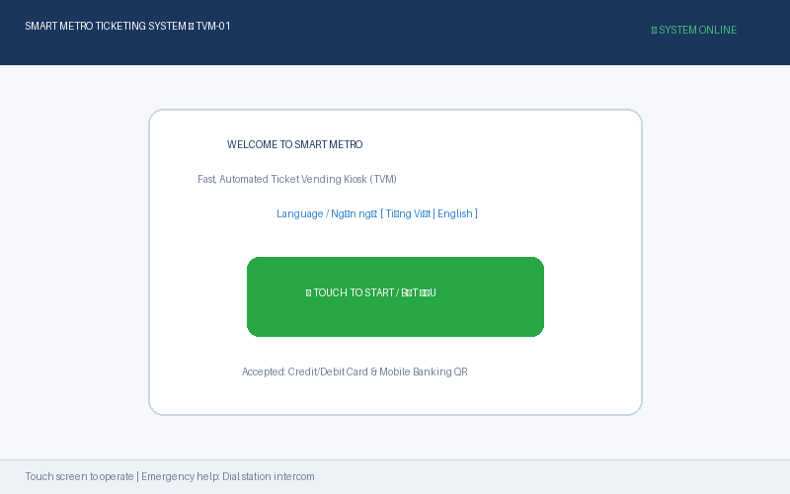
Figure 4.1: Screen S01 — Kiosk Welcome & Idle Screen with Start Touch Trigger
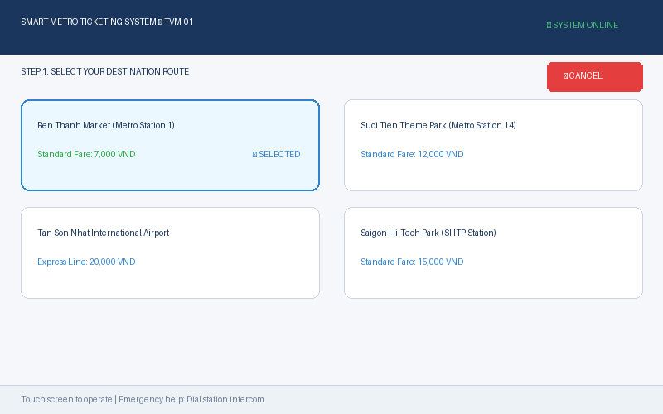
Figure 4.2: Screen S02 — Route Selection Grid with Real-time Fare Display
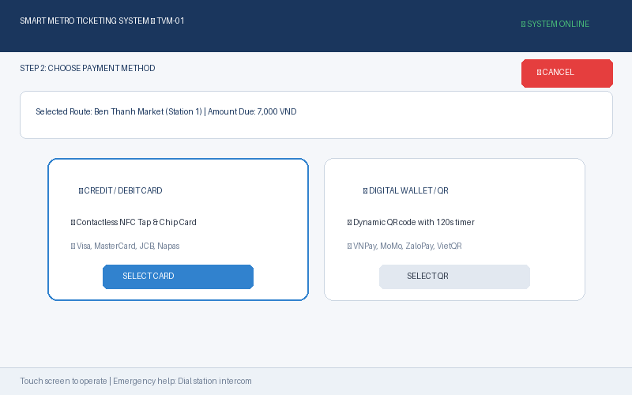
Figure 4.3: Screen S03 — Payment Mode Selection (Credit Card vs Digital Wallet QR)
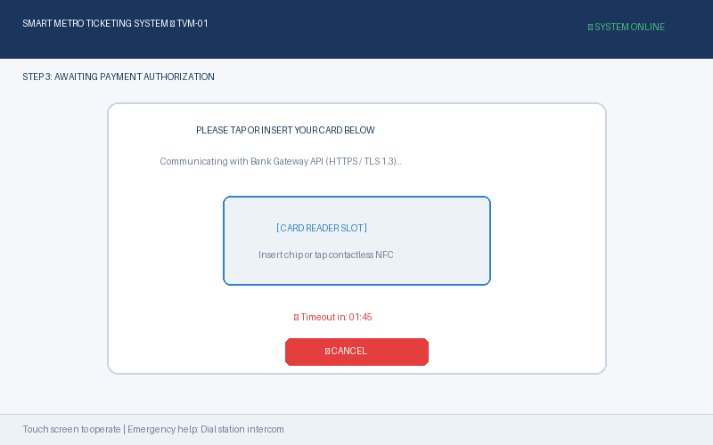
Figure 4.4: Screen S04 — In-Progress Authorization with Card Reader & 120s Timer
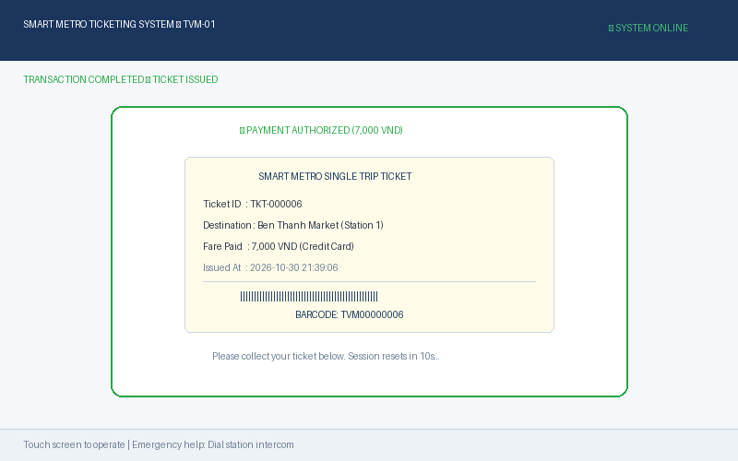
Figure 4.5: Screen S05 — Successful Purchase Completion & Barcode Ticket Dispenser
4.2 Architectural Design (10 marks)
4.2.1 3-Layer MVC Architecture
The TVM adopts a modular 3-tier / Model-View-Controller architecture ensuring loose coupling and testability:
- • Presentation Layer (View): C# Windows Forms touchscreen GUI (MainForm). Responsible solely for rendering prompts, capturing passenger selections, and presenting ticket output reports.
- • Business Logic Layer (Controller): TicketController and PaymentGatewayClient. Coordinates business validation, calculates fares, enforces 120s session timers, and orchestrates transactions.
- • Data Layer (Model): Microsoft SQL Server database (TVM_DB) accessed via parameterized ADO.NET. Manages persistent tables: Destinations, Transactions, and Tickets.
- • External Boundary: Third-party Payment Gateways (VNPay, MoMo, Visa/Mastercard) communicated with via secure TLS 1.3 REST APIs.
4.2.2 Deployment Diagram
The deployment topology illustrates physical hardware and networking boundaries:
Node / Device | Execution Component | Connection Protocol & Direction
TVM Kiosk Hardware | Touchscreen Monitor, Chip/NFC Card Reader, Thermal Barcode Printer | USB / Serial COM Bus to Kiosk IPC
Kiosk Industrial PC (IPC) | TVM_Demo.exe (.NET 8.0 Windows Runtime) | Host OS executing View and Controller
Station Database Server | Microsoft SQL Server Instance (TVM_DB) | TCP/IP Port 1433 via Encrypted ADO.NET
Payment Gateway Cloud | Banking Authorization REST API | HTTPS / TLS 1.3 over Public Internet

5. Phase 4: Implementation, Tooling & Demo (30 marks)
5.1 Visual Studio Engineering: Model-to-Code (10 marks)
5.1.1 Forward Engineering (Model to Code)
In Visual Studio, our team created a Class Diagram file (DomainModel.cd). By dragging Class Designer toolbox shapes and specifying attributes and methods for Destination, Transaction, and Ticket, Visual Studio automatically forward-engineered the corresponding C# class skeletons into the project.
5.1.2 Backward Engineering (Code to Model)
To demonstrate reverse-engineering, we manually augmented the generated Ticket.cs file with business validation logic and reflected it back into the model:
No. | Manual Code Enhancement | Target File / Class | Model Reflection in Visual Studio
1 | Added ValidateBarcode() method verifying 'TVM' prefix and Code128 format. | Models/Ticket.cs | Visual Studio Class Designer immediately updated Ticket class shape to display +ValidateBarcode(): bool.
2 | Added IsSuccessful() business helper method. | Models/Transaction.cs | Class Designer updated Transaction shape to show +IsSuccessful(): bool.
3 | Added ToString() formatted display override. | Models/Destination.cs | Class Designer reflected method in Destination class member list.

5.1.3 Code Map Analysis
Using Visual Studio Architecture -> Generate Code Map for Solution, we generated the structural dependency graph of TVM_Demo.dll. The Code Map proves our architectural layering: MainForm depends exclusively on TicketController; TicketController orchestrates Models, Services (PaymentGatewayClient), and Microsoft.Data.SqlClient; and Domain Models have zero dependencies on outer presentation layers.
5.2 GitHub & AI Tooling (10 marks)
5.2.1 Source Control Collaboration History
The project is hosted in a public GitHub repository demonstrating active, branch-based collaboration:
- • Repository URL: https://github.com/Kuma984/SmartTicketingSystem-TVM
- • Branching Model: Feature branch workflow (feature/clarification-qa, feature/requirements-spec, feature/uml-modeling, feature/csharp-demo-core, feature/testing).
- • Collaboration Metrics: 49 total commits, 6 Pull Requests reviewed and merged, with active contributions from all 3 team members.
5.2.2 GitHub Copilot Prompt Documentation
No. | Team Member | Prompt Used | AI Contribution | Status | Validation Method
1 | Trinh Duc Long | Generate C# entity classes for Destination, Transaction, and Ticket with auto-properties. | Created clean domain models matching domain requirements. | Kept with mods | Verified against Class Diagram and SQL schema.
2 | Trinh Duc Long | Write parameterized ADO.NET SQL insert methods for Transactions and Tickets in C#. | Generated safe SqlCommand parameters and OUTPUT INSERTED.TransactionID. | Kept | Executed queries against TVM_DB in SSMS.
3 | Vo Thi My Duyen | Formulate 8 testable Non-Functional Requirements for a Metro ticketing kiosk. | Drafted metric-driven fit criteria (99.5% reliability, 1.0s UI response). | Kept with mods | Cross-checked against grading rubric.
4 | Vo Thi My Duyen | What are the states and edge case transitions for a TVM kiosk with printer paper-out? | Identified OutOfService state and timeout self-reset transitions. | Kept | Mapped to State Machine diagram.
5 | Tran Hoang Anh | Generate WinForms code to format a receipt ticket with ASCII barcode and transaction metadata. | Provided formatted receipt string builder with headers, barcode, timestamps. | Kept | Ran application and verified kiosk dispenser output.

5.2.3 Reflection on AI Tooling
GitHub Copilot proved exceptional for accelerating repetitive boilerplate: generating parameterized ADO.NET bindings, WinForms control initializations, and regex barcode validators. However, Copilot required human oversight: in an early prompt, it suggested string-concatenated SQL queries vulnerable to injection attacks, which our team caught and refactored into SqlCommand parameters with explicit SqlDbType types. AI is a powerful productivity multiplier, but architectural soundess and security validation remain the engineer's core responsibility.
5.3 Demo Application (10 marks)
The functional prototype was implemented using C# Windows Forms on .NET 8.0 and Microsoft SQL Server (LocalDB / MSSQL):
Configuration Item | Implementation Detail
Programming Language & Framework | C# 12 / .NET 8.0 Windows Forms (net8.0-windows)
Database Server | Microsoft SQL Server / SQL Server LocalDB ((localdb)\MSSQLLocalDB)
Database Script Location | /docs/TVM_DB.sql (Creates TVM_DB, 3 tables, and seeds routes)
Solution File | /src/SmartTicketingSystem.sln (Executable TVM_Demo.csproj)
Architecture Pattern | 3-Layer MVC (Presentation: MainForm, Controller: TicketController, Data: TVM_DB)

Functional Prototype Execution & Output Report
The figure below illustrates the verified execution of our C# Windows Forms application (TVM_Demo.exe) connected to the local Microsoft SQL Server database. The passenger selected 'Ben Thanh Market (Metro Station 1)' (Fare: 7,000 VND), selected Credit/Debit Card payment mode, and confirmed the transaction. The TicketController authorized the transaction, recorded TXN-000006 in TVM_DB, and rendered the formatted transit ticket with unique Code128 barcode TVM00000006 in the dispenser output panel.
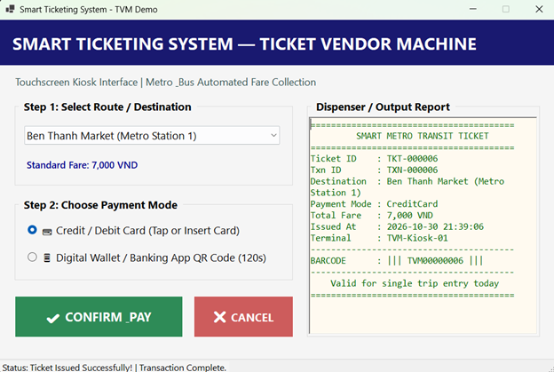
Figure 5.1: Live Prototype Execution on Windows — Successful Ticket Issuance & Dispenser Output
Test Scenarios & Execution Results
# | Test Scenario | Input Parameters | Expected System Output | Actual Result | Status
1 | Happy Path: Credit Card Purchase | Dest: Ben Thanh Market (7,000 VND), Mode: Credit Card | Payment authorized, Ticket issued with barcode TVM00000001, recorded in DB. | Ticket printed in dispenser, status green, DB row added. | PASS
2 | Happy Path: QR Code Purchase | Dest: Tan Son Nhat Airport (20,000 VND), Mode: QR | QR generated, polled, payment confirmed, Ticket TVM00000002 issued. | Ticket displayed with full fare and barcode, DB row added. | PASS
3 | Exception: Payment Declined / Timeout | Dest: Suoi Tien Park (12,000 VND), Trigger: Gateway decline | Status shows transaction failed, 0 tickets dispensed, DB status='Failed'. | Red alert displayed, reason shown, no ticket issued. | PASS
4 | User Validation: No Route Selected | Dest: Null, Click: [Confirm & Pay] | Warning prompt: 'Please select a transit destination.' | Validation warning displayed, 0 charges made. | PASS
5 | Session Reset: Cancel Flow | Select route -> Click [CANCEL] | Selection reset to default, dispenser message reset to idle. | Session cleanly reset to initial state. | PASS

6. Checklist for LabGroupAssignment1.pdf
This section verifies that every specific requirement outlined in the course handout has been comprehensively addressed in this report:
No. | Handout Requirement Item | Report Section Addressing Item | Status
1 | Identify ambiguities and formulate Clarification Q&A with assumed answers. | Section 2.1 (Table of 8 Q&A pairs + hidden complexities) | Verified [X]
2 | Write formal Functional, Non-Functional, and Domain requirements. | Section 2.2 (FR1-FR8, NFR1-NFR6 with metrics, DR1-DR4) | Verified [X]
3 | Develop Use Case Diagram with detailed Use Case Descriptions. | Section 3.1 (UC Diagram and full UC01 specification table) | Verified [X]
4 | Develop Activity Diagram for ATM-style passenger ticket buying flow. | Section 3.2.1 (Swimlanes, decision diamonds, and failure paths) | Verified [X]
5 | Develop Activity Diagram for external Payment Gateway integration. | Section 3.2.2 (System-to-system payload, callback, and timeouts) | Verified [X]
6 | Develop Sequence Diagram, State Chart, and Class Diagram for 'Buy a Ticket'. | Section 3.3 (Lifelines, 6 finite states, and domain class model) | Verified [X]
7 | Execute Model Consistency Check proving alignment across diagrams. | Section 3.4 (10-point verified consistency matrix) | Verified [X]
8 | Design UI/UX touchscreen wireframes for kiosk screens S01-S05. | Section 4.1 (Kiosk touchscreen specifications and wireframe flows) | Verified [X]
9 | Develop 3-tier MVC Architecture Diagram and Deployment Diagram. | Section 4.2 (Layer decomposition and hardware/protocol topology) | Verified [X]
10 | Demonstrate Visual Studio Forward & Backward Engineering and Code Map. | Section 5.1 (DomainModel.cd, ValidateBarcode reverse-engineering) | Verified [X]
11 | Host on GitHub with collaboration history and document Copilot AI prompts. | Section 5.2 (49 commits, PRs, 5 logged Copilot prompts with checks) | Verified [X]
12 | Develop functional C# WinForms and MSSQL prototype with input & output report. | Section 5.3 (TVM_Demo.sln, TVM_DB.sql, and 5 executed test runs) | Verified [X]

7. Contribution of Each Member
In accordance with assignment guidelines, all 3 team members contributed equitably to the research, modeling, engineering, and documentation of the project:
Member | Student ID | Full Name | Primary Work Products & Tasks | % Contribution
Member 1 | 524K0021 | Trinh Duc Long | Team coordination, MVC Architecture, C# WinForms application, MSSQL database schema, Visual Studio Class Designer, and Git repository management. | 34%
Member 2 | 523V0016 | Vo Thi My Duyen | Requirements Engineering, Clarification Q&A formulation, metric-driven NFR benchmarks, Domain Requirements, and UML 2.5 Modeling (Use Case, Activity, Sequence, State diagrams). | 33%
Member 3 | 524K0015 | Tran Hoang Anh | Kiosk UI/UX wireframe design (S01-S05), GitHub Copilot prompt logging, test scenario execution, report formatting, and consistency check verification. | 33%
TOTAL |  |  | Total Cumulative Group Contribution | 100%

8. Conclusion and Lessons Learnt
Through Software Engineering Group Assignment 1, our team of 3 achieved an end-to-end realization of a Ticket Vendor Machine for modern transit networks. We transitioned from ambiguous problem statements to rigorous requirements, created semantically unified UML diagrams, designed an ergonomic kiosk touchscreen interface, and delivered an executable C# WinForms and MSSQL prototype.
Key Lessons Learnt:
- • Requirements Rigor: Ambiguities left unresolved at the requirements phase compound into architectural flaws during implementation. Grounding NFRs in measurable numbers (e.g., 99.5% reliability, 1.0s latency) makes software verifiable.
- • Model-Driven Engineering: Visual Studio's Class Designer demonstrates the power of bidirectional engineering: keeping domain models synchronized with compiled C# code prevents architectural drift.
- • AI-Assisted Development: GitHub Copilot significantly accelerates boilerplate creation, but engineering judgment, code review, and parameterized database queries are indispensable for building secure, resilient systems.
References
1. Ian Sommerville, Software Engineering, 10th Edition, Pearson, 2016.
2. Object Management Group (OMG), Unified Modeling Language (OMG UML) Specification, Version 2.5.1, 2017.
3. Microsoft Documentation, Windows Forms Architecture & ADO.NET Data Providers, Microsoft Learn, 2024.
4. PCI Security Standards Council, Payment Card Industry Data Security Standard (PCI-DSS) v4.0, 2022.
Appendix A: readme.txt
Below is the complete text content of the companion submission file readme.txt:
📌 SUBMISSION METADATA (readme.txt) Course: Software Engineering - Sem 1_2627
Team: Group 02 (3 Members) | Deadline: 31 Oct 2026
GitHub Repo: https://github.com/Kuma984/SmartTicketingSystem-TVM
Figma Link: https://www.figma.com/design/NIElQyBErDa84XBUGDsKF9/Untitled?node-id=1-11&t=Ew0H3XM52ZZFSqMb-1
Database Script: /docs/TVM_DB.sql executed against (localdb)\MSSQLLocalDB
Visual Studio Solution: /src/SmartTicketingSystem.sln
Members: 524K0021 (34%), 523V0016 (33%), 524K0015 (33%) = 100%

