# Company PavlodarNaturProduct

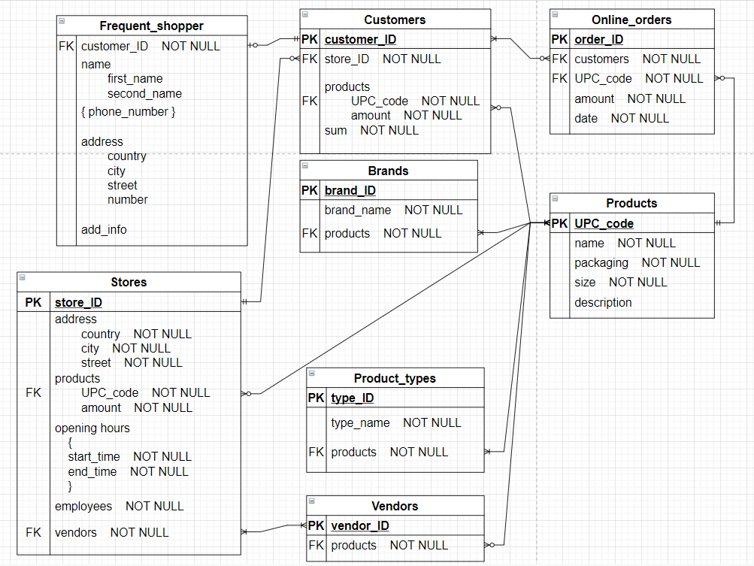

**Products** can be from one to several **types and brands**. Since the **products** in the **prod_types and** **brands** tables are **lists**, the relationship will be **one or many to one or many**.

The relationship between **products and stores, customers, vendors** is **zero or many to one or many**, because these lists do not necessarily have all products.

The relationship between **products and online orders** is **one and only one to zero or many**, because each order is placed one product at a time for several customers.

The connection between **vendors and stores** is **one or many to one or many**, because both can have several partners.

The connection between **freq_shopper and customer**, because not all customers are freq_shopper.

The connection between **store and customers** is **one and only one to zero or many**, because the customer comes to a particular store.

Communication between **customers and online orders** is **one or many to zero or many**, because several people can order a product.