PROJECT REPORT

*Computer Programming Lab (CSL-113)*

**

**PROJECT TITLE:**

**BS (CS) – 1B**

*Group Members*

|  |  |
| --- | --- |
| **Name** | **Enrollment** |
| 1. Sadia Saeed | 02-134242-005 |
| 2. Ayesha Khan | 02-134242-091 |
| 3. Kumail Abbas Tabassum | 02-134242-107 |

**Submitted to: Ma’am Mehwish Saleem**

**BAHRIA UNIVERSITY KARACHI CAMPUS**

*Department of Computer Science*

# ABSTRACT

The **Online Book Inventory Management System** is designed to revolutionize the way book inventories are managed by providing an efficient, user-friendly platform. This system facilitates essential tasks such as managing book records, tracking sales, handling customer data, and overseeing supply operations. With features like advanced search and filter capabilities, billing integration, and data consistency checks, the system eliminates the inefficiencies and errors of manual inventory management. By automating processes, it ensures real-time tracking of inventory, ultimately enhancing the productivity and profitability of bookstores.

# INTRODUCTION:

The Online Book Inventory Management System aims to provide a comprehensive digital solution for managing book inventories, streamlining operations, and improving data accuracy. It enables users to perform various operations such as adding, deleting, and updating book records, searching and filtering books by criteria like title and author, and managing sales and customer records. Additional features include user login functionalities, supply chain management, and sorting books by year or author. By transitioning from manual to automated processes, the system ensures efficient inventory management and supports the smooth functioning of online and offline bookstores.

# PROBLEM STATEMENT:

Before this there was book inventory management system in which records were maintainedon paper. IT become difficult to modify data. In manual system it is quite time consuming to check previous records and there is chances of errors. There is possibility that data in different registers have different values which means entries of same data donot matches. They can’t perform calculation perfectly manually. A system must be needed to keep proper record and handle all inventory efficiently. This aims to provide ease of use for customers and operators through effective record keeping and efficient operations.

# METHODOLOGY:

## Planning

* + Define the system's objectives, core functionalities, and user requirements, focusing on inventory tracking, sales management, and customer data handling.
  + Choose appropriate language such as C++ for implementation, and plan the system’s architecture and user interface design.
  + Develop a timeline for project development phases including design, implementation, and testing.

## Data Collection

* + Compile data for books, including title, author, genre, publication year, ISBN, price, and quantity.
  + Gather information on customer records, purchase history, and supplier details.

## System Design

* + Create a design for the system with separate components for inventory management, sales processing, and user authentication.
  + Develop database for storing book details, transaction records, and user information.
  + Design a user-friendly interface for easy interaction.

## Implementation

* + Write the code using C++ to implement the designed modules, ensuring proper handling of CRUD operations (Create, Read, Update, Delete) for book records.
  + Integrate features like book search and filter, inventory alerts, and billing functionalities.
  + Connect the application to a relational database for efficient data storage and retrieval.

## Testing

* + Conduct unit testing for individual modules to ensure they work as expected.
  + Perform integration testing to verify the seamless interaction between various components.
  + Carry out user acceptance testing to gather feedback and refine the system based on user needs.

## Deployment and Training

* + Develop the system on the target platform for real-world use.
  + Train bookstore staff on using the system, including data entry, transaction processing, and report generation.

## Monitoring and Maintenance

* + Regularly monitor the system for performance issues.
  + Implement updates and enhancements based on evolving requirements and user feedback.

# PROJECT SCOPE:

Implementing the core functionality of the inventory system using programming languages like C++. It employs software engineering principles for efficient code design, modularization, and maintainability, designing and managing a database to store information about books and the inventory. It manages a collection of books with details including title, author, genre, price, and quantity, Sales management, customer (Records, Purchase history), supplies management, Search and filter(genre/author) (Name, author, ISBN) , loyalty program, its billing and perform CRUD operations (Create, Read, Update, Delete) on book records and provide an intuitive interface for bookstore staff to interact with the inventory.

# CODE:

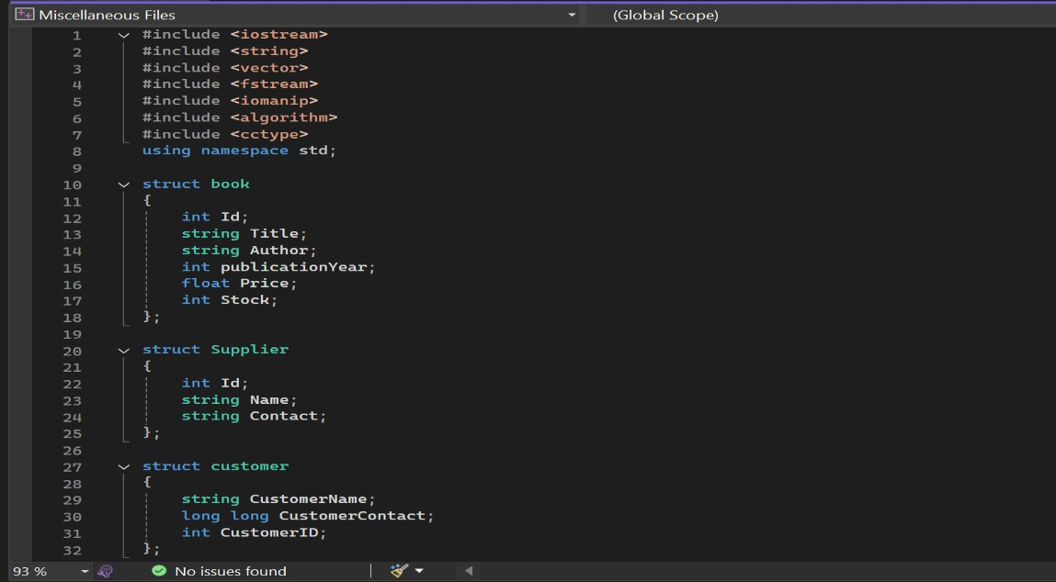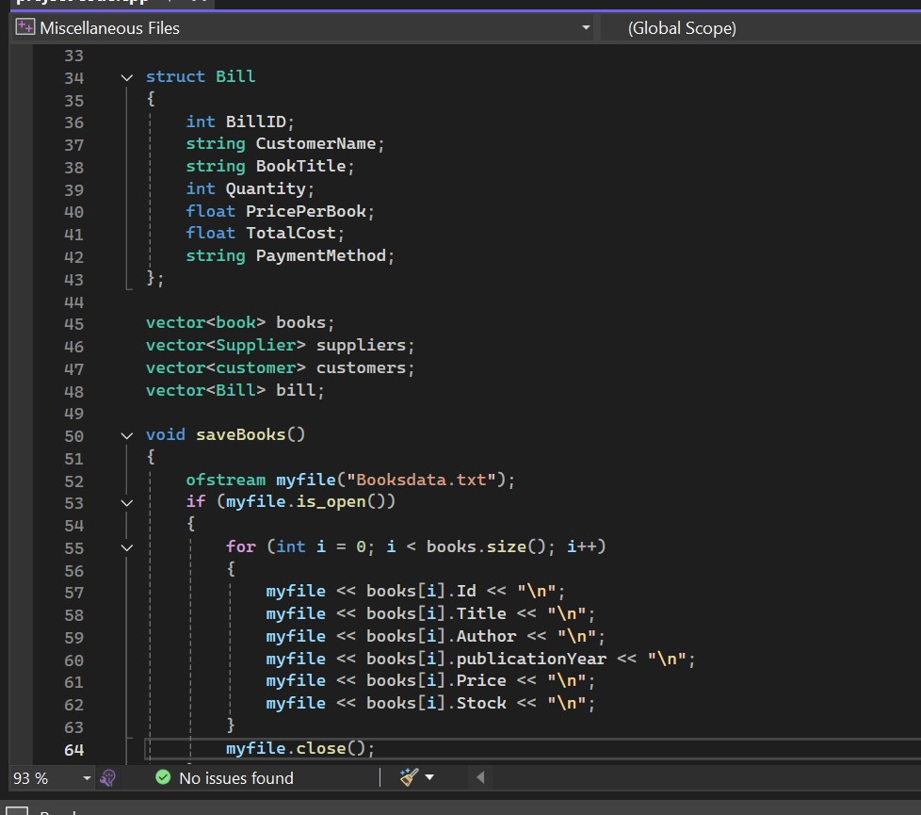

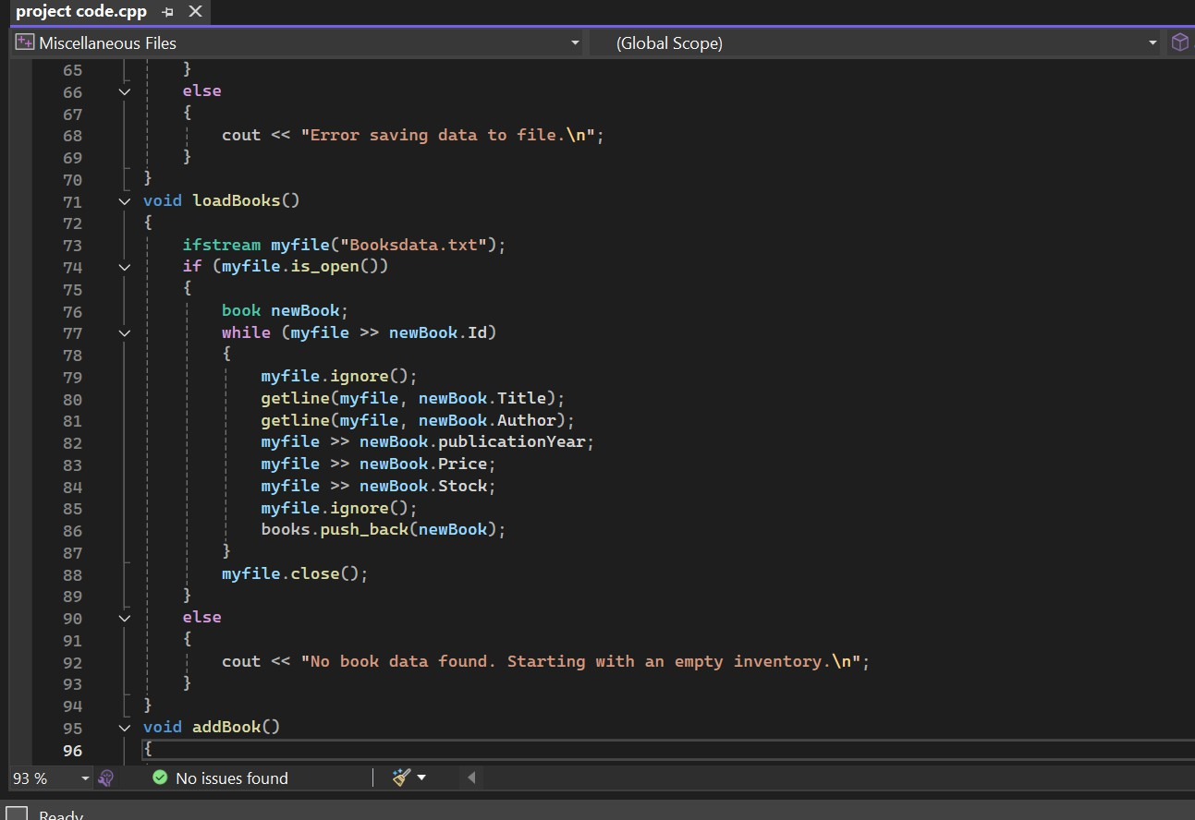

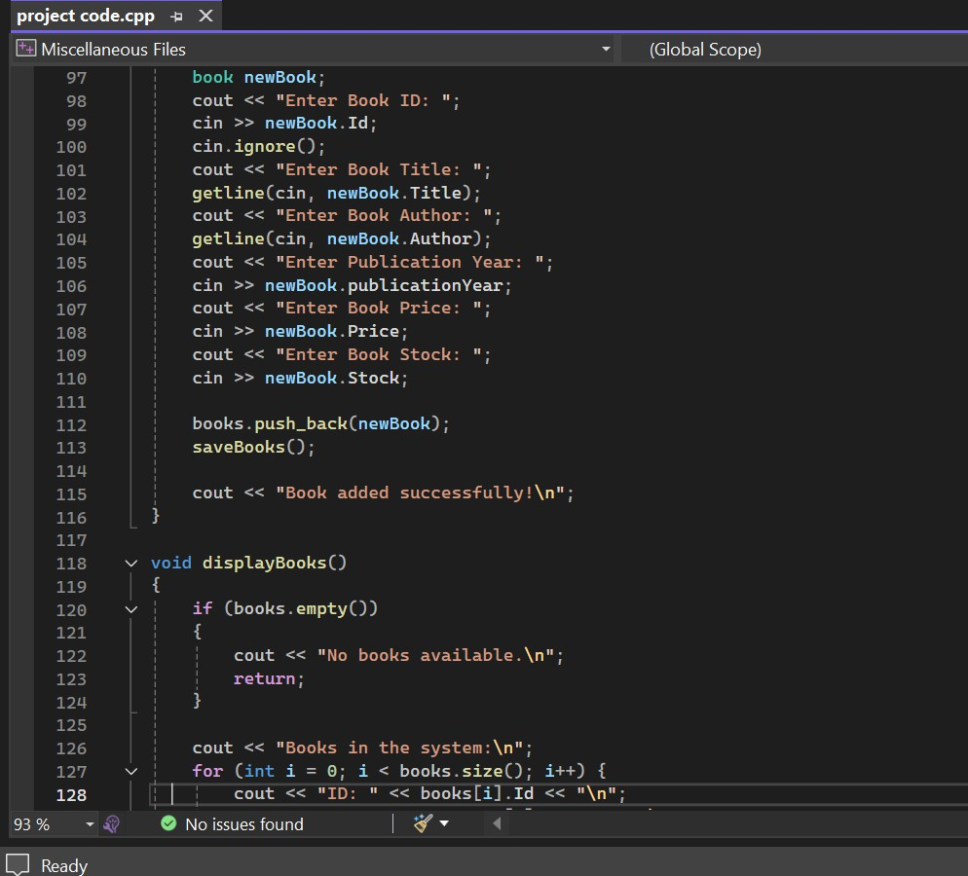

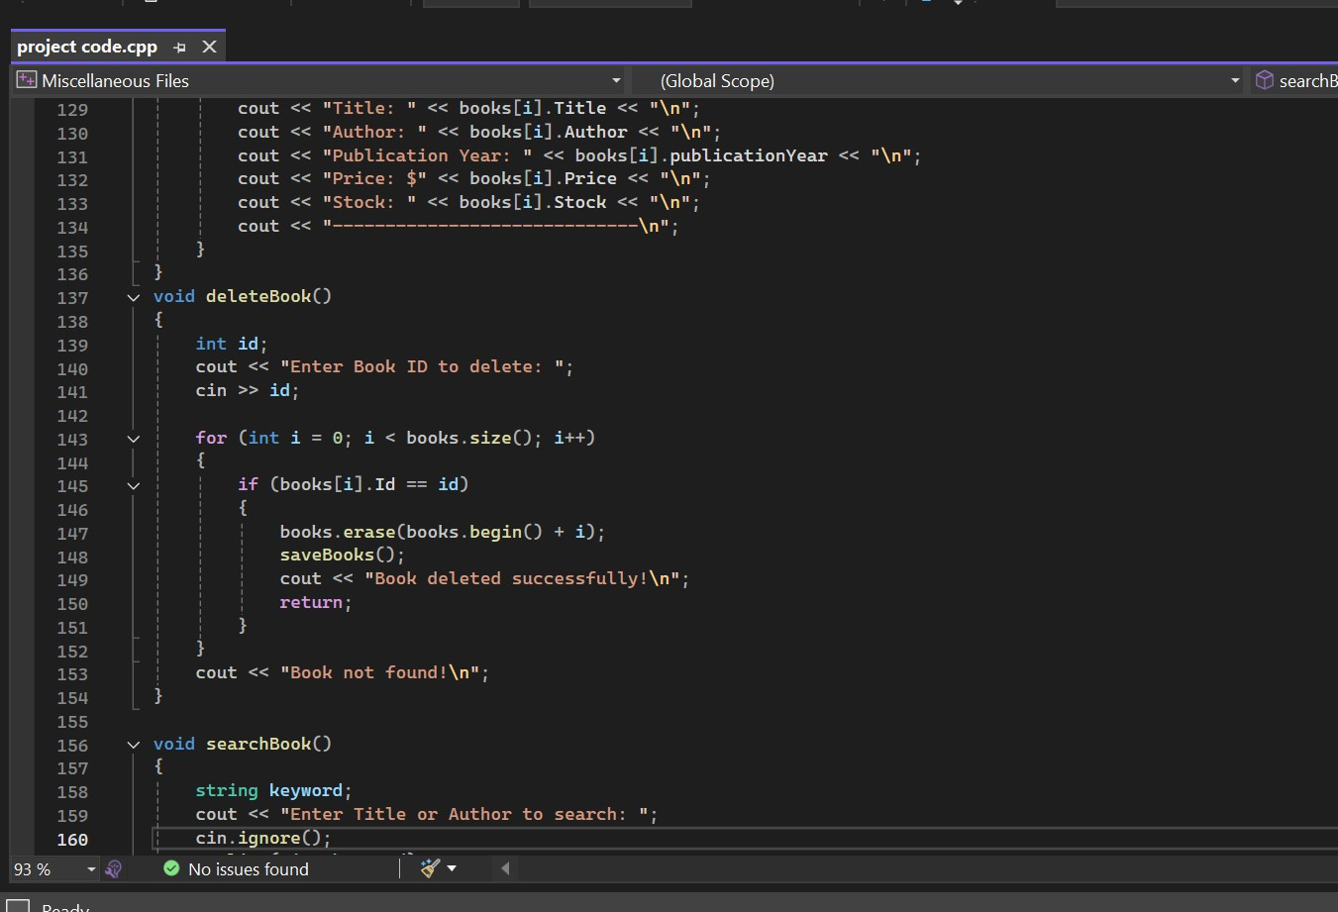

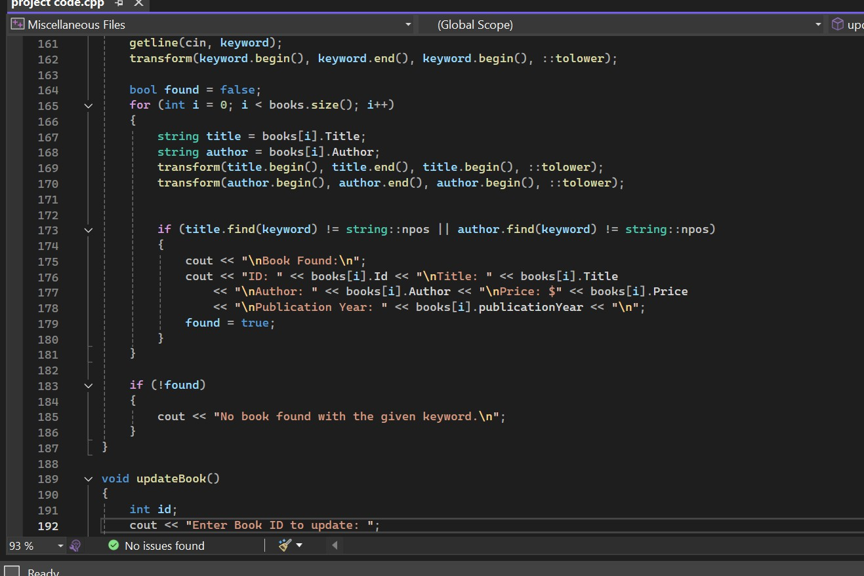

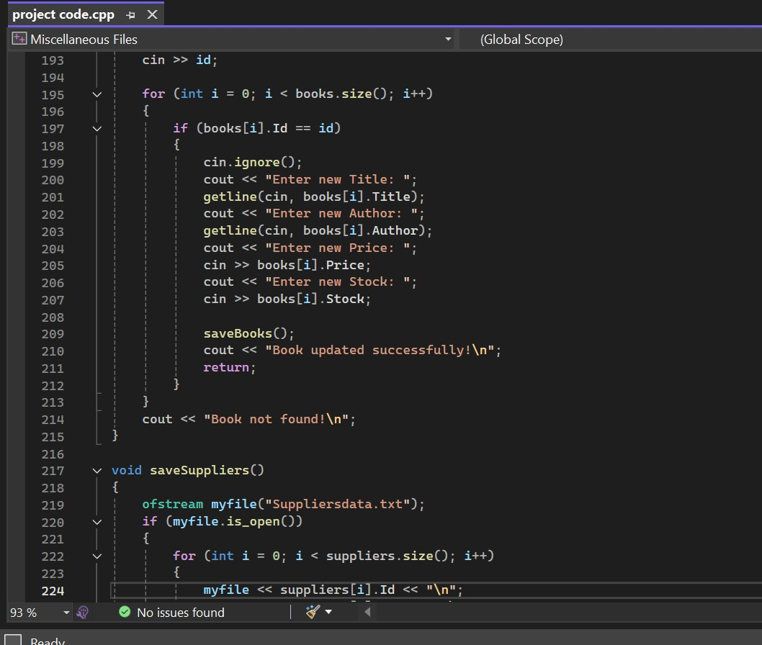

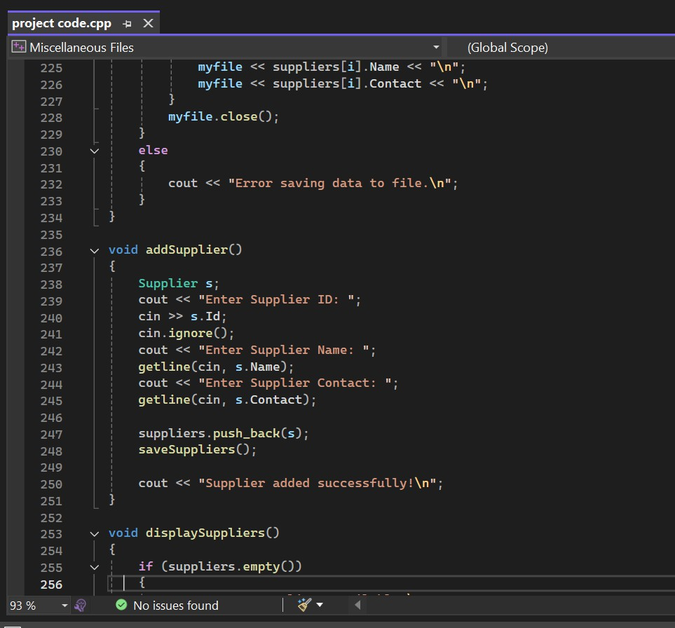

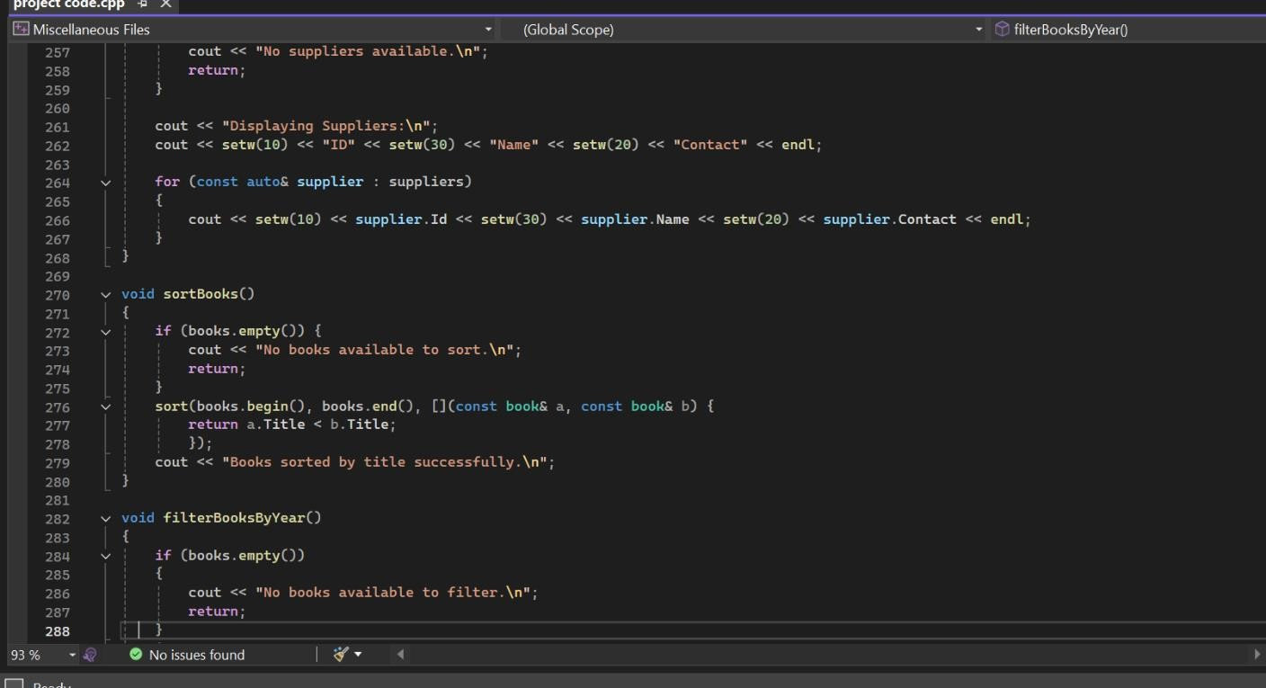

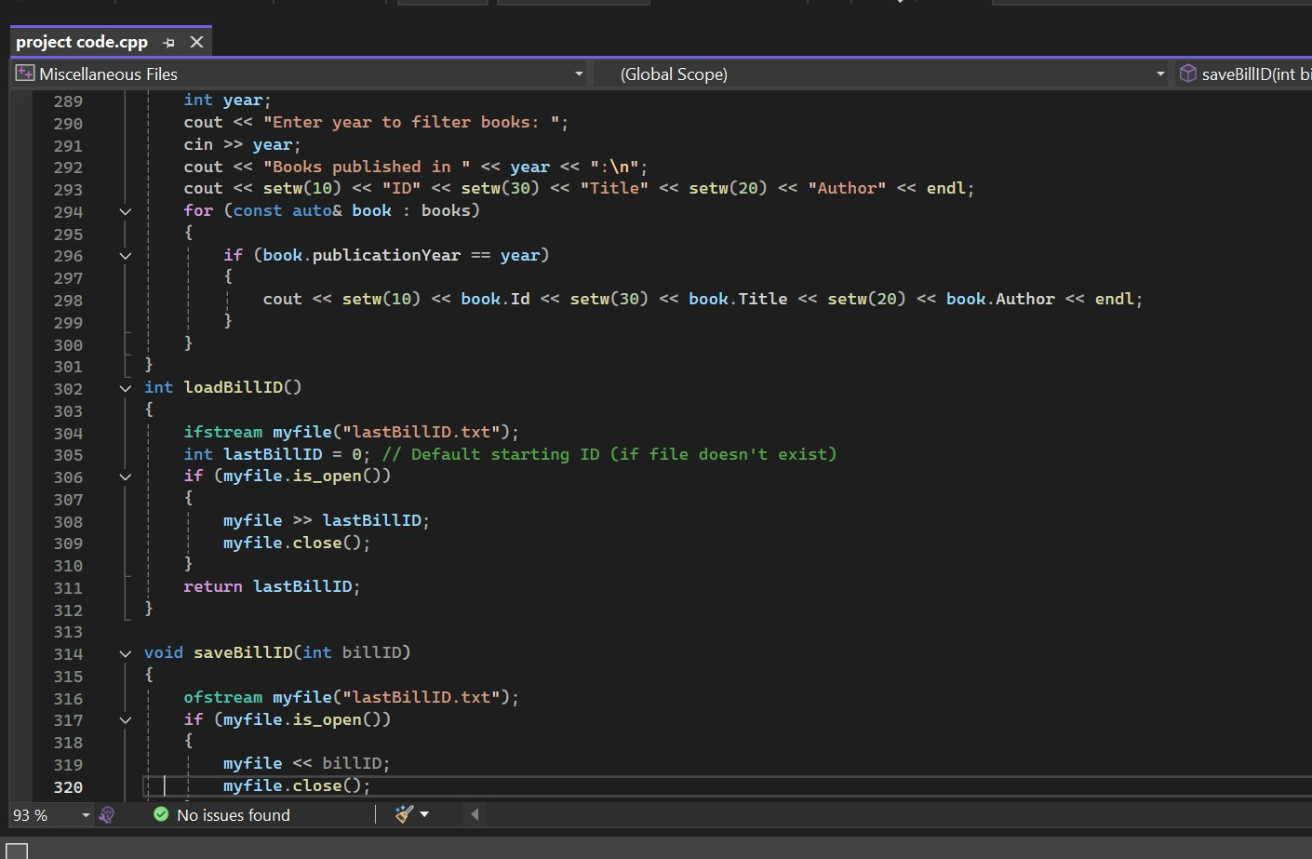

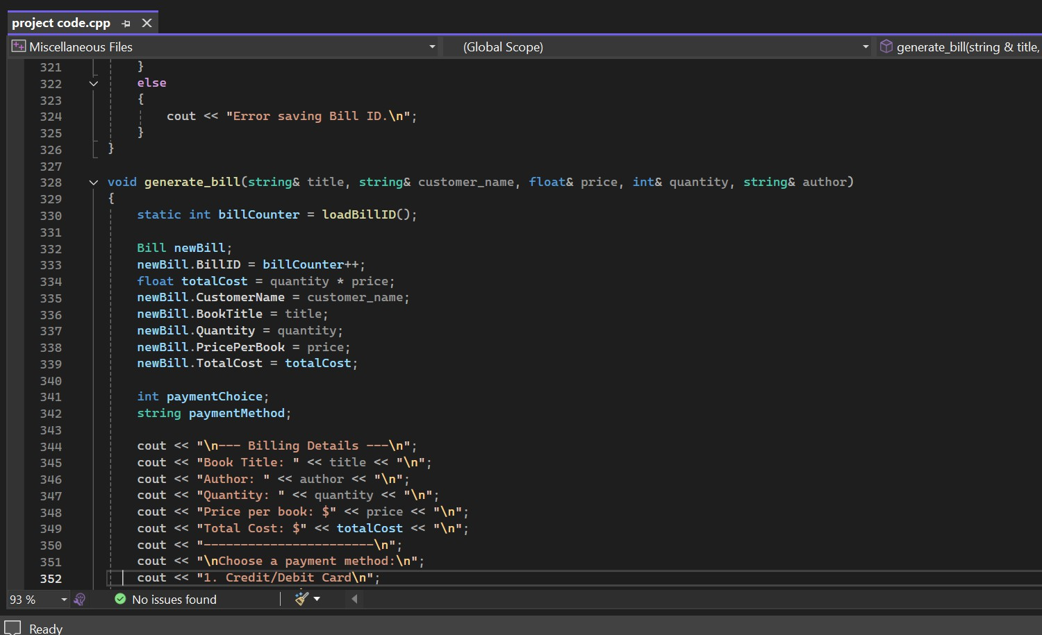

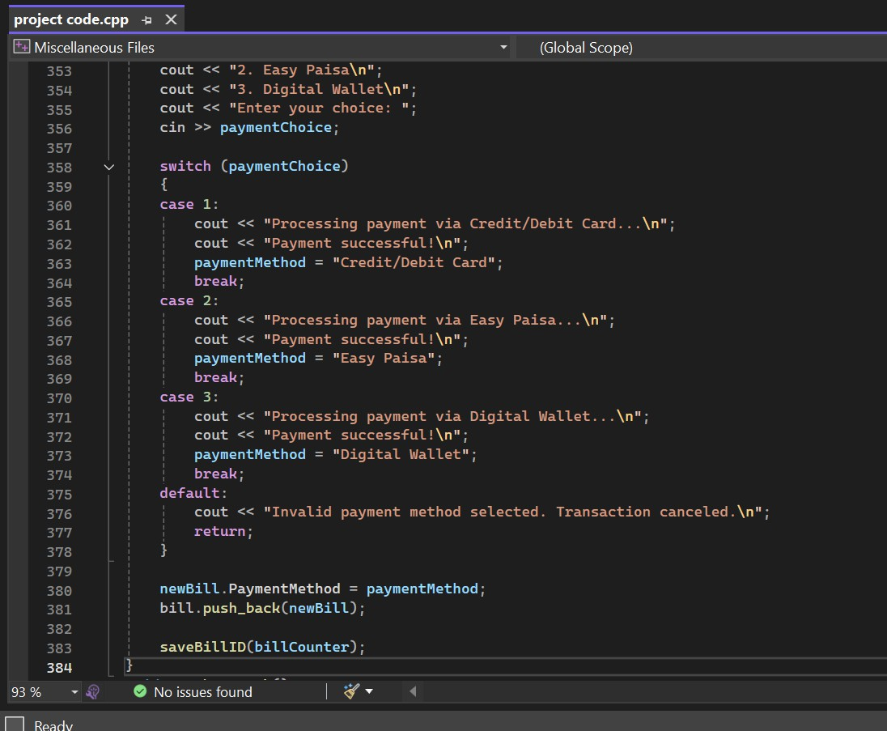

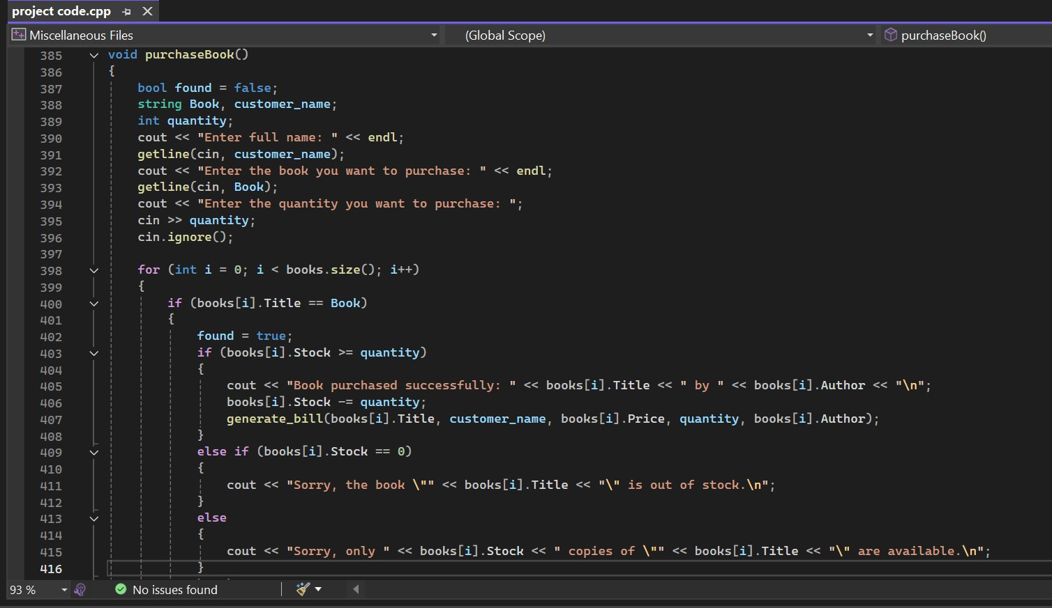

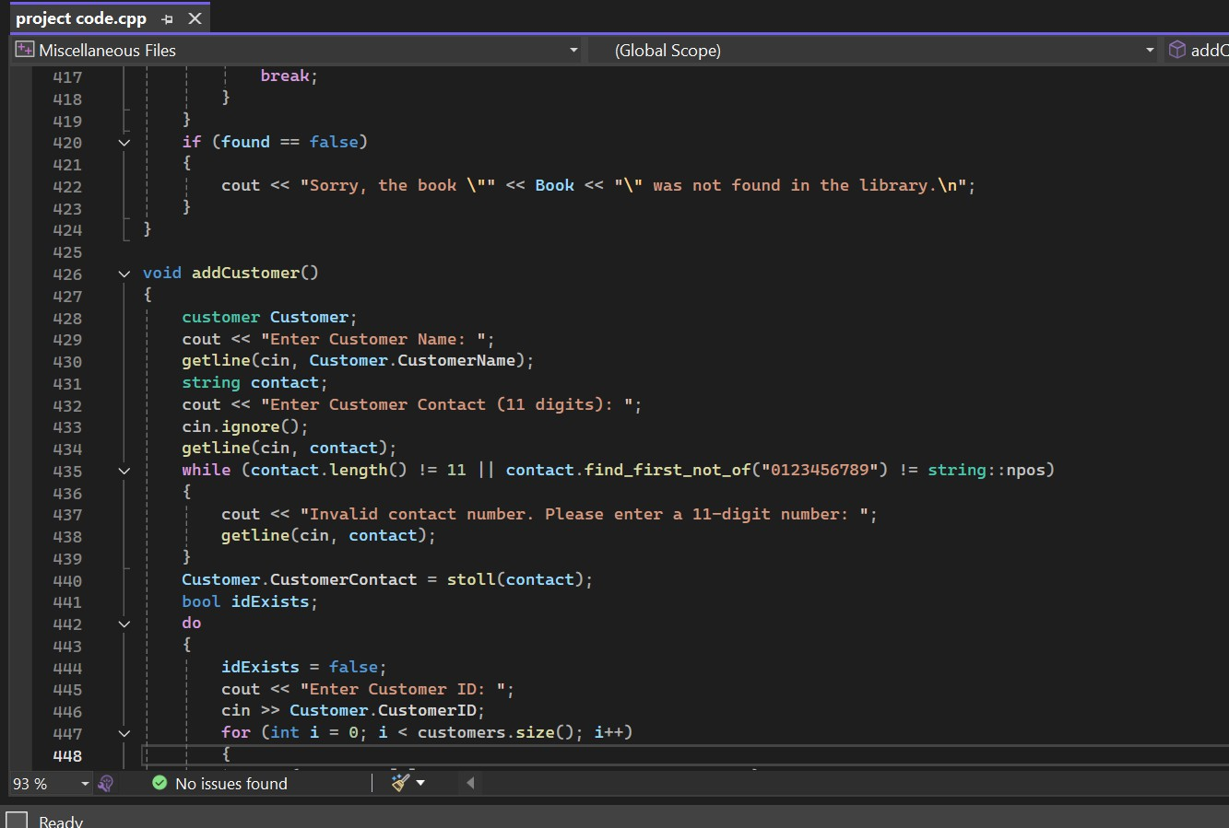

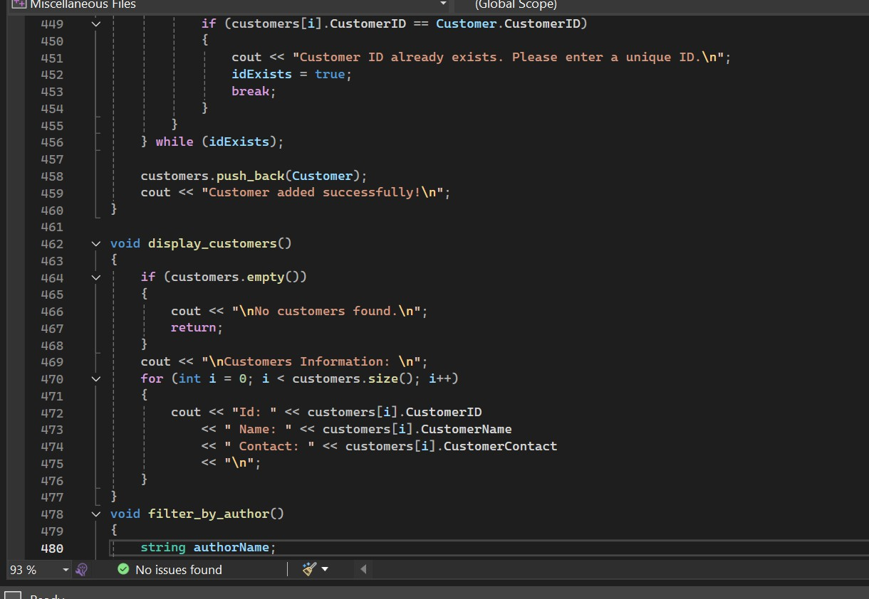

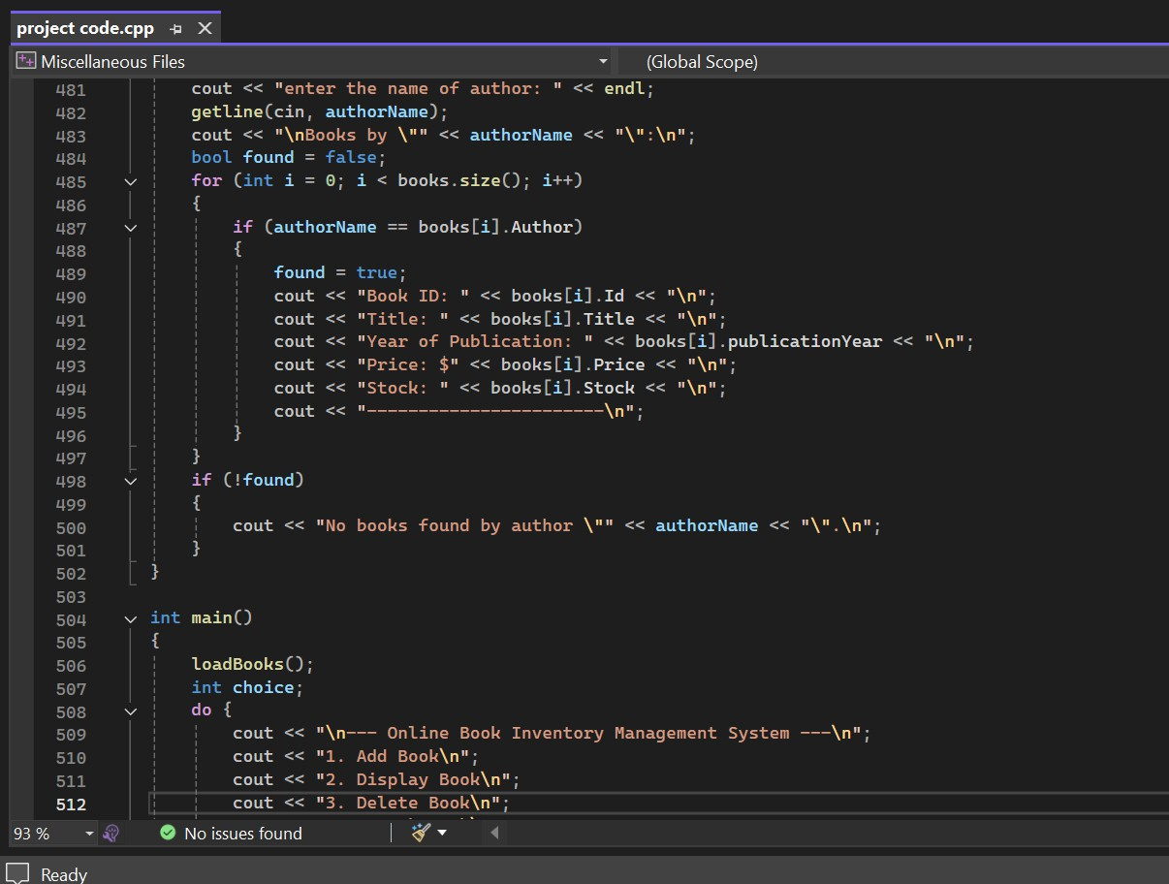

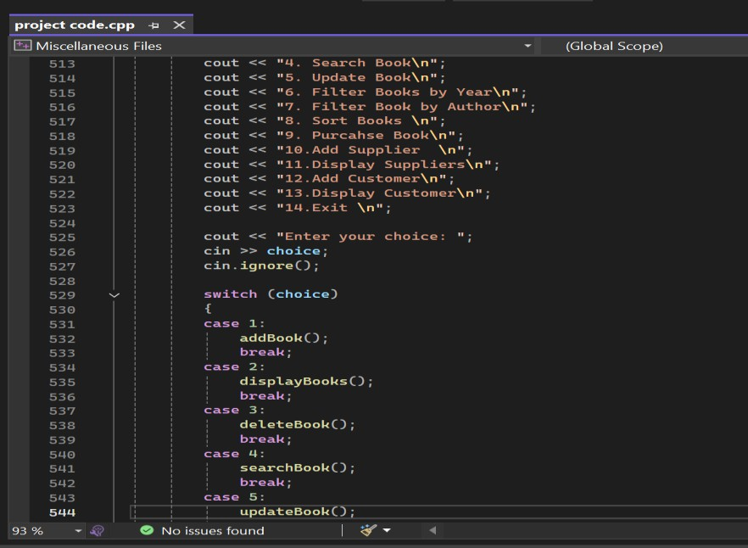

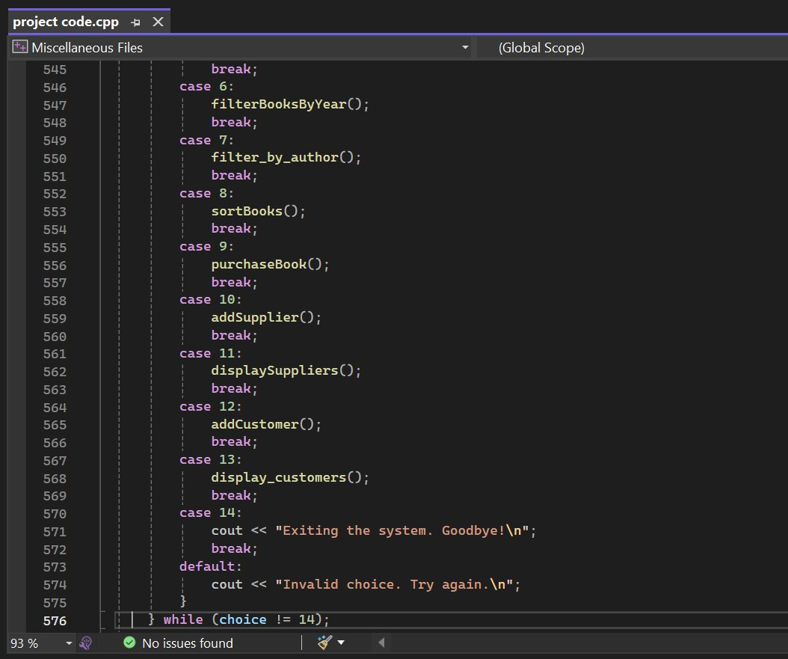

**OUTPUT:**

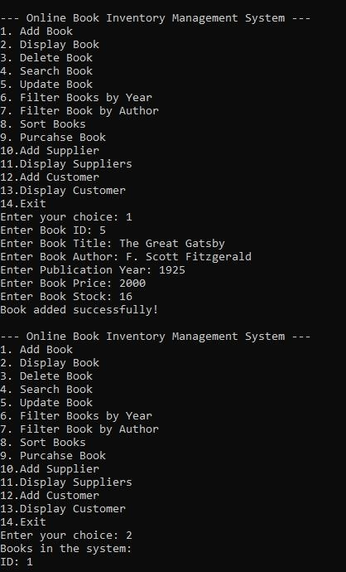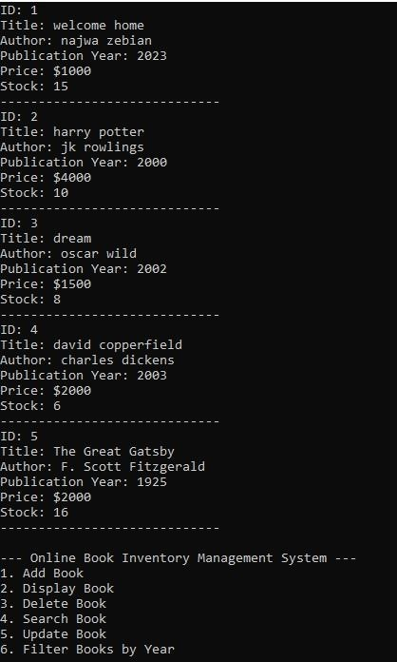

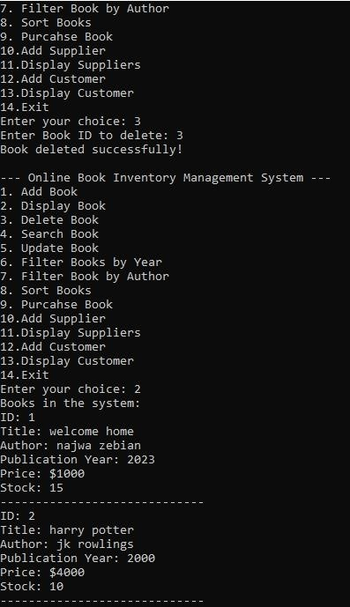 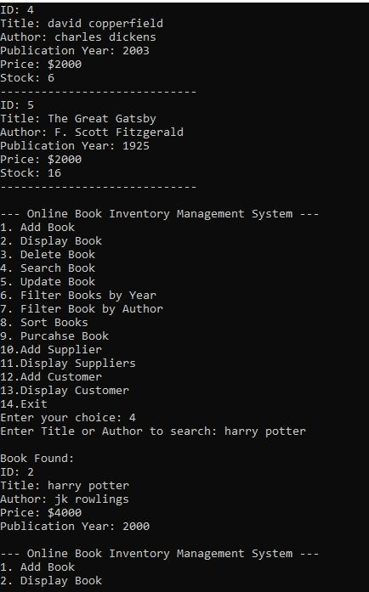

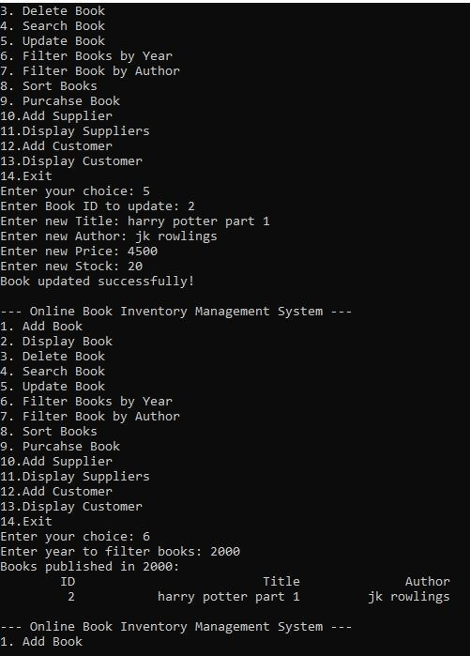 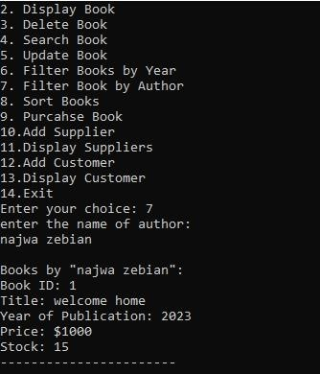

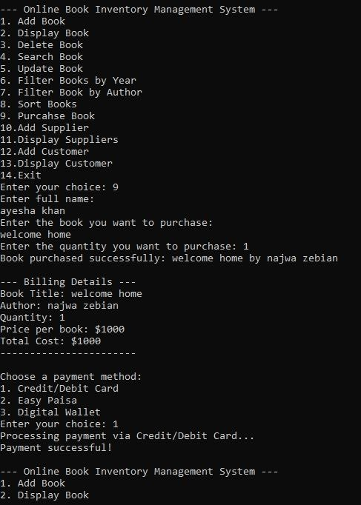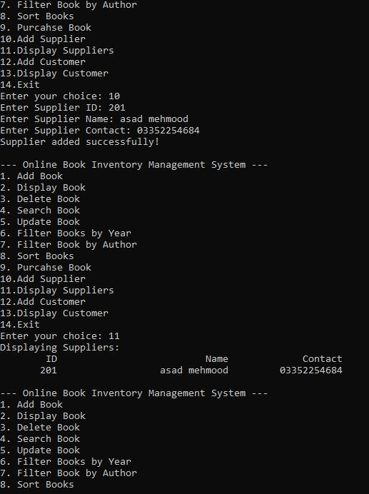

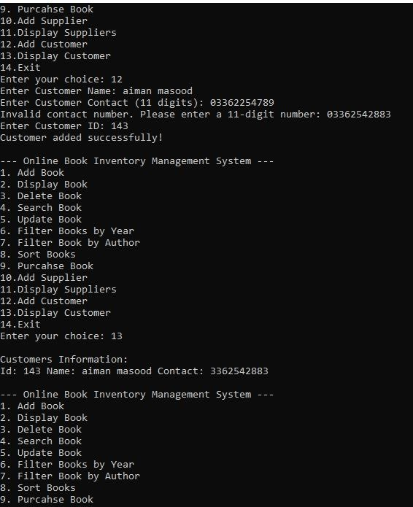

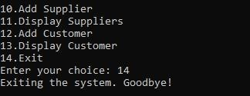

# FUTURE DEVELOPMENT:

The Online Book Inventory Management System can be expanded with the following enhancements:

## Mobile App Integration

* + Develop a mobile application for accessing inventory and sales data on the go.

## AI-Powered Recommendations

* + Use AI to suggest books to customers based on their purchase history or preferences.

## Integration with E-commerce Platforms

* + Enable seamless integration with popular e-commerce platforms for online sales and inventory synchronization.

## Multi-Language and Multi-Currency Support

* + Add support for multiple languages and currencies to cater to a global audience.

## Barcode and QR Code Integration

* + Simplify inventory management by enabling barcode or QR code scanning for book details and transactions.

## Automated Email and SMS Notifications

* + Notify customers about new arrivals, promotions, and loyalty rewards through Email or SMS.

# CONCLUSION:

In conclusion, business that deals with books needs a online book inventory system as a management tool. The technique reduces the possibility of overstocking while assisting in ensuring that there is always a sufficient supply of books. Improved customer happiness, more sales, and lower inventory management costs are all results of efficient inventory management. Lean inventory management, forecasting techniques, and the use of inventory management software are just a few of the approaches to managing book inventory that are covered in depth in the literature on book inventory management. The several publications cover a variety of subjects, including planning for material requirements, forecasting, and inventory management rules. Organizations can use these tools to determine the best method for managing their book inventory. The book inventory system needs to be continually examined and enhanced if it is to be effective. This entails routinely examining inventory data to spot trends and patterns, modifying inventory levels and reordering guidelines as necessary, and making sure the inventory management system is operating at its best. In conclusion, an efficient book inventory system can assist businesses in streamlining their processes and giving customers better service.

Businesses may optimize their book inventory, streamline processes, and cut costs by putting best practices in inventory management into practice and employing the right inventory management software.