**DOCUMENTATION**

#### By

#### Abdul Wasay Tabba (2312144)

#### Kumail Ameen(2312158)

##### **ACKNOWLEDGMENT**

##### We are really grateful because we managed to complete our project within the time given by our teacher [Abid Ali and Usama Khalid]. This assignment cannot be completed without the effort and co-operation from our group members, Group

members [Kumail Ameen ,and Abdul Wasay Tabba].

##### We also sincerely thank our teacher for the guidance and encouragement in finishing this project and also for teaching us in this course.

##### Last but not the least, we would like to express our gratitude to our friends and respondents for the support

##### **CONTENT**

**Introduction 4**

**Objectives of the project 5**

**Topic of Our Project 6**

**Software Requirements 7**

**WORK ANALYSIS 8**

**Code**

**Erd Diagram**

### 1. Introduction

This ****Library Management System (LMS)**** is designed exclusively for administrative users, providing a robust interface for managing core library operations. Key features include:

****Admin Access Control****

****Book Management**** (CRUD operations)

****Category & Author Management****

****Member Management****

****Fine Tracking****

Built on modern web technologies, the system ensures data integrity and offers actionable insights through visualizations.

### 2. Objectives of the Project

| **Objective** | **Description** |
| --- | --- |
| **Centralized Administration** | Single platform for managing books, members, and fines |
| **CRUD Operations** | Full Create/Read/Update/Delete functionality for all entities |
| **Inventory Management** | Track book status (Available/Issued) and metadata |
| **Member Supervision** | Admin-controlled member access and activity tracking |
| **Fine Management** | Overdue book tracking with fine calculations |
| **Data Visualization** | Charts for book categories, availability, and fines |
| **Security** | Restricted admin access for sensitive operations |

### Project Topic

### A secure web application for librarians to manage:

Book catalog (titles, categories, authors)

Member registrations

Fine collections

Admin registrations  
Issued Books  
Return Books

### 4. Software Requirements

| **Component** | **Technology** |
| --- | --- |
| **Frontend** | HTML5, CSS3, JavaScript |
| **Backend** | Node.js, Express.js |
| **Database** | PostgreSQL |
| **Libraries** | Chart.js, CORS, dotenv |
| **IDE** | VS Code |

### 5. Work Analysis

| **Task** | **Abdul Wasay** | **Kumail Ameen** |
| --- | --- | --- |
| **Analysis** | ✓ | ✓ |
| **Design** | ✓ | ✓ |
| **Coding** | ✓ | ✓ |
| **Testing** | ✓ | ✓ |
| **Documentation** | ✓ | ✓ |

### Code Implementation

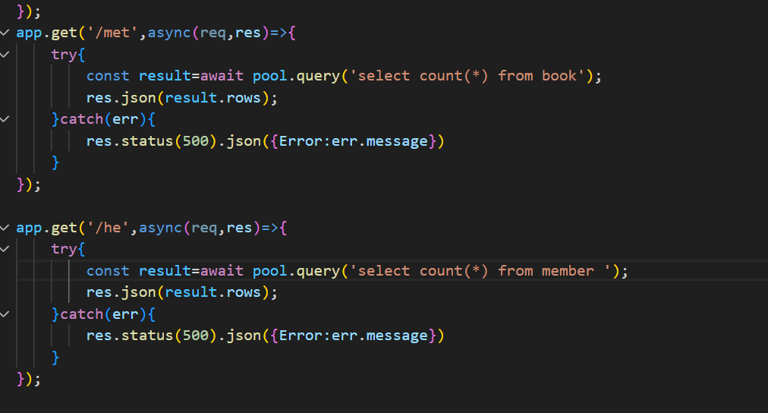

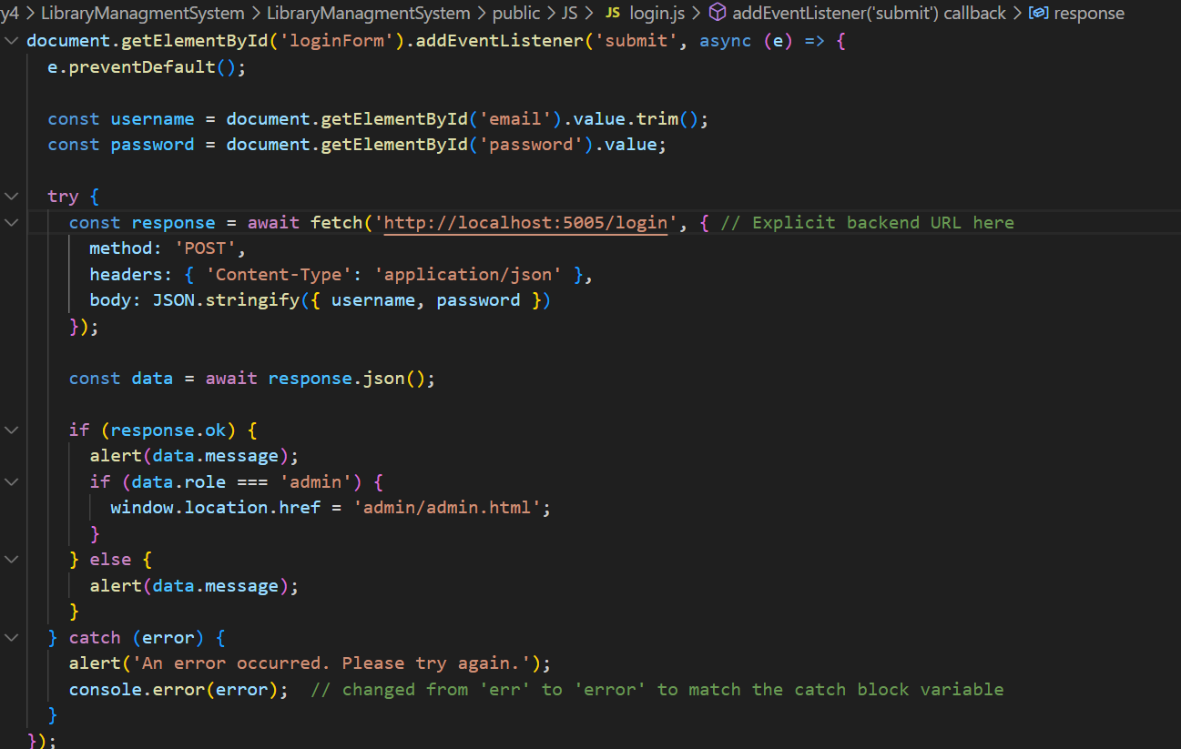

### 7a.DATA VISUALISATION :

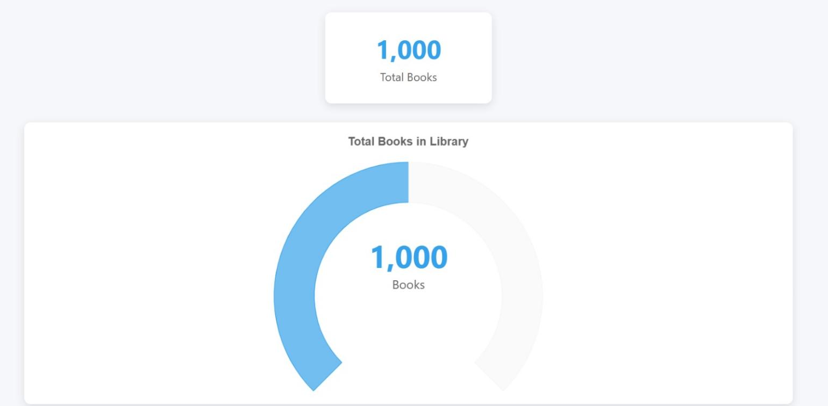

**7b.FRONTEND AND FUNCTIONS :**

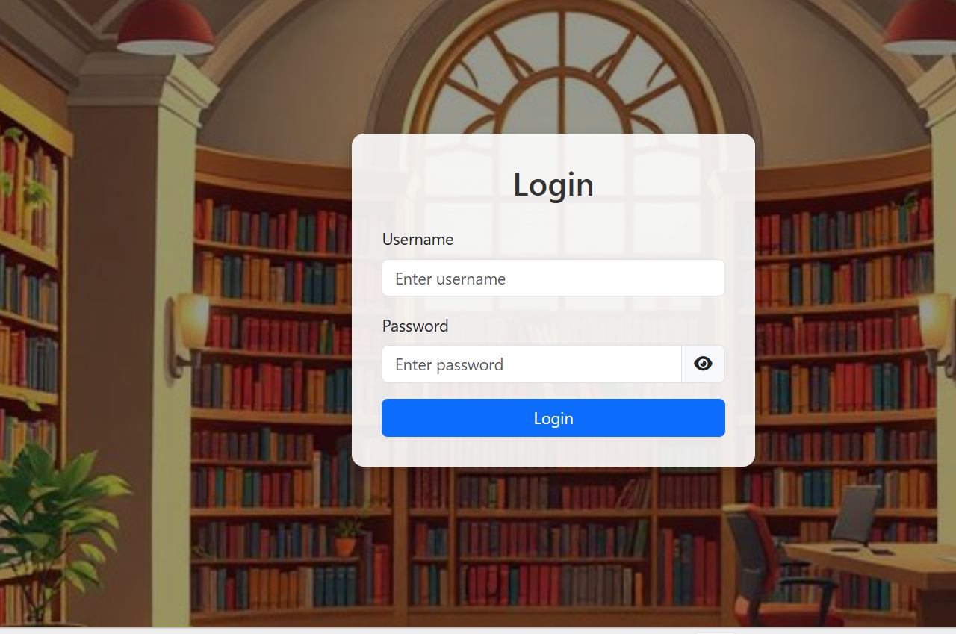

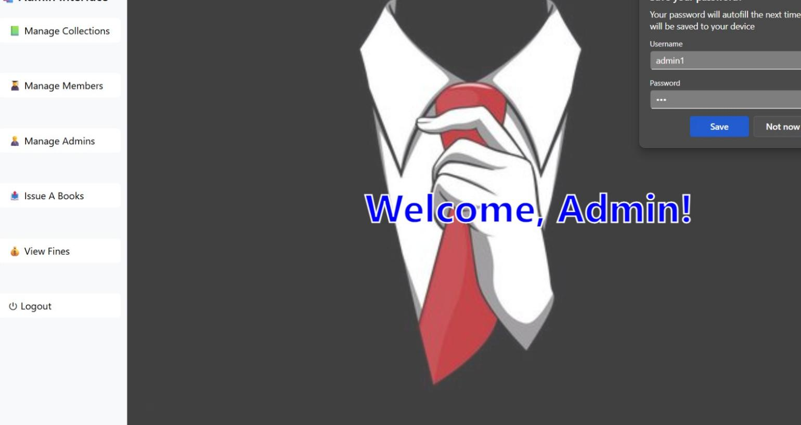

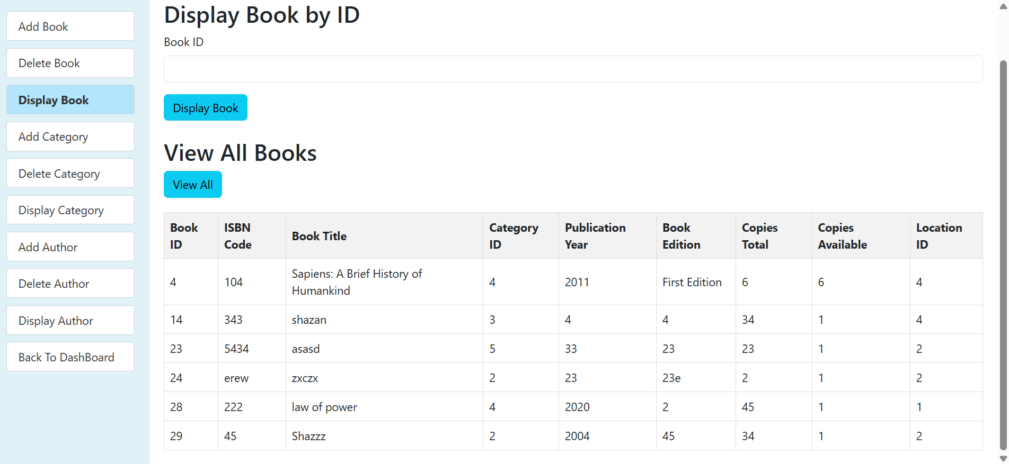

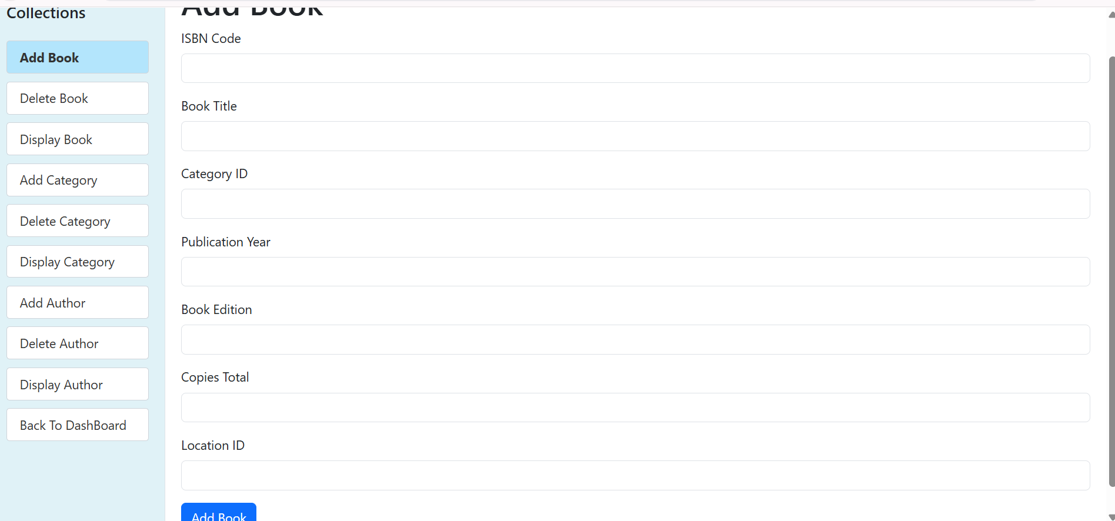

### 8. ERD Diagram

(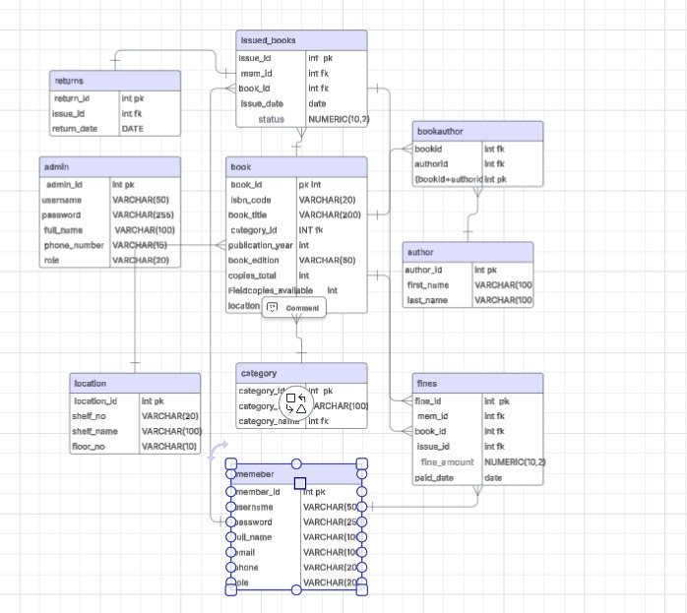

## THANK YOU