Exercise 4. Answer Sheet

Student's Name: _______________________ Student's ID: _____________________

Problem 1. (50 points) Consider the following graph and assume node A as a root.
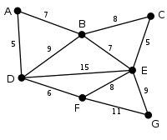

a) Draw a spanning tree obtained by using the Breadth Fist Search (BFS) algorithm.

Put your answer here.

b) Draw a spanning tree obtained by using the Depth First Search (DFS) algorithm.

Put your answer here.

c) Draw the minimum spanning tree obtained by the Prim's algorithm.

Put your answer here.

Problem 2. (50 points) Write a program implementing Kruskal's algorithm. Upload your source code. Show your input graph and the obtained MST in the space below.

