**Exercise 3. Answer Sheet**

Student's Name: Tsuyoshi Kumamoto Student's ID: s1250050

***Problem 1.*** *(25 points)* Consider the following adjacency matrix:

0 1 1 1 0 0

1 0 1 0 0 0

0 0 0 0 1 0

0 1 1 0 1 0

0 1 0 0 0 0

0 0 0 1 1 0

a) Draw a directed graph which corresponds to this adjacency matrix.

Put your answer here.

|  |  |  |  |  |  |  |
| --- | --- | --- | --- | --- | --- | --- |
|  | a | b | c | d | e | F |
| A | 0 | 1 | 1 | 1 | 0 | 0 |
| B | 1 | 0 | 1 | 0 | 0 | 0 |
| C | 0 | 0 | 0 | 0 | 1 | 0 |
| D | 0 | 1 | 1 | 0 | 1 | 0 |
| E | 0 | 1 | 0 | 0 | 0 | 0 |
| F | 0 | 0 | 0 | 1 | 1 | 0 |

A: b, c, d

B: a, c

C: e

D: b, c, e

E: b

F: d, e

b) Write the adjacency list of the graph from a).

Put your answer here.

A: b, c, d

B: a, c

C: e

D: b, c, e

E: b

F: d, e

***Problem 2.*** *(25 points)*Consider the following graph:

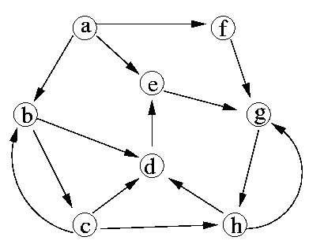

a) Starting from vertex a, in what order the Breath First Search algorithm will traverse the vertices

of this graph?

Put your answer here.

a,b,e,f,c,d,g,h

b) Starting from vertex a, in what order the Depth First Search algorithm will traverse the vertices of this graph?

Put your answer here.

a, b c h d e g f

***Problem 3.*** *(50 points)*Based on the pseudo-code for Depth First Search algorithm given at the lecture, write a program implementing it. Given the following graph, starting from node 1, calculate the discovery and finishing time of each node and fill the table starting from node 1. (Don't forget to upload your program!)

6

5

4

3

2

1

|  |  |  |  |  |  |  |
| --- | --- | --- | --- | --- | --- | --- |
| Node | 1 | 2 | 3 | 4 | 5 | 6 |
| Discovery time |  |  |  |  |  |  |
| Finishing time |  |  |  |  |  |  |