**Exercise 4. Answer Sheet**

Student's Name: Tsuyoshi Kumamoto Student's ID: s1250050

***Problem 1.*** (*50 points*) Consider the following graph and assume node A as a root.

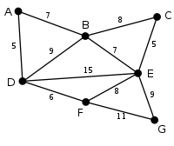

a) Draw a spanning tree obtained by using the Breadth Fist Search (BFS) algorithm.

Put your answer here.

[ A, D, B, F, C, E, G]

b) Draw a spanning tree obtained by using the Depth First Search (DFS) algorithm.

Put your answer here.

[ A, D, F, G, B, E, C]

c) Draw the minimum spanning tree obtained by the Prim's algorithm.

Put your answer here.

***Problem 2.*** *(50 points)*Write a program implementing Kruskal'salgorithm. Upload your source code. Show your input graph and the obtained MST in the space below.