Class: CMSC203 CRN 23118

 Program: Lab 1

Instructor: Huseyin Aygun

 Summary of Description: Movie description

 Due Date: 09-29-25

 Integrity Pledge: I pledge that I have completed the programming assignment independently.

 I have not copied the code from a student or any source.

Student’s Name: Kevin Umanzor

**Complete the following three parts of Lab 1. Name your file as FirstInitialLastName_Lab1.docx**

**Task 1**

Provide the screen shots from Task 1 here:

Submit both Java files from Task 1, even though you have not changed Movie.java

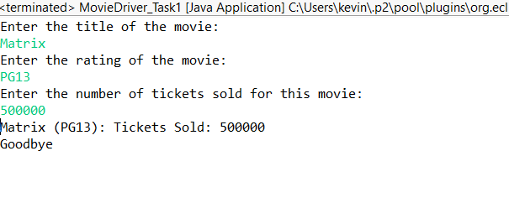

**Task 2**

Provide the screen shots from Task 2 here:

Submit both Java files from Task 2, even though you have not changed Movie.java

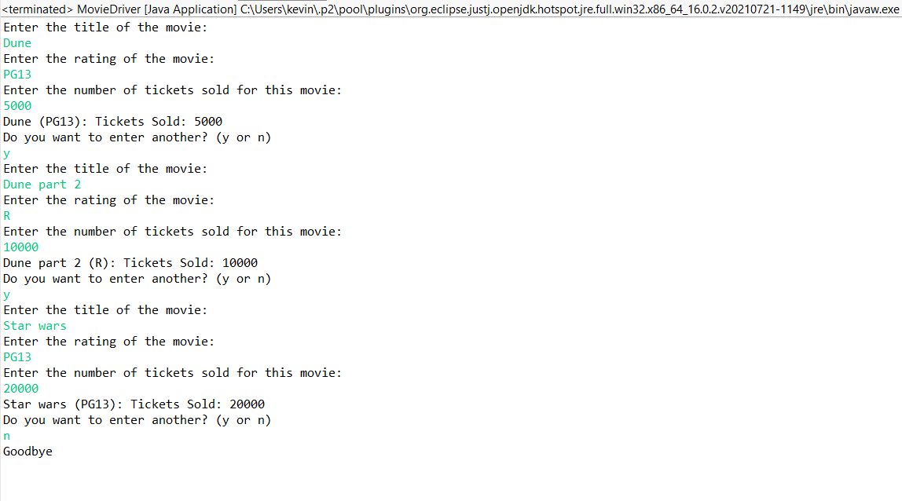

**Task 3**

Provide the screen shots from Task 3 here:

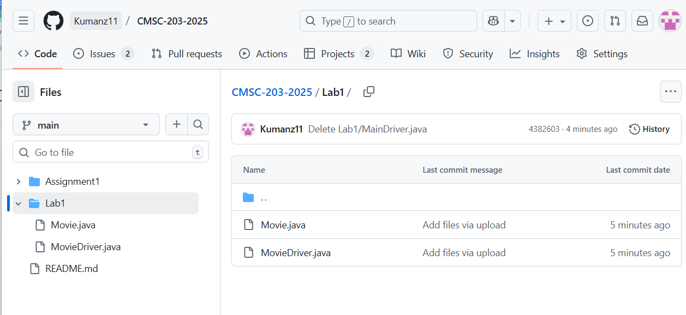

**Lessons Learned** <Provide answers to the questions listed below>**:**

Write about your Learning Experience, highlighting your lessons learned and learning experience from working on this assignment.

What have you learned?

I have learned how to create an object in java and use the toString method to display information of that object

What did you struggle with?

I didn't necessarily struggle but I'd say the hardest part was implementing the loop so that the program would continuously ask the user about the movie until a keyword was given.

What parts of this assignment were you successful with, and what parts (if any) were you not successful with?

I'd say I was successful with the entirety of the project as I created the movie object with the right information as well as successfully implemented the loop.

Provide any additional resources/links/videos you used to while working on this assignment.

Did not use any additional resources other than Pearson.

**Deliverables for Lab1:**

Submit FirstInitiallastName_Lab1.zip

  Include the following files in your zip file:

   1.1 FirstInitiallastName_Lab1.doc based on a provided template:

   1.2 both Java files from Task 1 with the names Movie.java, MovieDriver_Task1 (even though you have not changed Movie.java)

   1.3 both Java files from Task 2 with the names Movie.java, MovieDriver_Task2 (even though you have not changed Movie.java)

**Check List:** <Provide answers to the column Y/N or N/A >**:**

| **#** |  | **Y/N** | **Comments** |
| --- | --- | --- | --- |
|  | **Lab 1 files:** |  |  |
|  | * FirstInitialLastName_Lab1.docx/pdf | **y** |  |
|  | * Source java files from Task 1 | **y** |  |
|  | * Source java files from Task 2 | **y** |  |
|  | **Program compiles** | **y** |  |
|  | **Program runs with desired outputs** | **y** |  |
|  | **Documentation file: Screenshots of** | **y** |  |
|  | * Task1 | **y** |  |
|  | * Task2 | **y** |  |
|  | * Task3 | **y** |  |
|  | * Lessons Learned | **y** |  |
|  | * Checklist is completed and included in the Documentation | y |  |