**Exercise 3: Stored Procedures**

**Scenario 1: The bank needs to process monthly interest for all savings accounts.**

* + **Question: Write a stored procedure ProcessMonthlyInterest that calculates and updates the balance of all savings accounts by applying an interest rate of 1% to the current balance.**

**Scenario 2: The bank wants to implement a bonus scheme for employees based on their performance.**

* + **Question: Write a stored procedure UpdateEmployeeBonus that updates the salary of employees in a given department by adding a bonus percentage passed as a parameter.**

**Scenario 3: Customers should be able to transfer funds between their accounts.**

* + **Question: Write a stored procedure TransferFunds that transfers a specified amount from one account to another, checking that the source account has sufficient balance before making the transfer.**

**Code**

CREATE TABLE accounts (

  account_id     NUMBER PRIMARY KEY,

  customer_id    NUMBER,

  account_type   VARCHAR2(20),

  balance        NUMBER(10, 2)

);

-- Create employees table

CREATE TABLE employees (

  employee_id       NUMBER PRIMARY KEY,

  employee_name     VARCHAR2(50),

  department_id     NUMBER,

  salary            NUMBER(10, 2),

  performance_rating NUMBER(5, 2)

);

-- Create transactions table (for fund transfers)

CREATE TABLE transactions (

  transaction_id   NUMBER GENERATED ALWAYS AS IDENTITY,

  from_account     NUMBER,

  to_account       NUMBER,

  amount           NUMBER(10,2),

  transaction_date DATE DEFAULT SYSDATE

);

-- Insert into accounts

INSERT INTO accounts VALUES (101, 1, 'savings', 5000.00);

INSERT INTO accounts VALUES (102, 2, 'checking', 3000.00);

INSERT INTO accounts VALUES (103, 3, 'savings', 8000.00);

INSERT INTO accounts VALUES (104, 4, 'savings', 12000.00);

-- Insert into employees

INSERT INTO employees VALUES (1, 'John Smith', 10, 50000.00, 4.5);

INSERT INTO employees VALUES (2, 'Alice Brown', 10, 60000.00, 4.0);

INSERT INTO employees VALUES (3, 'Bob Johnson', 20, 55000.00, 3.8);

COMMIT;

CREATE OR REPLACE PROCEDURE ProcessMonthlyInterest IS

BEGIN

  FOR acc IN (

    SELECT account_id, balance

    FROM accounts

    WHERE account_type = 'savings'

  ) LOOP

    UPDATE accounts

    SET balance = balance + (acc.balance * 0.01)

    WHERE account_id = acc.account_id;

    DBMS_OUTPUT.PUT_LINE('✅ Interest added to Account ID: ' || acc.account_id ||

                         ' | New Balance: ' || TO_CHAR(acc.balance * 1.01, '99999.99'));

  END LOOP;

END;

/

CREATE OR REPLACE PROCEDURE UpdateEmployeeBonus(

  p_dept_id IN NUMBER,

  p_bonus_percent IN NUMBER

) IS

BEGIN

  FOR emp IN (

    SELECT employee_id, salary

    FROM employees

    WHERE department_id = p_dept_id

  ) LOOP

    UPDATE employees

    SET salary = salary + (emp.salary * (p_bonus_percent / 100))

    WHERE employee_id = emp.employee_id;

    DBMS_OUTPUT.PUT_LINE('🎉 Bonus applied to Employee ID: ' || emp.employee_id ||

                         ' | New Salary: ' || TO_CHAR(emp.salary * (1 + p_bonus_percent / 100), '99999.99'));

  END LOOP;

END;

/

CREATE OR REPLACE PROCEDURE TransferFunds(

  p_from_account IN NUMBER,

  p_to_account IN NUMBER,

  p_amount IN NUMBER

) IS

  v_balance NUMBER;

BEGIN

  SELECT balance INTO v_balance FROM accounts WHERE account_id = p_from_account FOR UPDATE;

  IF v_balance < p_amount THEN

    DBMS_OUTPUT.PUT_LINE('❌ Transfer failed: Insufficient balance.');

  ELSE

    UPDATE accounts SET balance = balance - p_amount WHERE account_id = p_from_account;

    UPDATE accounts SET balance = balance + p_amount WHERE account_id = p_to_account;

    INSERT INTO transactions(from_account, to_account, amount)

    VALUES (p_from_account, p_to_account, p_amount);

    DBMS_OUTPUT.PUT_LINE('💸 Transfer successful: ₹' || p_amount ||

                         ' from Account ' || p_from_account ||

                         ' to Account ' || p_to_account);

  END IF;

EXCEPTION

  WHEN NO_DATA_FOUND THEN

    DBMS_OUTPUT.PUT_LINE('❌ Account not found.');

  WHEN OTHERS THEN

    DBMS_OUTPUT.PUT_LINE('❌ Error: ' || SQLERRM);

END;

/

EXEC ProcessMonthlyInterest;

EXEC UpdateEmployeeBonus(10, 10);

EXEC TransferFunds(101, 102, 1000);

**Output:**

**Scenario 1:**

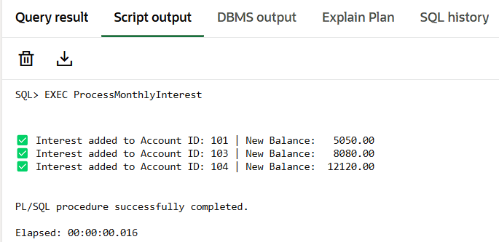

**Scenario 2:**

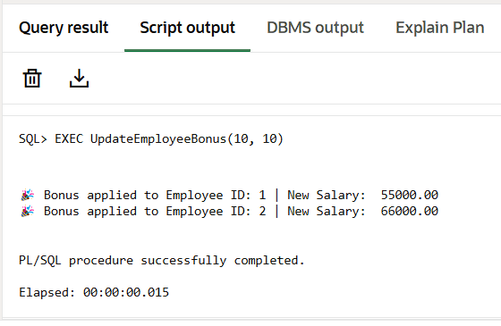

**Scenario 3:**

