CHAPTER-1
INTODUCTION
ORIGIN OF FINANCE:
Finance originated around 3000 BCE in ancient Mesopotamia, where temples and places served as early banks for storing valuables, leading to the development of credit, loans, by 1800 BCE formal debt regulation in the code of Hammurabi. It evolved from barter systems to metallic money and banking, formalizing in medieval Italy and establishing modern theory by the 1950s.
- Ancient beginnings
- Finance began with the barter system, where goods were exchanged directly.
- Around 3000 BCE in Mesopotamia, people started recording transactions on clay tablets.
- Temples and palaces acted like early financial institutions, storing wealth and lending grain or silver.
- Introduction of money
- The first metal coins were introduced in Lydia around the 7th century BCE
- Money replaced barter, making trade easier and more efficient.
- This led to the growth of markets and economic activity.
- Birth of banking
- Banking systems emerged in ancient Greece and Rome.
- Modern banking developed in medieval Italy, especially in cities like Florence.
- The Medici family played a major role in developing banking practices like loans, deposits, and bookkeeping.

- Development of financial markets
- The first stock exchange was established in Amsterdam in the 17th century.
- Companies began issuing shares to raise capital.
- Financial markets expanded globally, enabling investment and economic growth
Modern Finance
Finance today includes banking, investments, insurance, and financial technology (fintech).
Global institutions, stock markets, and digital platforms dominate.
Concepts like corporate finance, public finance, and persona finance evolved.

INTRODUCTION TO FINANCE
Finance is an important field that contributes significantly to the functioning of moder economies. It includes a wide range of operations involving the management of money and other financial resources. Finance is a vital for making intelligent budgeting, investing, saving, and spending decisions at all levels, from individual homes to organizations and governments. At its foundation, finance is about knowing how money works and how to use it to achieve specific objectives. This includes raising cash in a variety of ways, such as issuing stocks on bonds, managing assets to achieve maximum return, and assessing risks to reduce potential losses.

1.2 DEFINITION OF FINANCE:
Finance is the science and practice of managing money and other financial assets. It entails the study, creation, and administration of funds, including bow money is raised, invested, and spent by individuals, businesses, and governments, Finance's fundamental purpose is to optimize resource allocation, control risks, and maximize investment value.

1.3 MEANING OF FINANCE:
Finance is the science and art of managing money and financial resources effectively, and the activity of earning, spending, saving, investing, and managing money.

1.4 SCOPE OF FINANCE:

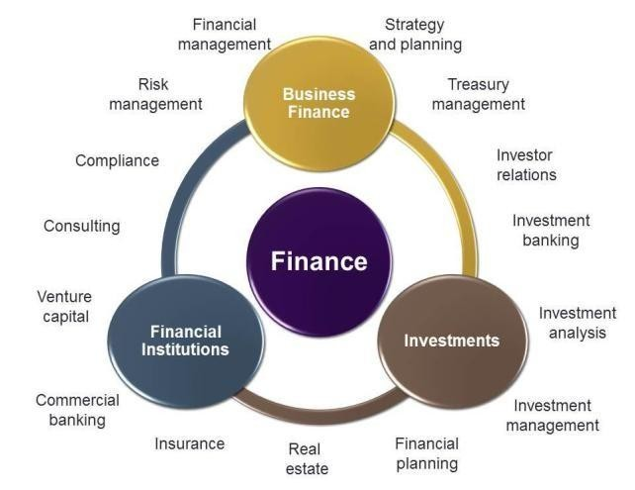
- Strategy and Planning - A strategy is a comprehensive plan or method used to accomplish a certain goal or group of goals. It entails choosing how to compete in the market, where to put resources, and what steps to follow in order to accomplish long-term goals Planning is the process of establishing objectives and deciding the actions required to accomplish them.
- Treasury Management - Treasury management is the oversight and control of an organization's financial resources, usually by its treasury department or function. The fundamental purpose of treasury management is to guarantee that the business has enough liquidity to meet its financial obligations and improve its overall financial performance.
- Investor Relations -Investor Relations (IR) is the strategic management department within a corporation that communicates with investors, analysts, shareholders, and other stakeholders. The major purpose of Investor Relations is to foster strong connections and open communication between the company and the financial community.
- Investment Banking- Investment banking is a type of banking that specializes in providing financial advice services, raising capital, and conducting mergers and acquisitions (M&A) for firms, governments, and other organizations.
- Investment Analysis - Investment analysis aims to help investors make informed decisions that optimize the risk-return trade-off while also aligning with their financial goals and preferences.
- Investment Management- Investment management, often known as asset management, is the professional management of various securities and assets (such as stocks, bonds, real estate, commodities, and other investments) on behalf of individuals or institutions.
- Financial Planning - Financial planning is a complete process that assists people, families, and organizations in assessing their financial condition, setting financial goals, and developing a strategy to accomplish those goals.
- Real Estate - The term "real estate" refers to property that includes land, buildings, natural resources, and other improvements attached of located on it. It is a physical asset class that Includes a variety of residential, commercial, industrial, and agricultural properties.
- Insurance- Insurance is a financial agreement that protects against the possibility of financial loss. The risk of potential losses is transferred from an individual of corporation (the insured) to an insurance firm (the insurer) in exchange for the payment of a premium.
- Commercial Banking - Commercial banking encompasses the banking activities and services offered by financial institutions (banks) to enterprises, corporations, and government agencies.
1.5 ADVANTAGES OF FINANCE:
- Ensures Availability of Funds
Finance helps in raising and allocating capital as per the needs of the business or individual ensures liquidity and smooth day-to-day operations.
- Supports Business Growth and Expansion
Adequate financing enables companies to invest in new projects, expand operations, or enter new markets. Helps in technology upgrades, research and development, and hiring skilled employees.
- Aids in Decision-Making
Financial analysis helps in making informed decisions about investments, expenses, pricing and profitability, Tools like budgeting, forecasting, and cost-benefit analysis are finance based.
- Increases Profitability
Effective financial management ensures optimal use of resources, minimizes costs, and enhances profits.
- Risk Management
Finance involves tools and strategies (like insurance, diversification, hedging) that help in identifying, assessing, and minimizing risks.
- Enhances Investor Confidence
Sound financial planning and transparent reporting boost investor trust and attract more investment Improves company’s reputation and market valuation.
- Facilitates Long-Term Planning
Finance helps individuals and organizations plan for the future—like retirement, expansion, or sustainability
- Improves Operational Efficiency
With proper budgeting and fund allocation, businesses can reduce waste, control spending, and streamline operations.

- Promotes Economic Development
At a national level, finance supports infrastructure development, industrialization, and social programs, driving economic growth.

1.6 DISADVANTAGES OF FINANCE:

- Risk of Over-Borrowing
Excessive reliance on debt can lead to high interest costs and financial distress.
- Cost of Financing Raising finance
whether through loans, equity, or issuing bonds—often involves high costs such as:
- Interest payments
- Administrative or underwriting fees
- Dividend obligations
- Mismanagement or Misallocation of Funds
Improper financial planning can lead to wastage, unproductive investments, or cash flow problems.
- Dependency on External Sources
Relying too much on external finance can make a business or individual vulnerable to creditors or investors.
- Interest Rate Fluctuations
Loans and credit are sensitive to interest rate changes. Rising rates increase the cost of borrowing, reducing profitability.
- Market Volatility and Investment Risks
Financial markets are unpredictable. Investments can lead to losses due to market crashes, inflation, or poor economic conditions.

- Complexity and Regulation
Finance involves complex calculations, compliance, and legal regulations that require expertise.
- Short-Term Focus
Companies may focus on short-term financial gains (like boosting EPS) rather than long-term sustainability, leading to unstable growth.

  - TYPES OF FINANCE
- PERSONAL FINANCE
- CORPORATE FINANCE
- PUBLIC FINANCE

