Experiment-11

Change Hardware compatibility of a VM (Either by clone/create new one) which is already created and configured.

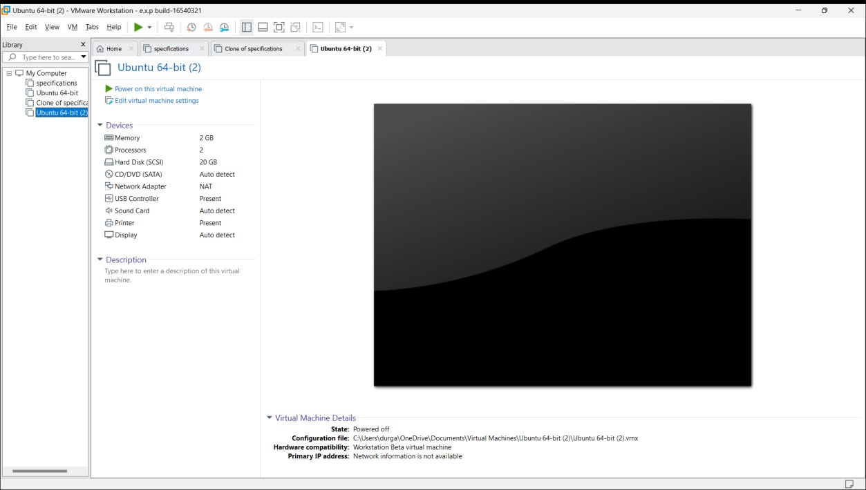

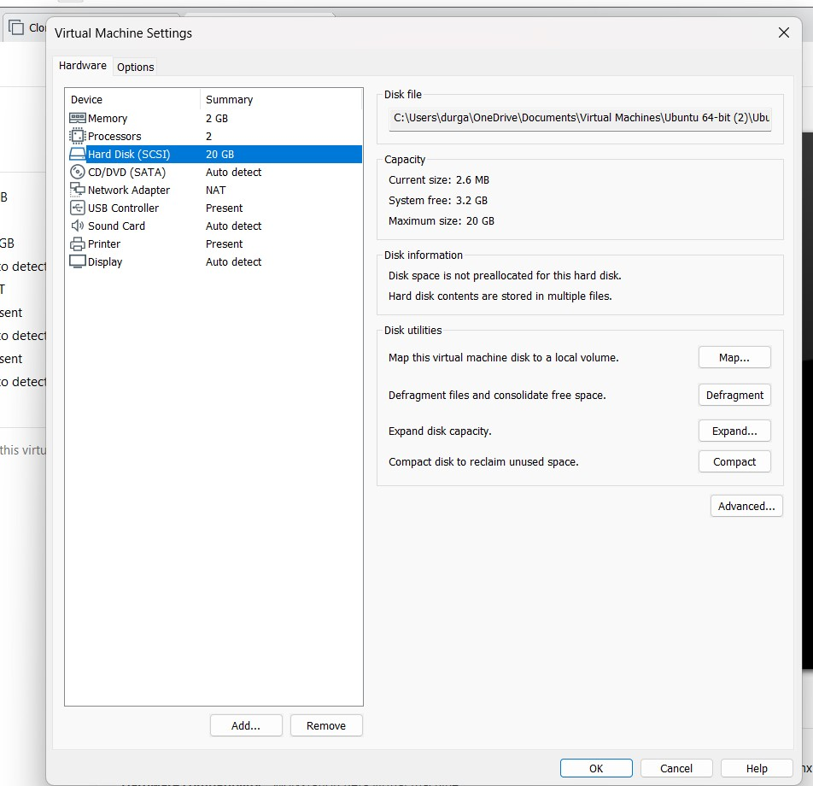

1. Vaishnav kumar {192210190}

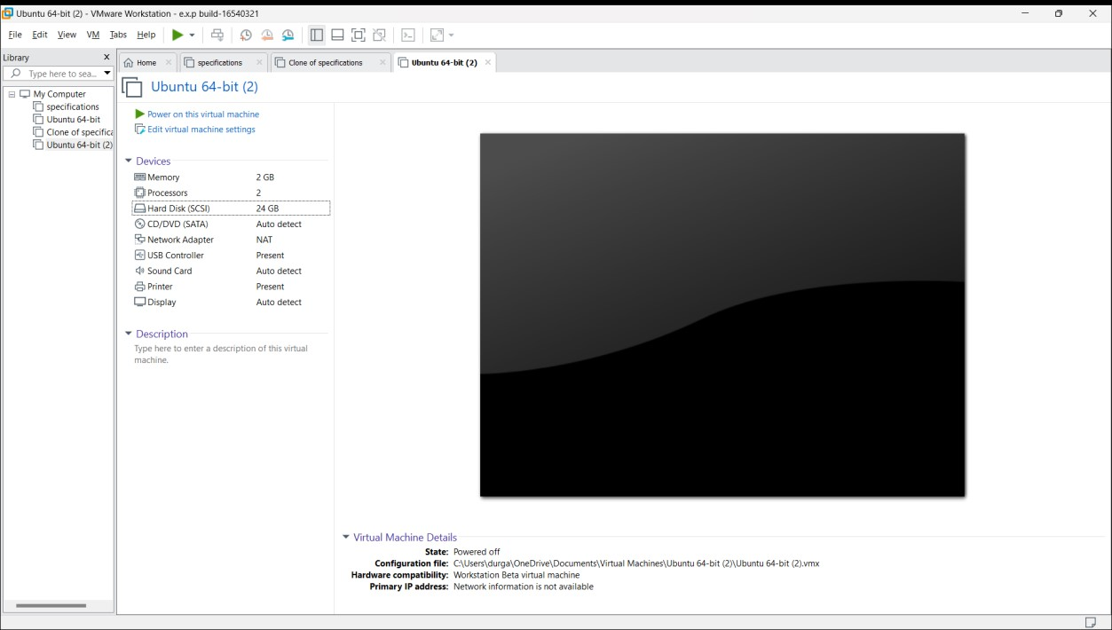

1. Vaishnav kumar {192210190}