Experiment-5

Create a simple cloud software application for Library book reservation system for SIMATS library using any Cloud Service Provider to demonstrate SaaS

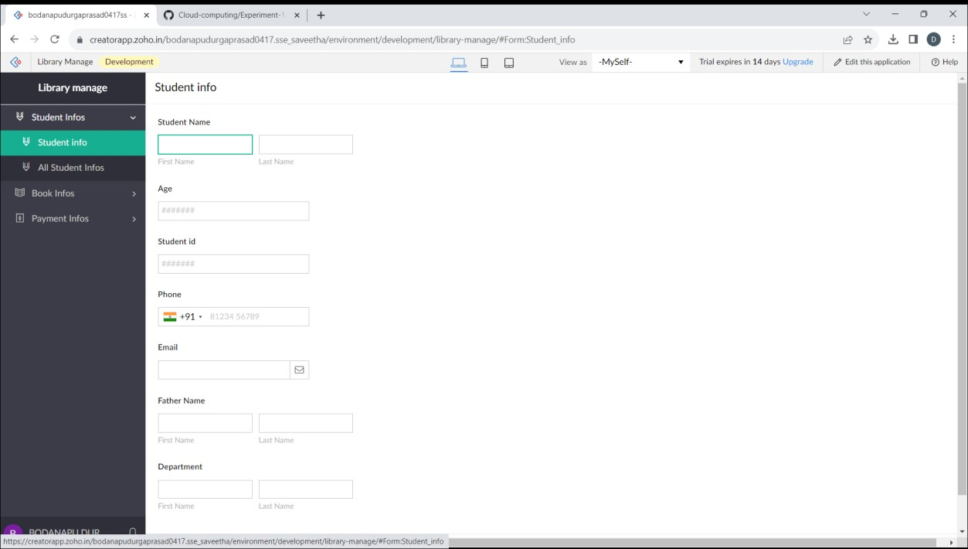

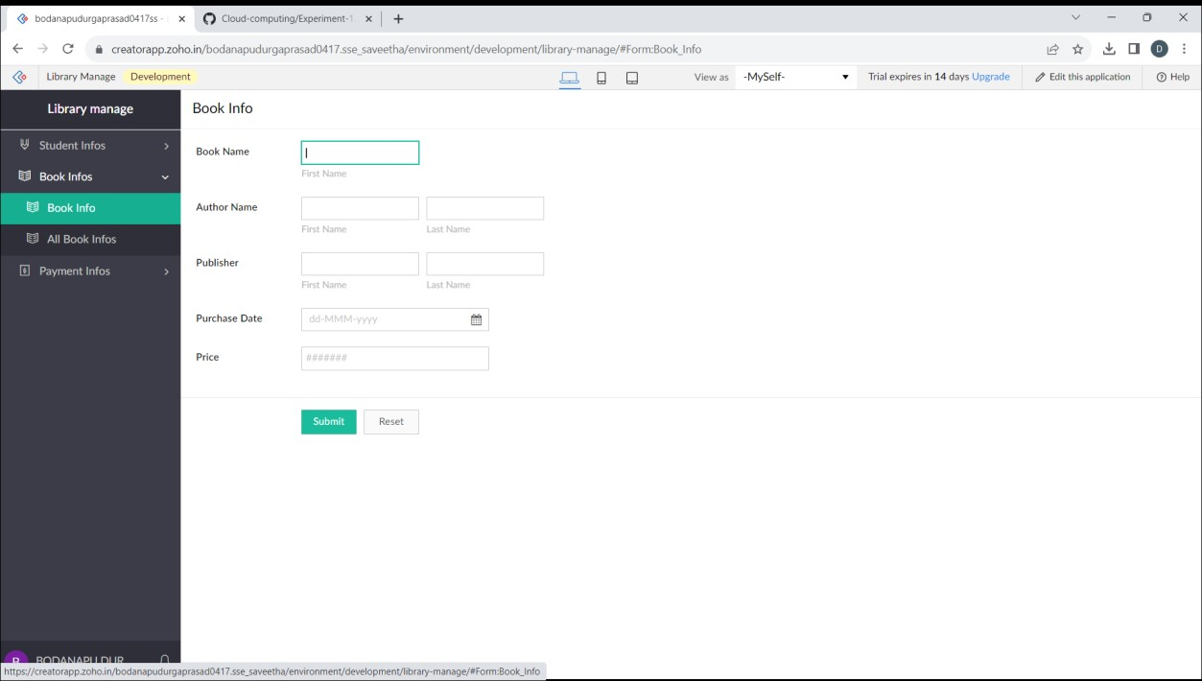

1. Vaishnav Kumar-192210190

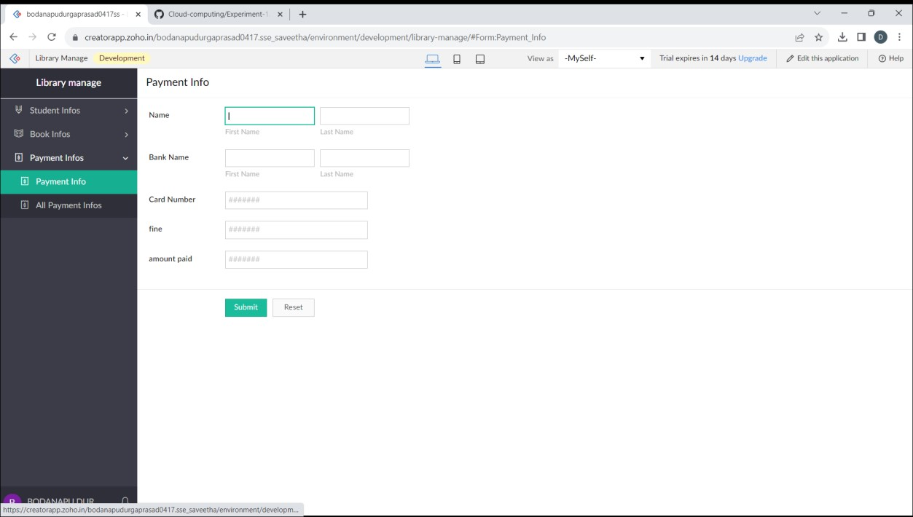

1. Vaishnav Kumar-192210190