Experiment-8

Create a Virtual Hard Disk and allocate the storage using VM ware Workstation

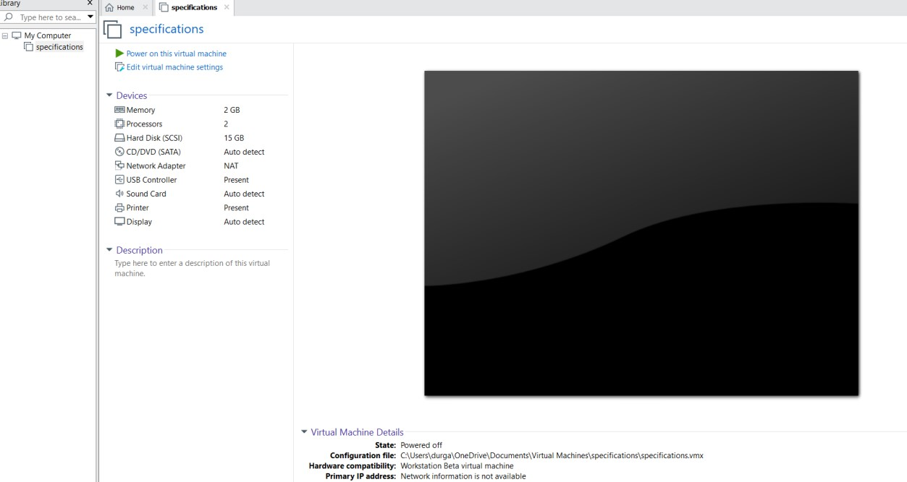

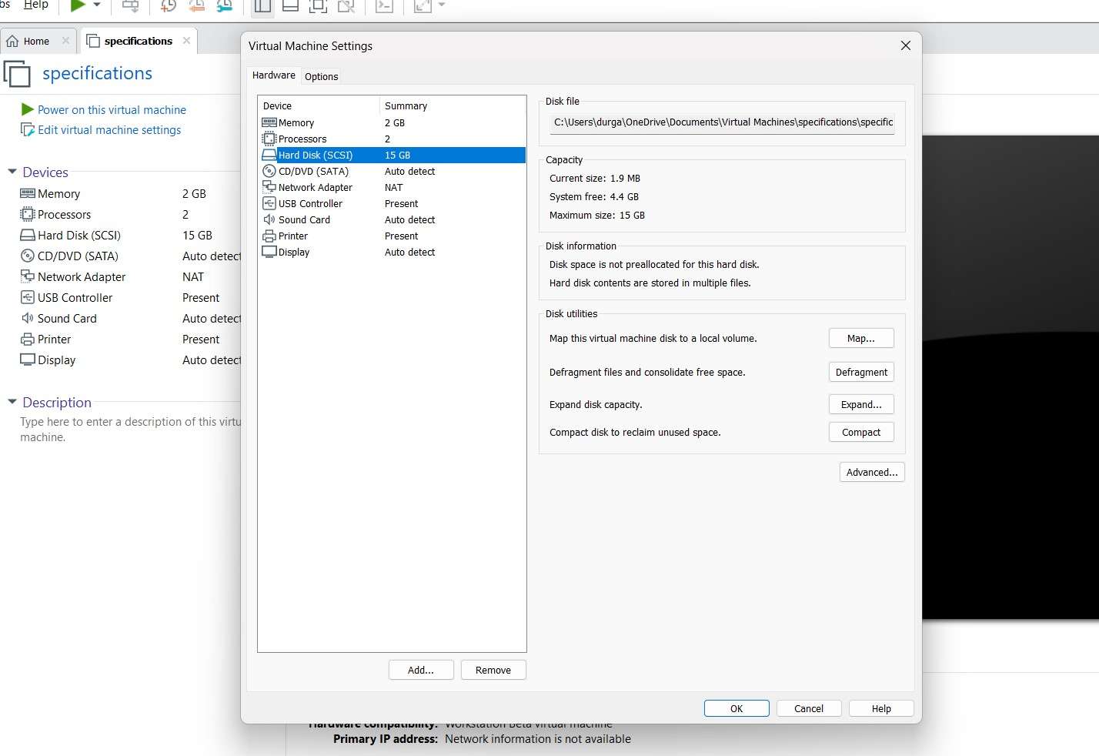

1. Vaishnav kumar {192210190}

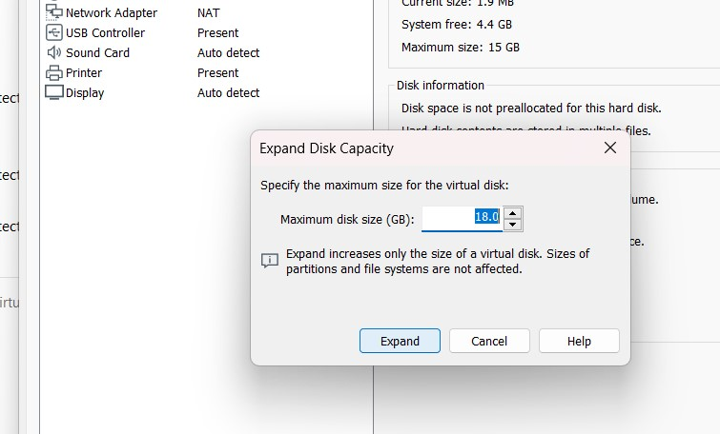

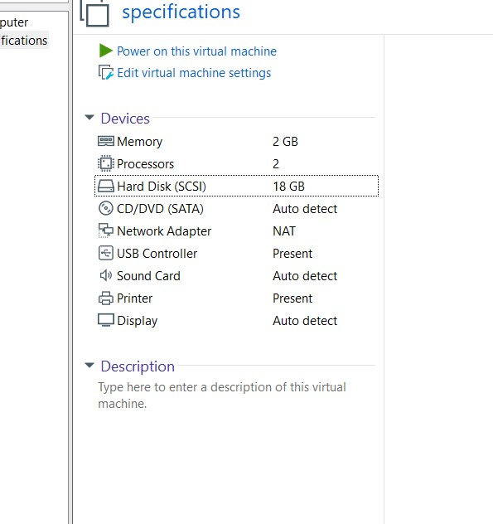

1. Vaishnav kumar {192210190}