|  |
| --- |
| LockedMe  Application Screenshots |

|  |  |
| --- | --- |
| Author | Srujan Kumar Jady |
| Purpose | Screenshot of the Application |
| Date | 11th August 2021 |
| Version | 1.0 |

**Version History :**

# Main Menu Screenshot

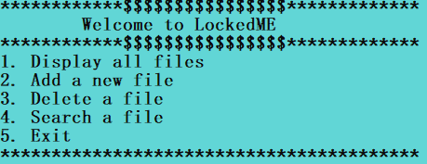

# Displaying all Files

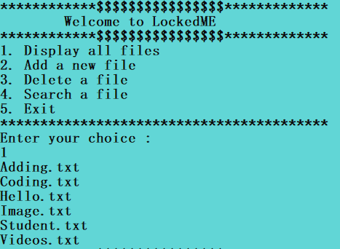

# Adding a new File

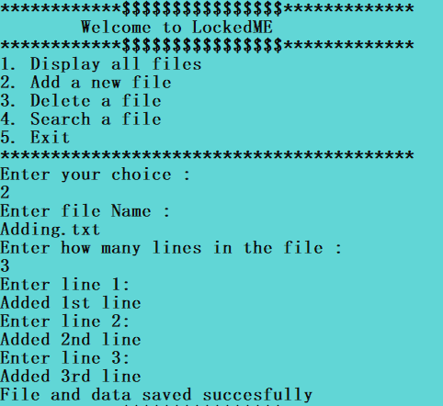

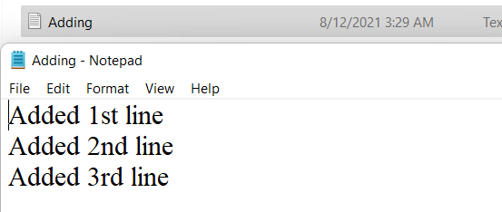

# Deleting a File

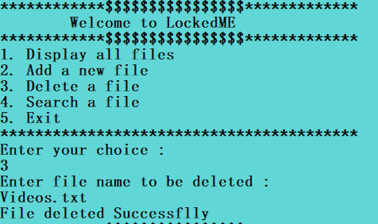

# Searching a File

