1.Build a basic HTTP server that can handle different routes and HTTP methods (GET, POST, PUT, DELETE).

const http = require('http');

// Helper function to handle sending responses function sendResponse(res, statusCode, message) { res.writeHead(statusCode, { 'Content-Type': 'application/json' }); res.end(JSON.stringify({ message }));

}

// Create HTTP server const server = http.createServer((req, res) => { const { method, url } = req;

// Route: / if (url === '/') { if (method === 'GET') { sendResponse(res, 200, 'Hello, World! This is the root route.');

} else { sendResponse(res, 405, `Method ${method} not allowed on this route.`);

}

}

// Route: /items

else if (url === '/items') { if (method === 'GET') { sendResponse(res, 200, 'Fetching all items...');

} else if (method === 'POST') { sendResponse(res, 201, 'Creating a new item...');

} else { sendResponse(res, 405, `Method ${method} not allowed on this route.`);

}

}

// Route: /items/:id (using simple regex for demonstration) else if (url.match(/^\/items\/\d+$/)) { const id = url.split('/')[2];

if (method === 'GET') { sendResponse(res, 200, `Fetching item with ID: ${id}`);

} else if (method === 'PUT') { sendResponse(res, 200, `Updating item with ID: ${id}`);

} else if (method === 'DELETE') { sendResponse(res, 200, `Deleting item with ID: ${id}`);

} else { sendResponse(res, 405, `Method ${method} not allowed on this route.`);

}

}

// Handle 404 - Not Found else { sendResponse(res, 404, 'Route not found.');

}

});

// Server listens on port 3000 server.listen(3000, () => { console.log('Server is running on http://localhost:3000');

});

Output:

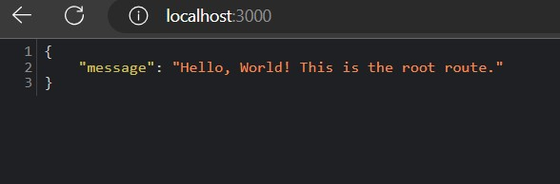

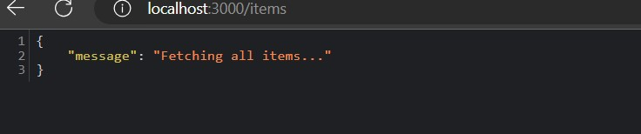

2.Create a server that allows users to upload files and save them to the server's filesystem.

const http = require('http'); const formidable = require('formidable'); const fs = require('fs'); const path = require('path');

const hostname = '127.0.0.1'; const port = 3000; const server = http.createServer((req, res) => { if (req.method.toLowerCase() === 'get') {

res.writeHead(200, { 'Content-Type': 'text/html' }); res.end(`

<form action="/upload" enctype="multipart/form-data" method="post">

<input type="file" name="fileupload"><br><br>

<input type="submit" value="Upload File">

</form>

`);

} else if (req.url === '/upload' && req.method.toLowerCase() === 'post') {

const form = new formidable.IncomingForm();

form.parse(req, (err, fields, files) => {

if (err) { console.error('Error parsing the form:', err); res.writeHead(500, { 'Content-Type': 'text/plain' }); res.end('An error occurred during the file upload.');

return;

}

const uploadedFile = files.fileupload;

const oldPath = uploadedFile.filepath; const newPath = path.join(__dirname, 'uploads', uploadedFile.originalFilename); fs.rename(oldPath, newPath, (err) => {

if (err) { console.error('Error saving the file:', err); res.writeHead(500, { 'Content-Type': 'text/plain' }); res.end('File could not be saved.');

return;

}

res.writeHead(200, { 'Content-Type': 'text/plain' }); res.end('File uploaded and saved successfully!');

});

});

} else {

res.writeHead(404, { 'Content-Type': 'text/plain' }); res.end('Route not found.');

}

});

const uploadDir = path.join(__dirname, 'uploads'); if (!fs.existsSync(uploadDir)) { fs.mkdirSync(uploadDir);

}

server.listen(port, hostname, () => { console.log(`Server running at http://${hostname}:${port}/`);

});

Output:

