**A**

**PROJECT REPORT**

**ON**

**“LAN Network Establishment in Academic Block- 3 in CUH”**

Submitted for the Partial Fulfillment of the requirement for the award of

**Master of COMPUTER APPLICATION**

**in**

**Computer Science and information techonology**

**2014 – 2017**

**submited by**

**Rajesh kumar (5490)**



**Department of Computer Science and information Technology,**

**Central University of Haryana**

**Jant – PaliMahendergarh Haryana**

**UNDER THE SUPERVISION OF**

**External Supervisor Internal Supervisor**

Eng. Rajesh Kumar Ms. Sangeeta Rao

(Systematic Communication Private Ltd) Assistant Professor

Dept. of Computer Science

**acknowledgment**

I am exceedingly appreciative of my supervisor **Ms. Sangeeta Rao**and **Co-Advisor Eng. Rajesh Kumar (Systematic communication private Ltd.)** his supervision and for offering me generous upbringing to deal with the topic of Project in my own style. He always blessed me with his creative ideas without which it would have been impossible for me to complete this work.

I extend my thanks to Ms. NehaYadav who equipped me with project tools to analyses any text in an unconventional way. I am thankful to Dr.Sunil Bharti, Mr. Vijay Kumar, Mr. Suresh Kumar and Mr. Sonu Singh. & Ravi, Taught me throughout the course and helped me in completing my project. I am also grateful to Eng. Rajesh Kumar and Sangeeta Rao for their valuable inputs, guidance, encouragement and cooperation for my entire project work.

It gives me immense pleasure to express my regards to my loving parents Sh.Rajendra Kumar and Smt.RamWati Devi, and my siblings Surendra Kumar , Sunil Saroha , Kamal Sharma, Dr.Anil without whose support I could not have been able to realize my dream of conducting Project .

I am also thankful to Sunaina and many more friends of mine for their support and encouragement. Lastly, I convey my sincere thanks to all who contributed and helped me while carrying out the research work.

**(Rajesh Kumar)**



Mahendergarh

(Established vide Act No. 25 (2009) ofParliament)

Villages – Jant-Pali, Post – Pali, Distt. – Mahendergarh – 123029 (Haryana) Ph:01285-249404

Website: www.cuh.ac.in, Email:sangeeta@cuh.ac.in

Website: [www.cuh.ac.in,](http://www.cuh.ac.in/) E-mail:[snehsataeng@cuh.ac.in](mailto:snehsataeng@cuh.ac.in)

No.CUH/2017 Date:



**DECLERATION**

Rajesh Kumar a bonafide student of M.C.A 6th semester, in the department of computer science and information technology ,at Central university of Haryana would like to declare that the project report entitled , **“LAN Network Establishment in Academic Block- 3 in CUH”,** A Study and research work is won building network establish ,this project report is main and important submitted by me in partial fulfilment of the requirements for the award of Degree of Master of Computer Application in the department of Computer science and information technology is my original work .

Signature of the Head of the Department Signature of the Supervisor

(With seal) (With seal)



Mahendergarh

(Established vide Act No. 25 (2009) ofParliament)

Villages – Jant-Pali, Post – Pali, Distt. – Mahendergarh – 123029 (Haryana) Ph:01285-249404

Website: www.cuh.ac.in, Email:sangeeta@cuh.ac.in

Website: [www.cuh.ac.in,](http://www.cuh.ac.in/) E-mail:[snehsataeng@cuh.ac.in](mailto:snehsataeng@cuh.ac.in)

No.CUH/2017 Date:

s



**CERTIFICATE**

. This is to certify that the project entitled**“LAN Network Establishment in Academic Block- 3 in CUH”**LAN network use Academic block -3 establishment. All building is connected throw LAN network**. Central University of Haryana, carried out by Mr. Rajesh Kumar,** the student of MCa final year atCentral University of Haryana during the 6th semester 2017 in complete fulfillment of the requirements for the award of the degree of Master of Computer Application and that the project has not formed the basis for the award previously of any degree.

**Internal Supervisor**

Place:Mahendergarh (Ms. Sangeeta Rao)

Date: Assistant Professor, CUH

**External Supervisor** (Eng. Rajesh Kumar)

(Systematic communication Private limited .Delhi)

**CHAPTER 6**

**NETWORK ESTBLISHMENT**

The Network was established in Academic Block -3 of **Central UNIVERSITY HARYANA.** This block is divided in four floors, all floors dived two (A & B) parts, my project work is LAN networking establishment in Block- 3. My work is properly LAN establishment. I establish LAN network properly completed in this building all floors .In this building mostly all departments are professionally worked. All student and faculty needs LAN network for prepration.In this building establishment eight server, Figure according are as follows as,

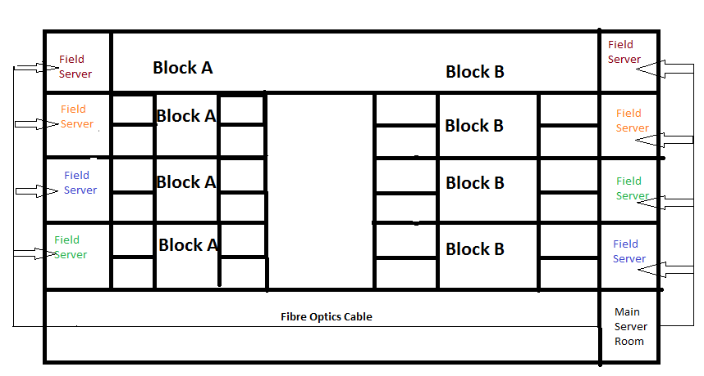

And all server is connected is main server by physically. This building is divided two type server.

* **Main server**
* **Field server**