**1. Employee Master Management System**

* **Concepts Covered**: DDIC, TMG, Classical/ALV Report
* **Features**:
  + Custom table for employees (Emp ID, Name, Dept, Salary, DOJ)
  + TMG enabled
  + Classical report to display list of employees
  + Add filtering (e.g., department-wise)

**Create Package**

GO TO ->T.CODE-> SE80 -> Object Navigator Screen- > Chose Dropdown list - > Package - > Package Name - > ZEMP_MASTER

Traction Request - A4HK905778

**DATABASE TABLE CREATE**

Go TO -> T.CODE -> SE11 ->Dictionary Change Table Screen- >

Create – Domain And Database Table

**Table Name:** - ZEMP_MASTER_DT

**Short Description**: Employee Master Table

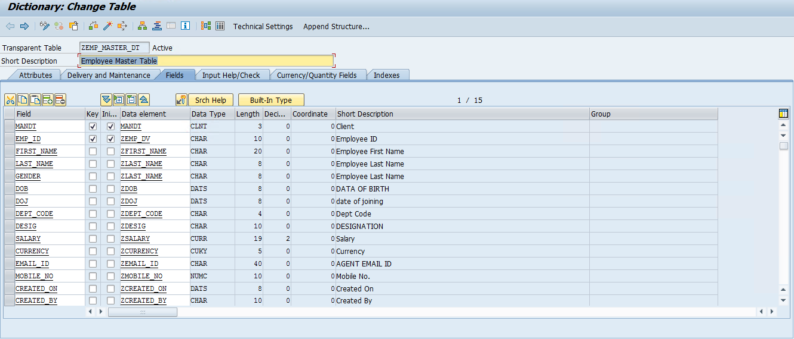

* **Contents**

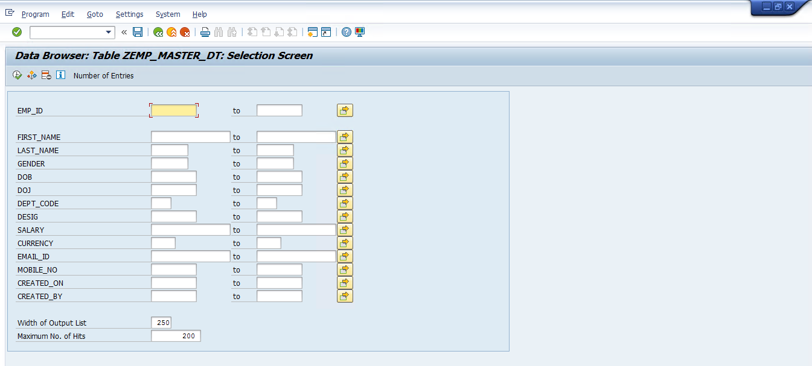

* **Insert The Data Employee Master Table**

**Utilities -> Table Contents -> Create Entries**

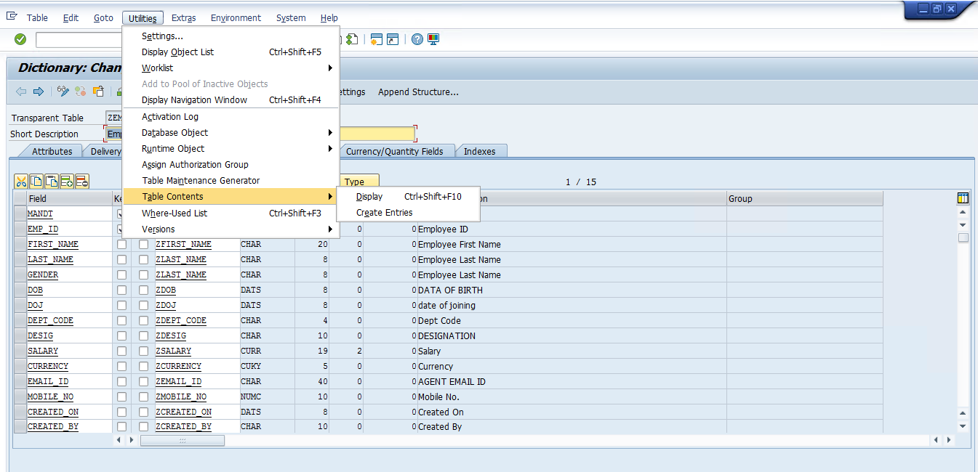

* **OPEN SCREEN**

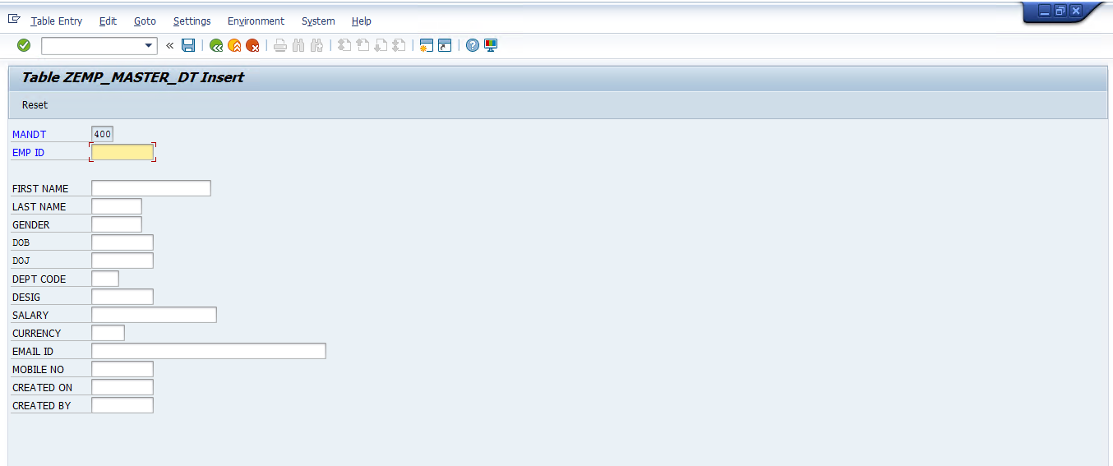

**CHECK INSERT DATA EMPLOYEE MASTER TABLE**

GO -> T. Code - > SE16n ->OPEN SCREEN

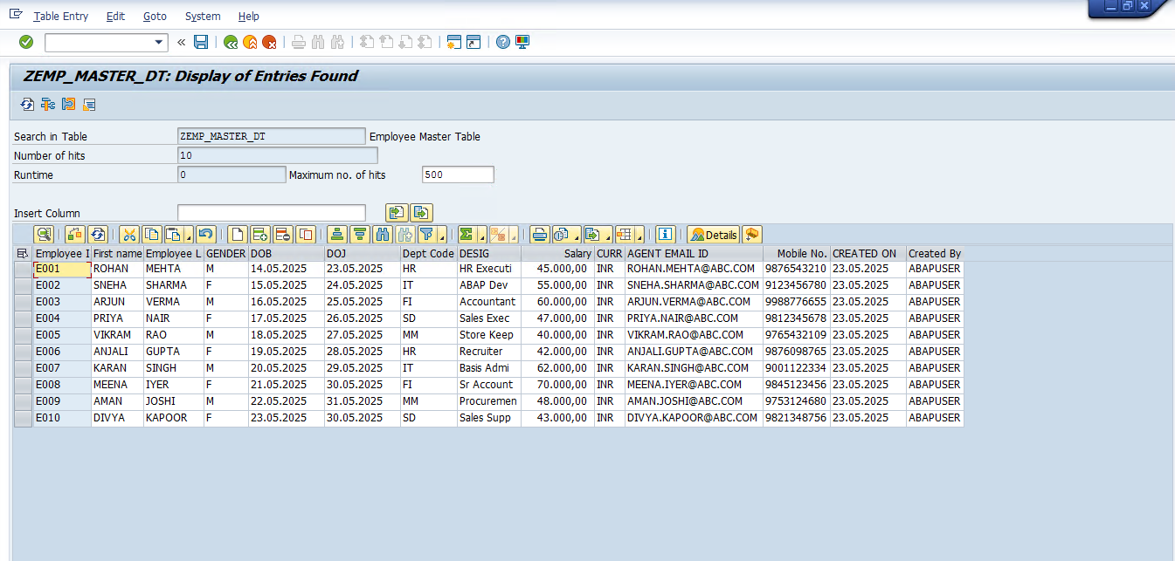

* **CREATE TMG**

GO -> Utilities -> Table Maintenance Generator

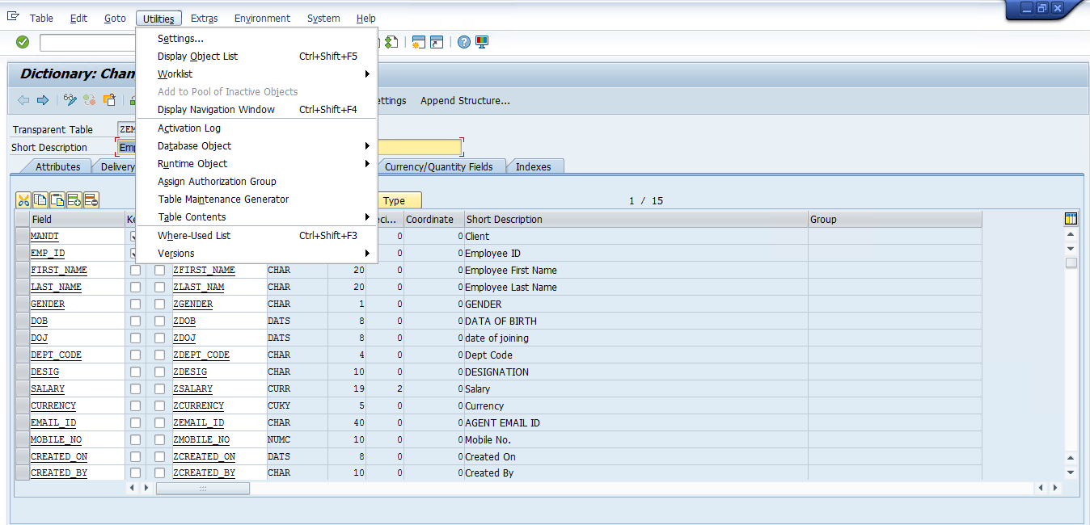

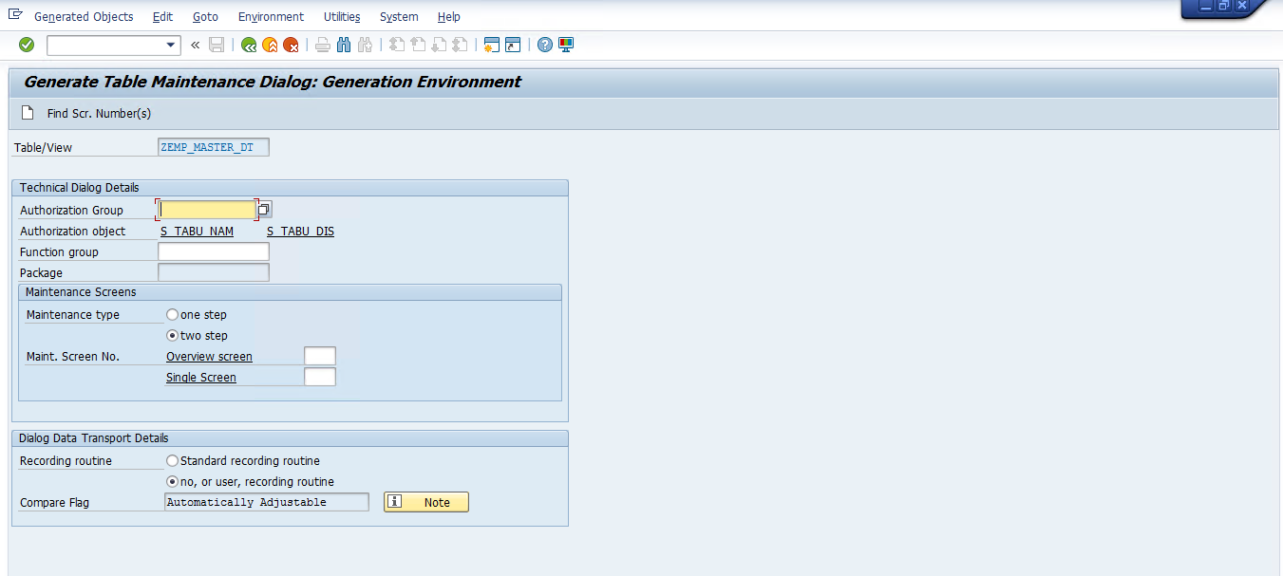

**CREATE FUNCATION GROUP**

GO -> SE80 -> Object Navigator Screen -> Chose Dropdown list -> Function Group -> ZEMP_MASTER_FUN

**Short Description** : - Employee Master Function Group

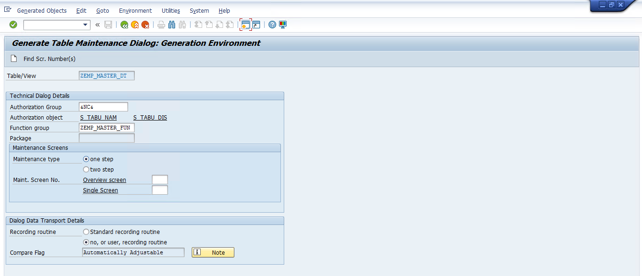

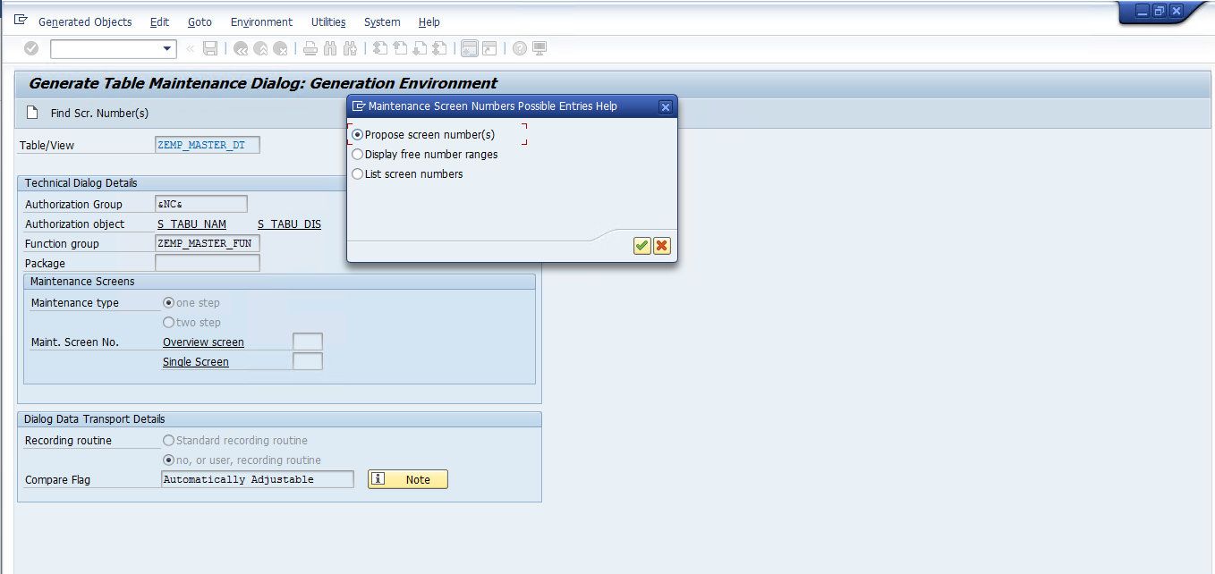

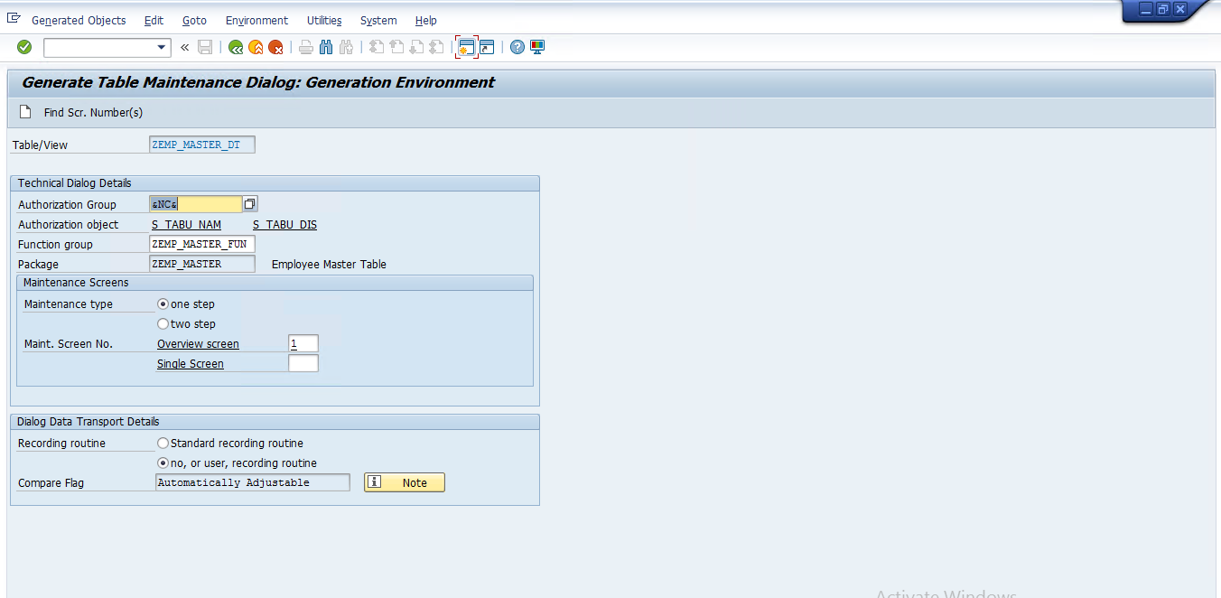

* **COMPLATE TMG CREATE PROCESS**

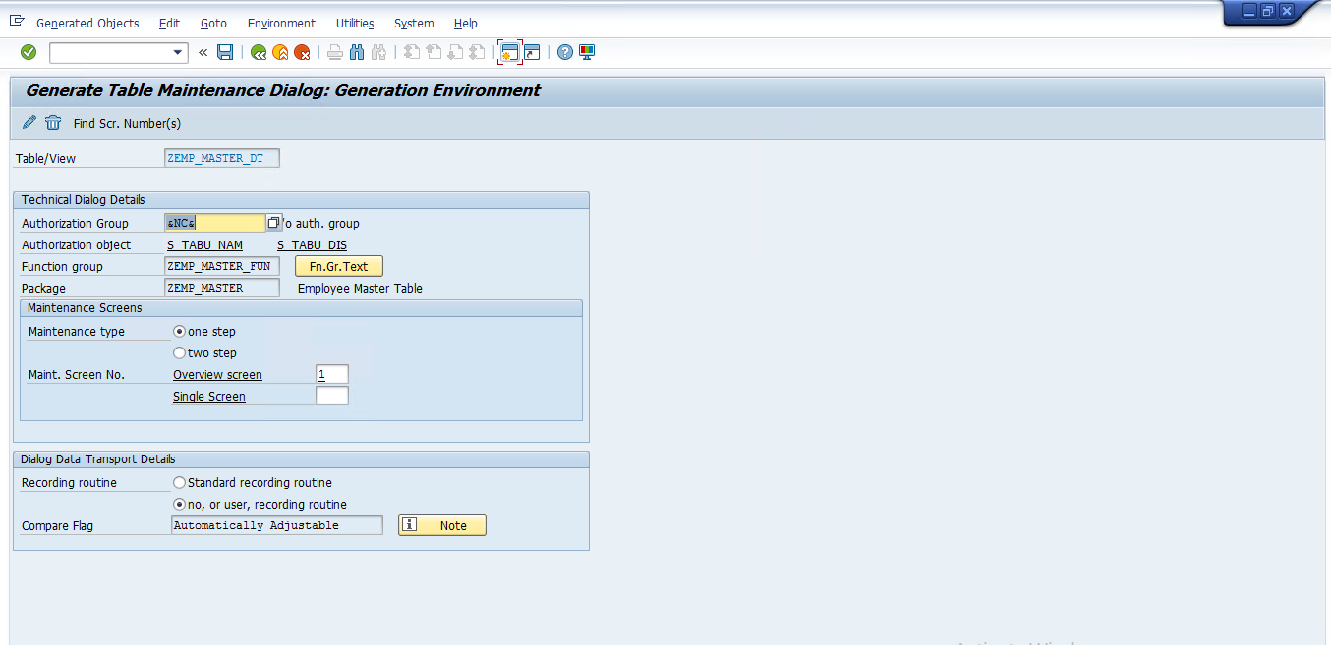

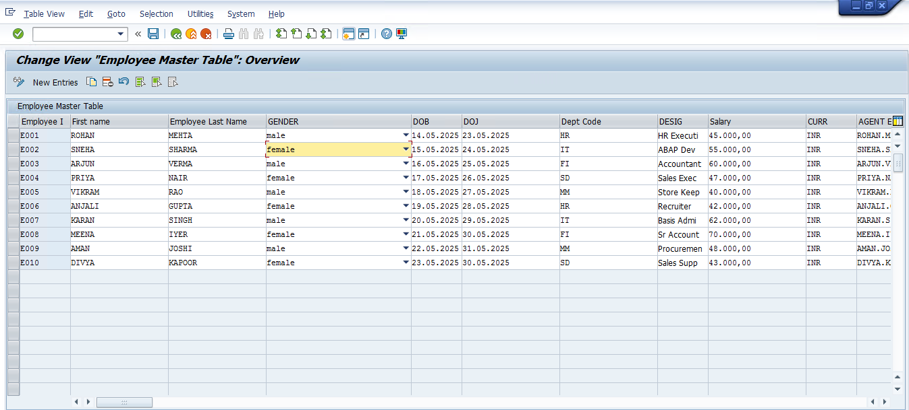

GO -> T. Code -> SM30 -> Enter->OPEN SCREEN

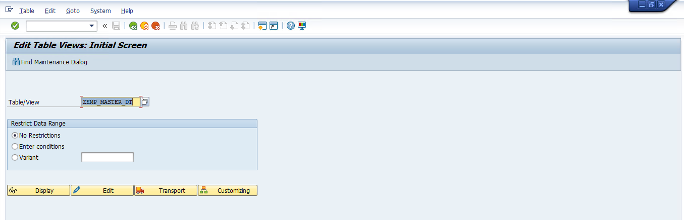

* **EDIT**

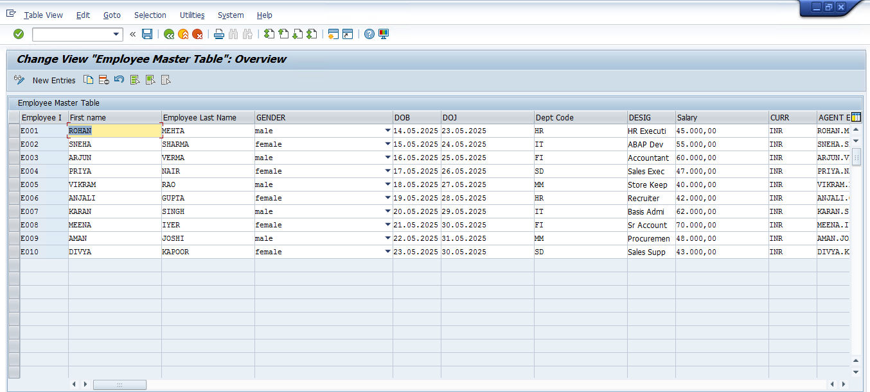

* **CREATE CUSTOME T CODE**

GO ->T. Code -> SE93 ->OPEN SCREEN -> Maintain Transaction.

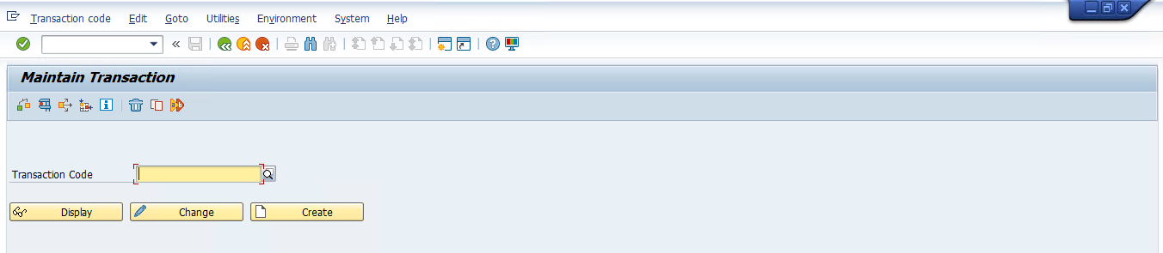

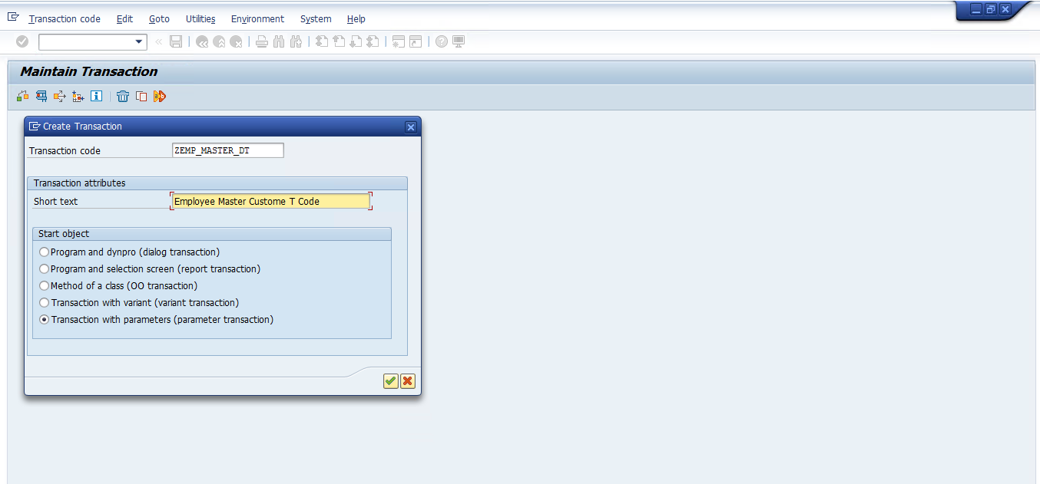

* **CREATE PARAMETER TRANSACTION**

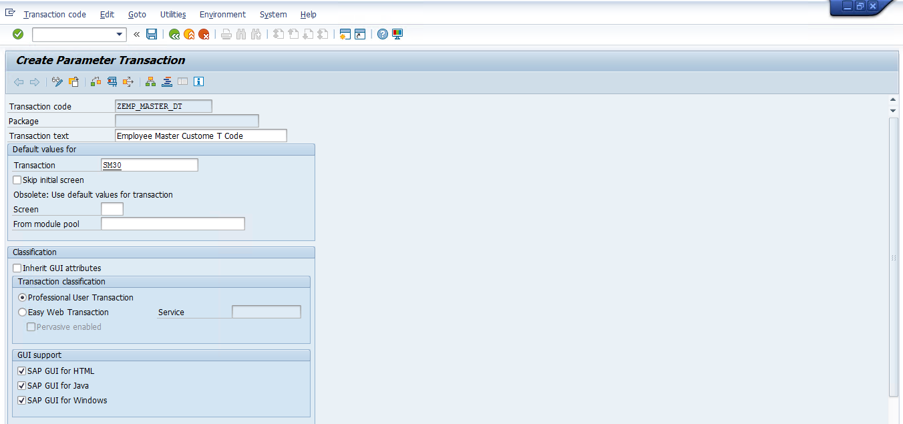

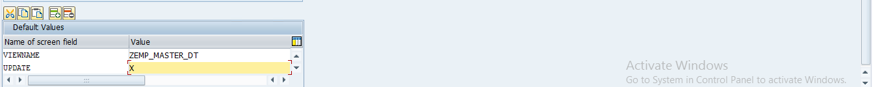

* **CREATE CUSTOME T CODE FOR EMPLOYEE MASTER DATA**

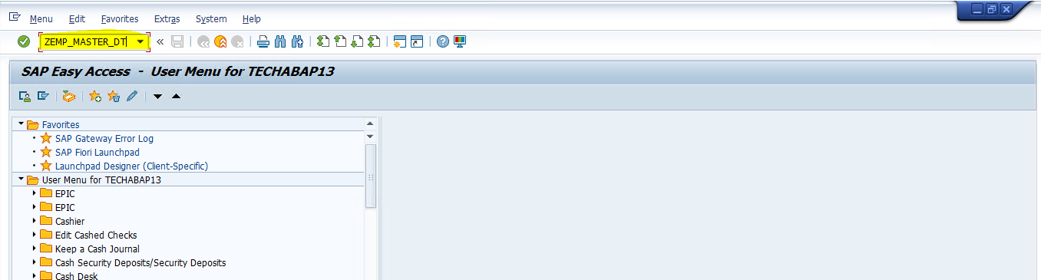

* **ENTER OUTPUT RESULT**

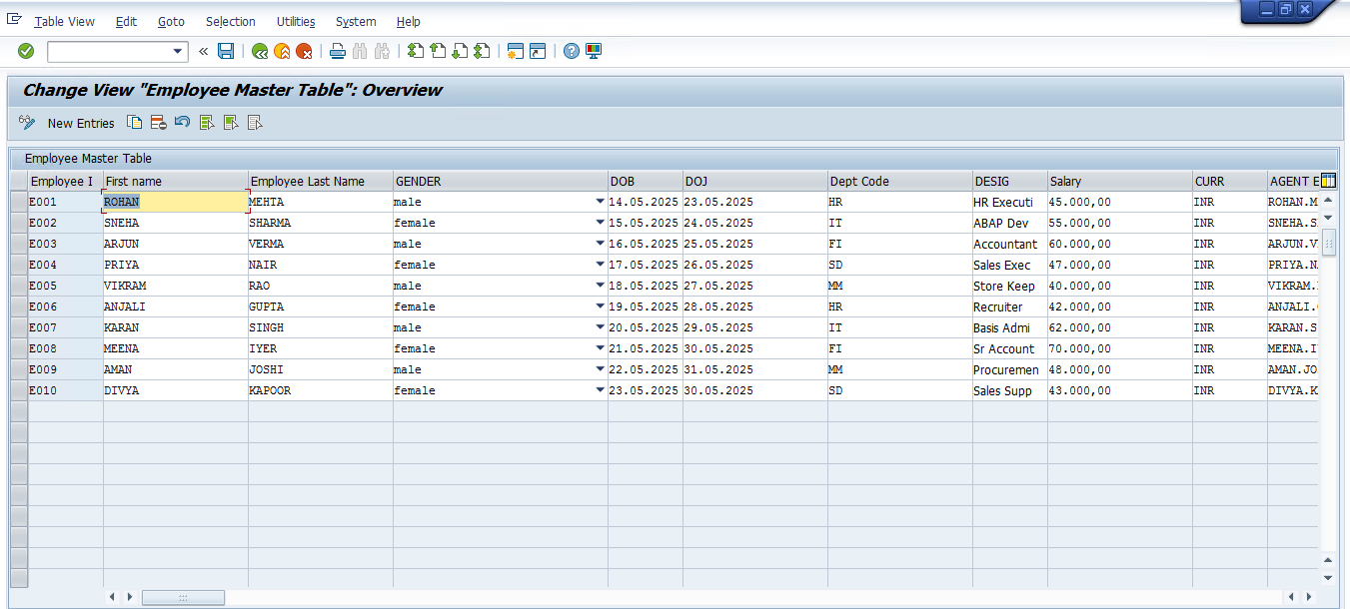

* **CREATE VIEW**

Go To -> T Code -> SE11 -> Dictionary Change Table Screen

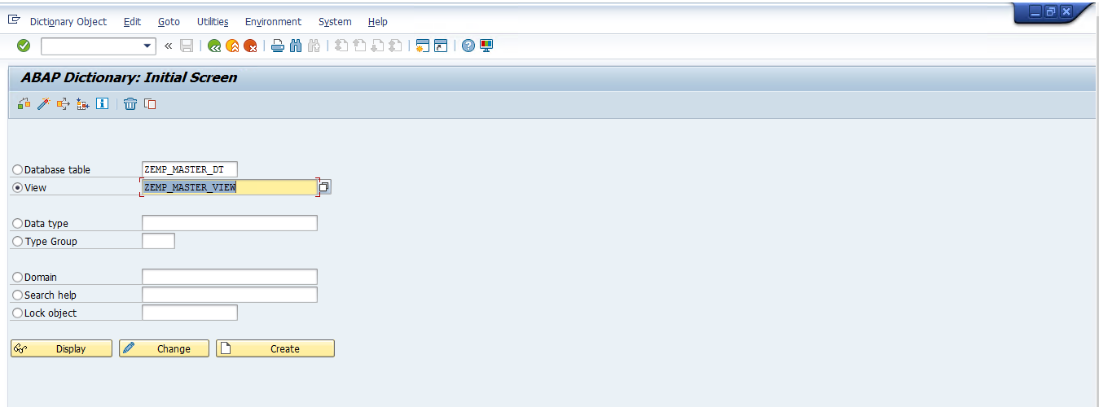

* **CREATE**

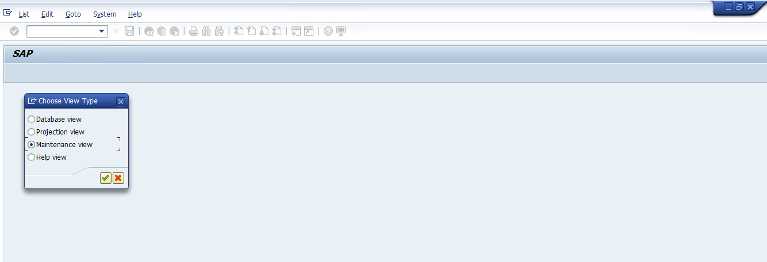

* **Maintenance View First Step**

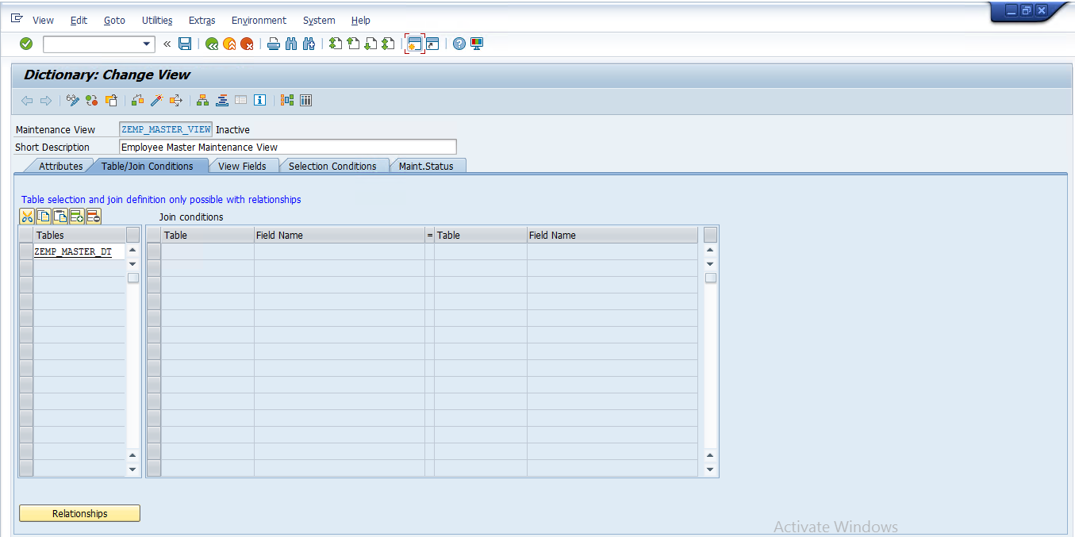

* **Maintenance View Second Step**

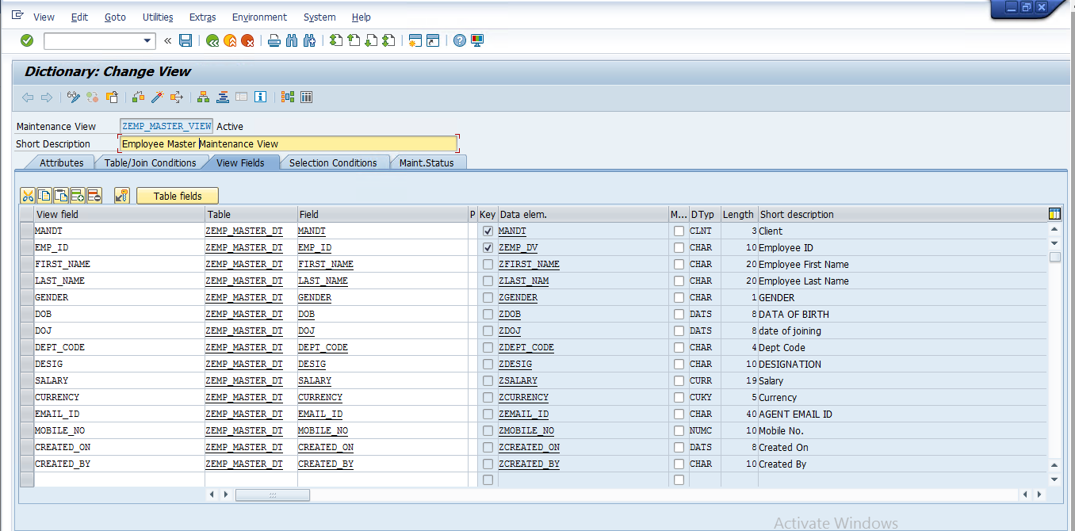

* **CREATE TMG Maintenance View**

Go To -> Utilities -> Table Maintenance Generator

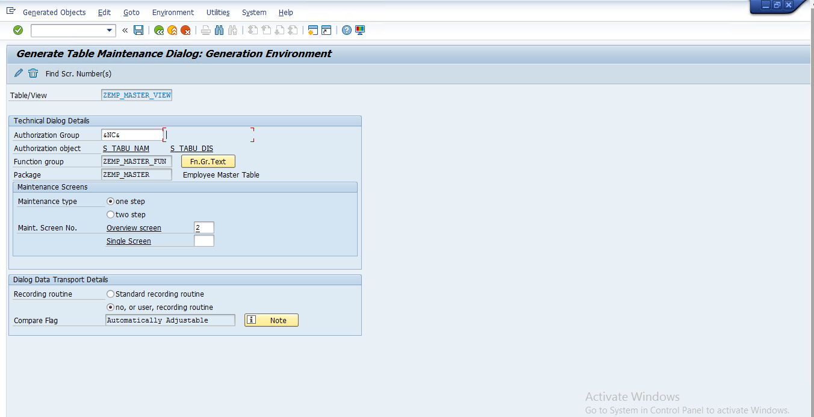

* **Contents**

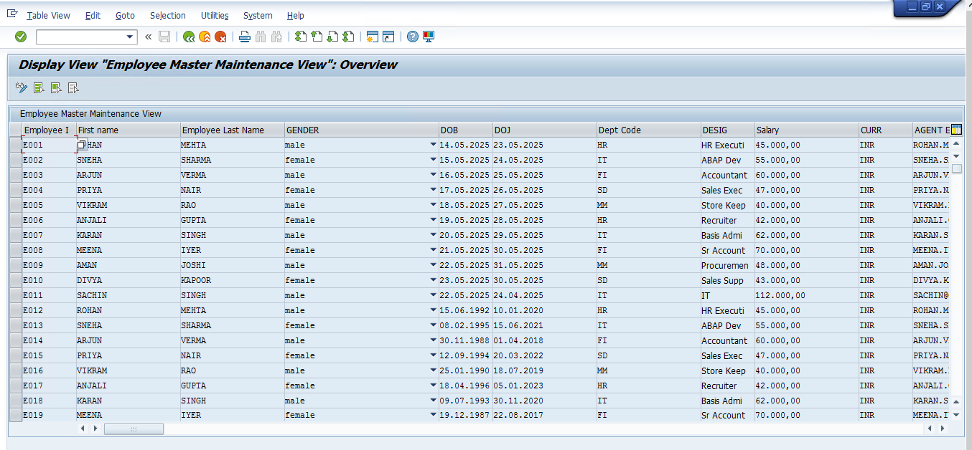

* **Database View**

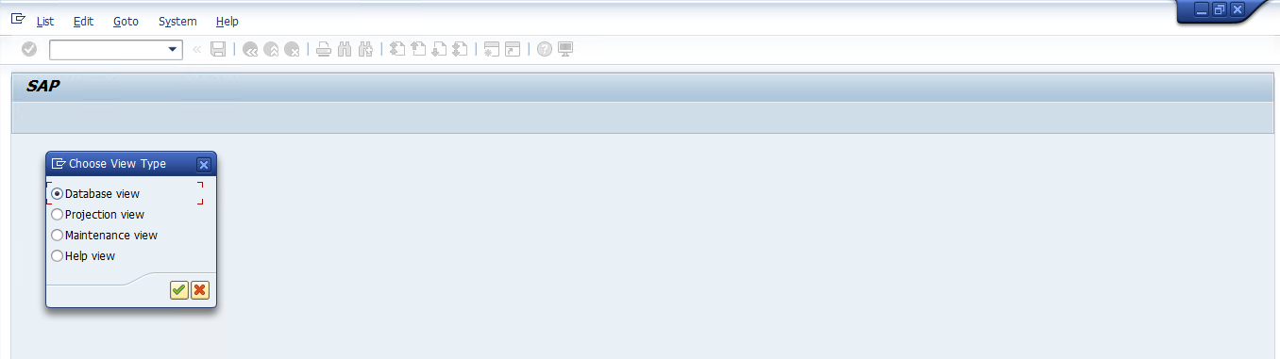

* **Database View First Step**

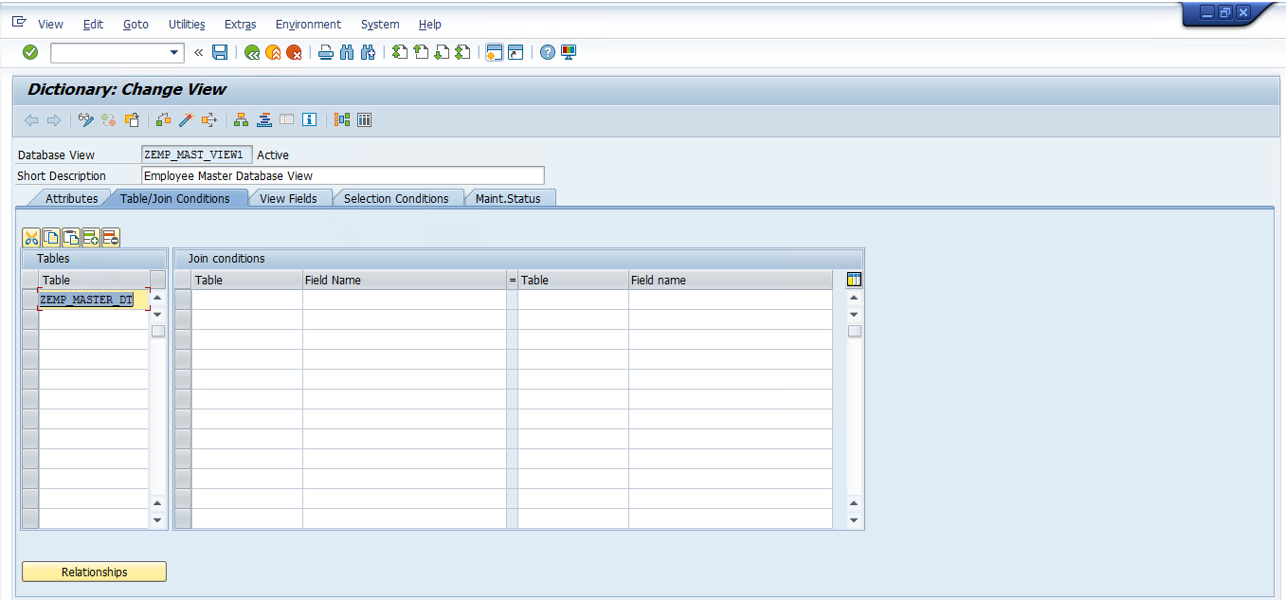

* **Database View Second Step**

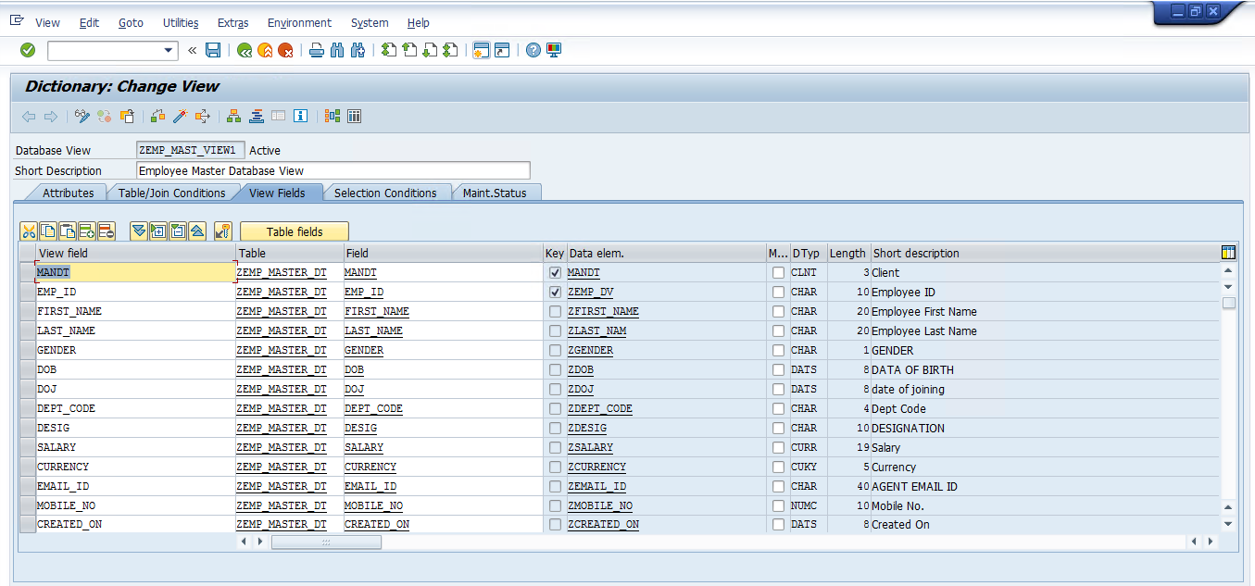

* **NOTE CREATE TMG Database View (All Ready Disable)**

Go To -> Utilities -> Table Maintenance Generator -> Disable

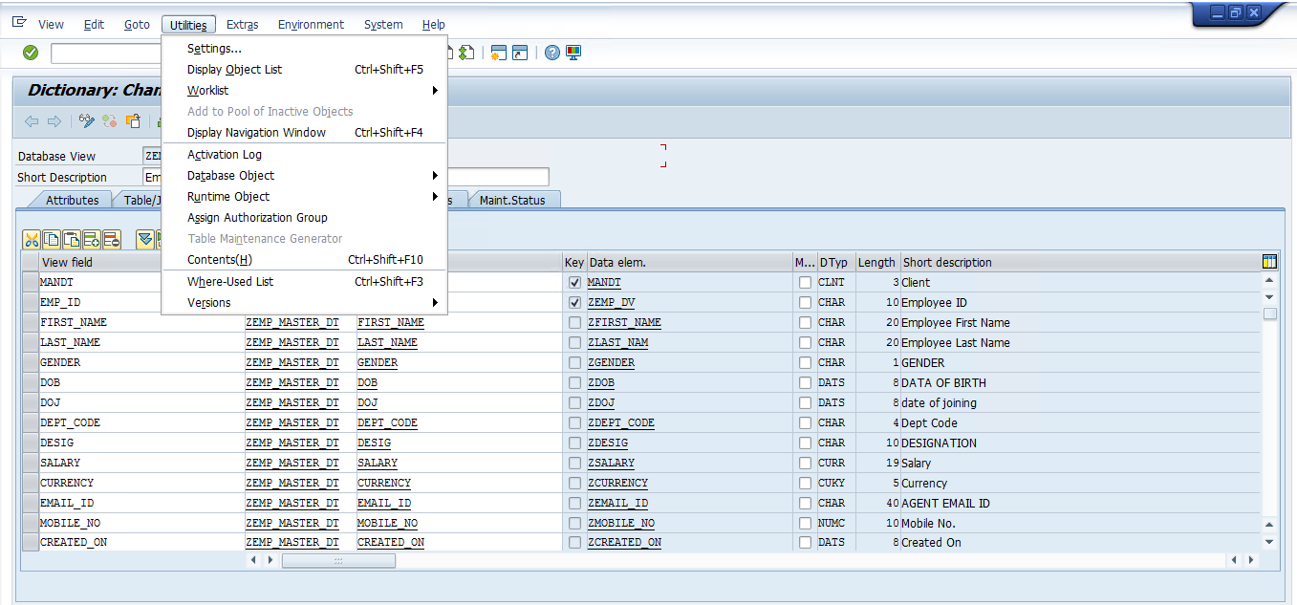

* **Click The Contents Show the Database View Table**

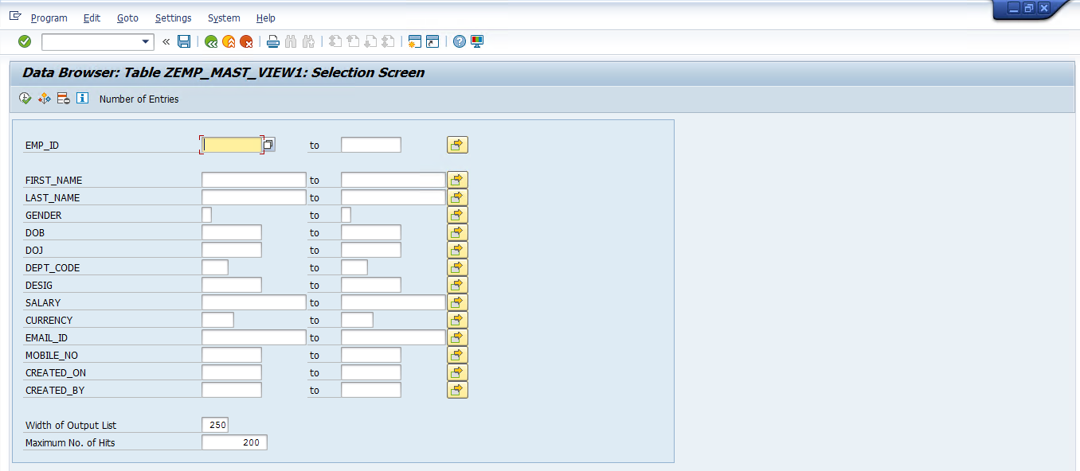

* **Click Execute Button Show the Result**

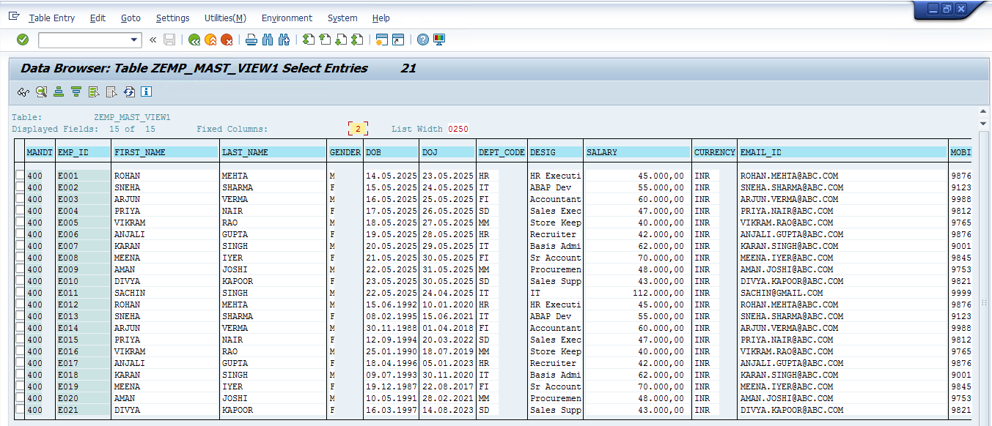

* **Projection View**

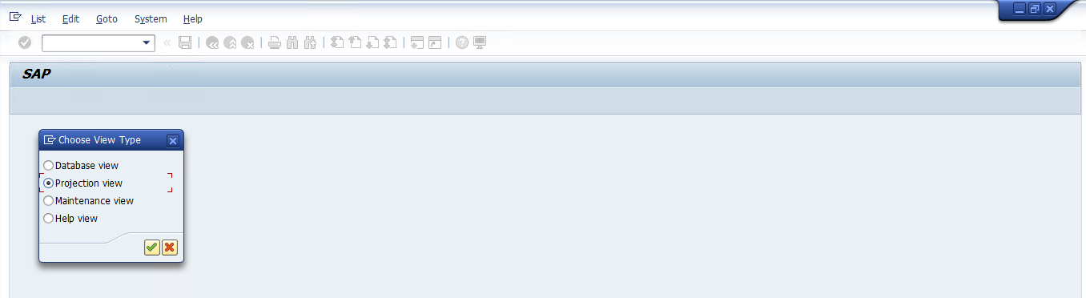

* **Fill The Basis Table -> ZEMP_MASTER_DT**

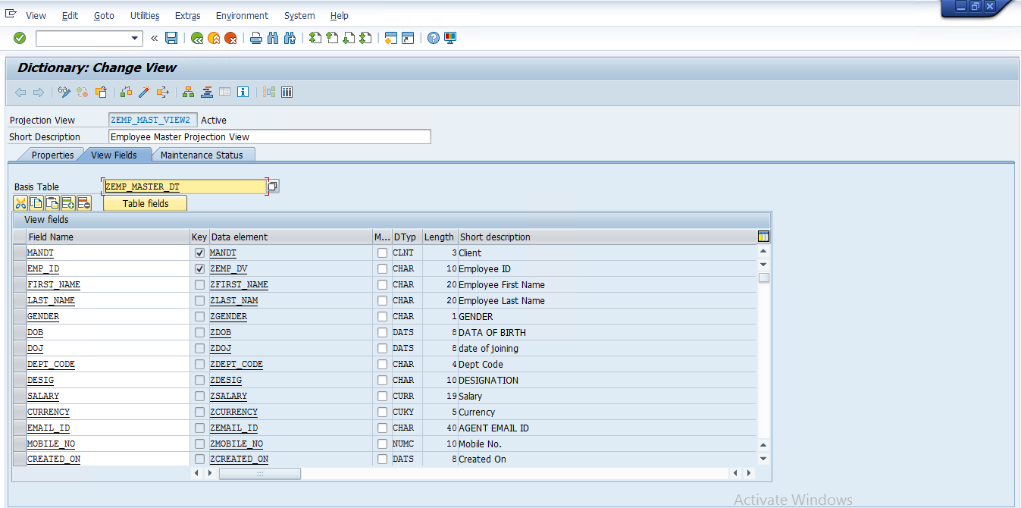

* **NOTE CREATE TMG Database View (All Ready Disable)**

Go To -> Utilities -> Table Maintenance Generator -> Disable



* **Click The Contents Show the Database View Table**

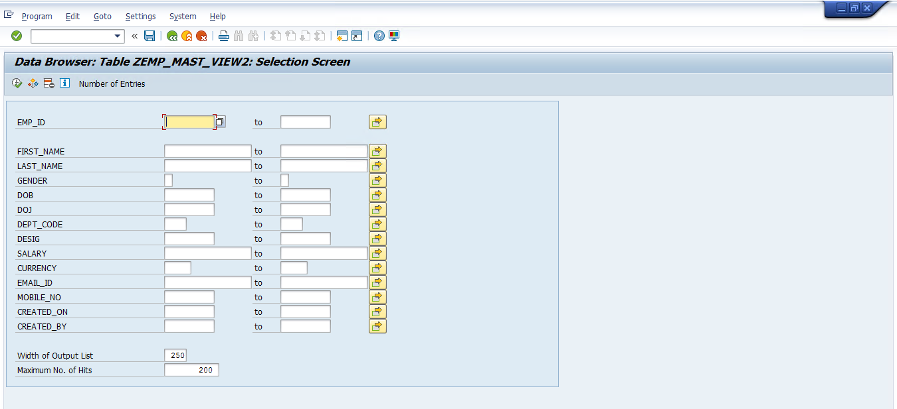

* **Click Execute Button Show the Result**

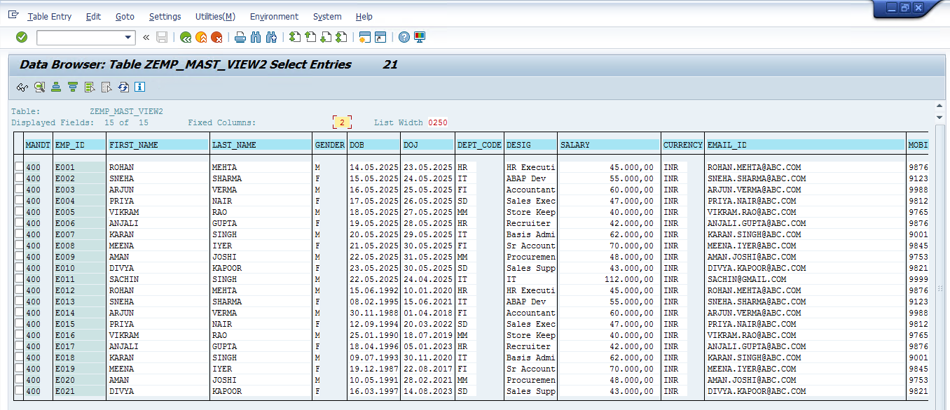

* **Help View**

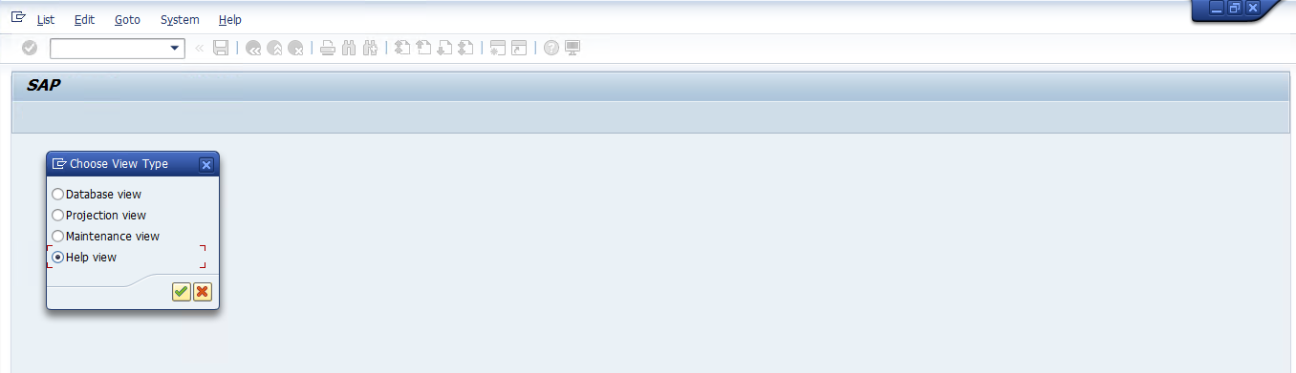

* **Help View First Step**

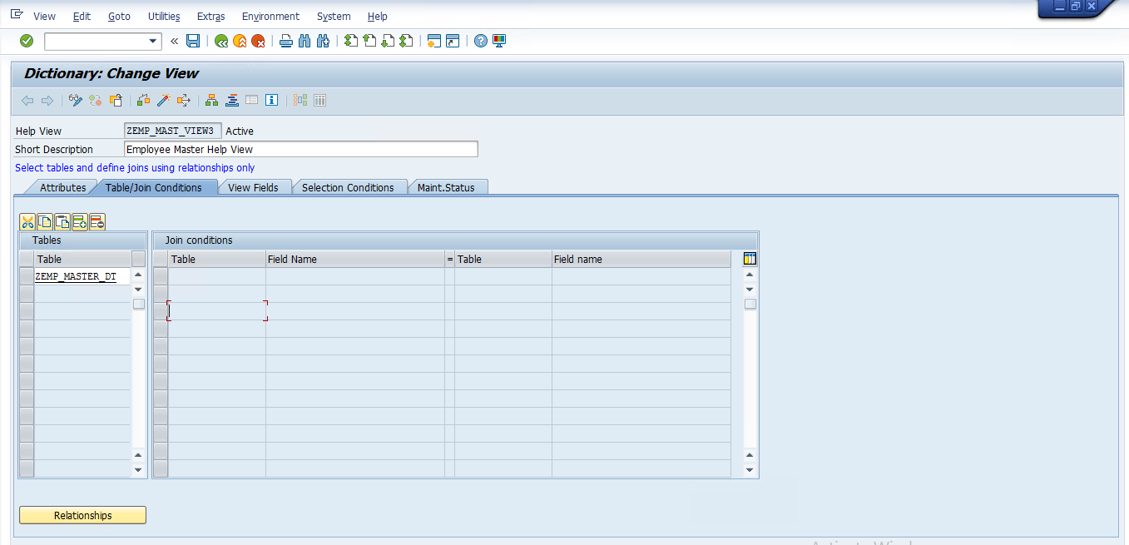

* **Help View Second Step**

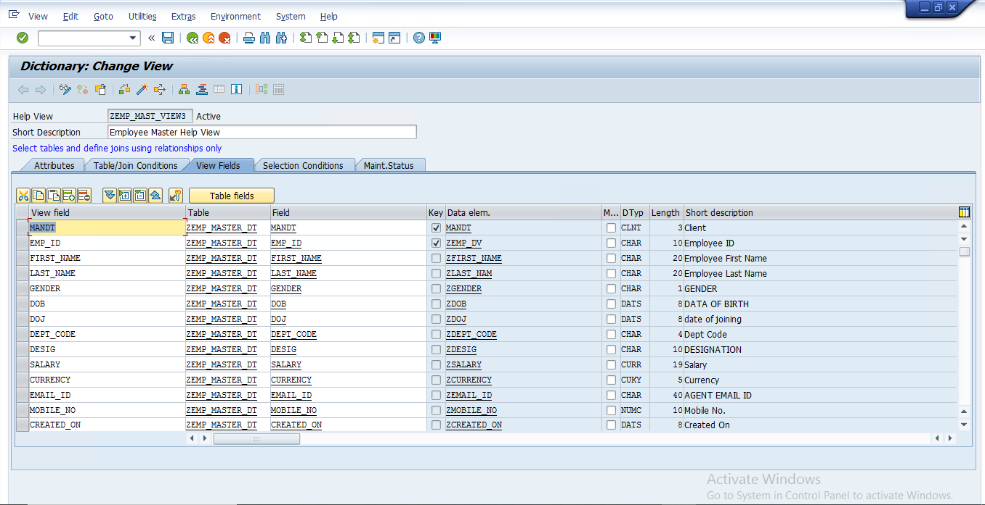

* **CLASSICAL REPORT GET THE DATA SINGLE TABLE**

GO TO - > T Code -> SE38 -> ABAP Editor -> Radio Button Check -> Source Code-> Fill Report Name

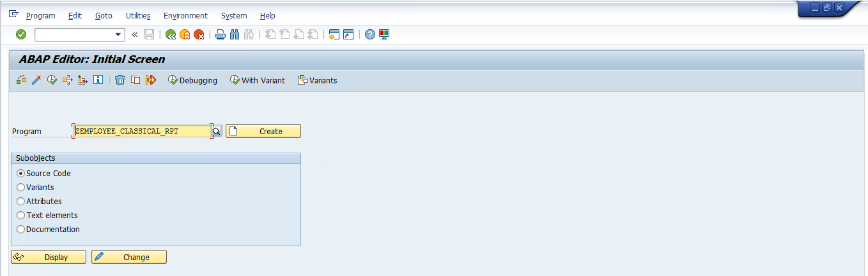

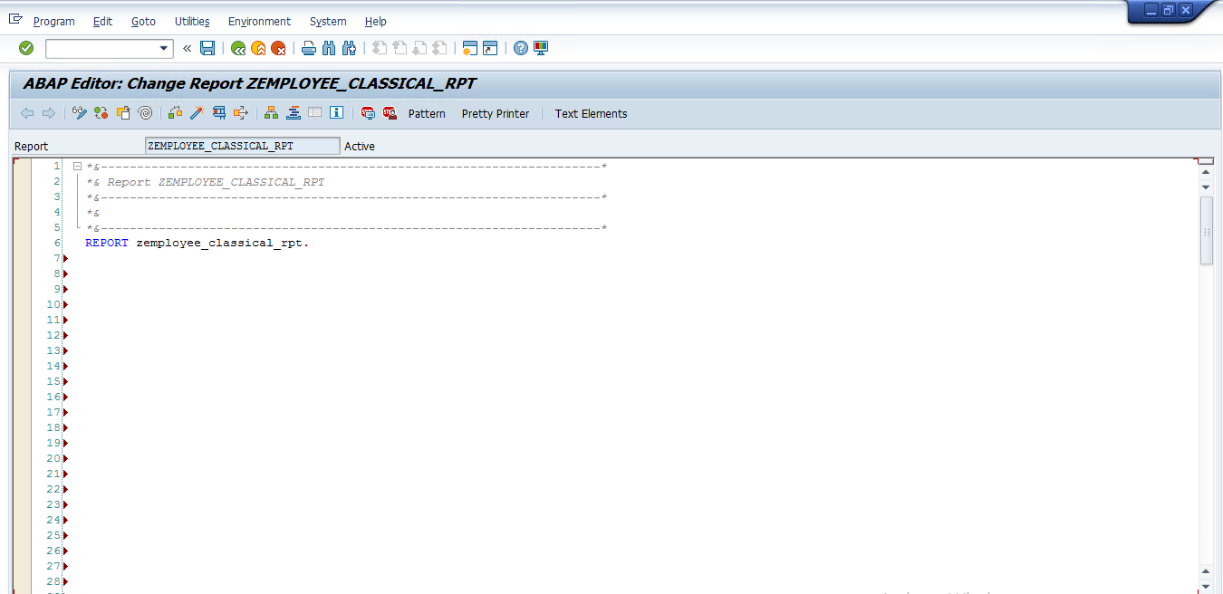

*\*&---------------------------------------------------------------------\**  
*\*& Report ZEMPLOYEE_CLASSICAL_RPT*  
*\*&---------------------------------------------------------------------\**  
*\*&*  
*\*&---------------------------------------------------------------------\**  
REPORT zemployee_classical_rpt.

TABLES : zemp_master_dt.  
  
TYPES : BEGIN OF Ty_ZEMP_MASTER_DT,  
 emp_id TYPE zemp_master_dt-emp_id,  
 first_name TYPE zemp_master_dt-first_name,  
 last_name TYPE zemp_master_dt-last_name,  
 gender TYPE zemp_master_dt-gender,  
 dob TYPE zemp_master_dt-dob,  
 doj TYPE zemp_master_dt-doj,  
 dept_code TYPE zemp_master_dt-dept_code,  
 desig TYPE zemp_master_dt-desig,  
 salary TYPE zemp_master_dt-salary,  
 currency TYPE zemp_master_dt-currency,  
 email_id TYPE zemp_master_dt-email_id,  
 mobile_no TYPE zemp_master_dt-mobile_no,  
 created_on TYPE zemp_master_dt-created_on,  
 created_by TYPE zemp_master_dt-created_by,  
 END OF ty_zemp_master_dt.  
  
  
DATA: it_ZEMP_MASTER_DT TYPE TABLE OF ty_ZEMP_MASTER_DT,  
 Wa_ZEMP_MASTER_DT TYPE ty_zemp_master_dt.  
  
  
SELECTION-SCREEN: BEGIN OF BLOCK B1 WITH FRAME TITLE text-001.  
  
SELECT-OPTIONS: s_EMP_ID FOR zemp_master_dt-emp_id.  
PARAMETERS: p_rb1 RADIOBUTTON GROUP A.  
PARAMETERS: P_rb2 RADIOBUTTON GROUP A.

SELECTION-SCREEN END OF BLOCK B1.  
  
IF p_rb1 = 'X' AND s_emp_id IS NOT INITIAL.  
  
 SELECT emp_id  
 first_name  
 last_name  
 gender  
 dob  
 doj  
 dept_code  
 desig  
 salary  
 currency  
 email_id  
 mobile_no  
 created_on  
 created_by  
  
 FROM zemp_master_dt  
 INTO TABLE it_zemp_master_dt.  
  
ELSEIF p_rb2 = 'X'.  
 SELECT emp_id  
 first_name  
 last_name  
 gender  
 dob  
 doj  
 dept_code  
 desig  
 salary  
 currency  
 email_id  
 mobile_no  
 created_on  
 created_by  
  
 FROM zemp_master_dt  
 INTO TABLE it_zemp_master_dt.  
 ELSE.  
 write:/ 'no data found'.  
ENDIF.  
  
LOOP AT it_zemp_master_dt INTO wa_zemp_master_dt.  
  
 WRITE : / wa_zemp_master_dt-emp_id,  
 wa_zemp_master_dt-first_name,  
 wa_zemp_master_dt-last_name,  
 wa_zemp_master_dt-gender,  
 wa_zemp_master_dt-dob,  
 wa_zemp_master_dt-doj,  
 wa_zemp_master_dt-dept_code,  
 wa_zemp_master_dt-desig,  
 wa_zemp_master_dt-salary,  
 wa_zemp_master_dt-currency,  
 wa_zemp_master_dt-email_id,  
 wa_zemp_master_dt-mobile_no,  
 wa_zemp_master_dt-created_on,  
 wa_zemp_master_dt-created_by.  
  
ENDLOOP.

