STAC WARS - PS2
Solar Radiation: Analysis and Prediction
Voyage-123 observation data, 1 Sep - 31 Dec 2016

1. The data
The file has 32,686 readings taken roughly every 5 minutes, with 11 columns: radiation, temperature, pressure, humidity, wind direction, wind speed, and the sunrise and sunset time for each day. Nothing is missing. A few things I had to deal with before doing anything else:
- The file is sorted newest-first, so I sorted it by time.
- The column called Data is the date, but it has a useless 12:00:00 AM attached. I took the date part and joined it with the Time column to get a real datetime.
- Only 118 of the 122 days between 1 Sep and 31 Dec are present. There is one long hole of about 2.6 days that ends on 8 Dec, and a few other days (9 Sep, 15 Sep, 8 Sep) have only about 120-145 readings instead of about 288.
- 4,311 humidity readings are above 100%, which is physically odd. It looks like the sensor saturates a little above 100, so I left the values as they are (the maximum is 103) and just kept it in mind.
The units are not given. Going by the ranges, I read temperature as °F (34 to 71), pressure as inches of mercury (about 30.4), wind speed as mph and radiation as W/m². I only use units for labelling, nothing in the analysis depends on them.

2. Part A: Visualisations

2.1 Radiation over time
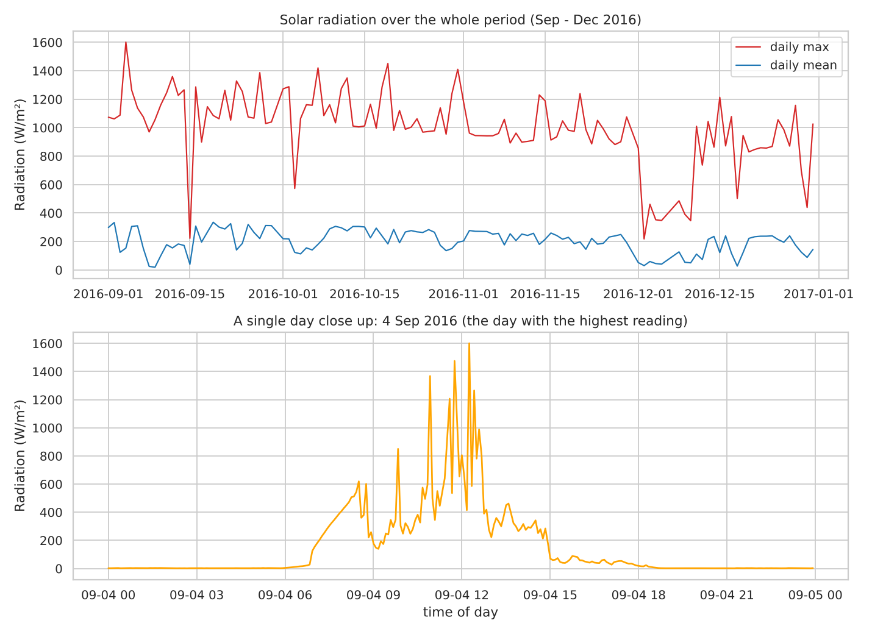
Figure 1. Top: daily max and mean radiation for the whole period. Bottom: one day (4 Sep) in detail.
The daily maximum jumps around a lot (the middle half of days sit between about 910 and 1,160 W/m², with a few dull days as low as 218) while the daily mean is much smoother. There is a clear drop in December. The close-up of 4 Sep shows what a single day looks like: flat near zero at night, a sharp rise after sunrise and a fall in the evening.

2.2 Radiation by hour of day
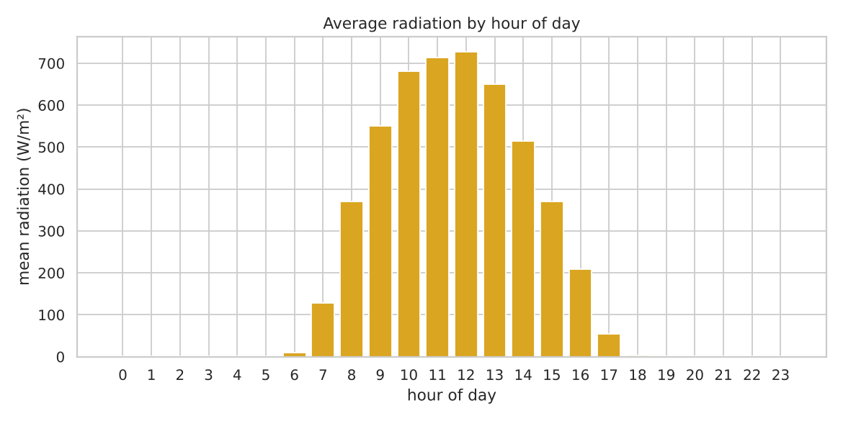
Figure 2. Mean radiation for every hour of the day.

2.3 Radiation against other parameters
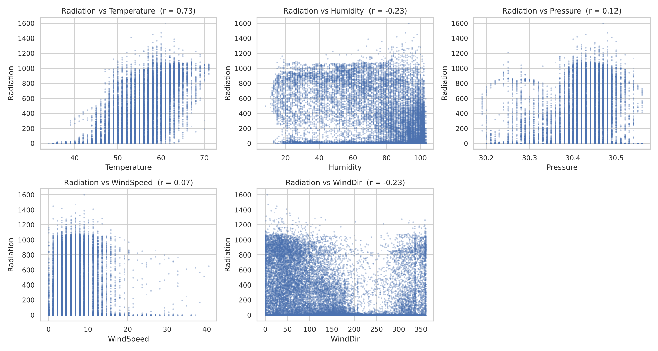
Figure 3. Radiation against temperature, humidity, pressure, wind speed and wind direction (all readings).
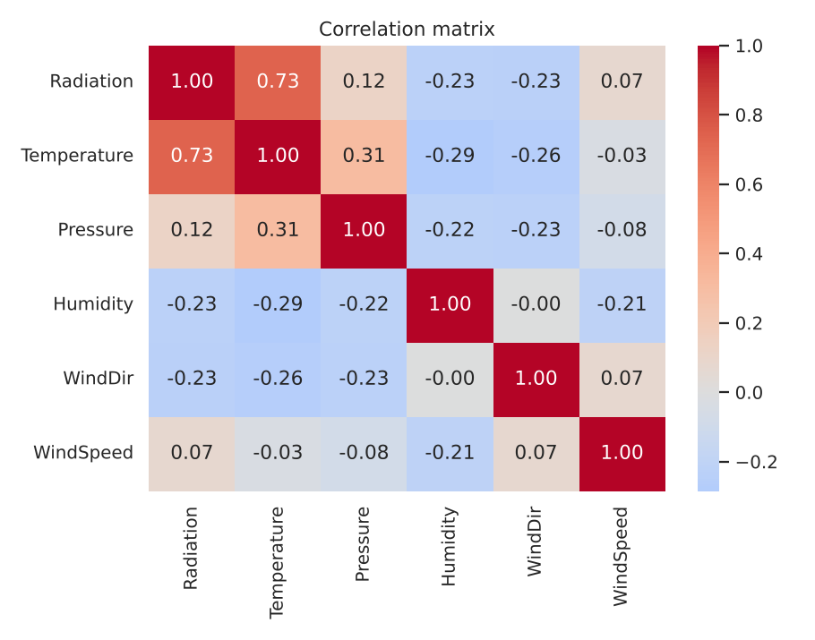
Figure 4. Correlation matrix.
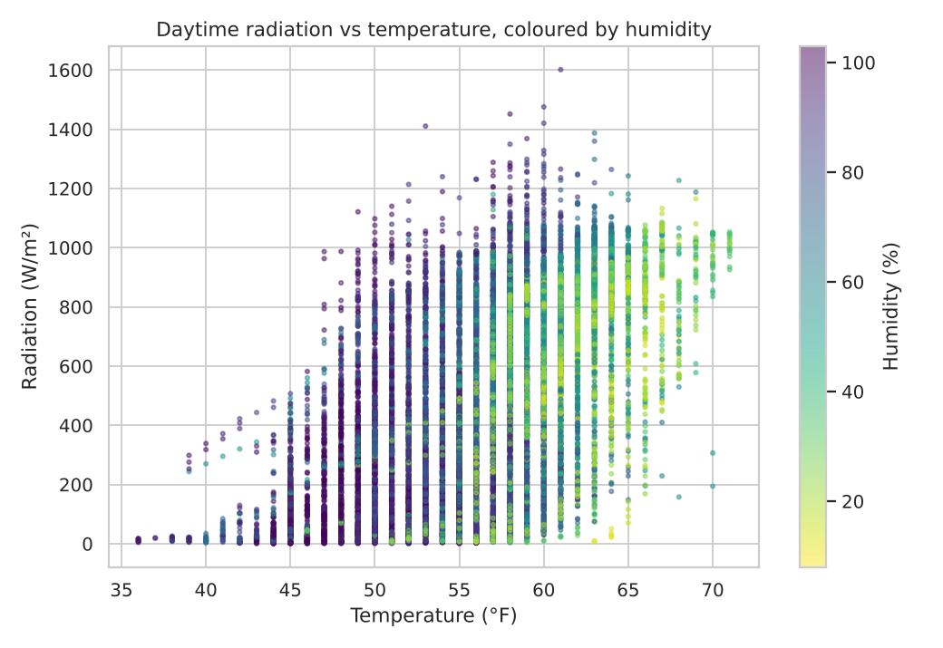
Figure 5. Daytime readings only: radiation vs temperature, coloured by humidity.

2.4 Outliers
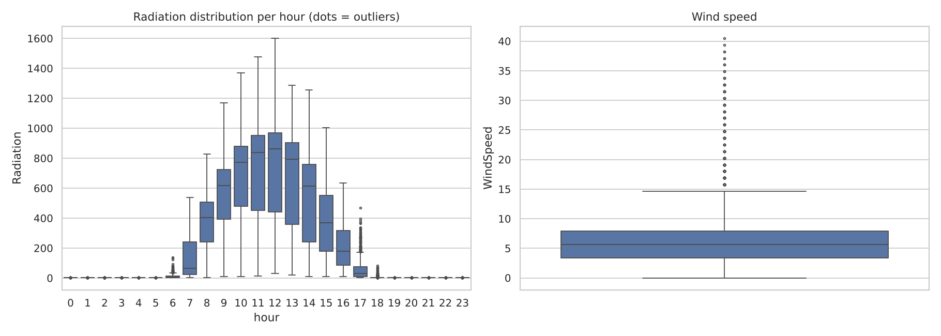
Figure 6. Radiation per hour (left) and wind speed (right) as boxplots.

2.5 Bonus plot
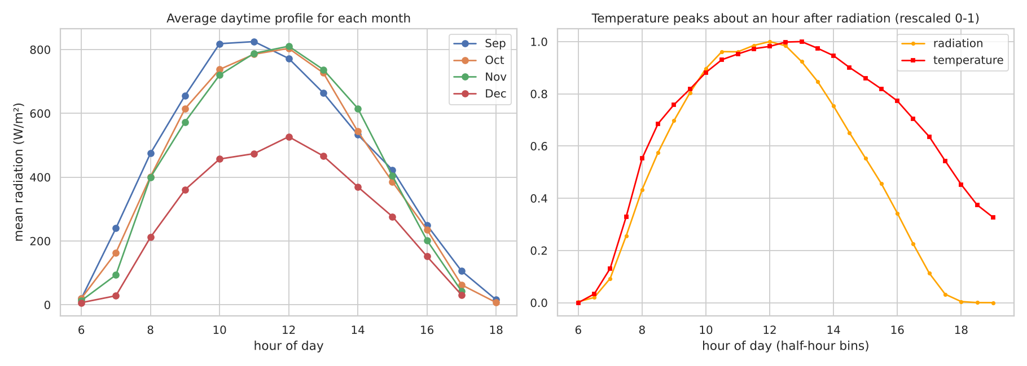
Figure 7. Left: average daytime profile for each month. Right: radiation and temperature rescaled to 0-1 over the day.

3. Part B: Inferences

When is radiation highest?
Around midday. The average radiation is highest in the 12:00 hour (727.5 W/m²), with 11:00 (713.7) and 13:00 (649.5) close behind. If the readings are grouped in half-hour bins, the peak is at 12:00-12:30 (about 733 W/m²). Between roughly 18:30 and 06:00 the reading just sits at about 1.3 W/m², which I treat as the sensor's night floor. On average the daily peak comes 5.79 hours after sunrise (median 5.76), which is close to the middle of a 12 to 12.5 hour day.

Which parameter is most strongly related to radiation?
Temperature, clearly. The correlations with radiation are:
Parameter | All hours (r) | Daytime only (r)
Temperature | 0.735 | 0.646
Humidity | -0.226 | -0.394
Wind direction | -0.230 | -0.154
Pressure | 0.119 | 0.235
Wind speed | 0.074 | 0.126
Temperature leads in both cases. Humidity is the second most useful one once you look at daytime only, and its relationship is the interesting one (below). Wind speed and pressure are weak. One caution: part of the temperature correlation is just both of them following the clock, since it is cold at night and warm at noon. The daytime-only value of 0.65 is the fairer number.

Radiation, temperature and humidity together
Figure 5 shows that high radiation readings sit at high temperature and low humidity, and the low-radiation readings at any temperature are mostly the humid ones. Averaging only the daytime readings by humidity band makes this concrete:
Humidity band (%) | Mean radiation (W/m²) | No. of readings
0 - 40 | 564.1 | 2,433
40 - 60 | 636.6 | 2,094
60 - 80 | 556.1 | 2,868
80 - 100 | 320.3 | 6,558
above 100 | 208.6 | 1,655
Up to about 80% humidity, the mean radiation stays around 560-640. Above 80% it falls sharply, to roughly half. My reading of this is that humidity is mostly a sign of clouds or mist: when the air is that damp, less sunlight gets through. So humidity does not reduce radiation gradually, it behaves more like a threshold. Temperature then follows radiation, so humid and cloudy days tend to be cooler as well.

Outliers
- High spikes. 49 readings are above 1,200 W/m², while most clear-sky noon readings top out near 1,050-1,100 (the flat ceiling in Figure 3). The biggest are 1,601.26 W/m² on 4 Sep at 12:15 and 1,475.40 on the same day at 11:45. This is the same day I chose as the 'highest' in Part C, and it is a strange one: its average humidity was 93.9% and its average radiation only 153.6 W/m², well below the overall mean of 207.1. So it was a heavily clouded day with a couple of sudden bursts. I think these are cloud-edge effects, where sunlight reflected off the sides of clouds adds to the direct beam for a few minutes. I cannot prove that from this data, but the pattern (extreme peak on a very humid day, only around midday) fits. A faulty sensor is the other possible explanation.
- Dips at midday. 784 of the 6,763 readings between 10:00 and 14:00 (11.6%) are below 200 W/m². These are passing clouds or rain and they are what make the boxplots for the middle hours so wide.
- Wind. The 99th percentile of wind speed is 16.9 but the maximum is 40.5, so there are a few storm-type readings. High winds show up with low radiation, which fits a weather front.
- Humidity above 100%. See Section 1. It looks like a calibration or saturation issue.
A side note: the usual 1.5 x IQR rule does not work well here. For daytime radiation it gives a lower fence of about -820 W/m², which is impossible, because the data is bunched at the top and has a long tail of low values from cloud. So I judged outliers from the plots instead.

Bonus insights
- Temperature peaks about an hour after radiation. In half-hour bins, mean radiation peaks at 12:00 and mean temperature at 13:00 (right panel of Figure 7). This makes sense since the ground and air keep heating as long as incoming energy is greater than what is lost, so the temperature lags. It also means temperature at 15:00 still looks 'high' while radiation has already dropped, which is a trap for any model that leans on temperature.
- December is a different regime. Mean daytime radiation is 467.9 (Sep), 468.2 (Oct) and 480.0 (Nov), so those three months are essentially the same, then it falls to 306.3 in December. At midday (10:00-14:00) the average goes from about 720-734 in Sep-Nov to 459 in December, and the mean temperature falls from 58-61 to 52.5. The drop is bigger than the shorter days alone would give, so December was also cloudier or damper. This matters for the model in Section 5.

4. Part C: Solar day analysis
Done in Pandas and NumPy (see solar_analysis.py). The Data and Time columns were combined into a datetime column, and the readings were grouped by date. The daily average uses all readings of the day, including the night ones, as the task is worded. The full 118-row table is saved as daily_solar_report.csv.

Highest radiation day
Item | Value
Date | 4 Sep 2016
Maximum radiation | 1601.26 W/m²
Time of the maximum | 12:15:04
Temperature at that time | 61 °F
Humidity at that time | 93 %
Wind speed at that time | 9.0 mph
Sunrise / sunset that day | 06:08 / 18:35 (day length 12 h 27 min)
Peak after sunrise | 6 h 07 min 04 s (about 6.12 h)
Peak before sunset | 6 h 19 min 56 s
The peak happened at 49.1% of the way through the daylight hours, which is very close to solar noon. So the timing is normal even though the value is not (see the outlier discussion above).

Top 5 days by average radiation
Rank | Date | Average (W/m²) | Max that day (W/m²)
1 | 19 Sep 2016 | 335.50 | 1085.75
2 | 2 Sep 2016 | 333.47 | 1062.01
3 | 22 Sep 2016 | 325.52 | 1053.17
4 | 25 Sep 2016 | 319.92 | 1075.29
5 | 28 Sep 2016 | 312.40 | 1029.30
All five are in September, and none of them is the 'record' day. They are days with clear skies from sunrise to sunset, where the max stays around 1,030-1,090 and the average is high because there are no cloud dips. I think this is a better way to find the genuinely sunniest days than looking at the single largest reading, which gave 4 Sep (daily average only 153.6), then 19 Oct, 7 Oct, 31 Oct and 27 Sep.

5. Bonus: predicting radiation

Features
Weather: temperature, pressure, humidity, wind direction, wind speed. Time: hour of day as a decimal, day of year, minutes since sunrise and minutes until sunset. The sunrise-based features tell the model where it is in the day more directly than the clock does, since sunrise moves through the season. I did not use UNIXTime because it would let a model memorise dates instead of learning anything.

Method
Random 80/20 train-test split (random_state = 42). I tried linear regression as a baseline and a random forest (200 trees, min 2 samples per leaf) since the relationship with time of day is clearly not a straight line. Metrics are RMSE and R² on the test set.

Scores
Model / setup | RMSE (W/m²) | R²
Linear regression, random split | 191.25 | 0.6238
Random forest, random split | 76.36 | 0.9400
Random forest, split by date (train before 8 Dec, test after) | 131.45 | 0.7497
Random forest, weather columns only, random split | 156.15 | 0.7492

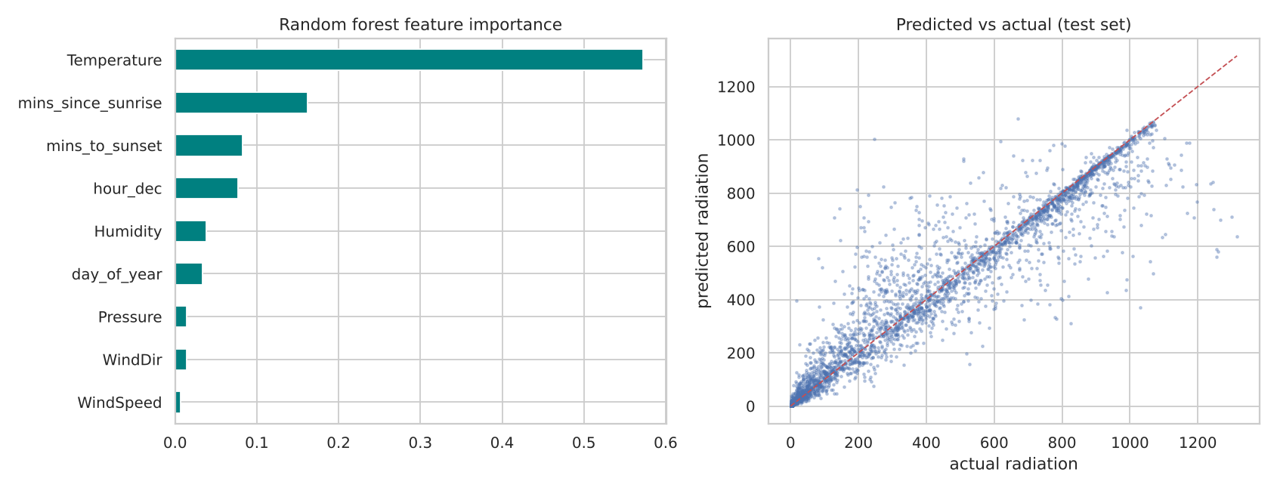
Figure 8. Random forest: feature importance and predicted vs actual radiation on the test set.

Which features matter
Feature | Importance
Temperature | 0.572
Minutes since sunrise | 0.162
Minutes to sunset | 0.083
Hour of day | 0.077
Humidity | 0.038
Day of year | 0.034
Pressure | 0.015
Wind direction | 0.014
Wind speed | 0.007

Temperature is the strongest feature, which matches Part B. The four time-of-day features together add up to about 0.32, so the position in the day matters a lot. Humidity is the most useful of the rest, as expected from the threshold effect. Wind and pressure contribute almost nothing.

Caveats
- The 0.94 R² comes from a random split. Readings 5 minutes apart are almost identical, so the test rows have near-twins in the training set and the score is optimistic. When I trained on the first 80% of the days and tested on the later ones, R² dropped to 0.75 (RMSE 131). That is the more honest number for forecasting.
- Most of that drop is because the test period is December, which is cloudier and cooler than anything the model saw (see Part B), and tree models cannot extrapolate to conditions they have not seen. More months of data would help.
- Temperature is itself driven by radiation, so using it as an input is a bit circular if the goal is to forecast the sun. The weather-only model (R² 0.75) and the time-only information still carry most of the signal. A true forecast would need cloud cover or satellite data.

6. Summary
- Radiation peaks at about 12:00 (roughly 6 hours after sunrise) and is flat at about 1.3 W/m² overnight.
- Temperature is the best single predictor (r = 0.74 overall, 0.65 in daytime). Humidity above about 80% cuts daytime radiation roughly in half.
- The highest reading, 1601.26 W/m² on 4 Sep at 12:15, comes from a cloudy, very humid day, so it is probably a cloud-reflection spike. The genuinely sunniest days were in September, led by 19 Sep (average 335.5 W/m²).
- A random forest predicts radiation with RMSE 76 and R² 0.94 on a random split, and RMSE 131 and R² 0.75 when tested on later dates.
_________________________THANK YOU_______________________________

