Assignement-1

Order List :-

<!DOCTYPE html>

<html lang="en">

<head>

    <meta charset="UTF-8">

    <meta http-equiv="X-UA-Compatible" content="IE=edge">

    <meta name="viewport" content="width=device-width, initial-scale=1.0">

    <title>Order List</title>

</head>

<body>

    <h2> Student Name </h2>

    <ol>

        <li>Sudhanshu Kumar</li>

        <li>Govind Kumar</li>

        <li>Sandeep chhotu</li>

        <li>Shri Ram</li>

        <li>Sita</li>

    </ol>

</body>

</html>

**Out Put**

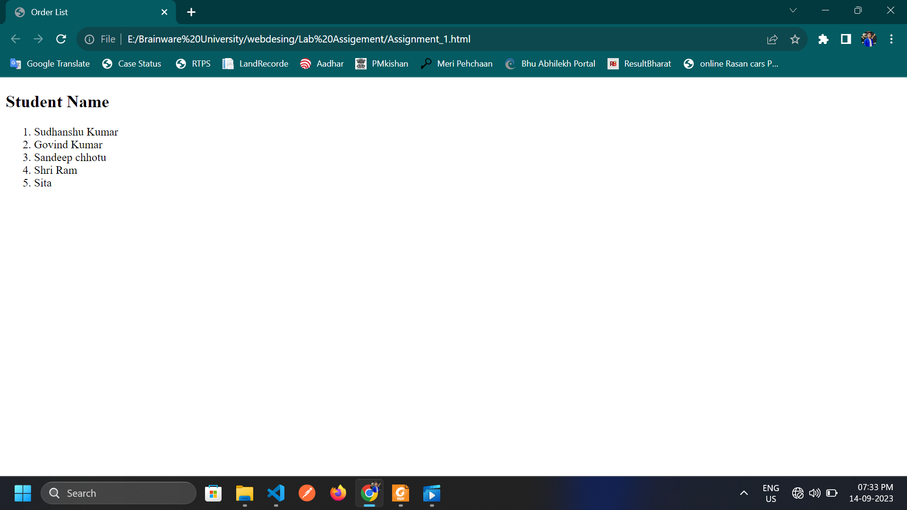

Unorder :-

<!DOCTYPE html>

<html lang="en">

<head>

    <meta charset="UTF-8">

    <meta http-equiv="X-UA-Compatible" content="IE=edge">

    <meta name="viewport" content="width=device-width, initial-scale=1.0">

    <title>Order List</title>

</head>

<body>

    <h1> This is Unorder List</h1>

    <ul>

        <li>1kg King Edward potatoes</li>

        <li>100ml milk</li>

        <li>50g salted butter</li>

        <li>Freshly grated nutmeg</li>

        <li>Salt and pepper to taste</li>

     </ul>

</body>

</html>

**Out Put** 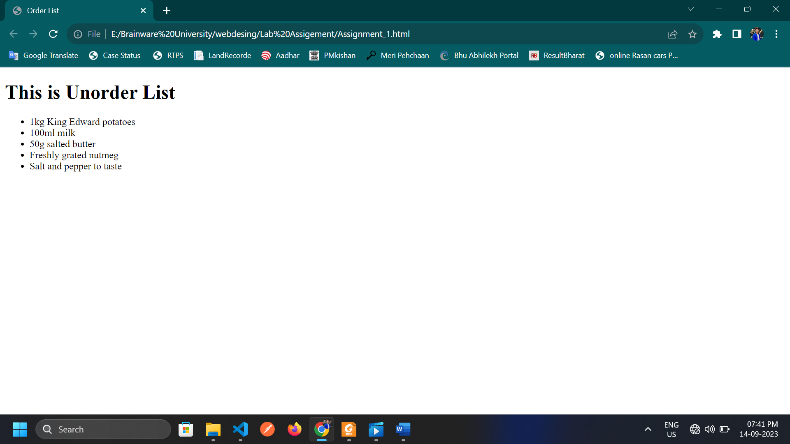

Difination List :-

<!DOCTYPE html>

<html lang="en">

<head>

    <meta charset="UTF-8">

    <meta http-equiv="X-UA-Compatible" content="IE=edge">

    <meta name="viewport" content="width=device-width, initial-scale=1.0">

    <title>Order List</title>

</head>

<body>

    <h1> This is Definition List</h1>

    <dl>

        <dt><b>Apple</b></dt>

        <dd>An apple is a round, edible fruit</dd>

        <dt><b>Mango</b></dt>

        <dd>A Mango produce by the tropical</dd>

        <dt><b>Gava</b></dt>

        <dd>May help lowes blood sugar</dd>

        <dt><b>Banana</b></dt>

        <dd>Improve gat, Kindly and heart helth</dd>

        </dl>

</body>

</html>

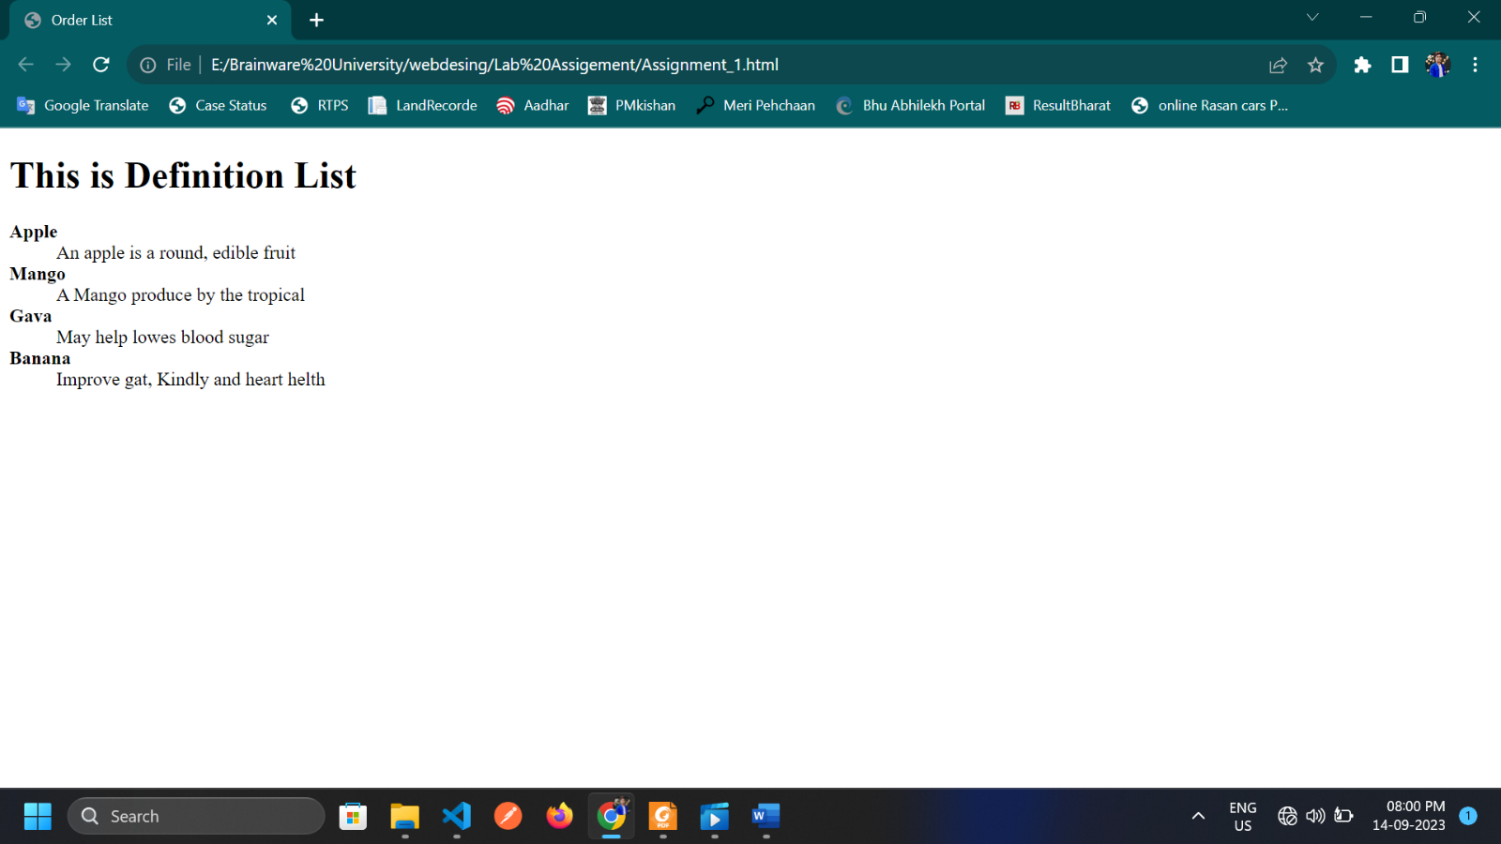**Out Put** :-

* Table Tag

<!DOCTYPE html>

<head>

    <title>Table tag</title>

    <style type="text/css">

        table,th,td{

            border: 1.5px solid rgb(30, 169, 223);

            border-spacing:0px ;

        }

    </style>

</head>

<body>

    <h1>This is table Tag</h1>

   <table>

    <tr>

        <th>Name</th>

        <th>Age</th>

        <th>City</th>

        <th>Mobile No.</th>

    </tr>

    <tr>

        <td>Sudhanshu Kumar</td>

        <td>22</td>

        <td>Bhagalpur</td>

        <td>7079456637</td>

    </tr>

    <tr>

        <td>Govind kumar</td>

        <td>23</td>

        <td>Bhagalpur</td>

        <td>6202378965</td>

    </tr>

    <tr>

        <td>Ram</td>

        <td>25</td>

        <td>Aaodihya</td>

        <td>9977676856</td>

    </tr>

   </table>

</body>

</html>

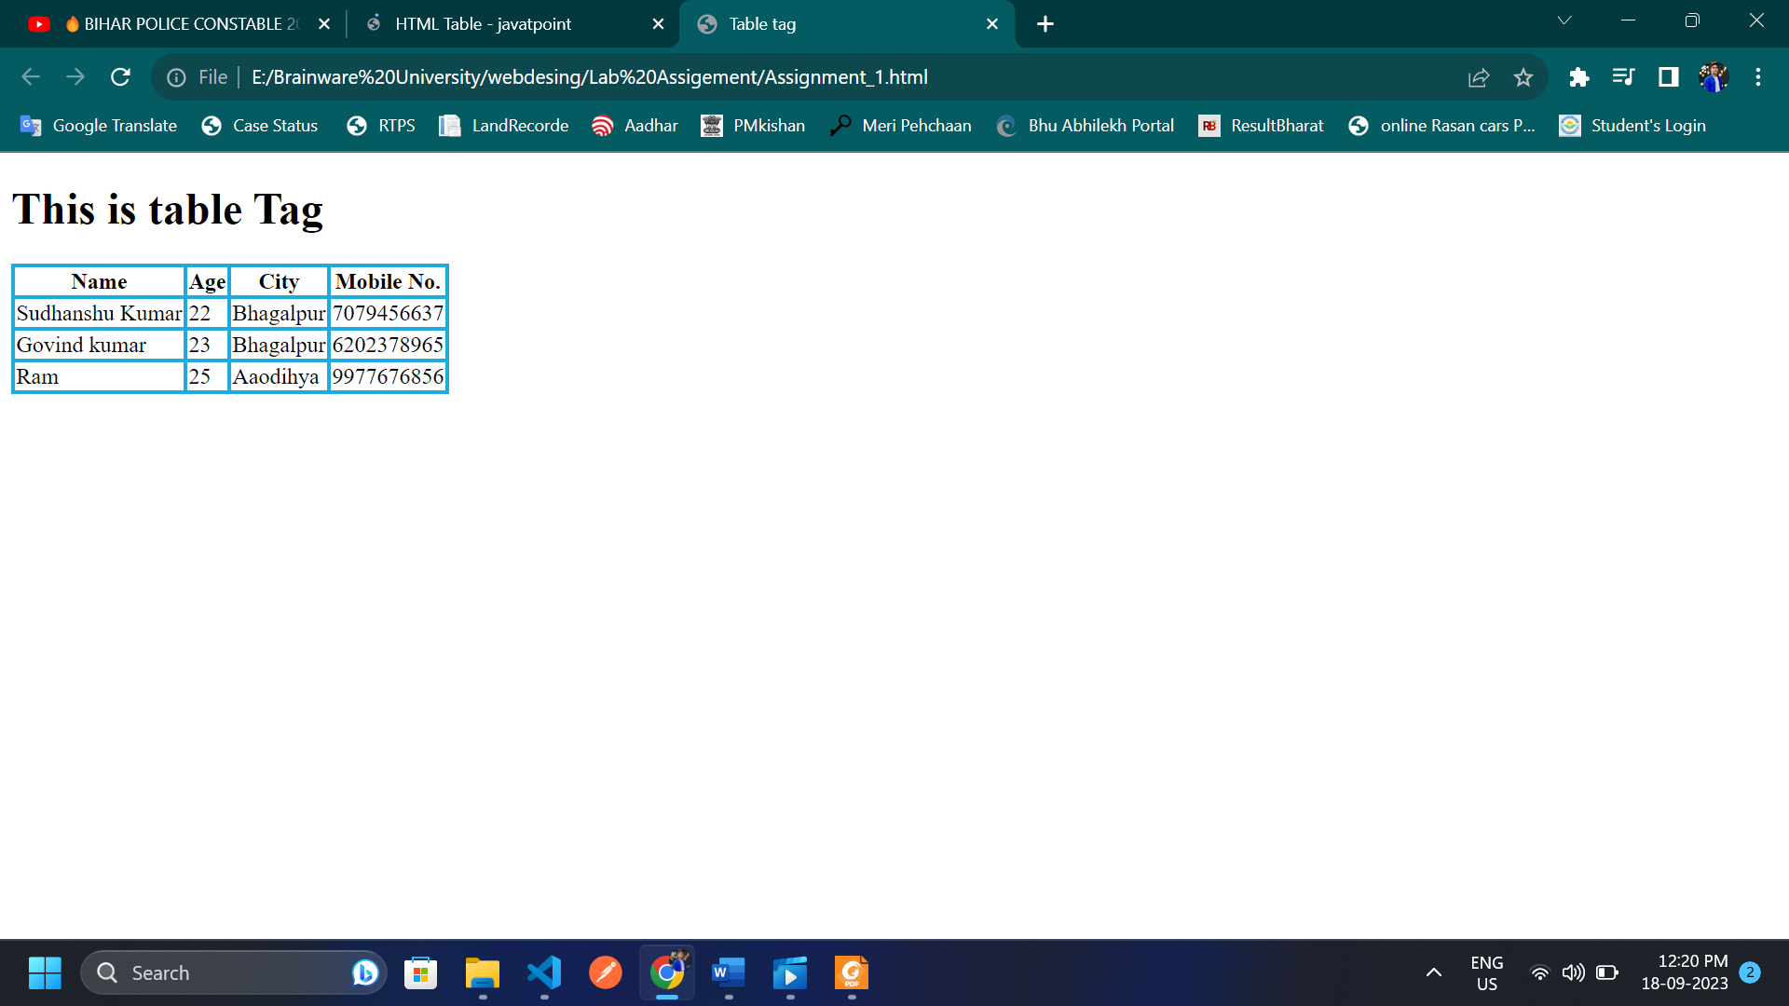

* HyperLink Assg-3

<!DOCTYPE html>

<html lang="en">

<head>

    <meta charset="UTF-8">

    <meta http-equiv="X-UA-Compatible" content="IE=edge">

    <meta name="viewport" content="width=device-width, initial-scale=1.0">

    <title>HyperLink Tag</title>

</head>

<body>

    <h1>click the link below and<br> bavigate the other link </h1>

    <a href="https://www.sarkariresult.com/">Sarkari Result</a>

</body>

</html>

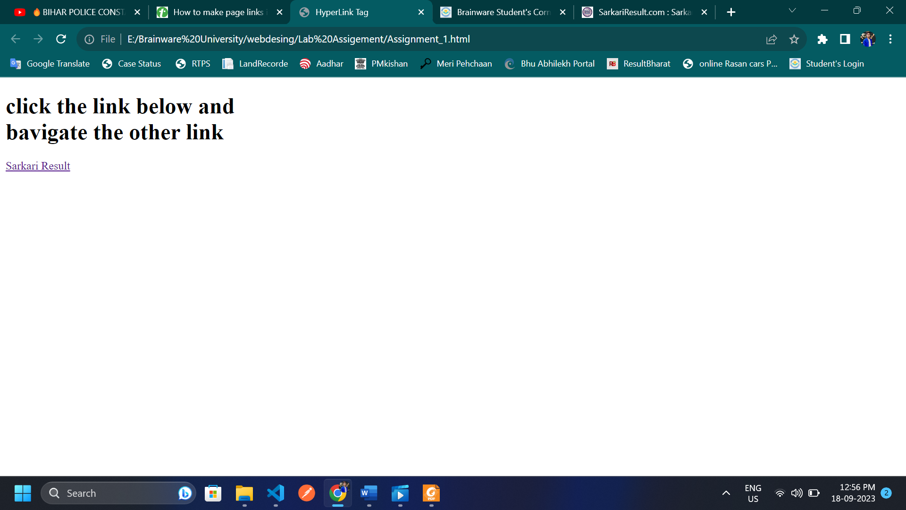

Regisrtaion form

<!DOCTYPE html>

<html lang="en">

  <head>

    <title>Home</title>

    <meta charset="UTF-8" />

    <meta name="viewport" content="width=device-width" />

    <style type="text/css">

    body{

        margin: 0;

        padding: 0;

        font-family: Roboto;

        background-repeat: no-repeat;

        background-size: cover;

        background: linear-gradient(120deg, #007bff, #ebdf5f);

        height: 100vh;

        overflow: hidden;

      }

      .center{

        position: absolute;

        top: 50%;

        left: 50%;

        transform: translate(-50%, -50%);

        width: 29vw;

        background: white;

        border-radius: 10px;

      }

      .center h1{

        text-align: center;

        padding: 0 0 20px 0;

        border-bottom: 1px solid silver;

      }

      .center form{

        padding: 0 40px;

        box-sizing: border-box;

      }

      form .txt_field{

        position: relative;

        border-bottom: 2px solid #cf2d2d;

        margin: 30px 0;

      }

      .txt_field input{

        width: 100%;

        padding: 0 5px;

        height: 40px;

        font-size: 16px;

        border: none;

        background: none;

        outline: none;

      }

      .txt_field label{

        position: absolute;

        top: 50%;

        left: 5px;

        color: #adadad;

        transform: translateY(-50%);

        font-size: 16px;

        pointer-events: none;

      }

      .txt_field input:focus ~ label,

      .txt_field input:valid ~ label{

        top: -5px;

        color: #2691d9;

      }

      .txt_field input:focus ~ span::before,

      .txt_field input:Valid ~ span::before{

        width: 100%;

      }

      input[type="Submit"]{

        width: 100%;

        height: 50px;

        border: 1px solid;

        border-radius: 25px;

        font-size: 18px;

        font-weight: 700;

        cursor: pointer;

      }

      input[type="Submit"]:hover{

        background: #2691d9;

        color: #e9f4fb;

        transition: .5s;

      }

      .signup_link{

        margin: 30px 0;

        text-align: center;

        font-size: 16px;

        color: #666666;

      }

      .signup_link a{

        color: #2691d9;

        text-decoration: none;

      }

      .signup_link a:hover{

        text-decoration: underline;

      }

      .HomeAbout{

        width: 100vw;

        height: 25vh;

      }

    </style>

  </head>

  <body>

    <div class="container">

      <div class="center">

          <h1>Register</h1>

          <form method="POST" action="">

              <div class="txt_field">

                  <input type="text" name="name" required>

                  <span></span>

                  <label>Name</label>

              </div>

              <div class="txt_field">

                  <input type="email" name="email" required>

                  <span></span>

                  <label>Email</label>

              </div>

              <div class="txt_field">

                  <input type="password" name="password" required>

                  <span></span>

                  <label>Password</label>

              </div>

              <div class="txt_field">

                  <input type="password" name="cpassword" required>

                  <span></span>

                  <label>Confirm Password</label>

              </div>

              <input name="submit" type="Submit" value="Sign Up">

              <div class="signup_link">

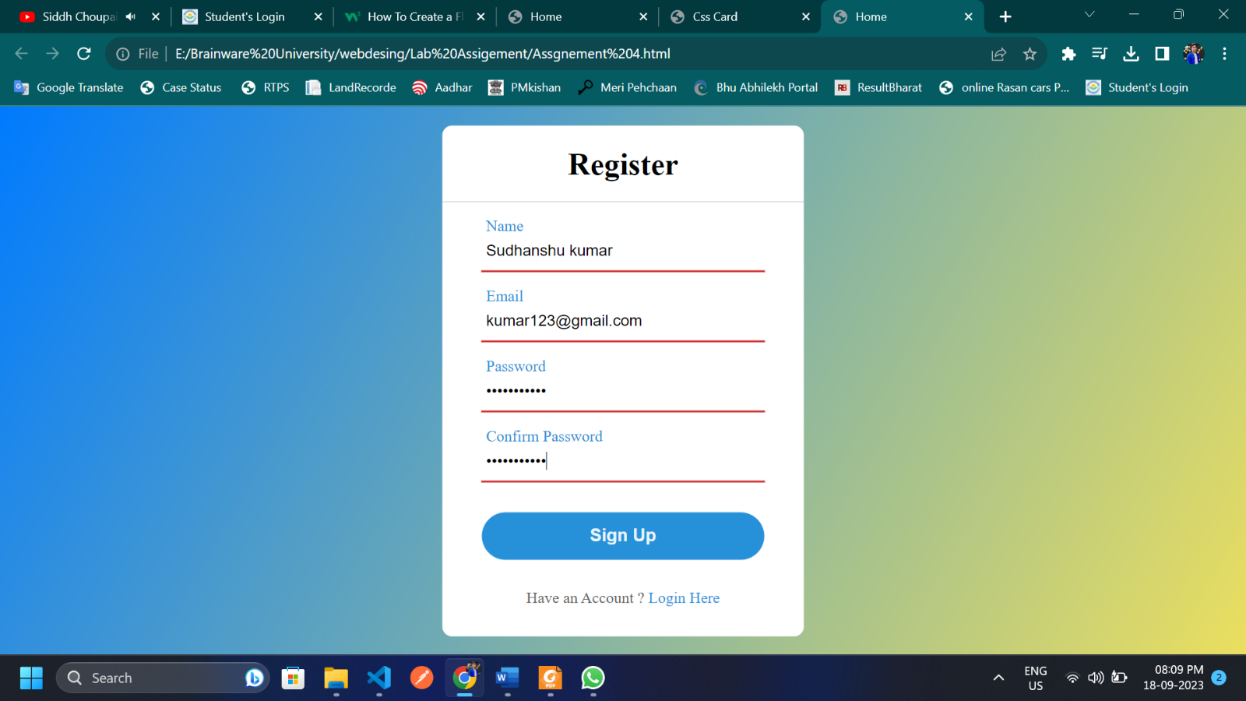                  Have an Account ? <a href="#">Login Here</a>

              </div>

          </form>

      </div>

  </div>

  </body>

</html>