Slide 1 — TITLE
Title: Amazon Sales Dashboard — Exploratory Analysis
Subtitle: Sales performance by Category, Shipping status and State
Author: Kumar Saripalli
Dataset: Amazon sales dataset (Kaggle) — {date range}
Tools: Power BI / Tableau
Footer: Exported on {export date}
Speaker notes: One sentence summary: “This dashboard summarizes product category performance, shipping status distribution, and category-level sales across states to surface where revenue is concentrated and where operational bottlenecks (shipping) appear.”

Slide 2 — Objective & Scope
Title: Objective & Scope
Content (bullets):
- Objective: Provide actionable business insights from Amazon sales data.
- Scope:
  - KPI cards: Total categories, Total orders (or Total sales count), Total sales amount.
  - Charts: Sales by category (donut), Shipping by status (stacked bar), Category by state (clustered column).
- Time period: {start date} — {end date}
- Filters applied: {e.g., completed orders only / exclude refunds / only product orders}
Speaker notes: Clarify assumptions like whether refunds/returns are excluded and how shipping statuses are defined.

Slide 3 — Data Summary
Title: Dataset Summary
Content (table or bullets):
- Rows (orders): {# orders}
- Unique categories: {# categories}
- Unique states: {# states}
- Key fields used: OrderID, Category, SalesAmount, ShippingStatus, State, OrderDate, Quantity
Speaker notes: Mention any cleaning steps: removed nulls, standardized category names, aggregated multiple SKUs into category-level sales, converted currency if needed.

Slide 4 — KPI Snapshot
Title: KPI Snapshot
Visual: Show your three cards (centered):
- Total Categories: {value}
- Total Sales (orders): {value}
- Total Sales Amount (₹ / $): {value}
Text under cards (1–2 lines):
- Quick takeaway: e.g., “{Category X} is largest category by revenue. Total orders are {value}, with average order value of {calculated value}.”
Speaker notes: Explain calculations:
- Total Sales Amount = SUM(SalesAmount)
- Total Sales (orders) = COUNTDISTINCT(OrderID) or SUM(Quantity) depending on what you show
- Total Categories = COUNTDISTINCT(Category)
Formatting tips: Use large numeral fonts, one accent color for the primary KPI, subtle gray for labels. Add small trend arrow (↑/↓) if you have period-over-period.
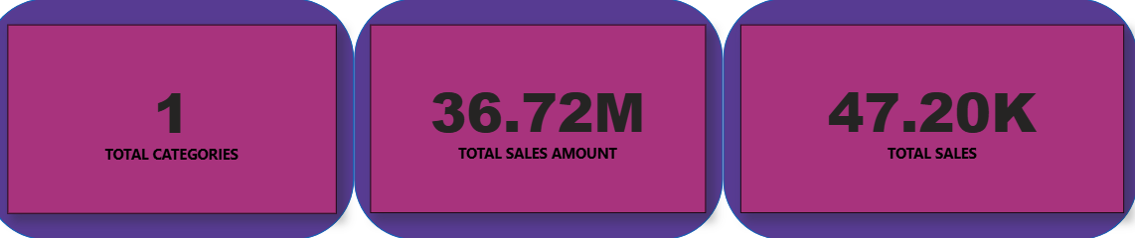

Slide 5 — Chart 1: Donut Chart — Sales by Category
Title: Sales by Category — Donut Chart
Subtitle / One-liner: “Shows each category’s share of total revenue.”
How to read it:
- Each slice = category revenue as a percentage of total sales amount.
- Slice size indicates contribution; center label shows total sales amount.
Key things to call out (example copy):
- Top 1–2 categories contribute {X%} of revenue — indicates concentration risk.
- Long tail of smaller categories collectively contributes {Y%} — opportunity to bundle/promote.
- If one category dominates >40% — recommend diversification or targeted supply chain focus.
Speaker notes / Talking points:
- “Category A accounts for {X%} of total revenue, followed by Category B at {Y%}. Together they represent {X+Y%} of sales — which suggests marketing and inventory should prioritize these categories.”
- Mention any anomalies (e.g., small category with unexpectedly high revenue).
Formatting tips:
- Use 4–6 colors max. Emphasize top category with an accent color and fade others. Show percentage and revenue labels for the top 3 slices only to avoid clutter. Provide a legend with category names and absolute values.
Suggested actionables:
- Investigate supply and margin on top categories.
- Create targeted promotions for high-margin smaller categories.
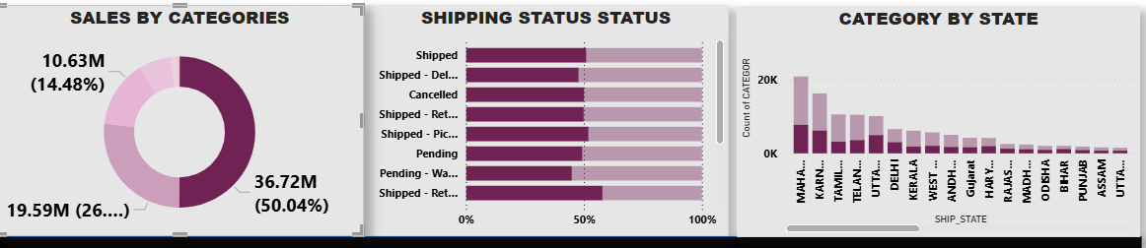

Slide 6 — Chart 2: Stacked Bar Chart — Shipping by Status
Title: Shipping Status Distribution (Stacked Bar)
Subtitle / One-liner: “How orders are distributed across shipping statuses (Delivered, Pending, Returned, Cancelled, etc.)”
How to read it:
- X-axis: {Time / Category / State — whichever you used}.
- Y-axis: Count of orders (or percentage).
- Each bar is split by shipping status segments.
Key things to call out (example copy):
- High share of Delivered indicates operational strength.
- Noticeable Pending or Delayed segments in {period or state} — potential logistics bottleneck.
- Returned and Cancelled segments indicate product/quality or fulfillment issues.
Speaker notes / Talking points:
- “Returned orders are {value}% of total — investigate top-returned SKUs and reasons (size, quality, mismatch).”
- If Pending spikes on particular dates: “These align with promotional days — consider scaling logistics.”
Formatting tips:
- Use a consistent color palette for statuses across the presentation (e.g., Delivered = green/accent, Pending = amber, Returned = red).
- Add data labels only for segments >5% to avoid clutter. Consider showing bars as 100% stacked to highlight distribution rather than volume.
Suggested actionables:
- Investigate root cause of returns/cancellations.
- Improve communication or SLA on delayed shipments.
- Consider leading-time adjustments for states with chronic delays.

Slide 7 — Chart 3: Clustered Column Chart — Category by State
Title: Category Sales by State — Clustered Column Chart
Subtitle / One-liner: “Compares category revenue across states to identify geographic strength and under-penetration.”
How to read it:
- X-axis: States (grouped).
- Within each state group: columns for each category (or top categories).
- Y-axis: Sales amount.
Key things to call out (example copy):
- State A shows strong sales across multiple categories — a mature market.
- State B has strong sales in Category X but weak presence in Category Y — targeted growth opportunity.
- Consider normalizing by population or GDP if you want per-capita insights.
Speaker notes / Talking points:
- “Category X drives most revenue in State A, while Category Y underperforms in State B despite similar population — suggests distribution or marketing gap.”
- If clusters are too many, show top 3 categories only per state or split state groups into regions.
Formatting tips:
- Keep axis labels rotated if space-constrained. Use consistent color per category across all slides. Use a small margin and gridlines off to reduce clutter. Consider using sorting (states by total revenue) for clearer story flow.
Suggested actionables:
- Expand inventory and promotions in states where category shows traction.
- Pilot localized marketing in underperforming states.
