CUSTOMER TABLE(MASTER/PARENT TABLE):
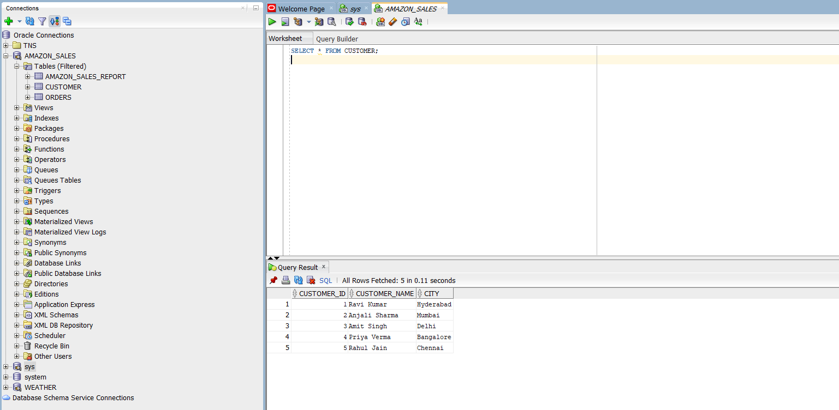
ORDERS TABLE(CHILD TABLE):
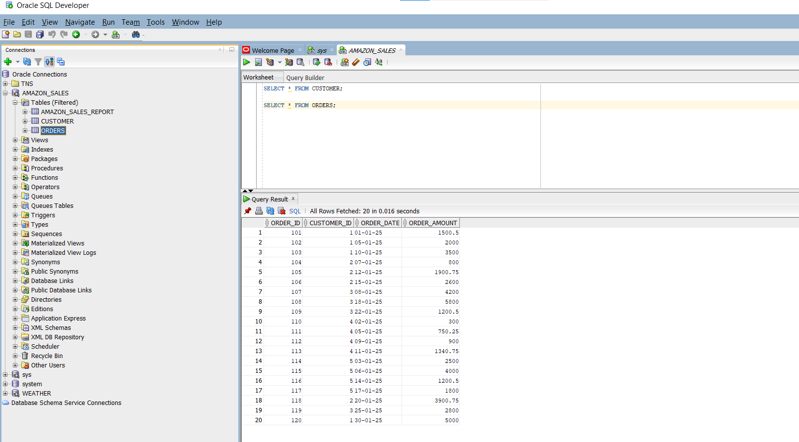
------------------------------------------------------------
-- SIMPLE SUBQUERY (IN WHERE clause)
-- Get customers who placed at least one order
------------------------------------------------------------
SELECT customer_id, customer_name
FROM customer
WHERE customer_id IN (
SELECT customer_id
FROM orders
);
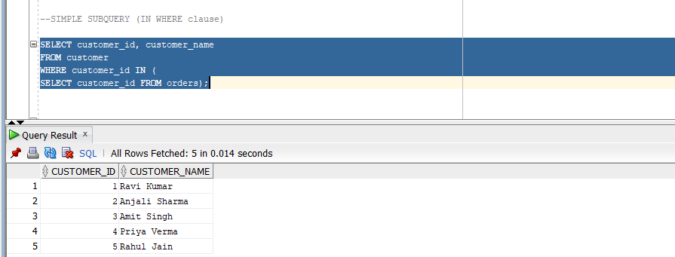

------------------------------------------------------------
-- NESTED SUBQUERY (Multiple levels)
-- Find customers with order amount greater than avg of all orders
------------------------------------------------------------
SELECT customer_id, customer_name
FROM customer
WHERE customer_id IN (
SELECT customer_id
FROM orders
WHERE order_amount > (
SELECT AVG(order_amount)
FROM orders
)
);
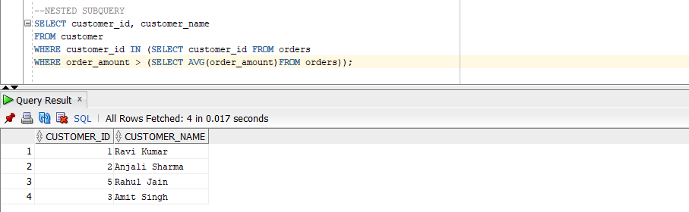

------------------------------------------------------------
-- SCALAR SUBQUERY (In SELECT)
-- Display each order with total company revenue
------------------------------------------------------------
SELECT
order_id,
customer_id,
order_amount,
(SELECT SUM(order_amount) FROM orders) AS total_sales
FROM orders;
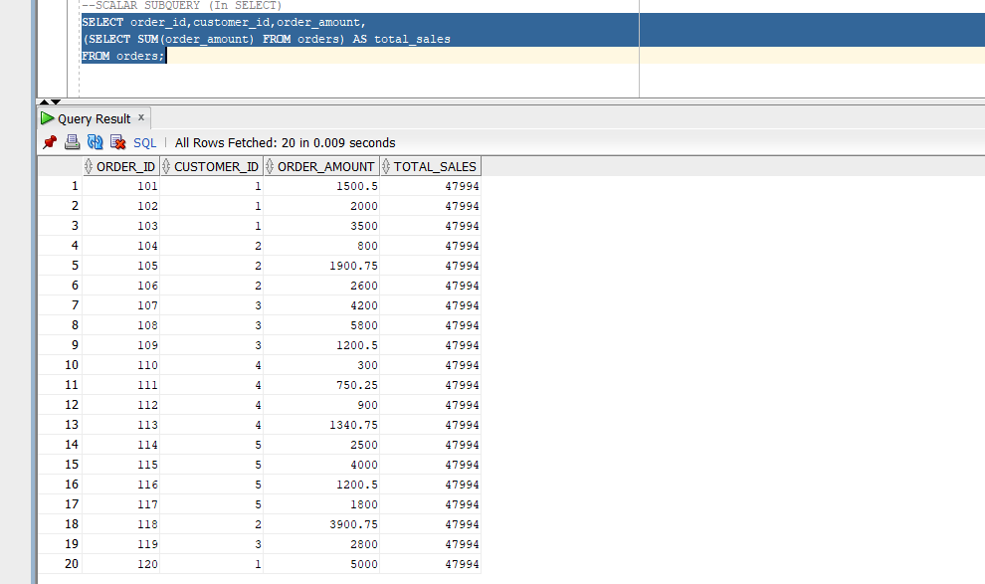

------------------------------------------------------------
-- 4️⃣ INLINE VIEW (Subquery in FROM clause)
-- Show top 5 highest order amounts only
------------------------------------------------------------
SELECT *
FROM (
SELECT order_id, customer_id, order_amount
FROM orders
ORDER BY order_amount DESC
) top_orders
WHERE ROWNUM <= 5;
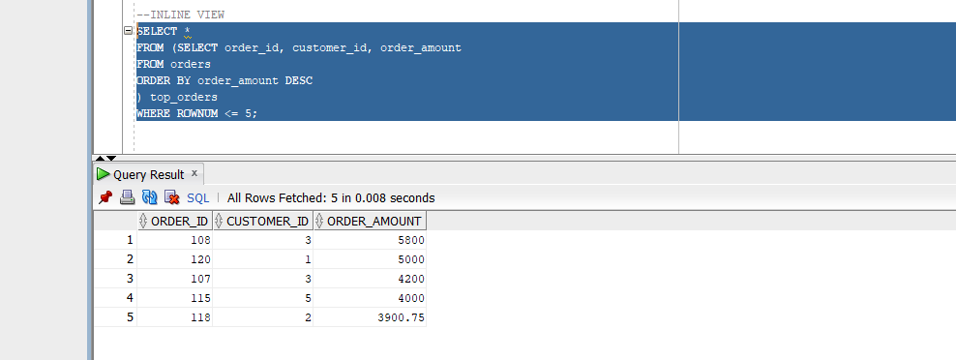

------------------------------------------------------------
--CORRELATED SUBQUERY (Depends on outer query)
-- Find orders greater than customer's average order amount
------------------------------------------------------------
SELECT
o.order_id,
o.customer_id,
o.order_amount
FROM
orders o
WHERE
o.order_amount > (
SELECT AVG(order_amount)
FROM orders
WHERE customer_id = o.customer_id
);
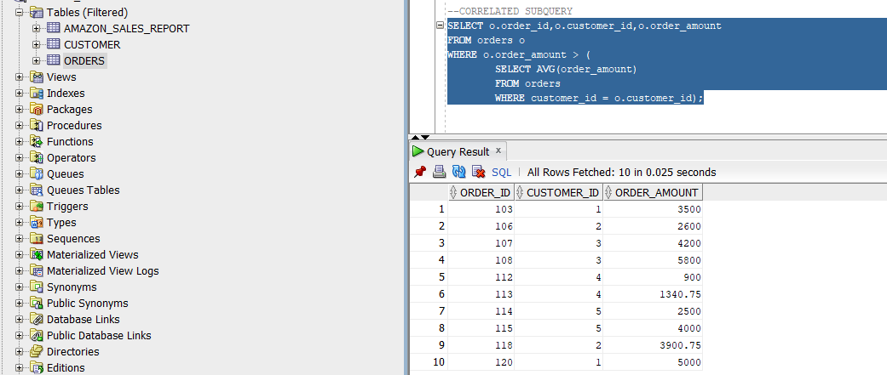

------------------------------------------------------------
--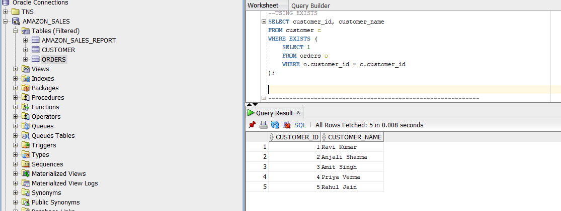USING EXISTS
-- Show customer names who have at least one order
------------------------------------------------------------
SELECT customer_id, customer_name
FROM customer c
WHERE EXISTS (
SELECT 1
FROM orders o
WHERE o.customer_id = c.customer_id
);

------------------------------------------------------------
-- USING = (Scalar comparison)
-- Show customer having maximum order amount
------------------------------------------------------------
SELECT customer_name
FROM customer
WHERE customer_id = (
SELECT customer_id
FROM orders
WHERE order_amount = (
SELECT MAX(order_amount) FROM orders
)
);


------------------------------------------------------------
-- USING NOT EXISTS
-- Customers who have NOT placed any orders
------------------------------------------------------------
SELECT customer_id, customer_name
FROM customer c
WHERE NOT EXISTS (
SELECT 1
FROM orders o
WHERE o.customer_id = c.customer_id
);
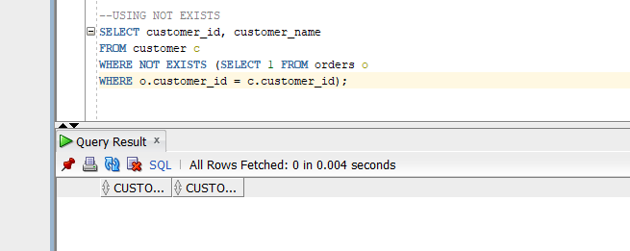

------------------------------------------------------------
--INLINE VIEW + GROUPING
-- Top customer by total purchase using inline view
------------------------------------------------------------
SELECT * FROM (
SELECT
customer_id,
SUM(order_amount) AS total_revenue
FROM orders
GROUP BY customer_id
ORDER BY total_revenue DESC
) revenue_table
WHERE ROWNUM = 1;
