

**Assignment 1: Written Assessment –**

**Linear Modeling Case Study**

**ANALYSIS WRITE UP**

Machine Learning - DAT-5303 - SFMBANDD1

Professor: Chase Kusterer

*March 5th, 2019*

*Team 10:*

Anant Kumar

Gaurav Keswani

Marialudovica Flocco

Martina Cerina

Nicolas Inzelmann

Table of Contents

Introduction 3

Insights and Implementation Recommendations 3

Parents Age 3

Education 4

Parents Race 5

Cigarettes and Alcohol 5

Prenatal Care and Visits 6

Conclusions 7

Appendix 8

# **Introduction**

The birth of a newborn is a beautiful, yet intensely stressful process and the number one concern of expecting parents, during pregnancy, is usually the baby’s health. The birthweight is one of the most significant indicators of the baby’s health and a relevant index to determine the life quality of its first months. On average, a newborn weighing in between 2,500 and 4,500 grams is considered to be healthy, while everything above or below could imply some health conditions.

Therefore, the purpose of this report is to model and analyze the factors influencing birthweight in order to provide useful insights for both expecting parents and public health providers.

# **Insights and Implementation Recommendations**

In order to determine the significant factors affecting the birthweight of the newborn, a dataset with 18 variables and 196 observations was analyzed. Using this data, a predictive model was developed. This model would predict birthweight of the newborn with an accuracy of 75.9%. From the exploration of this sample dataset some insights and recommendations can be inferred.

## **Parents Age**

Both, the age of the mother and the father are negatively correlated with the birthweight of the baby. Analyzing the different age groups of the underlying sample, the mothers’ age plays a significant role for the newborns weight (Exhibit 1). In specific, mothers older than 47, on average give birth to babies weighting 2,874 grams in contrast to younger mothers in the age of 34 to 39, whose babies have an average weight of 3,506 grams.

In addition, the fathers’ age is almost as influential for the birthweight as the mothers’ age. Surprisingly, this does not align with other researches which concluded that the fathers’ age is influencing the birthweight but far less significantly than the mothers’ age does. However, this discrepancy between the analyzed sample data and other research can be explained by a very high correlation between the mothers’ age and the fathers age. Therefore, it can be concluded that for the analyzed sample a social phenomenon exists which causes older fathers to be paired with older mothers. Consequently, it is reasonable that correlation of fathers’ age and birthweight in the sample is slightly higher than other researches have proven.

Based on these insights, couples considering becoming parents should be advised to make family plans at a younger age to maximize the chances of having a healthy baby. Since this causes financial challenges for many young couples, the parents should be advised well, which opportunities in terms of governmental support and saving options exist for them. In addition, governments should be involved and advised to facilitate policies for financial support/health care that allow young couples to become parents in a young age.

## **Education**

Analyzing the combined years of education of both the mother and the father, a higher degree of parents’ education can be associated with a higher birthweight. Based on additional research, this can be explained through higher incomes which more educated people receive on average. More financial flexibility can make the mother afford healthier nutrition options and healthier habits. At the same time, both parents can afford to work less during the pregnancy which could reduce stress and could influence the birthweight positively.

In order to maximize the chances of a healthy birthweight for all couples with different educational backgrounds and incomes, parents should be advised to consider paying more money for their own well-being during the pregnancy. This includes e.g. a healthier diet or working less. To facilitate this opportunity, governments should cooperate and support parents financially and facilitate general conditions through laws which ensure optimal working conditions for expecting parents and especially the mothers.

## **Parents Race**

Based on the data gathered, our analysis highlights that the race and ethnicity of the baby’s parents affect the birthweight quite significantly. As a matter of fact, data reveals that babies from black parents have the highest average birthweight of 3,437 grams compared to the other ethnicities’ babies, while white babies have the lowest (with an average of 3,213 grams). However, it should be noted that external researches do not support this trend. In fact, it seems that African American babies have double the chances to have a very low birthweight compared to white babies.

From our insights, it should be noted that race plays relevant significance in the determination of the birthweight. Therefore, parents and doctors should consider the baby’s ethnicity when evaluating the baby’s health and when developing the prenatal care plans. Moreover, since male babies weight more than female babies, the sex of a baby should also be considered in the development of prenatal cares, once found out.

## **Cigarettes and Alcohol**

It is commonly well known that cigarettes and alcoholic beverages are unhealthy substances. Given that they are proven to be harmful for grown-ups, it should come as no surprise that they are also highly unfavorable for the growth of a fetus. The negative effect of cigarettes and drinks on the birthweight is visualized in Exhibits 2 and 3.

Our analysis pointed out how, statistically, both smoking and drinking have highly negative effects on the birthweight of a newborn. With a correlation of -57% between cigarettes consumption and birthweight, and -74% between drink consumption and birthweight, it is proven that the higher the consumption of these substances, the lower the baby birthweight. Moreover, we can also conclude that drinking is more harmful than smoking. Finally, a further investigation of the correlation proved that, in both cases, the consumption of just one item of the substance is already harmful for the baby weight. However, in the case of drinking the most significant harm comes from the 4th to the 10th unit per month. While, in the case of cigarettes, the biggest significance comes from unit 11th to 17th per day. This means that, no matter what, drinking and smoking are always bad for the growth and the health of a baby. However, statistically, it cannot be determined what difference is caused by smoking 1 cigarette against 9 cigarettes per day or what difference is caused by drinking 1 drink against 4 per month. What can be proved, however, is that from the 10th cigarette up to the 17th, each and every other unit smoked is harming the weight of the newborn always more and more. As well as, from the 4th drink onwards, every unit drunk is increasingly hurting the baby.

Based on these insights, the only recommendation for parents should be to abstain themselves from any kind of toxic consumptions. Moreover, it would be worth to invest in further researches in order to determine the harm of each and every unit of cigs/drinks consumption. Finally, governments and health care providers should invest in educational campaigns and should provide free tools against toxic addictions to expecting mothers (i.e. smoking patch, nicotine gum etc.).

## **Prenatal Care and Visits**

During our analysis of the data, interesting discrepancies were discovered between some variables and external research. As a matter of fact, the number of prenatal visits seemed to be not relevant for the prediction of the birthweight. However, external sources appear to agree that a way to prevent low weighted and pre-terms babies is through prenatal care. It is during these visits that the health, nutrition and weight gain of the mother, which are considered key factors for the weight gained by the baby, are checked and monitored. Moreover, there is three times the chance to give birth to a low weighted baby, when the mother is not getting prenatal care.

Based on the abovementioned points, public health providers should start public campaigns to raise awareness about the topic of prenatal care, which can be underestimated. The objective will be to make the parents-to-be understand that the sooner they start taking care of the baby, the better it will be for the health of the newborn. One of the reasons why some parents don’t attend all of the advised 15 prenatal visits, might be the associated costs. Therefore, maternity aid or affordable insurance plans should be provided.

# **Conclusions**

In conclusion, various aspects like the parents age and healthy habits as well as the prenatal care influence the newborn’s weight and health. In order to address these specific factors optimally, public health providers should advice and educate the expecting parents to take appropriate actions. Abstaining from cigarettes and alcoholic drinks, following a specific prenatal care process and considering genetic and age-related aspects should be necessary steps to take care of during pregnancy. Moreover, health care providers should cooperate closely with governments to ensure that optimal conditions such as financing options, are facilitated.

# **Appendix**

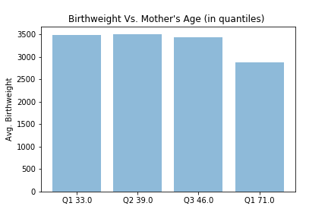Exhibit 1: Influence of mothers’ age on birthweight

Exhibit 2: Negative influence of alcoholic beverages on birthweight

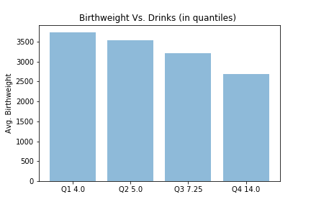

Exhibit 3: Negative influence of smoking on birthweight

