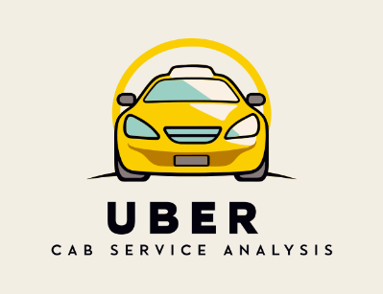
Uber Cab Service Analysis – Power BI Project Report

Kumar Boste

https://github.com/KumarBoste/Uber_Cab_Service_Analysis

Contents:

1. Project Overview

2. Problem Statement

3. Statistical Analysis

4. Data Visualization and Insights

5. Conclusion

Project Overview
The Uber Cab Service Analysis project aims to evaluate overall performance, demand trends, customer behavior, and revenue patterns of a cab service company using Power BI. The project integrates real-world ride-level data containing trip details, customer demographics, distance covered, ride outcomes, payment modes, and driver performance. Interactive dashboards help stakeholders monitor booking trends, evaluate customer and driver performance, track KPIs, and make data-driven decisions to optimize operations.

Problem Statement
With rising competition in cab services, companies must improve their operations. Key challenges include high cancellations, revenue fluctuations, peak-hour inefficiencies, and inconsistent ratings. This project aims to understand revenue contributors, demand patterns, cancellation reasons, satisfaction levels, and operational KPIs to help improve business decisions.

Statistical Analysis

Summary Metrics:
• Completed Bookings: 93K
• Lost/Cancelled Bookings: 57K
• Total Revenue: 52M
• Total Distance: 2.51M km
• Avg Distance per Trip: 24.64 km

Vehicle-Level Insights:
• Auto generated highest revenue (12.9M)
• Bike and Go Mini show strong performance
• Uber XL underperformed

Time-Series:
• High demand in Jan, Mar, Jun, Aug
• Lowest demand in February

Customer Behaviour:
• First-time riders: 48K
• Return riders: 5650
• Regular riders: 11K

Ratings:
• Avg Customer Rating: 4.40
• Avg Driver Rating: 4.23

Data Visualization and Insights

Overview Dashboard:
• Healthy booking volume but high lost bookings
• Seasonal revenue fluctuations observed

Vehicle Dashboard:
• Auto, Bike, Go Mini are top revenue drivers
• Uber XL underperforms due to high pricing/low demand

Revenue Dashboard:
• UPI (23M) is the most preferred payment mode
• Top pickup locations: Khandasa, Barakhamba, Saket, Badarpur

Customer Dashboard:
• Cancel reasons: driver unavailability, customer change, technical issues
• Peak hour analysis: 9AM–12PM and 3PM–6PM

Distance Dashboard:
• Total distance 2.51M km, dominated by economical vehicle types

Conclusion

The project provides valuable insights on operations, customer experience, and revenue optimization.

Key Findings:
• Auto & Bike dominate bookings and revenue
• High cancellations require better driver allocation
• UPI is the preferred payment mode
• Strong but improvable customer loyalty

Recommendations:
• Improve supply-demand matching
• Boost Uber XL performance with discounts
• Offer customer loyalty programs
• Improve driver incentives during peak hours

