Contents

**Requirements from Customer** 2

**Function points** 2

**Technology Stack** 3

**ER Diagram** 4

**Code Setup** 4

**Code execution** 4

# **Requirements from Customer**

The 3 main requirements are:

* It needs to be able to scan items in by quantity and weight
* It needs to be able to handle discount coupons… allow for two different types of coupons
  + % off total
  + Buy ‘x’ get ‘y’ free (i.e. buy 3 get 1 free)
* It should be able to provide a caller with a total cost and a list of items

Please note that we are only interested in the server side implementation and want to see code only, so please do not work on any UI, a console application is fine.

# **Function points**

1. Item Inventory
   1. Ability to Add/Edit Product information with quantity, Weight and price
   2. Item quantity will be reduced when confirming an order
2. Customer Information
   1. Ability to Add/Edit customer information’s
3. Discount
   1. Ability to Add/Edit Discount information’s.
   2. Discount should be applied for individual product.
   3. Discount should effect only for specific period
   4. Discount applied on percentage of product cost or freebies for specific quantity of purchase.
4. Cart
   1. Ability to add items into cart for individual customer.
   2. To list all the added items and apply the eligible discount for each item for specific customer.
5. Order
   1. Convert an order from cart for specific customer.
   2. Apply eligible discount for individual product.
   3. Calculate total cost and total discount.
   4. After confirming the order available quantity will be updated in Item Inventory

# **Technology Stack**

1. Microsoft Asp .Net Core 2.1.1
2. Web API
3. Entity Framework core
4. SQL Server 2008

[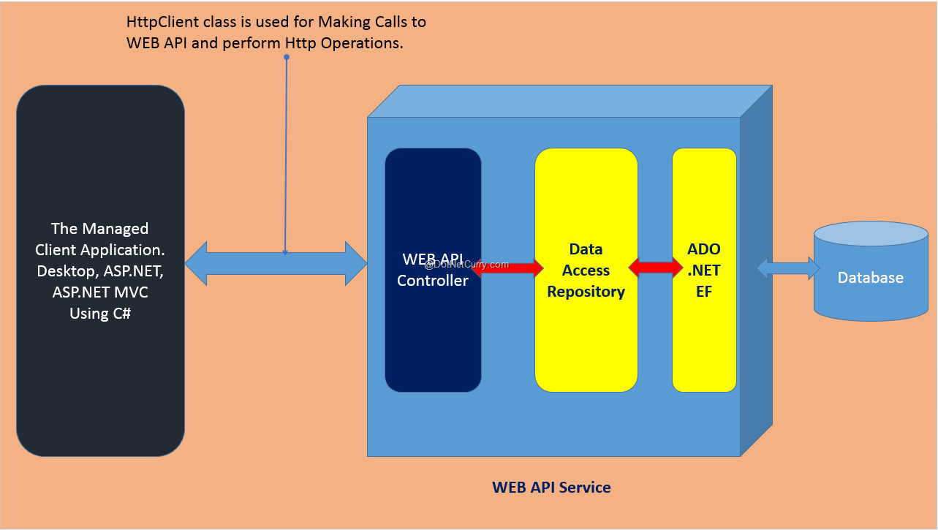](http://www.google.com/url?sa=i&rct=j&q=&esrc=s&source=images&cd=&cad=rja&uact=8&ved=2ahUKEwiWo7T79NvcAhXQIjQIHZTwBi0QjRx6BAgBEAU&url=http://www.dotnetcurry.com/aspnet/1192/aspnet-web-api-async-calls-mvc-wpf&psig=AOvVaw0r97_0YA4S7qLL1EHoAVIU&ust=1533764708843720)

Development Environment

1. Visual Studio 2017
2. SQL Server 2008
3. Swashbuckle Asp .Net Core 3.0.0 (Swagger UI)

# **ER Diagram**

Execute the uploaded SQL_Script.sql (from github)

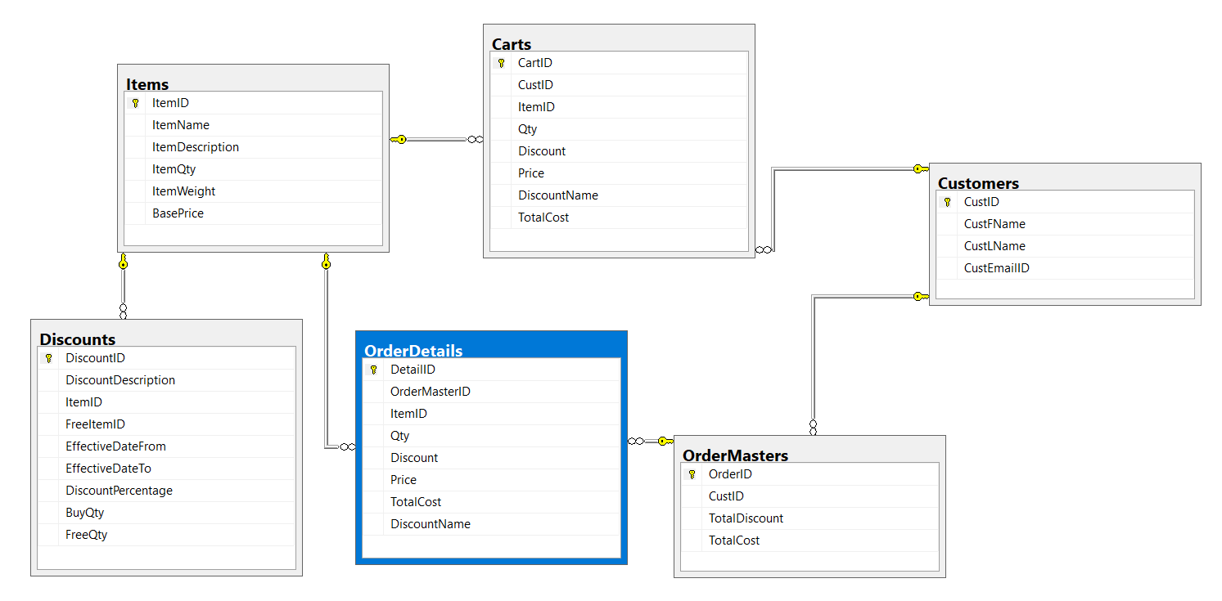

# **Code Setup**

1. Download the source code from github<https://github.com/KumarJanakiraman/SEW_CashRegister>
2. Execute the attached SQL_Script.sql for table creation
3. Open a Visual studio 2017 and solution from the source code.
4. Update the DB connection string in appsettings.json file.

# **Code execution**

UI is out of scope as mentioned in the requirement.

Swagger UI added for validating source code

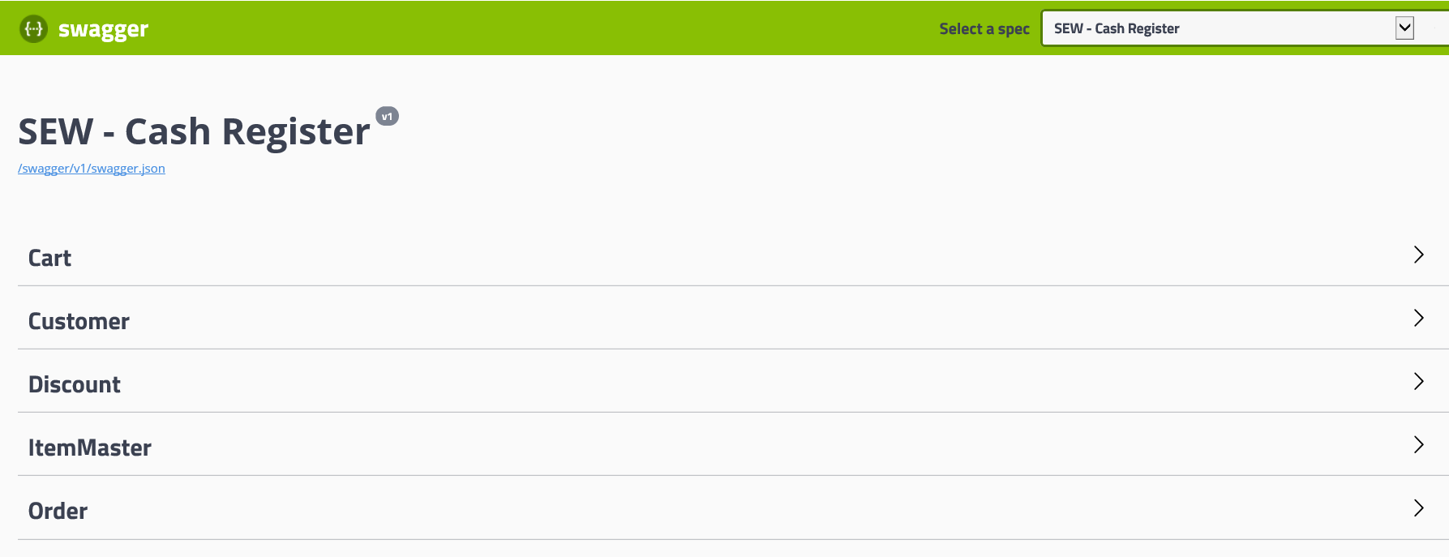

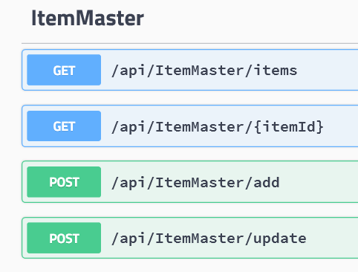

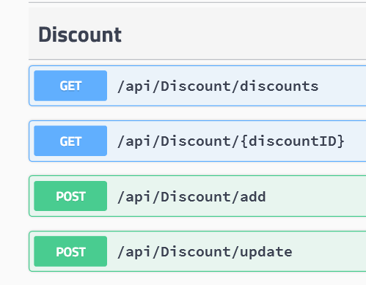

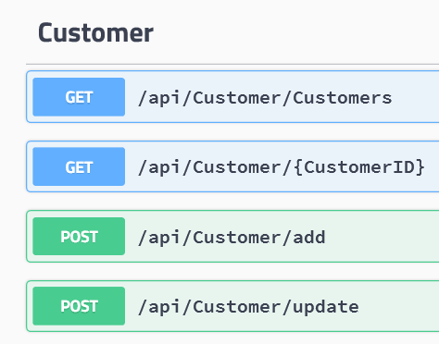

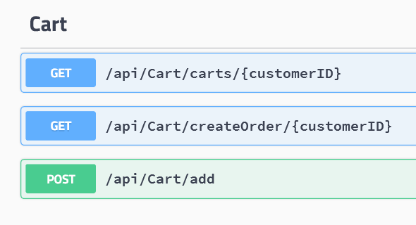s