**SCIENTIFIC CALCULATOR USING ARDUINO**

**Equation: y = (|sinx|-|cosx|)2**

**INTRODUCTION**

Although calculators have been around for thousands of years, electronic ones have been dominating the world for decades. From basic to scientific, calculators come in all shapes and sizes.

**AIM**

To build and execute basic operations on a scientific calculator using Arduino UNO.

**APPARATUS**

* Arduino UNO
* LCD 1602A liquid crystal display
* 4x4 button keypad
* Breadboard
* Potentiometer, 1-10Kohm
* Resistor, 200-1000 ohm
* Jumper wires

To be able to compile this program, we need to have both the LiquidCrystal.h and Keypad.h libraries installed in the Arduino UNO.

**ARDUINO UNO**

The Arduino UNO is an open-source microcontroller board based on the [Microchip](https://en.wikipedia.org/wiki/Microchip_Technology) [ATmega328P](https://en.wikipedia.org/wiki/ATmega328P) microcontroller and developed by [Arduino.cc](https://en.wikipedia.org/wiki/Arduino). The board is equipped with sets of digital and analog input/output (I/O) pins that may be interfaced to various expansion boards and other circuits. Here "UNO" means “one” in Italian and was chosen to mark the release of Arduino Software (IDE) 1.0.

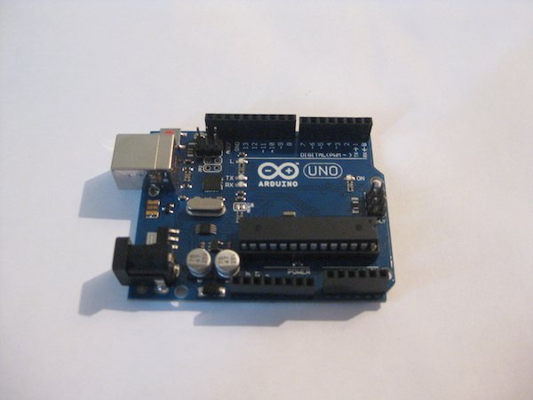

The Uno board is the first in a series of USB Arduino boards, and the reference model for the Arduino platform. The ATmega328 on the Arduino Uno comes preprogrammed with a bootloader that allows uploading new code to it without the use of an external hardware programmer. It communicates using the original STK500 protocol. The board has 14 Digital pins, 6 Analog pins, and programmable with the [Arduino IDE](https://en.wikipedia.org/wiki/Arduino#Software) (Integrated Development Environment) via a type B USB cable.

* **LED:** There is a built-in LED driven by digital pin 13. When the pin is HIGH value, the LED is on, when the pin is LOW, it's off.
* **Vin:** The input voltage to the Arduino/Genuino board when it's using an external power source (as opposed to 5 volts from the USB connection or other regulated power source). You can supply voltage through this pin, or, if supplying voltage via the power jack, access it through this pin.
* **5V:** This pin outputs a regulated 5V from the regulator on the board. The board can be supplied with power either from the DC power jack (7 - 20V), the USB connector (5V), or the VIN pin of the board (7-20V). Supplying voltage via the 5V or 3.3V pins bypasses the regulator, and can damage the board.
* **3V3:** A 3.3 volt supply generated by the on-board regulator. Maximum current draw is 50 mA.
* **GND:** Ground pins.
* **IOREF:** This pin on the Arduino/Genuino board provides the voltage reference with which the microcontroller operates. A properly configured shield can read the IOREF pin voltage and select the appropriate power source or enable voltage translators on the outputs to work with the 5V or 3.3V.
* **Reset:** Typically used to add a reset button to shields which block the one on the board.
* **Serial:** pins 0 (RX) and 1 (TX). Used to receive (RX) and transmit (TX) TTL serial data. These pins are connected to the corresponding pins of the ATmega8U2 USB-to-TTL Serial chip.
* **External Interrupts:** pins 2 and 3. These pins can be configured to trigger an interrupt on a low value, a rising or falling edge, or a change in value.
* **PWM**: 3, 5, 6, 9, 10, and 11 Can provide 8-bit PWM output with the analogWrite() function.
* **SPI**: 10 (SS), 11 (MOSI), 12 (MISO), 13 (SCK). These pins support SPI communication using the SPI library.
* **TWI**: A4 or SDA pin and A5 or SCL pin. Support TWI communication using the Wire library.
* **AREF:** Reference voltage for the analog inputs.

**LCD 16*2A**

The Arduino IDE has a built-in library (LiquidCrystal.h) that supports LCDs based on the Hitachi HD44780 chipset (and/or ones that are compatible with it). Other than displaying text on an LCD, the library can also handle printing floating point numbers to a specified amount of decimal places, which makes things easier for the developer.

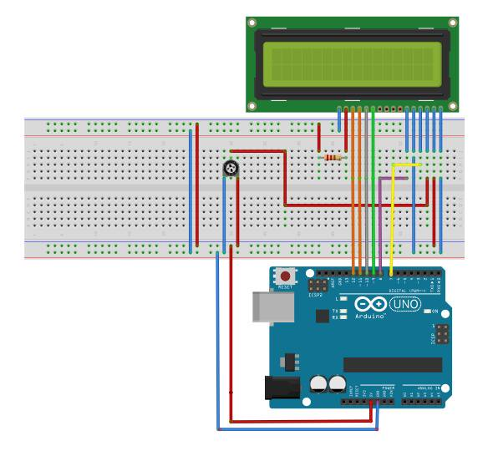

For example:

double Pi = 3.1415926535;

Lcd.print (Pi,4);

This will print 3.1415 on the LCD where 4 represents 4 decimal places. The LCD in this example uses 4-bit data transfer Pins D4-D7 (11-14 on the board). The potentiometer acts as a voltage divider and controls contrast of the displayed text. Its middle pin connects to Pin V0 (pin3) of the display.

**4x4 KEYPAD**

There is a library for Arduino Keypad.h that is capable of handling a button matrix and it eliminates the need for external pull-up resistors because it enables on-chip integrated pull-up resistors, and it also sets high impedance on all unused column pins.

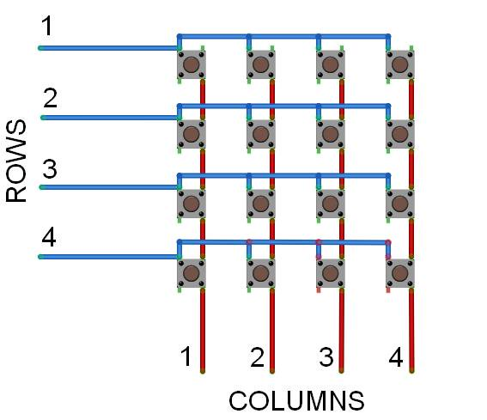 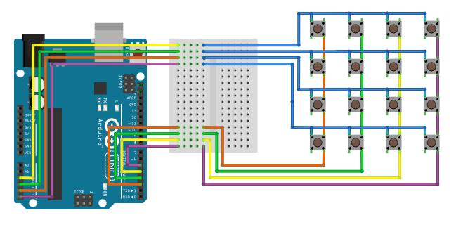

**CODE**

#include <Keypad.h>

#include <LiquidCrystal.h>

#include <math.h>

//used 'D' for enter

LiquidCrystal lcd(3,2,12,13,11,10);

const byte ROWS = 4;

const byte COLS = 4;

char keys[ROWS][COLS] = {

{'1','2','3','A'},

{'4','5','6','B'},

{'7','8','9','C'},

{'#','0','*','D'}

};

byte rowPins[ROWS] = {5, 4,15,14};

byte colPins[COLS] = {8, 7, 6,9};

String show_val = "";

double prev_val = 0;

bool status = false;

char oper_vector[5] = {'+','-','*','/','%'};

Keypad keypad = Keypad( makeKeymap(keys), rowPins, colPins, ROWS, COLS );

void setup(){

Serial.begin(9600);

lcd.begin(16, 2);

operation_information();

}

void loop(){

status = false;

long enter_val = getNumber();

Serial.print("You have chosen:");

Serial.print(enter_val);

Serial.println();

lcd.clear();

lcd.print("you have chosen:");

lcd.setCursor(0,2);

lcd.print(enter_val);

delay(2000);

if(enter_val == 15){

BODMAS();

}

else{

show_val = "";

prev_val = process(enter_val,status);

while(1){

status = true;

Serial.println("press only D to start new computation.");

show_val = "";

long enter_val1 = getNumber();

if(enter_val1==0){

Serial.println("starting new computation.");

break;

}

else{

Serial.print("you have chosen:");

Serial.println(enter_val);

lcd.clear();

show_val = "";

String myString = String(prev_val);

getshow_val(myString);

lcd.print(show_val);

prev_val = process(enter_val1,status);

}

}

}

delay(6000);

lcd.clear();

show_val = "";

}

void operation_information(){

Serial.println("Choose the option:");

Serial.println("1.ADD");

Serial.println("2.SUB");

Serial.println("3.MULT");

Serial.println("4.DIV");

Serial.println("5.ABS");

Serial.println("6.SIN");

Serial.println("7.COS");

Serial.println("8.TAN");

Serial.println("9.SQRT");

Serial.println("10.Loge");

Serial.println("11.Log10");

Serial.println("12.exp");

Serial.println("13.pow");

Serial.println("14.square of number");

Serial.println("16.EQUATION");

Serial.println("17.COSEC");

Serial.println("18.SEC");

Serial.println("19.COT");

}

String operation(int num1)

{

String ret_val = "";

while(1){

if(num1==1){

ret_val = "+";

}

else if(num1==2){

ret_val = "-";

}

else if(num1==3){

ret_val = "*";

}

else if(num1==4){

ret_val = "/";

}

else if(num1==5){

ret_val = "abs :";

}

else if(num1==6){

ret_val = "sin :";

}

else if(num1==7){

ret_val = "cos :";

}

else if(num1==8){

ret_val = "Mod";

}

else if (num1==9){

ret_val = "SQRT: ";

}

else if(num1==10){

ret_val = "Loge:";

}

else if(num1==11){

ret_val = "Log10:";

}

else if(num1==12){

ret_val = "exp:";

}

else if(num1==13){

ret_val = "pow:";

}

else if(num1==14){

ret_val = "square of a number:";

}

else if(num1==16){

ret_val = "EQUATION:";

}

break;

}

getshow_val(ret_val);

return ret_val;

}

double process(int num,bool status){

double val1 = prev_val;

if(num==1){

if(status==true){

}

else{

lcd.clear();

Serial.println("Enter the first number.");

val1 = (double)getNumber();

Serial.println(val1);

}

String oper = operation(num);

lcd.clear();

lcd.print(show_val);

Serial.println(oper);

Serial.println("Enter second number.");

double val2 = (double)getNumber();

Serial.println(val2);

lcd.clear();

lcd.print(show_val);

lcd.setCursor(0,2);

double result = val1 + val2;

lcd.print(result);

Serial.println("Result is:");

Serial.println(result);

return result;

}

else if(num==2){

if(status==true){

}

else{

lcd.clear();

Serial.println("Enter the first number.");

val1 = (double)getNumber();

Serial.println(val1);

}

String oper = operation(num);

lcd.clear();

lcd.print(show_val);

Serial.println(oper);

Serial.println("Enter second number.");

double val2 = (double)getNumber();

Serial.println(val2);

lcd.clear();

lcd.print(show_val);

lcd.setCursor(0,2);

double result = val1 - val2;

lcd.print(result);

Serial.println("Result is:");

Serial.println(result);

return result;

}

else if(num==3){

if(status==true){

}

else{

lcd.clear();

Serial.println("Enter the first number.");

val1 = (double)getNumber();

Serial.println(val1);

}

String oper = operation(num);

lcd.clear();

lcd.print(show_val);

Serial.println(oper);

Serial.println("Enter second number.");

double val2 = (double)getNumber();

Serial.println(val2);

lcd.clear();

lcd.print(show_val);

lcd.setCursor(0,2);

double result = val1 * val2;

lcd.print(result);

Serial.println("Result is:");

Serial.println(result);

return result;

}

else if(num==4){

if(status==true){

}

else{

lcd.clear();

Serial.println("Enter the first number.");

val1 = getNumber();

Serial.println(val1);

}

String oper = operation(num);

lcd.clear();

lcd.print(show_val);

Serial.println(oper);

Serial.println("Enter second number.");

long val2 = getNumber();

Serial.println(val2);

lcd.clear();

lcd.print(show_val);

lcd.setCursor(0,2);

double result = val1 / val2;

lcd.print(result);

Serial.println("Result is:");

Serial.println(result);

return result;

}

else if(num==8){

lcd.clear();

show_val = "";

String oper = operation(num);

lcd.clear();

Serial.println(oper);

if(status==true){

String myString = String(val1);

getshow_val(myString);

lcd.print(show_val);

}

else{

Serial.println("Enter the number.");

val1 = (double)getNumber();

Serial.println(val1);

}

lcd.setCursor(0,2);

double result = tan(val1*0.01745);

lcd.print(result);

Serial.println("Result is:");

Serial.println(result);

return result;

}

else if(num==5){

lcd.clear();

show_val = "";

String oper = operation(num);

lcd.clear();

Serial.println(oper);

if(status==true){

String myString = String(val1);

getshow_val(myString);

lcd.print(show_val);

}

else{

Serial.println("Enter the number.");

val1 = (double)getNumber();

Serial.println(val1);

}

lcd.setCursor(0,2);

double result = abs(val1);

lcd.print(result);

Serial.println("Result is:");

Serial.println(result);

return result;

}

else if(num==16){

lcd.clear();

show_val = "";

String oper = operation(num);

lcd.clear();

Serial.println(oper);

if(status==true){

String myString = String(val1);

getshow_val(myString);

lcd.print(show_val);

}

else{

Serial.println("Enter the number.");

val1 = (double)getNumber();

Serial.println(val1);

}

lcd.setCursor(0,2);

double result = square(abs(sin(val1*0.01745)-abs(cos(val1*0.01745))));

lcd.print(result);

Serial.println("");

Serial.println(result);

return result;

}

else if(num==7){

lcd.clear();

show_val = "";

String oper = operation(num);

lcd.clear();

Serial.println(oper);

if(status==true){

String myString = String(val1);

getshow_val(myString);

lcd.print(show_val);

}

else{

Serial.println("Enter the number.");

val1 = (double)getNumber();

Serial.println(val1);

}

lcd.setCursor(0,2);

double result = cos(val1);

lcd.print(result);

Serial.println("Result is:");

Serial.println(result);

return result;

}

else if(num==9){

lcd.clear();

show_val = "";

String oper = operation(num);

lcd.clear();

Serial.println(oper);

if(status==true){

String myString = String(val1);

getshow_val(myString);

lcd.print(show_val);

}

else{

Serial.println("Enter the number.");

val1 = (double)getNumber();

Serial.println(val1);

}

lcd.setCursor(0,2);

double result = sqrt(val1);

lcd.print(result);

Serial.println("Result is:");

Serial.println(result);

return result;

}

else if(num==10){

lcd.clear();

show_val = "";

String oper = operation(num);

lcd.clear();

Serial.println(oper);

if(status==true){

String myString = String(val1);

getshow_val(myString);

lcd.print(show_val);

}

else{

Serial.println("Enter the number.");

val1 = (double)getNumber();

Serial.println(val1);

}

lcd.setCursor(0,2);

double result = log(val1);

lcd.print(result);

Serial.println("Result is:");

Serial.println(result);

return result;

}

else if(num==11){

lcd.clear();

show_val = "";

String oper = operation(num);

lcd.clear();

Serial.println(oper);

if(status==true){

String myString = String(val1);

getshow_val(myString);

lcd.print(show_val);

}

else{

Serial.println("Enter the number.");

val1 = getNumber();

Serial.println(val1);

}

lcd.setCursor(0,2);

double result = log10((double)val1);

lcd.print(result);

Serial.println("Result is:");

Serial.println(result);

return result;

}

else if(num==12){

lcd.clear();

show_val = "";

String oper = operation(num);

lcd.clear();

Serial.println(oper);

if(status==true){

String myString = String(val1);

getshow_val(myString);

lcd.print(show_val);

}

else{

Serial.println("Enter the number.");

val1 = getNumber();

Serial.println(val1);

}

lcd.setCursor(0,2);

double result = exp((double)val1);

lcd.print(result);

Serial.println("Result is:");

Serial.println(result);

return result;

}

else if(num==17){

lcd.clear();

show_val = "";

String oper = operation(num);

lcd.clear();

Serial.println(oper);

if(status==true){

String myString = String(val1);

getshow_val(myString);

lcd.print(show_val);

}

else{

Serial.println("Enter the number.");

val1 = (double)getNumber();

Serial.println(val1);

}

lcd.setCursor(0,2);

double result = 1/sin(val1*0.01745);

lcd.print(result);

Serial.println("");

Serial.println(result);

return result;

}

else if(num==18){

lcd.clear();

show_val = "";

String oper = operation(num);

lcd.clear();

Serial.println(oper);

if(status==true){

String myString = String(val1);

getshow_val(myString);

lcd.print(show_val);

}

else{

Serial.println("Enter the number.");

val1 = (double)getNumber();

Serial.println(val1);

}

lcd.setCursor(0,2);

double result = 1/cos(val1*0.01745);

lcd.print(result);

Serial.println("");

Serial.println(result);

return result;

}

else if(num==19){

lcd.clear();

show_val = "";

String oper = operation(num);

lcd.clear();

Serial.println(oper);

if(status==true){

String myString = String(val1);

getshow_val(myString);

lcd.print(show_val);

}

else{

Serial.println("Enter the number.");

val1 = (double)getNumber();

Serial.println(val1);

}

lcd.setCursor(0,2);

double result = cos(val1*0.01745)/sin(val1*0.01745);

lcd.print(result);

Serial.println("");

Serial.println(result);

return result;

}

else if(num==14){

lcd.clear();

show_val = "";

String oper = operation(num);

lcd.clear();

Serial.println(oper);

if(status==true){

String myString = String(val1);

getshow_val(myString);

lcd.print(show_val);

}

else{

Serial.println("Enter the number.");

val1 = getNumber();

Serial.println(val1);

}

lcd.setCursor(0,2);

double result = square((double)val1);

lcd.print(result);

Serial.println("Result is:");

Serial.println(result);

return result;

}

if(num==13){

if(status==true){

}

else{

lcd.clear();

Serial.println("Enter the first number.");

val1 = (double)getNumber();

Serial.println(val1);

}

String oper = operation(num);

lcd.clear();

lcd.print(show_val);

Serial.println(oper);

Serial.println("Enter second number.");

long val2 = getNumber();

Serial.println(val2);

lcd.clear();

lcd.print(show_val);

lcd.setCursor(0,2);

double result = pow(val1,(double)val2);

lcd.print(result);

Serial.println("Result is:");

Serial.println(result);

return result;

}

}

void getshow_val(String str){

show_val = show_val + str;

}

long getNumber()

{

long second = 0;

while(1)

{

char Key = keypad.getKey();

if(Key >= '0' && Key <= '9')

{

second = second * 10 + (Key - '0');

lcd.clear();

String myString = String(Key);

getshow_val(myString);

lcd.print(show_val);

}

if(Key == 'D') {

break;

}

}

return second;

}